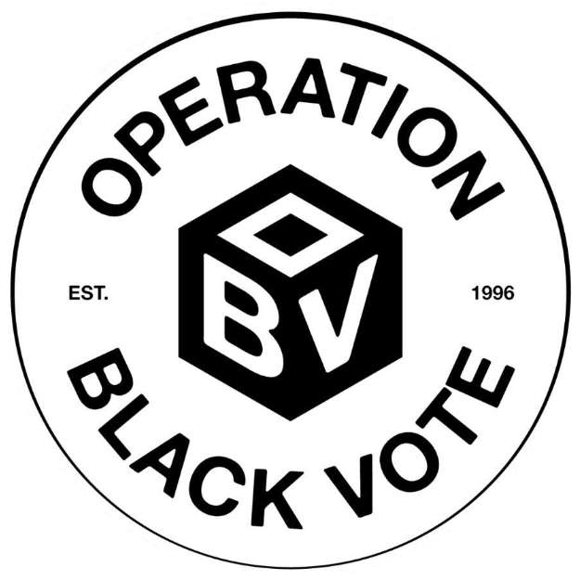
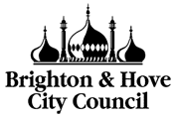
Operation Black Vote & Brighton & Hove City Council
Civic Leadership Programme 2026

Programme Outline

Introduction: Brighton & Hove’s Civic Leaders

Operation Black Vote in partnership with Brighton & Hove City Council is delighted to launch a unique Civic Leadership Programme to nurture Brighton & Hove’s future leaders. The aim of the project is to address the deficit of Black and minority ethnic individuals in all areas and at all levels of civic and public life.

Building upon the unprecedented success of Operation Black Vote’s award-winning Shadowing Schemes – MP, Magistrates, Councillor, National Assembly for Wales and Parole Board – this project aims to help tackle the under representation of Black and minority ethnic individuals in many areas of civic and public life and also demystify the functions of key public institutions.

Programme aims and objectives:

- To gain invaluable experience of life as a Public Appointee
- To give participants the opportunity to explore their chosen areas of public life
- To obtain a variety of transferable skills and the confidence to use those skills to consider becoming a civic leader
- To equip participants with both the knowledge and the confidence to speak to others about civic engagement, and how they may get involved
- To improve the representation of Black and minority ethnic communities in areas of public life throughout Brighton & Hove
- To give Public Appointees the opportunity to gain greater understanding of different aspects of the diverse communities they seek to serve.

Who is eligible?

We are looking for 30 dynamic individuals from Black and minority ethnic backgrounds, aged 18 years upwards who live or work in Brighton & Hove, with a keen interest in positively contributing to their community.

What does the programme comprise of?

The programme will be based in Brighton & Hove and comprise of both online and in person blended learning, some evening and some daytime attendance, with approximately 6-12 non-consecutive days over a six-month period. (The number of days will vary from a minimum of 6 days to a maximum of 12 days dependent upon the number of areas of public life you wish to observe).

Individuals will participate in a mixture of in person observation and training sessions across four areas of public life. Candidates may choose between 2-4 areas of public life from the following areas:

Education: School Governors
Policing: Police and Crime Panels
Criminal Justice System: Magistrates
Health: Health Board of Brighton & Hove NHS Foundation Trust
Voluntary Sector: Trustees
Local Government: Councillors

The initiative will focus on giving participants first-hand knowledge of the roles and responsibilities of Board Members, Trustees and other public appointees and an insight into the systems and procedures of public bodies. Our aim is that upon completion, this leadership programme will equip and motivate participants to engage in public life. Participants will also be encouraged to become Community Ambassadors, explaining and promoting the benefits of civic engagement and encouraging others to become involved in community affairs. The scheme will also give Board Members and public appointees an opportunity to gain a greater understanding of Black and minority ethnic communities. OBV view this process as essential to involving Black and minority ethnic communities in the wide scope of activities within the decision-making process.

The Process

OBV in conjunction with Brighton & Hove City Council will select a total of 30 Black and minority ethnic men and women to participate in the Programme. Candidates will comprise a mix of Black and minority ethnic communities.

Participants will follow a Programme devised by OBV that allows a unique perspective of the work in six areas of public life. These may be: School Governor, Police and Crime Panels, Magistrate, Health Board Member, Trustee and Councillor.

Participants will attend observation and training sessions that will allow them to become familiar with:

- How each area of public life works
- Roles and responsibilities of being a Public Appointee
- The process and procedures of each area of public life
- Benefit to the community of each area of public life
- How Public Appointments are made.

The scheme also includes a learning seminar looking at areas such as:

- Developing leadership techniques
- Presentation and public speaking skills
- Importance of civic activism
- Issues regarding race, equality and Black and minority ethnic representation.

Requirements of Applicants:
- Applicants must be 18 years or older
- Must demonstrate a genuine interest in community affairs
- Must be able to commit between 6-12 working days to complete the programme.
(Number of days will vary from a minimum of 6 days to a maximum of 12 days dependent upon number of areas of public life you wish to observe).

Is there a fee?

No. There is not a cost to participate in the programme, as OBV are keen to promote the benefits of Black and minority ethnic engagement in civic life.

Travel and food costs will be reimbursed for observation sessions and learning seminars.

What happens when the scheme has finished?

OBV’s Shadowing Schemes and leadership programmes have received numerous awards for their ability to inform and inspire. Many graduates have become Councillors, Magistrates, School Governors, with others creating political history as political firsts.

Our aim is that upon completion, this leadership programme will equip participants with the skills and motivations to engage in public life. All participants who successfully complete the programme will be invited to a graduation event and awarded with a certificate.

In addition, participants will join OBV’s Alumni programme, which will provide assistance, support and networking opportunities to further develop your civic aspirations.

What is the next step?

If you are interested in becoming a future civic leader of Brighton & Hove, complete the application form and return it to OBV by 23:59, Sunday 23 August 2026.

Applications can be obtained by:

- Visiting our website: www.obv.org.uk
- Emailing us at: brighton-hove@obv.org.uk
- Telephoning: 0208 983 5430.

You will be notified of the outcome of your application by early September 2026
Interview dates will be during the first half on September 2026

