Information Report for Pupils with Special Educational Needs and Disabilities - December 2025

1. The kinds of Special Educational Needs and disabilities (SEND) that are provided for by Kippax Greenfield Primary School | There are 4 broad categories of need as described by the 2014 Code of Practice, which we provide for within school.  These are:  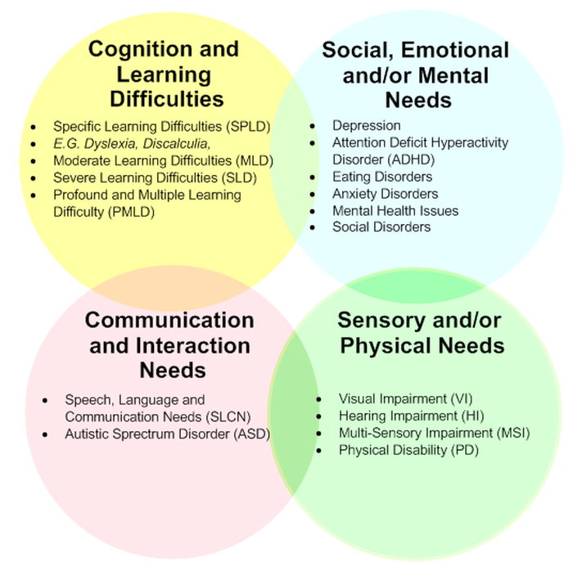  • Communication and Interaction  This includes children with speech and language difficulties and those who demonstrate features within the autistic spectrum.  • Cognition and Learning  This includes children who demonstrate features of moderate, severe, profound or specific learning difficulties such as dyslexia, dyscalculia or dyspraxia.  • Social, Emotional and Mental Health  This includes children who  have significant difficulties in managing their emotions and behaviour. Children may also be withdrawn, hyperactive or lack concentration.  • Sensory and/or Physical Needs  This includes children with sensory, multisensory and physical difficulties.
2. Who to contact at Kippax Greenfield Primary School regarding a SEND query. | The Special Educational Needs Coordinator (SENDCO) at Kippax Greenfield Primary School is Mrs Kate Falkingham  They can be contacted through the school office as follows:  Email: kgpsoffice@brigshawtrust.com  Phone: 0113 2876195
3. The systems in place for identifying a person who may have Special Educational Needs and Disabilities | At Kippax Greenfield Primary School we identify the needs of pupils by considering the needs of the whole child, not just his or her special educational needs and disabilities.  In identifying a child as needing SEND support, the class teacher, working with the SENDCO, will carry out a clear analysis of the pupil’s needs. This will draw on:  • The teacher’s assessment and experience of the pupil  • Their previous progress and attainment  • The views and experience of parents, the pupil’s own views and, if relevant, advice from external support services.  Children identified as having SEND may be monitored by the class teacher, given extra support through group or individual interventions by appropriate staff, a learning support assistant, or placed on the SEND register if appropriate. There are times when a child’s SEND requirement may already be in place before they arrive at school through consultation with outside agencies.
4. The systems in place for monitoring, assessing and reviewing pupils progress towards outcomes. | We offer a Graduated approach to SEND support. This means we carry out the process of Assess, Plan, Do, Review on a regular basis to make sure we are continually meeting the individual needs of children in our school.  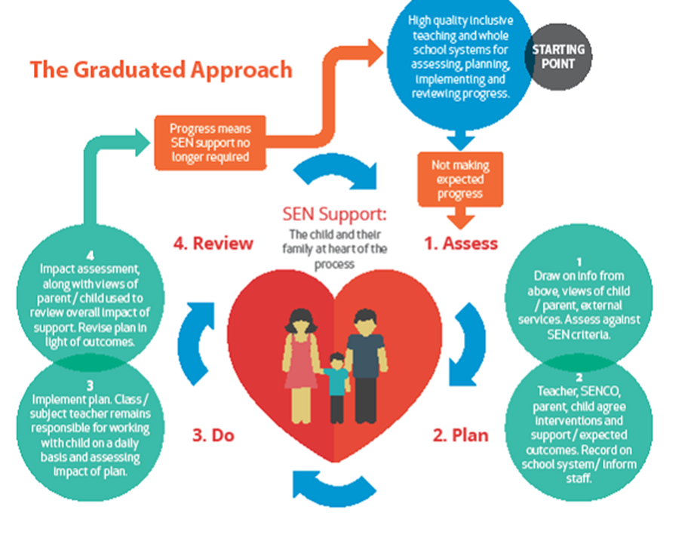  The school will use a variety of assessment and organisational tools, conversations with teachers, support staff, parents/carers and learners to carry out the process effectively.  1. Assess - The school will use a variety of methods to assess the SEND need. These include:  - Teacher assessment  - Internal data on attainment, progress, behaviour, attendance and work samples  - Parent and student views  - Advice from external agencies  2. Plan - The school will create a plan of action for the student in partnership with parents/carers, the student and teachers. This will include:  - Reasonable adjustments teachers should make to provide adaptive teaching  - What additional provision/intervention is needed to ensure they make progress  - SMART (Specific, Measurable, Achievable, Realistic and Timed) targets are set  3. Do - The plan will then be implemented for a period of time before it is reviewed again.  4. Review - The plan will be reviewed by parents/carers, the student and teachers. The review will be looking at:  - Has the student met or is on track to meet expected targets? What evidence is there?  - Has there been any improvement on their rate of progress?  - How is the student responding to the targeted provision?  - Are there changes to the SEND?  At this stage it is hoped that a fuller understanding of the need has been established and from this it will be decided to either:  - Continue with the current plan since it is proving to be successful  - Try different strategies that might prove to be more successful  Referrals can be made to specialist external agencies and professionals for further assessment and advice
5. The approach to teaching pupils with Special Educational Needs and Disabilities at Kippax Greenfield Primary School. | At Kippax Greenfield Primary School we ensure all pupils have access to High Quality First Teaching. We believe that successful teaching and learning is not just about good lessons; it stems from the culture and environment we create. We believe that by developing emotional intelligence and creating the appropriate supporting conditions all children will thrive, because all of this impacts on how children behave as learners.  As such, we create a positive learning environment with:  • Different approaches to learning so all children can access learning  • Children taking responsibility for their own learning, including SEND children having responsibility of their own targets  • All children working collaboratively together, supported by adults and children alike  • Making mistakes is integral to learning and children are supported in how to improve from these  • Effort of all children is rewarded  • Positive exchanges are predominant
6. The adaptations made to the curriculum for pupils where needed.  6. Continued | Our vision of 'Growing Greatness at Greenfield' is at the heart of our curriculum. We want our pupils to enjoy lives of choice and opportunity and our curriculum is designed to ensure our children build lifelong knowledge and skills across the full breadth of subjects whilst also being equipped with the communication skills and personal attributes to enable them to be successful global citizens. Our curriculum, which is underpinned by the National Curriculum, has clearly sequenced content and progression designed specifically for our mixed-age classes and incorporates carefully selected opportunities to build cultural capital. It enables pupils to master knowledge and skills yet is adapted according to their needs. Our use of regular retrieval practice and low-stakes quizzing helps children remember in the long-term the content they have been taught.  All of our inclusive classrooms contain:  - Visuals which are regularly referred to during the school day to reinforce key messages and instructions to all children.  - Clear and concise teacher modelling with frequent checking for understanding which allows teachers to make adaptations as needed during lessons.  - Different ways for children to share, show and record their learning (including the use of technology)  - An appropriate level of challenge for each child with supportive tools or resources such as writing frames or partly-completed examples.  - Time and opportunity for pupils to help and support one another.  SEND is the responsibility of everyone; every teacher is a teacher of every young person including those with SEND or any other additional need. We work closely with our children, families and a wide range of professionals to ensure the best possible educational outcomes. Teaching and support staff work together to plan appropriately adapted lessons that meet the specific needs of all our learners. All children have access to high quality first teaching. However, for some children further additional support may be needed to help them achieve their targets. This will be implemented in line with Inclusive Mainstream Practice Guidance i.e. the provision the local authority expects to be made available for students with SEND in mainstream schools.  Students who require adjustments, additional support or intervention above that provided as part of quality first teaching will have a SEND Learning Plan/Pupil Profile to highlight strengths and areas of need. They provide strategies to support the student, teaching and support staff in order to provide a positive impact on progress, development and access to the curriculum. All Learning plans are written using guidance provided by professionals working with the student, the student themselves (where appropriate) and parents.  When accommodating children with physical difficulties classes can be moved around to ensure fair access for all. The local authority representative, SEND and Health & Safety governors and parents will also be invited to look around and check the accessibility of the building. The school works effectively with relevant professionals (e.g. Visually Impaired Team) to enable children with specific needs to attend our school, ensuring appropriate access internally and externally.  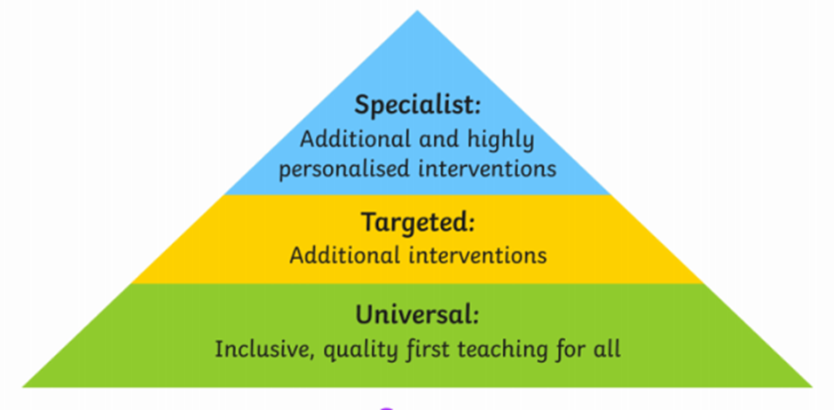  Universal Wave 1 - Applicable to all students:  All students will sit within Wave 1. This is our Universal offer to all students, whether they have additional needs or not. High quality, inclusive teaching ensures that planning and implementation meets the needs of all students, and builds on high expectations for all students, including those with SEND. It is about the day-to-day interactions that take place in the classroom and the different pedagogical approaches teachers use to engage and motivate learners which ensure good student progress.  Targeted Wave 2 (Monitoring) - Applicable to some students:  Additional needs have been identified, a referral may have been agreed or submitted. Students may move to Wave 2 if they are not making expected progress in an identified area of need e.g. learning, concentration or social interaction. At this point, interventions will be implemented; following this, students may still require additional interventions. Students that do not make expected progress or need more targeted support move to Wave 3.  Specialist Wave 3 (School Support)- Applicable to some students:  Students who move to Wave 3 will be placed on the SEND register and will receive a SEND Learning Plan or a Pupil Profile. These plans will be written with provision outlined.  Some students will make a good level of progress whilst on the SEND register and move back to Wave 2 where their progress (as for all our students), will be closely monitored.  Wave 4 (EHCP) - Applicable to few students:  If adequate support has been put in place over a prolonged period of time without any success and/or the student is performing significantly below age expected levels, then an application for an Education, Health and Care Needs Assessment may be made to the local Authority. In considering whether an Education, Health and Care Needs Assessment is necessary, the local authority will consider whether there is evidence that despite the school having taken relevant and purposeful action to identify, assess and meet the special educational needs of the child or young person, they have not made expected progress.  An EHCP is a legally binding document that states the students education, healthcare and care needs.
7. The arrangements for consulting pupils with SEND to involve them in their education. | We recognise that all pupils have the right to be involved in making decisions and exercising choices. In lessons, children are involved in monitoring and reviewing their progress through the use of targets and success criteria. We endeavour to involve the pupils by encouraging them to:  • State their views about their education and learning  • Identify their own needs and learn about learning  • Share in individual target setting  • Self-review progress and set new targets  • Monitor their success at achieving the targets on their support or individual plan.
8. The arrangements for consulting parents of children with SEND. | We work closely with parents to ensure:  • Early and accurate identification and assessment of SEND leading to the correct intervention and provision  • Continuing social and academic progress of children with SEND  • Personal and academic targets are met and set effectively.  Meetings are held termly with parents of children on the SEND register by the class teacher, there may be occasions where the SENDCO attends as well to ensure the children are working towards their given targets and update parents on the progress. Where needed these meetings occur more frequently to make sure the needs to the children are being met.
9. Transition arrangements for children with SEND needs at Kippax Greenfield Primary School. | The admission arrangement for all pupils is in accordance with the national legislation are outlined in the school admission policy, this includes children with any level of SEND; those with an Education Health Care Plan (EHCP) and those without.  The School SENDCO works closely with feeder schools or nurseries where there are SEND children to transfer information to aid a smooth transition, where possible a meeting will occur to do this  • Support for children who are coming to terms with transition is carefully planned. This will include familiarisation visits and mentoring, whether this is inside the school e.g. moving between classes or transitioning to high school; additional transition days/visits are provided where necessary.  • For children accessing secondary school who are more vulnerable we offer ‘Travel Training’ to aid their understanding of ‘stranger danger’ and the Green Cross Code and safety of pupil transport.
10. The training of staff to support children and young people with SEND at our school. | Specialist training of staff working with SEND children takes place when required.  In the past we have had staff undertake training in;  - Numicon  - Phonics (including Read Write Inc)  - Dyslexia,  - Team Teach positive handling  - Autism Awareness  - Intensive Interaction  - Makaton  We work alongside a speech and language therapist from The Yorkshire Speechie Limited, who provides specialist training to the adults in school who deliver speech and language programmes relevant to the children they are working with.
11. The support offered for improving emotional and social development. | All children are taught PSHCE (Personal, Social, Health and Citizenship Education) as part of their curriculum and this covers a wide range of aspects including keeping ourselves safe, building relationships, mental health and wellbeing. In addition to this, teachers will hold circle times and address issues within their classes when they arise.  In school, we have a learning mentor who works with key children identified as needing extra support with their emotional and social development; this may involve 1:1 sessions or group sessions using games or Lego therapy to develop skills. The Head Teacher and Assistant Head offer children the opportunity to talk through their problems at lunchtimes if there are issues at playtimes using restorative conversations.  We have access to a counsellor through our local guidance and support service that we can refer children to where we feel they may benefit from having someone else to talk to. We will consult with parents and seek their permission prior to arranging this.
12. The outside agencies that Kippax Greenfield Primary School work with to ensure the needs of individual pupils are met. | The school has strong working relationships and links with external support services to fully support SEND pupils and aid school inclusion. Sharing knowledge and information with these support services is key to the effective and successful SEND provision within our school.  Some of the agencies we work with include:  - Speech and Language Therapists  - Inclusion Advisory Team (IAT)  - Educational Psychologists  - Local Authority Special Educational Needs and Inclusion Team  - Autism Specialists  - The Deaf and Hearing Impaired team  - Occupational Therapists  - Local Guidance and Support Team (family support, counselling)
13. Which policies do you need to look at to find further information about SEND provision at Kippax Greenfield Primary School | The following policies are available to find out more about the identification, provision and assessment of pupils with SEND within our school:  • SEND policy  • Safeguarding and Child Protection Policy  • Supporting Pupils with Medical Needs Policy  • School Behaviour Policy  • Teaching and Learning Policy  • Equality Opportunities Policy  • Accessibility Plan
14. The way to raise a complaint regarding the provision of SEND children. | Should a parent or carer have a concern about the additional provision made for their child, they should, in the first instance, discuss this with the class teacher and/or SENDCO. If the concern cannot be satisfactorily dealt with at this stage, it should be brought to the notice of the Head of School. The BLP Complaint Policy is published on the BLP and school website.
15. How accessible is the school? | See our Accessibility Plan on our website.
16. School resources and funding linked and matched to children’s needs. | Notional Inclusion Budget - this funding is needs based using a formula against the profile presented in the school census. It considers who requires additional support to access learning including factors such as social deprivation, demographics (e.g. EAL, Free School Meals eligibility) and levels of attainment. Schools are expected to fund the first £10,000 of any child or young person’s provision. This means that for any additional support (above core provision) there is an expectation that schools meet the first £6,000 of such provision. The notional budget is not specifically targeted at individual children and young people however schools are accountable for the use of this money for those children and young people needing it.  All students with an EHCP have additional funding allocated to meet their needs. Some students in Leeds are identified as having a higher level of need and have been allocated Funding For Inclusion (FFI) without an EHCP, each of which under SEND Reform Leeds will be considered for Statutory Assessment. The school uses the FFI funds to put appropriate support in place to meet the specific needs of a student. Working in partnership with professionals, money is targeted at children and young people with the most complex needs who require the most individualised provision. SEND funding can also be spent on the purchase of specialist equipment or resources that will support the student’s progress.  The notional SEND funds are used to provide a range of support for pupils with SEND which may include (but are not limited to) the following:  - SEND assistant support  - Daily Meet and Greet  - Pre and post teach  - Literacy and Numeracy intervention (small group or individual)  - Core subject tuition (small group or individual)  - Social, Emotional and Mental Health Groups e.g. social skills, self-esteem, anger management, Zones of Regulation  - Speech and Language intervention  - Purchase of assistive resources to be used in class  At the start of each academic year a considerable amount of planning and preparation is applied to ensure that all support staff are utilised effectively. This is done to ensure we meet the needs of all our pupils and achieve the best outcomes, as well as promoting independence and social skills.  Allocation of resources is the responsibility of the Senior Leadership Team and reflects priority of need which is advised by the SENDCo. This process is monitored by the Brigshaw Learning Partnership Directors and Local Governor.
17. Standard arrangements for SEND | See our SEND Policy on our website.
18. The arrangements for the admission of pupils with SEND | The admission arrangements for all pupils are in accordance with national legislation and are outlined in the school Admissions Policy. This includes children with any level of SEND; and those with an Education Health Care Plan (EHCP). We are an Academy and our school’s admission authority is the Brigshaw Learning Partnership (BLP). The BLP are responsible for determining the school’s admissions arrangements including this policy and deciding who can be offered a place in accordance with the policy.

