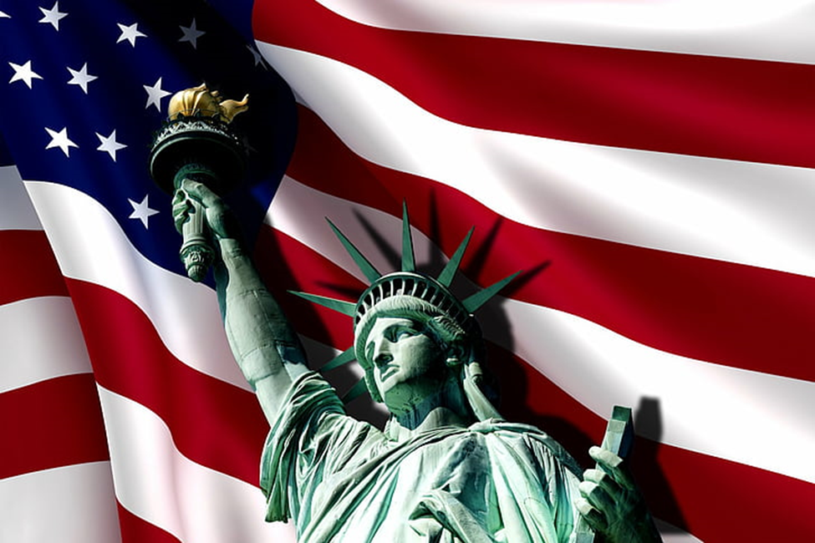
HIDDEN HARBOUR - 4TH Of July BOAT PARADE
Friday, July 4th at 4:00 Pm

You can watch from the shore, or be on your boat
It will start at 4PM, when we begin our float

Decorate your boat to have some fun
PLEASE skip the balloons and water guns

At the north end is where we will start
With flags flying high to fill your heart

Just gather up your red, white, and blue
So, we can salute America with you

Questions: Jeannie – 419-367-1445

