Skate Great
With

Congue nihil imperdiet doming id quod mazim placerat facer minim veni am ut wisi enim ad minimeniam, quis erat nostr uexe
rci tation ullamcorper nostru exerci tation ullam corper et iusto odio dig nissim qui blandit praesent lupta. Tummer delenit
augue duis dolore te feugait nulla facilisi. Con erattis sectetuer adip iscing elit, sed erat diam nonummy nibh magna erat.
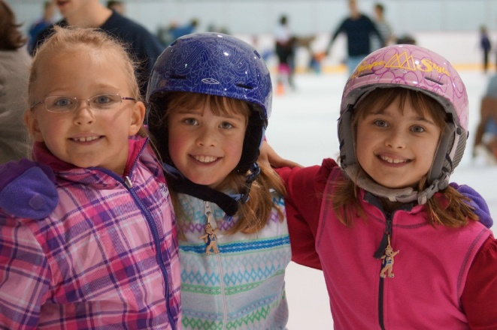
2026-2027 – Series 2
ICE ARENA
Piney Orchard
8781 Piney Orchard Parkway
Odenton, MD 21113
Do you have questions?
Stage 1: Discover, Learn and Play
Introductory Levels

Snowplow Sam 1 – 4 (3 – 5 year olds)
The Snowplow Sam levels are introductory classes allowing children with no prior skating experience to build confidence while learning the basic skills of skating. These classes are designed to help children under 6 years old develop the ABCs of movement – Agility, Balance, Coordination and Speed. Helmets are required for skaters at these levels.

Basic 1 & 2
These introductory levels allow new skaters with no prior skating experience to build confidence while learning to skate.

Stage 2: FUNdamentals
Basic 3 – 6
These levels continue to develop all of the fundamental skating skills on the ice. Focus is on learning edge work, transitions, and strengthening basic skating. These skills will allow the skater to continue on to advanced levels of skating.

Stage 3: Advanced
Pre-Free Skate
Free Skate 1 – 6
Skating Skills/Spins

Free Skate
Each free skate level is comprised of a variety of progressive skating skills, transitions, spins and jumps – all of which build on the previous skill, providing skaters a strong foundation of all elements. Instructors will focus on quality and mastery of skills.
Learn to Skate USA Class Curriculums
Contact us at:
410-672-7013
on the web: www.pineyicerink.com
or via email: pineyice.skating@gmail.com
Interested in competing or private lessons? Competitions exist for all levels! If at any time during the program your skater is interested in competing, please contact Kristan Waggoner, Director of Annapolis Skating Academy and Skating Director at Piney Orchard Ice Arena.
Saturday Class Times
10:30 | 11:10 | 11:40 | 12:10 | 12:40
*Edge Class | Free Skate  1 | Basic 1 | Snowplow 1 | Basic 4
& | Free Skate  2 | Basic 3 | Snowplow 2 | Basic 5
*Rising Stars | Free Skate  3 | FreeSkate 6 | Snowplow 3 | Basic 6
 | Free Skate  4 | Advanced Free Skate | Snowplow 4 | Pre-Free Skate
 | Free Skate  5 |  | Basic 2
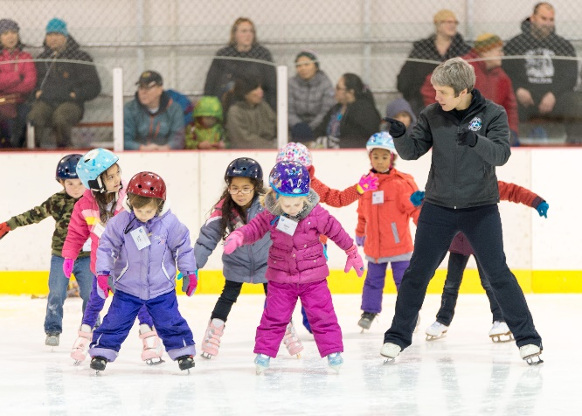
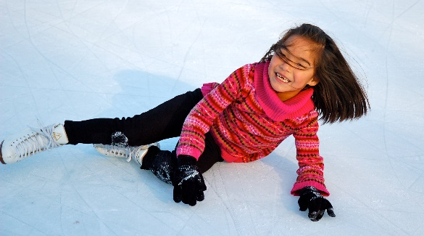

All Snowplow skater MUST wear a helmet.
Helmets optional for Basic 1 and up.
*Basic 6 thru Pre-Bronze Skating Skills are eligible to sign up.

Learn to Skate Dates

Series 2: Sept. 12th to Oct 24th

- 7 weeks –

Cost: $175 per series

Head to PineyIceRink.com -
To register, visit www.pineyicerink.com and select the Learn to Skate.

- All skaters are required to have a 1-year membership with Learn to Skate USA. The yearly membership is $18.50 and runs from July 1 to June 30. Instructions to sign up are on the website, make sure to sign up under Piney Orchard Ice Arena – ASA. Record and keep your membership number in a safe place as you’ll need it for future registration.

Program Benefits -
- Seven 30-minute lessons following the Learn to Skate USA curriculum
- USFS merit badges and certificates awarded upon completion of each level.
- Admission to six open skate/public sessions or three Freestyle session for skaters working on Pre-Free Skate level and above.
- Skate rental is included.

Your Child’s First Day of Skating
How to Register
Be on time -
Plan to arrive 20 minutes before class kicks off to check in at the desk and lace up your skates.

Helmets -
All Snowplow Sam skaters are required to wear one, and it is suggested for all other beginning skaters as well. Bike helmets work great. Fasten the buckle and check the chin strap often. Don’t allow your skater to wear anything under the helmet, and replace immediately if it shows any visible signs of damage. Never allow them to wear a helmet that does not fit or cannot be adjusted properly. PINEY ORCHARD DOES NOT PROVIDE HELMETS.

Bring lots of Layers -
Comfort and moving freely about ar essential for new skaters. Choose sweatpants or warm-up pants instead of bulkier snow pants. Socks: thin, not thick. Go with lightweight socks or thinner tights. Keep their hands warm. Since kids are taught to fall on day one, gloves or mittens are imperative to prevent hands from getting scraped up.

Fitting Skates -
Try on skates until the most comfortable pair is found. The rule of thumb: the closer the fit, the more control. Boots should be snug, giving toes just enough wiggle room without pinching. Feet should be immobile with the heel far back in the boot. Solid support is also necessary as staying upright takes a considerable amount of strength.

Each free skate level is comprised of a variety of progressive skating skills, transitions, spins and jumps – all of which buildon the previous skill, providing skaters a strong foundation of all elements. Instructors will focus on quality and mastery of skills.

