Future-Customer™ Analysis for American Transportation Safety Services Association
Based on findings and analysis by ChatGPT, following the Stellis AI Future Customer™ framework. All values are provided as samples of the analysis for reference by ATSSA, and should be evaluated in detail by organizational leadership to support an effective AI Strategy. The Future Customer analysis can be customized by using the Future Customer™ GPT available at: https://bit.ly/future-customer

Future Customer Question Analysis
1. What do customers say they value most today?
These reflect what agencies, contractors, and professionals in roadway safety rely on ATSSA for:
- Trustworthy safety training & certifications
- Standards and best practices for roadway safety devices
- Advocacy on public funding and safety regulations
- Access to technical resources and safety toolkits
- Networking and visibility at industry events
- Updates on safety tech and innovation
- Vendor access and supplier coordination
- Compliance with federal and state DOT guidelines
2. Which of those will AI soon make available to everyone?
- Training content can be commoditized via AI tutors and simulators
- Best practice guidelines can be instantly generated, benchmarked
- Technical knowledge will be broadly searchable, synthesized in real-time
- Supplier directories and procurement options can be AI-curated
- Regulatory updates can be tracked, summarized by bots
These become table stakes. Advantage fades unless ATSSA adds unique integration or exclusive data.
3. When everything is measured and tools are equal, what gives us the edge?
- Trusted validation of safety outcomes: Certifications based on measured effectiveness, not just training hours
- Interoperability standards leadership: Defining how smart infrastructure components talk to vehicles and agencies
- Human-in-the-loop safety layers: Validating edge cases, community acceptance, policy realism
- Outcome-based safety benchmarks: Crash reductions, near-miss detections, predictive maintenance metrics
4. Where will customers still want a real person they can trust?
- Certifying and auditing smart safety deployments
- Mediating between DOTs, vendors, and AI claims
- Interpreting ambiguous safety events (e.g. multi-factor crash causes)
- Training for hybrid human-machine traffic control
- Trust-building during high-risk pilot programs or deployments
5. What could we offer now that wasn’t possible before?
- Live safety performance dashboards (via sensor-integrated devices)
- Outcome-based training: Simulated crash-prevention, real-time feedback
- Certification for connected safety systems (V2X readiness, sensor compliance)
- AI-assist safety audits: Analyze near-misses, blind zones, driver behavior patterns
- Predictive funding maps: Recommend where funds will yield greatest safety gains

Results
A) Δ Table: Value Levers Shift (Sorted by Future Safety)
This table shows how current value levers hold up in a world where intelligence is cheap.
Rank | Value Lever | Today Index | Future Safety | Δ | Trend
1 | Outcome-based safety certification | 60 | 96 | +36 | Up
2 | Interoperability & standards leadership | 60 | 92 | +32 | Up
3 | Trust-based policy guidance & risk mitigation | 60 | 84 | +24 | Up
4 | Human-led audits and V2X validation | 60 | 80 | +20 | Up
5 | Smart infrastructure integration toolkits | 60 | 76 | +16 | Up
6 | Legislative advocacy & public funding guidance | 60 | 72 | +12 | Up
7 | Technical training & certification programs | 100 | 58 | -42 | Down
8 | Resource library & safety guidelines | 100 | 56 | -44 | Down
9 | Industry events and vendor exposure | 100 | 54 | -46 | Down

Visual Summary:
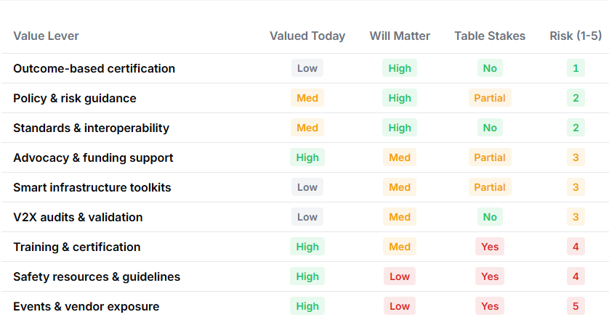
B) Matrix: Value Lever Risk
This shows which value levers are commoditizing and where monetization risk lies.
Value | Valued Today | Still Matter | Table Stakes | Monetization Risk (1–5)
Outcome-based safety certification | High | High | No | 1
Interoperability & standards leadership | High | High | No | 2
Trust-based policy guidance | High | High | Partial | 2
Human-led audits and V2X validation | High | Med | No | 3
Smart infrastructure integration kits | High | Med | Partial | 3
Legislative advocacy & funding support | High | Med | Partial | 3
Training & certification programs | High | Med | Yes | 4
Resource library & safety guidelines | High | Low | Yes | 4
Industry events & vendor exposure | High | Low | Yes | 5

C) Single-Score Ranking (Safest → Not)
Rank | Value | Future Safety
1 | Outcome-based safety certification | 96
2 | Interoperability & standards leadership | 92
3 | Trust-based policy guidance | 84
4 | Human-led audits and V2X validation | 80
5 | Smart infrastructure integration toolkits | 76
6 | Legislative advocacy & funding support | 72
7 | Technical training & certification | 58
8 | Resource library & safety guidelines | 56
9 | Industry events & vendor exposure | 54

Trailblazing Ideas for ATSSA
Product/Service Bets
- Outcome Certification Platform
Certify not just training completion, but real-world reduction in crashes, near-misses, or incidents based on sensor data and AI interpretation.
- ATSSA V2X Safety Stack™
Offer a modular certification kit and compliance checklist for manufacturers or agencies deploying connected safety devices — signal timing, signage readability, failover protocols, sensor alignment.
- Predictive Work Zone Insights
Help agencies predict work zone risk using integrated data from past crashes, vehicle sensors, and environmental factors.
Pricing & Contracting
- Performance-based Membership Tiers
Tie higher membership levels to demonstrable safety improvements, smart deployment certifications, or V2X integration readiness.
- Subscription Toolkits for Smart Integration
Ongoing access to updated compliance checklists, validation routines, and integration guidance as standards evolve.
Data & Partnerships
- Form a National V2X Readiness Index
Partner with DOTs, auto OEMs, and sensor providers to benchmark roadway readiness for vehicle-to-infrastructure integration.
- Crash/Near-Miss Data Consortium
Aggregate anonymized data from members to build predictive risk models — offer dashboards or insights as a paid service.
Go-to-Market Plays
- “Smart Safety Certified” Pilot Program
Launch with 3–5 DOTs and manufacturers to validate what V2X safety deployment should look like — award a badge or certification.
- ATSSA Smart Infrastructure Leadership Academy
Equip contractors, engineers, and public officials to lead smart deployments — blending policy, tech, and field realities.
- Crashless Corridor Campaign
Choose a corridor or metro to prove that near-zero incidents are possible with integrated smart safety — publicize metrics.

Trent’s Suggested Trends and Opportunities to Watch
Trend 1: Sensors will be every where and everything will be measured. Vehicle to Everything (V2X), Roadways, etc.
Opportunities:
- Measurement of integrated systems across multiple vendors, e.g., full roadways. Supports moving to prediction of safety incidents with different products.
- Independent provisioning of crash and near-miss data, anonymized across vendors.
- Prediction of best investments to increase safety.
Trend 2: AI is reducing R&D cost and timelines dramatically, increasing number of products and pace of change.
Opportunities:
- Product certification and product registry (especially AI-enabled products).
- Streamlining long approval processes by creating alternate, industry-created testing methods and self-governance, backed by quantifiable data.
Trend 3: Training content creation is simple, low-cost, personalized, and available broadly.
Opportunities:
- Cost reduction in training content creation: more, high-quality training with measurable impact.
- Real-Person certification becomes increasingly important to enhance trust.
- New certifications: building integrated systems, auditing and certifying designs.

