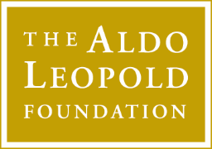
FOR IMMEDIATE RELEASE
Contact: Andy Radtke,
Phone: 1-608-606-1005
Email: andy@aldoleopold.org

Alexis Nikole Nelson, Dr. Jennifer Grenz, and Dr. Dacher Keltner Headline Leopold Week 2026

Explore Landscapes of Healing

[Baraboo, Wisconsin, January 22]
The Aldo Leopold Foundation is excited to announce a healing trio of virtual speakers during Leopold Week 2026, March 10-12! All are invited to register now and virtually attend the foundation’s annual grassroots Land Ethic® Live! celebration of Leopold Week. There is no cost to register or attend.

Last year’s Land Ethic® Live! programs attracted more than 20,000 registered participants from 50 states and 49 countries! All are encouraged to register today for the Aldo Leopold Foundation’s 2025 speaker series and the Leopold Week speakers at https://www.xxx.

This year’s Leopold Week theme is “Landscapes of Healing,” and will feature a ground-truthing virtual speaker series led by Alexis Nikole Nelson (@TheBlackForager), Dr. Jennifer Grenz, and Dr. Dacher Keltner. Join thousands of individuals from around the globe for three evenings of easy-access, online programming that will inspire and rejuvenate the land ethic in you, and in hearts everywhere.

As Aldo Leopold wrote in A Sand County Almanac, “One of the penalties of an ecological education is that one lives alone in a world of wounds.”

Balm, medicine, nourisher, and companion. The natural world is an expert healer. But in a world of wounds—both personal and ecological—how can we heal ourselves and our relationships with the land and each other? Join Nelson, Grenz, and Keltner, March 10-12 and find your earthy balm in 2026.

“The Leopold Week Speaker Series now reaches people inhabiting the lands of all continents,” said Buddy Huffaker, Leopold Foundation Executive Director. “Wherever you are, it’s easy to join these world-class voices who will show you the healing power of the natural, wild, and free!”

Listed below is the foundation’s lineup of virtual speakers for Leopold Week 2025:

Tuesday, March 10, 7:00 PM CST, USA
Dr. Jennifer Grenz (@jennifer_grenz), will share her journey to connect her head (western science) and her heart (indigenous worldview) to find a truer path toward ecological healing.
Wednesday, March 11, 7:00 PM CST, USA
Chef, forager, and influencer Alexis Nikole Nelson (@TheBlackForager) will share the joy of foraging the wild foods, medicines, and fibers found right in our own neighborhoods.
Thursday, March 12, 7:00 PM CST, USA
Dr. Dacher Keltner, a leading scholar in the study of emotions, will share how experiencing awe in nature can make us happier, kinder humans and better stewards of the land.

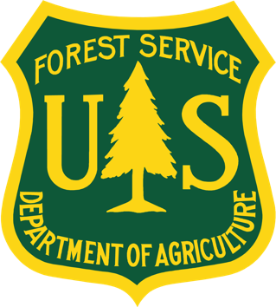
The United States Forest Service is Leopold Week 2025 Green Fire Sponsor

History:
Each year in early March, organizations and individuals across the country come together to celebrate Aldo Leopold and a land ethic through community readings, film screenings, outdoor activities, and more. From the first planned event in Lodi, Wisconsin, in 2000 to this year’s events, Leopold Week has been going strong for over 20 years. The Aldo Leopold Foundation has brought thousands together from every corner of the United States and around the globe in celebration of Aldo Leopold’s legacy.

The Aldo Leopold Foundation is a non-profit conservation organization fostering care of the land and community through the legacy of Aldo Leopold and the land ethic. The foundation is headquartered in Baraboo, Wisconsin, and welcomes visitors from around the world to the famed Leopold Shack, a National Historic Landmark.

###

Link to Zoom Event registration
Link to LEL! programs page
Link to ALF website

