

Mallee Family Violence Executive
Independent Chair
Expression of Interest (EOI)

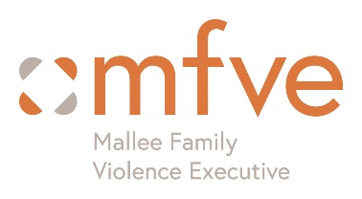

Our Acknowledgments
Acknowledgement of Country: The Mallee Family Violence Executive acknowledges the traditional owners and custodians of the Mallee region. We recognise their continued connection to the land and waters and acknowledge that sovereignty was never ceded.
We embrace diversity in all its forms, and respect everyone’s strengths and contributions irrespective of gender, ethnicity, culture, religious beliefs, sexual orientation, and political views.
Acknowledgement of victim survivors: We recognise the strength, resilience, and courage of victim survivors of family violence. Their voices and lived experiences continue to inform and strengthen our work. We also honour those who are unable to come forward and those whose voices can no longer be heard.

Overview
The Mallee Family Violence Executive (MFVE) is seeking Expressions of Interest from an experienced and respected leader to undertake the role of Independent Chair. The Independent Chair provides strategic leadership and governance oversight to the MFVE, supporting collaboration across community, health, government and specialist family violence services to drive integrated system reform and improved outcomes for victim survivors, children and families across the Mallee region. Working closely with the Principal Strategic Advisor (PSA), the Independent Chair will facilitate effective governance, lead strategic planning and stakeholder engagement, and promote shared leadership, accountability and collective impact in alignment with statewide family violence reform priorities.
Further information regarding the role, responsibilities and selection criteria is available in the Independent Chair Position Description.

About the Mallee Family Violence Executive
The Mallee Family Violence Executive (MFVE) is the Family Violence Regional Integration Committee (FVRIC) for the Mallee region and one of 14 Department of Families, Fairness and Housing (DFFH) funded regional committees across Victoria. FVRICs play a critical strategic leadership role in strengthening the family violence service system through collaboration, service integration, advocacy, and the implementation of the Victorian Government's family violence reforms.
The MFVE brings together senior representatives from government and non-government organisations, including specialist family violence services, child and family services, Victoria Police, justice and legal services, housing, community, and health sectors. Through this cross-sector partnership, the MFVE provides leadership and specialist expertise to strengthen system responses, improve family violence literacy, build workforce capability, and support an integrated approach to preventing and responding to family violence across the Mallee.
Guided by the MFVE Strategic Plan and Annual Action Plan, the partnership works to improve outcomes for victim survivors, children and families, while increasing accountability for people who use violence. The MFVE also plays an important role in identifying systemic issues, influencing policy and reform, and advancing regional priorities that contribute to a more effective and responsive family violence system.
DFFH provides funding to support the operation of FVRICs, including the Principal Strategic Advisor (PSA) role and regional initiatives. In the Mallee, Mallee Sexual Assault Unit Mallee Domestic Violence Service (MSAU-MDVS) serves as the auspice organisation, managing funding and employing MFVE staff. The work of the MFVE is supported by the PSA, who works closely with the Independent Chair and member organisations to lead the development, implementation, and monitoring of an integrated regional approach to family violence prevention and response.

Local Government Areas
The MFVE encompasses the local government areas of Mildura Rural City Council, Swan Hill Rural City Council, Buloke Shire and Gannawarra Shire.
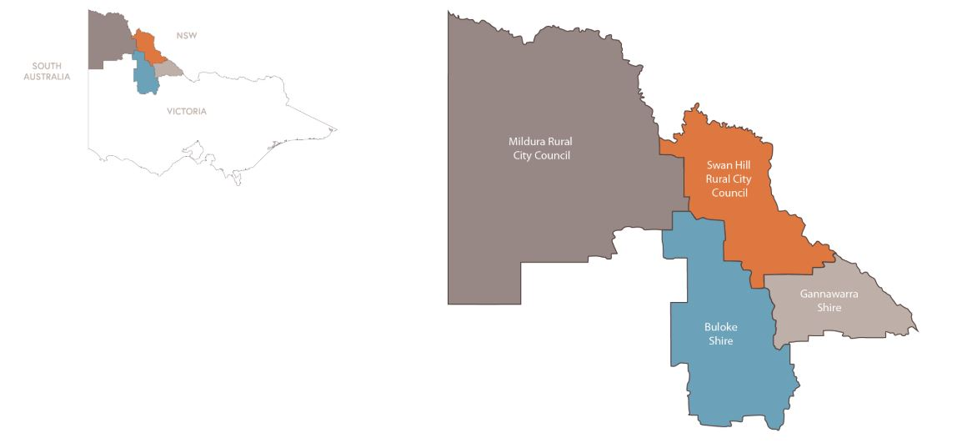

About the Role
The Independent Chair provides independent strategic leadership and governance oversight to the MFVE, working in partnership with the Principal Strategic Advisor (PSA) and member organisations to advance an integrated, responsive, and accountable family violence system across the Mallee region.
Acting in the interests of the partnership as a whole, the Chair is responsible for leading governance and strategic planning processes, chairing bi-monthly MFVE meetings, fostering collaboration and shared decision-making, and representing the collective voice of the MFVE in regional and statewide forums. The role plays a critical part in progressing the MFVE Strategic Plan and Annual Action Plan, strengthening cross-sector partnerships, driving system integration, and supporting the implementation of Victorian family violence reforms.
The Chair also provides professional supervision and strategic support to the PSA and works closely with member organisations to identify emerging issues, influence policy and reform initiatives, and improve outcomes for victim survivors, children and families, while enhancing accountability for people using violence.
Key Responsibilities
The Mallee Family Violence Executive (MFVE) is seeking an experienced and respected leader to undertake the role of Independent Chair.

Working collaboratively with MFVE member organisations, the auspice agency, and the PSA, the Independent Chair provides strategic leadership to ensure the effective governance, performance, and sustainability of the partnership. The role is responsible for overseeing governance and accountability frameworks, monitoring progress against strategic priorities, and maintaining strong partnership arrangements that support a coordinated and integrated family violence system.
The Independent Chair leads and facilitates the work of the MFVE by chairing meetings, fostering engagement and collaboration across member organisations, and promoting shared leadership and collective decision-making. The role represents the collective interests of the partnership, supports stakeholder engagement, strengthens cross-sector relationships, and helps address issues and opportunities affecting the regional family violence system.
A key function of the role is to provide strategic direction and oversight of the MFVE Strategic Plan and Annual Action Plan, ensuring regional priorities align with statewide reform objectives and Family Violence Regional Integration Committee (FVRIC) guidelines. Working closely with the PSA, the Chair supports the development, implementation, monitoring, and review of strategic initiatives that improve system integration and outcomes for victim survivors, children and families.
The Independent Chair also provides professional supervision, guidance, and performance oversight to the PSA, supporting their contribution to regional and statewide policy, planning, and reform initiatives, while ensuring alignment with the auspice agency's governance and employment frameworks.
This is an opportunity to provide influential leadership during a period of ongoing reform and system development, while contributing to a shared vision of safer communities and improved outcomes for individuals and families affected by family violence across the Mallee.

Remuneration and Tenure
The Independent Chair is engaged under a fixed-term contract. Remuneration is $8,200 per annum for approximately 82 hours of work, exclusive of approved travel reimbursement. The role offers flexible work arrangements and opportunities to contribute to both regional and statewide family violence reform initiatives.
How to Apply
Interested candidates are invited to submit an Expression of Interest outlining their suitability for the role and demonstrating how their skills, experience, and expertise align with the key selection criteria detailed in the Independent Chair Position Description.

Applications should include:
- A cover letter (maximum two pages) outlining relevant experience, skills, and interest in the role.
- A current curriculum vitae (CV).
- Details of two professional referees.
Applicants are encouraged to review the Independent Chair Position Description for a detailed overview of the role, responsibilities, and selection criteria.
Expressions of Interest should be submitted via email to:
Contact
Name | Donna Strong
Role | Principal Strategic Advisor  Mallee Family Violence Executive
Email | donnas@msau-mdvs.org.au
Mobile | 0408 106 286

For a confidential discussion about the role or to request a copy of the Position Description, please contact Donna Strong using the details above.

EOI Closing Date: September 9th 2026

