**Letter to teachers and staff**

Dear Teachers and Staff,

We’re writing to let you know that one of your pupils will soon be accessing school remotely using a telepresence robot called AV1.

AV1 is a small avatar robot that acts as the student’s eyes, ears and voice - their physical presence in the classroom while they’re unable to attend in person. Whether they’re at home, in hospital, or based elsewhere on site, AV1 helps them stay connected to both learning and friendships, without placing extra demands on staff.

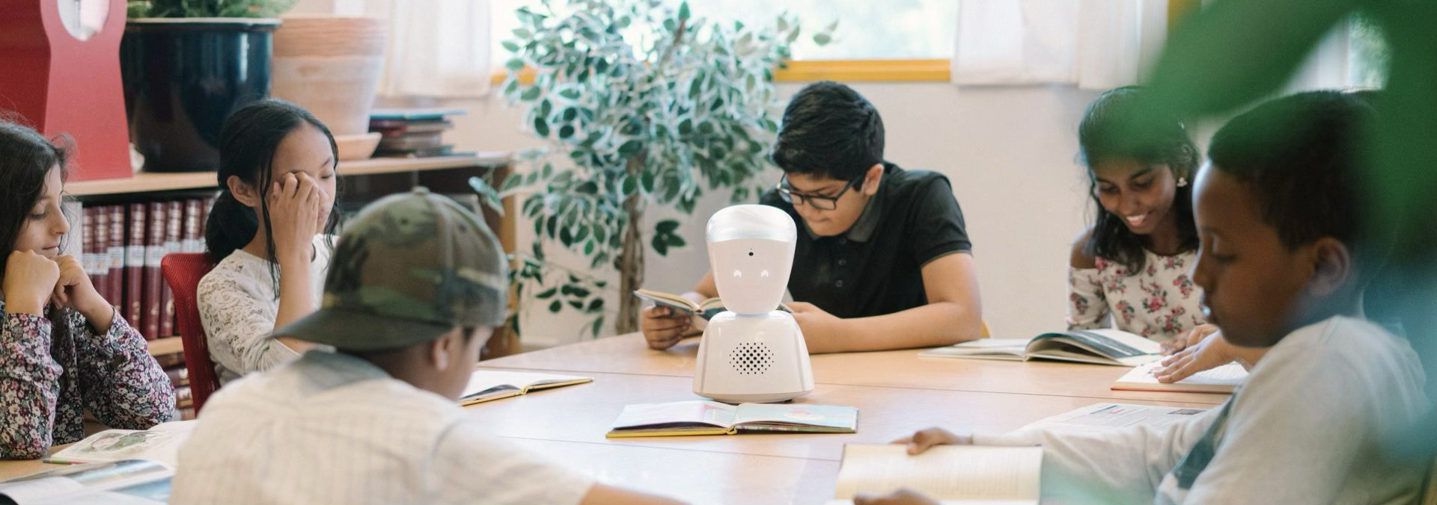

**What does AV1 do?**

AV1 enables pupils to join lessons live via a secure one-way video and audio stream. They control the robot through an app on their device, allowing them to look around, raise their hand, speak, or simply listen in. They can use AV1 for as little as one lesson or as much as a full school week, depending on how they’re feeling.

The robot sits discreetly in class, often decorated to reflect the pupil’s personality, and becomes ‘part of the furniture’ very quickly.

You’ll know AV1 is active when its head lifts and eyes light up.

**How does AV1 support staff and students?**

AV1 was designed with teachers and schools in mind. There’s no need to schedule or plan lessons differently - you simply switch AV1 on at the start of the day, and the student connects when they’re ready.

For students, AV1 can be a powerful reintegration tool, especially after prolonged absence. It allows them to reconnect gradually and safely with the rhythm of school life. This helps improve attendance, maintain friendships and ease anxiety about returning.

AV1 supports a wide range of students, including those with:

* Physical or medical needs
* Mental health challenges
* Neurodiverse conditions such as autism or ADHD
* Behavioural difficulties or school-based anxiety

For some students, AV1 is used on a short-term basis to prevent further escalation. For others, it complements existing alternative provision and creates a smoother pathway back into the classroom.

**Privacy, Security and Safeguarding**

We know safeguarding and privacy are top priorities, so here’s what you can expect:

* The live stream is end-to-end encrypted and cannot be recorded, viewed, or intercepted, even by No Isolation, the manufacturer.
* Recording or screenshotting within the AV1 app is impossible. If someone attempts to record using another device, the stream immediately terminates, the robot disconnects, and admin is notified.
* Only one student can access the robot at a time, via a secure login and personal PIN.
* AV1 does not store any data. There is no recording, logging, or archiving of video or audio.
* The robot’s head and eye lights clearly show when it’s live.
* Teachers always remain in control and can switch off the device if ever needed.
* AV1 has been GDPR-compliant from the outset and is used successfully in over 1,700 UK schools.

We’ve even run penetration tests with external cybersecurity firms and they were unable to hack the system, confirming just how secure it is.

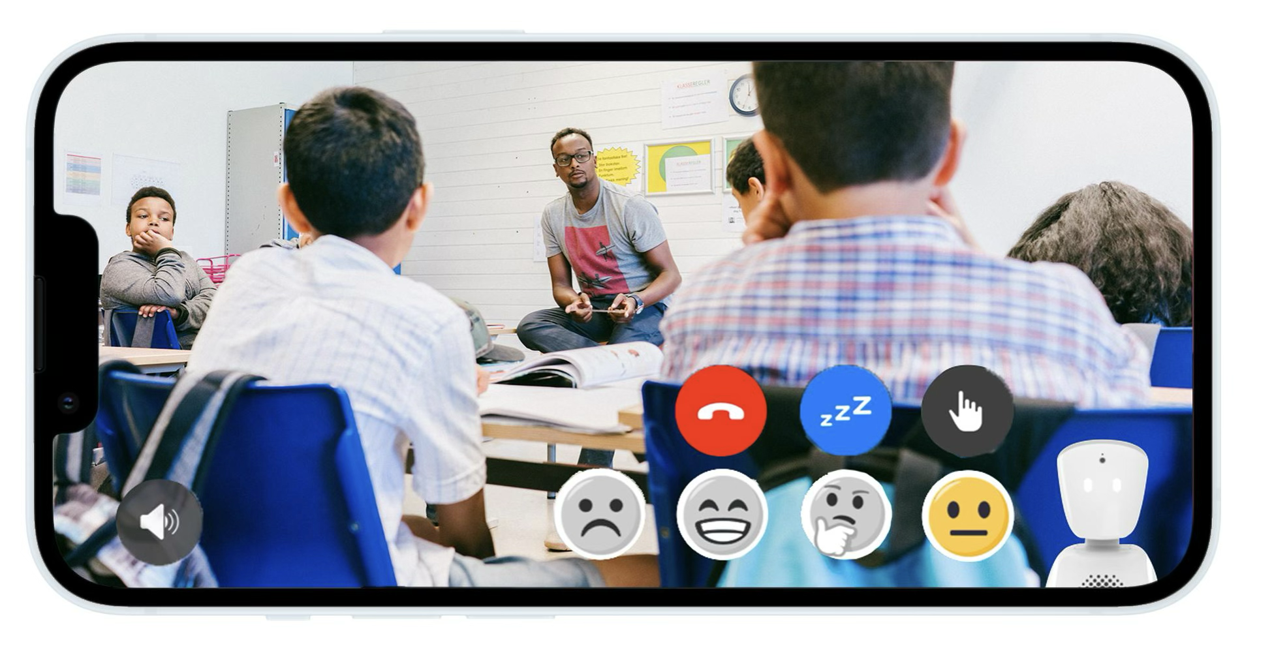

**Next Steps**

If you’d like to see AV1 in action, ask questions or explore how it works in more detail, there will be a short demonstration and Q&A at the upcoming staff meeting:

[Insert location details, date and time here]

Alternatively, please speak to [insert staff contact] if you have any immediate questions or would like to know more.

Thank you for your support in helping every child feel included, supported, and connected wherever they are.

Kind regards,

School Name