Parent Letter Draft

Dear Parents / Carers,

We’re writing to let you know that one of your child’s classmates will soon be using a telepresence robot called AV1 to access school remotely while they are unable to attend in person.

AV1 enables children who are unable to attend school in person to stay connected to their education and classmates. By joining lessons from home, hospital, or based elsewhere on site through a secure one way live stream, AV1 helps them stay part of the school community socially and academically.

The AV1 robot is designed specifically for classrooms in close consultation with teachers, schools and safeguarding professionals.

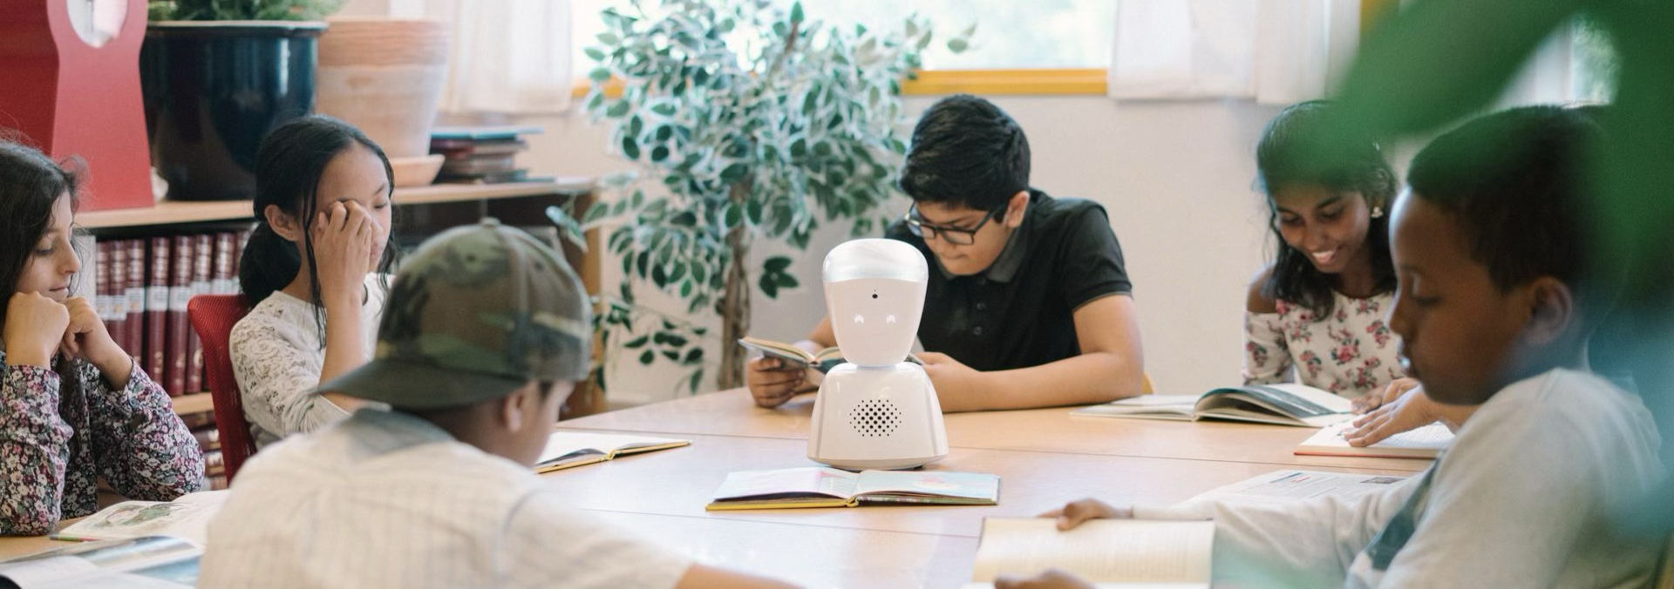

What is AV1 and how does it work?

AV1 sits in the classroom on behalf of the pupil who cannot attend. They control it using an app on their phone or tablet, allowing them to listen to lessons, watch the teacher and the board, ask questions and join in class discussions.

You’ll know AV1 is in use when its head rises and its eyes light up. Only one child, the registered user, can access AV1 at once and only after entering a unique security code.

Privacy and Security

AV1 was built with privacy at its core and is trusted by schools across 17 countries, including over 1,700 UK schools in more than 70 local authorities. Unlike general video conferencing tools, AV1’s stream is end-to-end encrypted and cannot be recorded or accessed by anyone other than the user. Not even No Isolation, the manufacturer, can see the live stream.

It is not possible to screenshot or record from within the AV1 app, and all users must accept terms and conditions that ensure appropriate and safe use. AV1 fully complies with UK GDPR regulations and all usual school safeguarding procedures remain firmly in place.

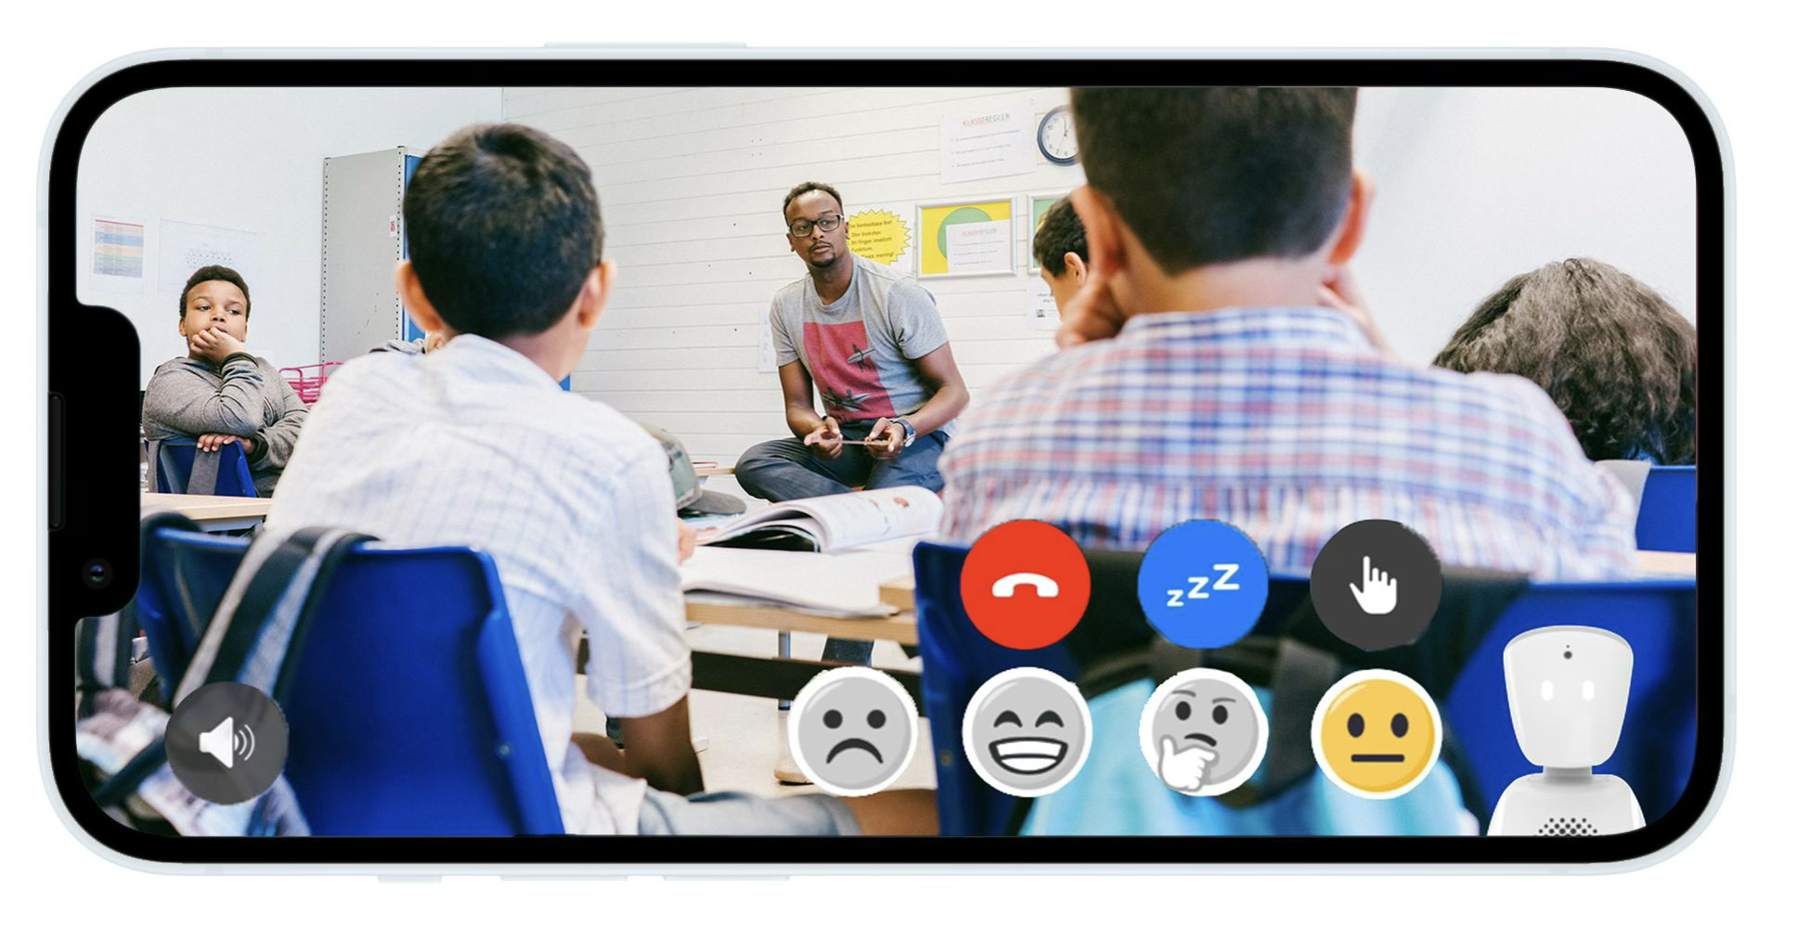

Learning More

If you’d like to learn more, please visit www.noisolation.com/uk where you’ll find information about how AV1 works, its safety features and stories from schools across the UK.

Links to Moulsham High / What is AV1 video / Case study page - if appropriate?

Thank you for your support in helping all children feel connected and included during their time away from school.

Kind regards,

School Name

