

Pure Healthcare Group Ltd

Carbon Reporting and Reduction Plan

Baseline year 2023.

Current reporting year 2025.

Contents

1. Introduction 2
2. Scope 1, 2 and 3 Emissions Definitions 3
3. Carbon impact for the baseline year 2023 4
3.1 Carbon emissions by source. 4
4. Carbon impact for the current reporting year 2025 5
4.1 Carbon emissions by source. 5
5. Year on Year Comparison202 6
5.1 Carbon Intensity 6
5.2 Analysis 7
6. Carbon Assessment Observations 7
7. Carbon Reduction Commitments /Actions 7
8. Measurement 7
9. Prioritise 9
10. Action Plan 9
11. Carbon Reduction Trajectory 11
12. Audit 11
13. Offsetting 11
14. Declaration 13

Introduction

Pure Healthcare Group Ltd (Pure Healthcare) has committed to reducing its carbon emission to Net Zero by 2050, using as far as possible direct reduction, and offsetting the remainder.

We do this because we are conscious of the environmental, social and economic imperative to act on climate change.

The UK Government amended the Climate Change Act 2008 in 2019 by introducing a target of at least 100% reduction in the net UK carbon account (i.e. a reduction of greenhouse gas emissions when compared to 1990 levels) by 2050. As a result, Central Government Departments, their Executive Agencies and Non-Departmental Public Bodies are required to ensure that suppliers to contracts with an annual value of in excess of £5 million (excluding VAT) per year are committed to achieving “Net Zero by 2050” for all procurements after 30th September 2021.

This has led to PPN 06/21 which applies to all new procurements from this date and this includes framework call-offs and Dynamic Purchasing Systems where the anticipated individual value of the call-off or DPS is £5 million (excluding VAT) per annum or more. To demonstrate compliance, we have set out our environmental management measures in our Carbon Reduction Plan which includes:

- Confirming our commitment to achieving Net Zero by 2050 for our UK operations.
- Details of our carbon footprint/current emissions for the sources included in Scope 1 and 2 of the GHG Protocol and a defined subset of Scope 3 emissions.
- Providing emissions reporting of the CO2e (Carbon Dioxide Equivalent) for the greenhouse gases covered by the Kyoto Protocol (predominantly carbon dioxide, methane and nitrous oxide).
- Setting out the environmental management measures we have adopted including specific carbon reduction measures.
- Publication of our Carbon Reduction Plan on our website.

Scope 1, 2 and 3 Emissions Definitions

Scope 1 Direct Emissions - these are direct greenhouse gas emissions that occur from sources that are controlled or owned by us (e.g. emissions from boilers, vehicles etc).

Scope 2 Energy Indirect Emissions - these are indirect greenhouse gas emissions associated from the purchase of electricity, heating or cooling and are measured and reported in alignment with our energy use.

Scope 3 Other Indirect Emissions - these fall into 15 categories and include all sources not specified within Scopes 1 and 2 above. The Scope 3 emissions that we are required to report on are:

- “Upstream” transportation and distribution of products purchased by us from Tier 1 suppliers (e.g. paper, computers, office consumables).
- Disposal and treatment of waste generated in facilities not owned or controlled by us.
- Transportation of employees for business related activities in vehicles not owned or operated by us.
- Transportation of employees between home and work in vehicles not owned or operated by us including in their own vehicles.
- “Downstream” transportation and distribution of products sold by us including retail and storage. This category is not applicable as Pure Healthcare is a service business and does not produce, transport or distribute products.

Carbon impact for the baseline year 2023

The tables below show our carbon footprint in our baseline year 2023, when we first started measuring our emissions.

Baseline Year: | 2023
Baseline Emissions Calculations: | All Scopes – tonnes CO2e/ year
Scope 1 CO2e: | 2.13
Scope 2 CO2e: | 3.19
Scope 3 CO2e (included sources): | 18.66
Total Emissions: | 23.98

3.1 Carbon emissions by source.

 | Tonnes CO2e
Gas | 2.13
Electricity | 3.19
Staff Commuting | 17.06
Staff Homeworking | 1.39
Office consumables | 0.12
Waste | 0.09
Total | 23.98

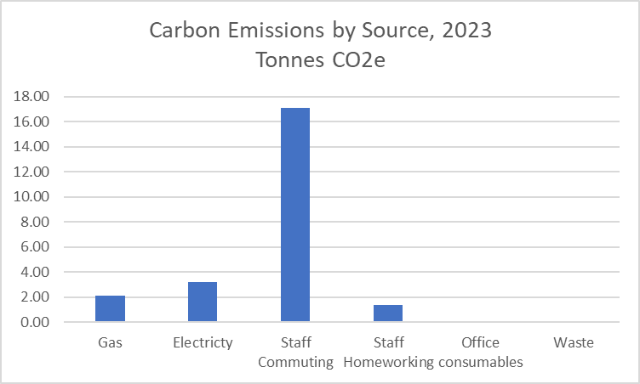

Carbon impact for the current reporting year 2025

The tables below show our carbon footprint in our current reporting year 2025

Baseline Year: | 2025
Baseline Emissions Calculations: | All Scopes – tonnes CO2e/ year
Scope 1 CO2e: | 1.43
Scope 2 CO2e: | 2.14
Scope 3 CO2e (included sources): | 4.71
Total Emissions: | 8.27

4.1 Carbon emissions by source.

 | Tonnes CO2e
Gas | 1.43
Electricity | 2.14
Staff Commuting | 3.25
Staff Homeworking | 0.69
Office consumables | 0.68
Waste | 0.09
Total | 8.27

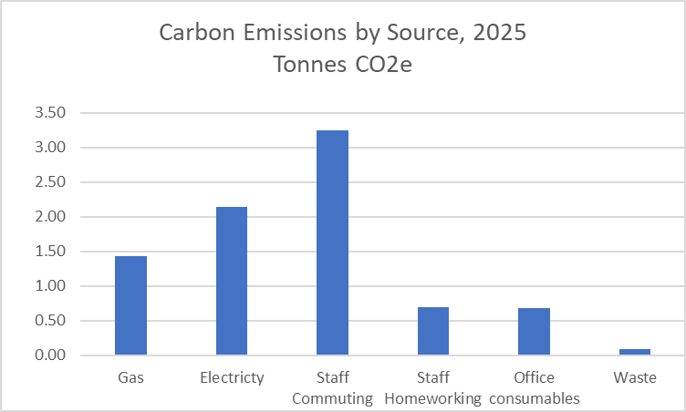

Year on Year Comparison202

 | 2023 | 2024 | 2025 | Tonnes change
Gas | 2.13 | 2.13 | 1.43 | -0.70
Electricity | 3.19 | 3.19 | 2.14 | -1.06
Staff Commuting | 17.06 | 7.40 | 3.25 | -13.81
Staff Homeworking | 1.39 | 1.39 | 0.69 | -0.69
Office consumables | 0.12 | 0.04 | 0.68 | 0.56
Waste | 0.09 | 0.09 | 0.09 | 0.00
Total | 23.98 | 14.24 | 8.27 | -15.71

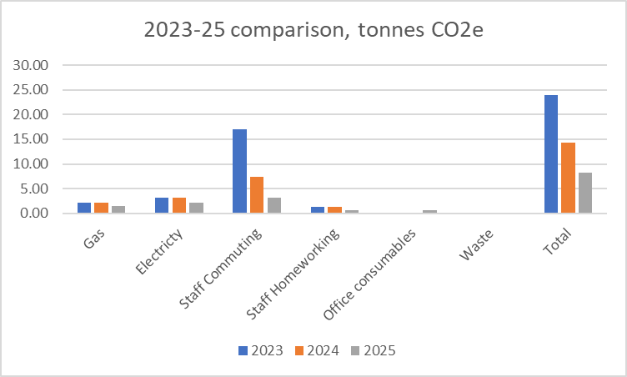

5.1 Carbon Intensity

Our chosen intensity metrics are kg/CO₂ per employee.

For the current year and baseline years therefore, our Carbon Intensity is:

Intensity tonne CO2 net per employee
2023 | 2024 | 2025
0.75 | 0.53 | 0.59

5.2 Analysis

During this period, the business reduced in size by headcount, and relocated to a smaller office within the same building. This accounts for the overall drop on emissions relating to most sources.

Note that the Carbon Intensity for 2025 is slightly higher than that of 2024. This is because of the reduced headcount, but the office area, and therefore emissions form energy, not falling at the same rate i.e. the fixed overhead of running the office.

Carbon Assessment Observations

Pure Healthcare operates from one office in Londonn The following observations were made by an external assessor on 9th April 2025.

- The business is located a modern building, rated D in its EPC.
- The EPC, from 2019, notes a number of opportunities for energy reduction. However, the building is not owned by Pure Healthcare, so cannot influence capital investments in its upkeep and energy improvement.

Carbon Reduction Commitments /Actions
Pure Healthcare is committed to achieving Net Zero by 2050 and as part of this commitment, has an interim targets of reducing emissions by 2030. This plan is reviewed annually by the Directors to check progress and establish if changes should be made to the actions we have in place to maximise our reduction in carbon emissions.

The basis of our Carbon strategy is one of Measure – Prioritise – Act – Measure – Repeat.

Measurement
We report on the sources of environmental impact over which we have operational control and calculate our carbon footprint monthly, in accordance with the Greenhouse Gas (GHG) Protocols Corporate Standard and report against the Kyoto Protocol greenhouse gasses in terms of:

- Actual targets – absolute reduction targets which compare actual figures in the target year to those in the base year.
- Intensity targets – based on a normalising factor.

We subscribe to a third party service to manage our data inputs, conduct the required calculations, set and record our intensity metrics, and provide monthly carbon reporting. The data that sits behind this is the UK Government Greenhouse Gas reporting database, updated when appropriate.

This provides us with our emissions by source, and total emissions by month, sets our intensity metrics and shows how we are tracking month-on-month.

Our base year for all measurements is 2023. This will not change unless there is a significant change to our company structure (e.g. a merger or acquisition) or a change in the company’s ownership, in which case the base year may move to the reporting year following the structural change.

Specific inputs and output used to calculate figures quoted in our Carbon Reduction Plan include:

- Electricity
- Heating Fuel
- Employee commuter mileage by type – walk / cycle / motorcycle / car / bus / train
- Business travel by private car / bus / rail
- Office consumables
- Waste

The use of gas and electricity by Pure Healthcare is not sub metered, and the building operators have not made available total energy consumption data. This makes emissions from gas and electricity impossible to measure.

Our solution has been to take the overall carbon emission figure as quoted in the EPC, and pro-rata that by the floor area occupied by us. That has then been further pro-rated on the basis of 40% for heating, and 60% for electricity (as per Energy Saving Trust suggestion).

Going forward, we will strive to persuade our landlords to provide sub-metering.

Conversion Factors

The conversion factors used throughout are the ‘2022 UK Government Greenhouse Gas Conversion Factors for Company Reporting.

Prioritise
Our monthly carbon calculation has enabled us to identify the largest sources of GHG emissions, and to focus our areas of impact. That does not imply however that we are not implementing actions across the board. We have been able to identify quick and easy wins which relate to relatively low impact areas whilst also implementing longer term multi-facet strategies for the larger emission areas.

Action Plan

9.1 Communication

We have successfully communicated our Net Zero ambitions across our workforce, and have formed an employee task force. This task force is charged with identifying where our staff can affect carbon reductions through behaviour change.

We will report our carbon emissions and progress against target to our employees monthly, via a display at both our offices.

We have developed a communication plan which describes our ambitions and commitments to our key customers and suppliers, and in our general communications.

9.2 Energy

Electricity whilst not one of our highest sources of carbon emissions, it is a significant operating cost and does have a carbon emissions associated with it.

- Renewable Electricity Purchase – we will lobby our landlord to source our electricity from a 100% renewable energy source.
- Lighting use – we will conduct an ongoing campaign to encourage users to turn off lights when not required or rooms are not in use. Otherwise, install further proximity controls or timers to lighting.
- Lighting type – Make it policy to only replace failed units with the lowest energy types available, currently LED.
- IT equipment - make it policy that all IT equipment is turned off (not stand-by) when not in use – lunchbreaks, meetings and out of hours. Otherwise, configure the technology to do this automatically.
- Heating controls – we will ensure that the buildings heating controls are optimised so as not to overheat or heat when unoccupied. We will ensure that key staff are proficient in the use of heating controls.

9.2 Waste

- This is another low impact area, which will arise primarily from waste paper and card. A behaviour change programme to reuse paper, print on both sides, only print when necessary will not only reduce the waste disposal emission, but the external emission associated with paper production and printing.

9.3 Office Consumables.

We have considered paper and printer cartridges here as the primary measurable consumables for the type of activity conducted at Pure Healthcare.

- Use only recycled paper, and ask employees to only print when absolutely necessary, to print on two sides.

- Ink cartridges have a surprisingly high carbon footprint. Their impact can be minimised by ensuring that empty cartridges are returned to a specialist recycler, rather than disposed into general waste, and that trials be run to assess whether third party second use cartridges may be suitable. Note that their performance and compatibility can be patchy, but that the market is well served.

9.4 Commuting

How employees travel to work is Scope 3 emission, meaning that it is outside the direct control of the business. Scope 3 emission reporting is mandatory under the new Government Agency procurement requirements.

For Pure Healthcare, commuting represents our greatest carbon impact.

All employees travel by public transport, and the majority from beyond a distance that is comfortable to travel by bicycle or on foot. This then remains the most environmentally friendly means of commuting.

Carbon Reduction Trajectory

Pure Healthcare are not in control of any of its primary emissions – energy use and staff commuting, so we find it impossible to forecast a trajectory to Net Zero. We don’t own our building, nor do we have individual energy metering. Staff commuting is out of our control and in any case, all by public transport.

In due course our landlord will be compelled to report and reduce the carbon impact of our building, which will start with energy efficiency improvements and from then could develop into, for example, rooftop solar PV installations and/or alternative heating fuels or types.

Our largest emission, staff commuting, will reduce as public transport decarbonises – current electric trains / tubes will decarbonise with the national grid mix, and buses switch to electric power or alternative fuels.

Audit
Whilst not compulsory, we have committed to an annual audit of our carbon data reporting, by an independent third party.

Offsetting
Offsetting our emissions is an option for us, and one that we will explore. We appreciate that offsetting will not impact of the carbon emission figures we are compelled to report however.

Carbon offsetting is an unregulated market, and has suffered some negative publicity due to exaggerated claims on carbon savings. We also note that the UK market has little capacity at present.

We will take expert guidance to identify a credible and verifiable carbon offsetting scheme, that nay be UK or Overseas based.

Declaration
This Carbon Reduction Plan has been completed in accordance with PPN 06/21 and associated guidance.

Emissions have been reported and recorded in accordance with the published reporting standard for Carbon Reduction Plans, the GHG Reporting Protocol Corporate Standard and we use the appropriate Government emission conversion factors for greenhouse gas company reporting.

Scope 1 and Scope 2 emissions have been reported in accordance with SECR requirements and the required subset of Scope 3 emissions have been reported in accordance with the published reporting standard for Carbon Reduction Plans and the Corporate Value Chain (Scope 3) Standard.

We confirm this Carbon Reduction Plan is reviewed and signed off at board level on an annual basis and is available on the home page of our website.

Signature: 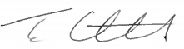

Name: Tony Constantinides

Job Title/Designation (must be a director or equivalent): Managing Director

Date: 26/01/2026

------------------------------------------------------------

