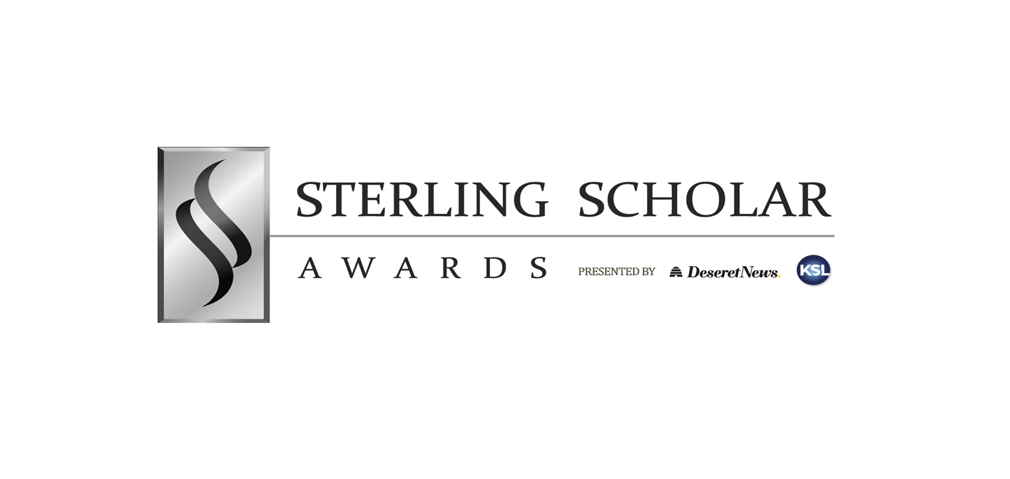

WASATCH FRONT REGION HANDBOOK
2026-2027

FOR NOMINEES, PARENTS, COORDINATORS, PRINCIPALS & JUDGES

SINCE 1962

©1994-2027 DESERET NEWS PUBLISHING COMPANY

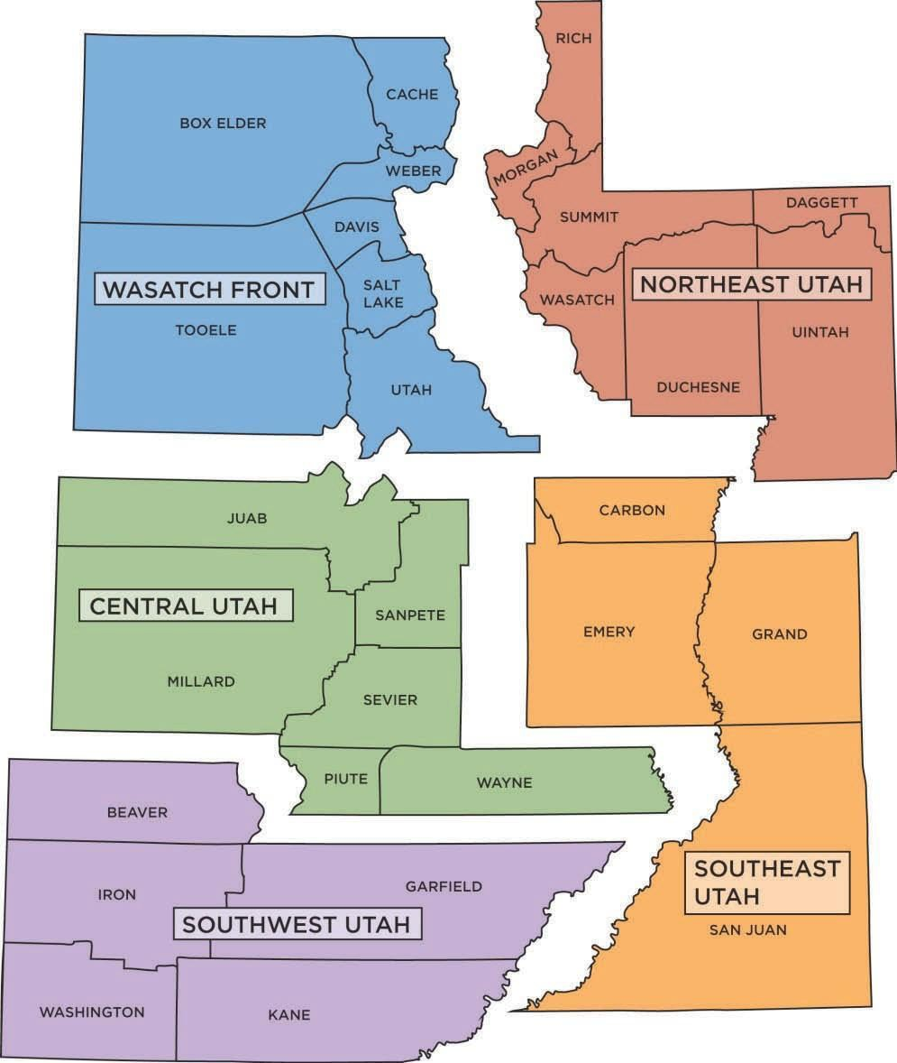
The 5 Different Sterling Scholar Regions

Due to the distance involved and different academic circumstances, the program is conducted in five independent areas throughout the state's 41 school districts and 29 counties. These areas are the Wasatch Front, Northeast Utah, Central Utah, Southeast Utah, and Southwest Utah. There is no "State" level competition.

Each region follows the guidelines established by Deseret News and KSL Broadcast Group, sponsors of the Sterling Scholar Awards since 1962. However, only the Wasatch Front competition is directly administered by Deseret News and the KSL Broadcasting Group. The program is sponsored in cooperation with Larry H. and Gail Miller Family Foundation, Utah State Office of Education, district officials, high school administrators as well as colleges and universities that support the program through scholarships and other financial assistance.

The purpose of the Sterling Scholar Awards is to publicly recognize and encourage the pursuit of excellence in scholarship, leadership and citizenship of high school students graduating in the 2026-2027 school year in the State of Utah. The Deseret News and KSL Broadcast Group developed the program to focus attention on outstanding students to recognize them publicly as well as award scholarships and tuition waivers from participating institutions. The Sterling Scholar Awards Program seeks to commend and encourage excellence among all nominees. All nominees are judged equally based on scholastic achievement without regard to race, color, religion, sex (including sexual orientation or gender identity), political preference, disability, or national origin.
The sponsors salute the extraordinary development of the talents and ideals of each year’s outstanding scholars. We gratefully acknowledge the cooperation and assistance of the Utah State Office of Education, Utah colleges and universities, school districts, high school administrations and faculties,
Utah businesses and many others.

(The name Sterling Scholar Awards is a registered U.S. trademark.)

2026-2027 STERLING SCHOLAR AWARDS PROGRAM

The Deseret News – KSL Broadcast Group Sterling Scholar Awards would like to acknowledge the outstanding achievements of all students nominated as Sterling Scholars from their high school. While only a few Sterling Scholar nominees will receive our highest recognition, nominees should be reminded that it is truly a great honor to be nominated by their teachers and administrators who know them best. These nominees encompass the essence of the Sterling Scholar Awards. Congratulations to all our nominees!

WHO IS ELIGIBLE?

The Sterling Scholar Awards are open to Utah public high school students in line to graduate in the current school year from a Utah public high school. It is expected that each school will nominate one candidate in any of the 14 categories. Each school may nominate only one nominee in each of the 14 categories and a nominee may be nominated in only one category. The selection and nomination process of a potential Sterling Scholar is left entirely up to each high school. Sterling Scholar officials consider a nominee a high school student if the student is graduating during the year 2027. A student can only be a Sterling Scholar applicant for one participating Sterling Scholar High School and should apply at the school they will be graduating from.

High school students who attend college classes full or part-time or are classified as foreign exchange nominees are eligible for the Sterling Scholar Awards. However, the program is designed to recognize scholastic achievement in Utah public high schools. To be selected as a Sterling Scholar nominee, students must have extraordinary scholarship scores as well as service in leadership and community service/citizenship opportunities at their Utah public high school. It is up to each school to determine if an individual has been in attendance enough to experience these leadership and community service/citizenship opportunities. Each Sterling Scholar nominee’s entire school experience will be considered, although emphasis will be placed on the high school years. High school officials are urged to nominate scholars for categories in which the nominees are genuinely interested and qualified.

METHOD OF NOMINATION

Ultimately, selecting nominees is the responsibility of the school principal and not the Deseret News or KSL Broadcast Group. No specific method of selection is required, although the process outlined below provides an excellent opportunity to encourage scholarship. Accordingly, the opportunity to apply to the Sterling Scholar program should be open to as many nominees as possible. The following procedure is encouraged to determine each school’s Sterling Scholar:

- Principal selects and assigns a committee of school faculty, including a Sterling Scholar coordinator, to administer the nomination process of public high school students, graduating in the 2026-2027 school year, for Sterling Scholar Awards participation.
- The committee should create a questionnaire that is distributed to nominees as a guide for evaluating activities, achievements and ambitions within an area of high school education that is characterized by one of the Sterling Scholar categories.
- The completed questionnaire and supporting materials should be submitted to the principal and/or assigned committee for review. Departmental advisors should be contacted for aid in nominee recommendations based on the submitted questionnaire and additional information.
- Ultimately, the principal will determine which individual in each category will be submitted as the school’s official nominee.

PLEASE NOTE: The Deseret News and the KSL Broadcast Group do NOT take part in the selection of nominees. All questions and concerns must be directed to the school and NOT the Deseret News or KSL Broadcast Group. All inquiries must be handled by the school coordinator, principal or assistant principal, who is responsible for contacting the Sterling Scholar director for clarification (this includes parents, nominees, teachers, etc.).

Sterling Scholar Wasatch Front Region Proccess

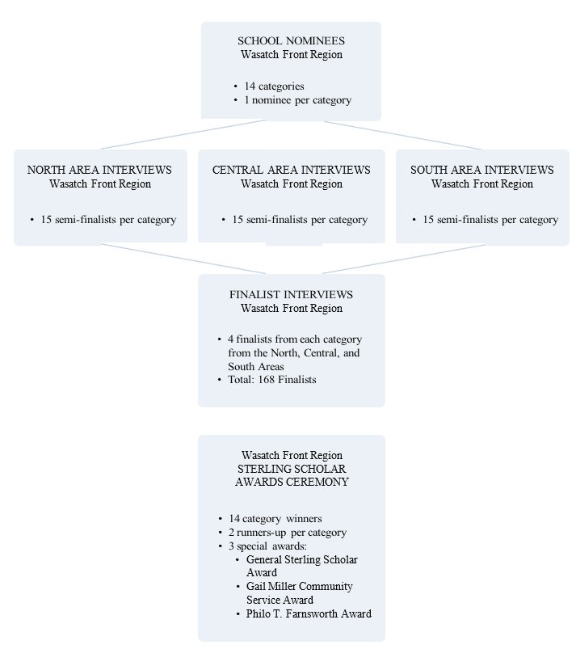

Region Finalist Scholarship Amounts

Each category winner - $2,500
Two runners-up per category - $1,000

General Sterling Scholar Award - $2,500

Gail Miller Community Service Award - $2,000

Philo T. Farnsworth Award - $1,000

* The Sterling Scholar program proudly provides scholarships in the above amounts at the Region Finalist level.
Additionally, many institutions in Utah offer financial assistance to different levels of Sterling Scholars. A complete list can be found below on our Financial Assistance By Participating Institutions page below, in the handbook, and on our website: https://www.sterlingscholar.org/regions#wasatch-front

After the Wasatch Front Region Awards Ceremony, you may claim your scholarship by sending us a copy of your university/school acceptance letter. You must include your student ID number, along with the contact information for your university/school to kizieranA@deseretmgt.com. A check will be mailed directly to your school and deposited in your account under your student ID number.

Please be aware that applications must be made immediately as your scholarship is available for the 2027-2028 school year. If you will not be attending school in the fall due to other circumstances (mission call, military service, health, etc.) please let me know so that we can discuss your options for future award. Funds will be held up to three years.

JUDGING & QUALIFICATIONS

Each nominee will be required to complete an electronic portfolio containing a Release Form, a photo, category-based showpiece items and other required information. (Please see “Guidelines for Preparing Portfolios”). Judging will be based on portfolios, exhibits and personal interviews that demonstrate excellence in the following areas:

- SCHOLARSHIP- 20 Points (20%) A nominee’s overall GPA, difficulty of class schedule, standardized test scores such as ACT and SAT, and similar scholarship items attained during high school will be used to establish points for Scholarship.

- CATEGORY EXPERTISE- 20 Points (20%) Emphasis is placed on the nominee’s ability and talent in their specific category. While judges seek evidence of growth and service in all activities, the nominee’s talent and aptitude within their category will receive particular emphasis.

- LEADERSHIP- 20 Points (20%) The qualities of leadership in Utah public high schools can be measured in part by the responsibilities placed on a nominee by the nominee’s teachers and fellow nominees. However, evidence of positive influence with fellow nominees also shall be considered an indication of leadership.

- COMMUNITY SERVICE/CITIZENSHIP- 20 Points (20%). Each Sterling Scholar nominee should exhibit a record of high standards of citizenship throughout the nominee’s high school years. Service to school, community or other organizations will be considered. The nominee’s attitude toward the acceptance of responsibility in contribution roles, as well as seeking out service opportunities, will be especially important. Evidence of a long-term commitment to service will also receive particular attention.

- INTERVIEW- 20 Points (20%)- Semi-finalist and Finalist Judging. During the interview, judges will evaluate the nominee’s ability to answer questions pertaining to their category. Body language, technical knowledge, communication skills, professional appearance and plans for continued education in the category will all be included in the interview point assessment.

The Wasatch Front Region has over 88 public high schools participating in the 2026-2027 Sterling Scholar Awards Program. To accommodate over 1,000 Sterling Scholar nominees the region is broken down into three areas (North, Central and South) from which semi-finalists will be sent to compete in the region finals. Monday, January 11, 2027 @ Midnight is the deadline for all electronic nominee portfolios. Semi-final category judges will access, review and award points to all the portfolios within their category and area. Judges will be provided for each category in each area and will be selected from a pool of public high school educators, higher education and/or the private sector. Judges in each category work together – but independently of all other judges. Four semi-finalists will be selected from each category in each area to compete in the finals. There are no provisions to allocate or distribute winners or runners-up among the schools. Judges are instructed to select the most qualified in each category without regard to school affiliation. ALL DECISIONS OF THE JUDGES ARE FINAL. Officials from the Deseret News and KSL Broadcast Group will not overrule any judges’ decisions absent clear and definite proof of fraud or abuse. The Deseret News and KSL Broadcast Group reserve the right to reschedule the judging of interviews and will notify nominees (schools) as may be appropriate.
All materials included in nominee’s portfolio, supporting materials or any content submitted as part of the Sterling Scholar application and award process must be, in the Deseret News and KSL Broadcast Group’s sole discretion, in good taste and may not contain any Objectionable Content. “Objectionable Content” means content that, in the Deseret News and KSL Broadcast Group’s sole discretion, is obscene, pornographic, illegal, libelous, defamatory, contains hate speech, or which would shock, insult, or offend based upon race, color, religion, sex (including sexual orientation or gender identity), or national origin.

CATEGORIES

NOTE: Upon entering the building for semi-final or final interviews, any interview exhibits, displays and/or artwork MUST be limited to what can be carried in the arms of the nominee without the help of others (exceptions made for some instruments). (Parents, fellow nominees, etc. may not assist in any way.) Nominees may not use carts or similar devices. Accompanists may only stay during the performance portion of the interview and must leave the room upon conclusion of the performance.

ENGLISH – For scholarship and achievement in one or more of the following areas: creative writing, English, journalism, literature and related subjects. Two examples of work either published or prepared as classroom assignments must be submitted. There will be an additional four portfolio pages allowed for this submission. The quality of thought, maturity, originality and technical skill will be considered.

MATHEMATICS – For scholarship and achievement in mathematics and related areas. Scholars may exhibit outstanding records in mathematics competitions and evidence of potential contributions to mathematical knowledge. Nominees should be prepared to calculate a mathematical equation(s) in the judging interviews. Nominees should submit state and national math scores and other standardized mathematics test scores.

SOCIAL SCIENCE – For scholarship and achievement in one or more of the following areas: American government, geography, history, economics, social issues, world affairs and/or related subjects. Scholars should have a broad background in the social sciences and demonstrate, exemplify and practice good citizenship. The nominees may have shown inventiveness in relating social studies to existing problems and in translating concepts into experiment.

SCIENCE – For scholarship and achievement in advanced work, inventiveness or outstanding service in one or more of the following areas: biology, chemistry, engineering, physics, health science, science and related subjects. Imagination, originality or special contributions will receive major consideration in judging.

WORLD LANGUAGES – For outstanding scholarship and persistence in the study of a world language. Nominees should have made unusual contributions to the field of world language study or demonstrated increasing interest in such studies at their school. Rankings received in world language festivals should be submitted. Nominees should also submit a brief resume of language projects or adventures in which they have participated. Nominees should be prepared to demonstrate their ability to communicate in the language by speaking, listening, reading and writing. For languages lacking a written component (for example, American Sign Language and some native American languages) the written component may be replaced by a translation, interpretation or literature exercise that demonstrates skills in grammar, syntax, and artistic forms. For languages lacking a spoken component (for example, Latin) the spoken component may be replaced with a written portion of the interview to display knowledge of the language. NOTE: World Language includes any language, other than English, offered for credit in the general curriculum (not as an independent study) of any high school, college or university within the state of Utah. A nominee born outside the United States or its territories attending an English-speaking high school may not use English or the nominee’s native tongue as a “foreign language.” Candidates may NOT compete in a language spoken in their home (native language). Deaf nominees, for whom ASL is their first language, are considered native language users. Students with an immediate family member that is Deaf are considered in the same manner as children of first-generation native world language users. NEW: Coordinators, please have your student or you use the drop down and select the language you are competing in on the website.

COMPUTER TECHNOLOGY – For outstanding scholarship and achievement in one or more of the following areas: Computer programming, interfacing, networking, repair, construction, design and illustration, media and multi-media, or other related fields. The nominee may have won awards or recognitions, implemented their skills on behalf of their school and community or demonstrated innovative progress in their field. Nominees are not expected to have experience in all listed fields, but expertise in at least one discipline.

SKILLED AND TECHNICAL SCIENCES EDUCATION – For outstanding scholarship and achievement in one or more of the following areas: Agriculture sciences, automotive services, automotive collision repair, cabinetmaking/millwork, carpentry, cosmetology/barbering, drafting/CADD, graphics/printing technology, law enforcement, machinist technician/CNC, welding, film making and other related fields. The nominee may have won awards in competitions, devised equipment or materials for school use or shown unusual progress in this study. Nominees are not expected to have experience in all listed fields, but expertise in at least one discipline.

FAMILY AND CONSUMER SCIENCES – For outstanding scholarship and achievement in one or more of the following areas: child development and care, interior design, family living, food and nutrition, culinary arts, clothing and fashion and other life skills. Nominees are not expected to have experience in all listed fields, but expertise in at least one discipline. Nominees may have won awards in youth organizations, other competitions or may have used skills to render service to their school, church or other organizations.

BUSINESS AND MARKETING – Demonstrate a high level of scholarship and achievement in one or more of the following areas: Business management, non-profit management, accounting, entrepreneurship, sales, marketing and other fields related to business occupations. Nominees may have won awards in competitions or exhibited proficiency in working with or in small or large businesses. Nominees may have held elected offices, captainships, and other evidence of peer acknowledged leadership. Nominees are also encouraged to provide evidence of successful outside activities that support business career development and interests. Evidence of excellence in standardized test scores, GPA, IB classes and quantitative AP courses should be provided.

SPEECH/THEATRE ARTS/DEBATE – For scholarship and achievement in one or more area of speech, theater arts and debate: debate, public speaking, oral interpretation, and/or (non-musical) theater. Nominees are not expected to have experience in all listed fields, just expertise in at least one discipline. Nominees should include in their portfolios two examples of their work or descriptions of their activities related to this category. Where possible, students are encouraged to submit their student record of accomplishments from the National Speech and Debate Association and/or International Thespian Society. They should also be prepared to give a brief demonstration of a past speech and theater arts performance, appropriate to their specialty, approximately two to three minutes in length. (Nominees should not be discouraged if judges interrupt the performance so that they can continue the interview.)

VOCAL PERFORMANCE – Nominees demonstrate outstanding scholarship and achievement in one or more of the areas of classical or musical theatre or vocal performance. Exceptional talent in composition will be considered, but service to school or community through this talent also will be among determining qualifications. Nominees are not expected to have experience in all listed fields, just expertise in at least one discipline. Nominees should include in their portfolios two examples of their work or descriptions of their activities related to this category. They should also be prepared to give a brief demonstration of their talent appropriate to their specialty, approximately two to three minutes in length. Nominees are allowed to bring pre-recorded accompaniment but must supply all the necessary equipment for playback purposes. (Nominees should not be discouraged if judges interrupt the performance so that they can continue the interview.) Vocal Performance interviewees are allowed to have a live or pre-recorded accompanist. If a live accompanist is chosen, they will be excused after the performance for the interview to continue. If a recording is used the student should bring a way to play the recording with them.

VISUAL ARTS – For scholarship and achievement in creative expression in one of more of the following areas: drawing, artistic photography, commercial art, mixed media, graphic art, painting, sculpture and related fields. The nominee may have demonstrated professional potential in one or more disciplines, contributed outstanding service to the school and successfully completed in district and state art shows. Nominees are allowed to display actual artwork during judging but only if the piece can be carried without assistance of any kind. Visual arts nominees must show some examples of artwork in their portfolio.

INSTRUMENTAL MUSIC – Nominee demonstrates outstanding scholarship and achievement in one or more of the areas of music. Exceptional talent in composition will be considered, but service to school or community through this talent also will be among determining qualifications. Nominees should be prepared to demonstrate their musical talent during a period of two to three minutes by performing with an instrument. (Nominees should not be discouraged if judges interrupt the performance so that they can continue the interview.) Drummers and Harpists are allowed to have one person help carry their instrument to the interview room. The helper should leave before the interview begins. Instrumental music interviewees are allowed to have a live or pre-recorded accompanist. If a live accompanist is chosen, they will be excused after the performance for the interview to continue. If a recording is used the student should bring a way to play the recording with them.

DANCE – For demonstrating exceptional skill, achievement and creative expression in artistic dance (ballroom dance included). Portfolios should include training received, dances choreographed, major performances and dance service rendered to the school or community. Nominees should be prepared to demonstrate their technique and choreographic skills by performing a self-choreographed solo composition, approximately two minutes in length. Nominees competing in ballroom dance may use a partner for the performance portion of the interview. The dance partner must leave the room upon conclusion of the performance. Nominees will also be asked to respond to an improvisational problem during part of the interview. No performance videos required – but should be included in the electronic portfolio. (Nominees should not be discouraged if judges interrupt the performance so that they can continue the interview.)

General Information and Portfolio Preparation

For Coordinators

Electronic Procedure: Each coordinator will receive, by e-mail, login information with a temporary password in October. Upon entering the Sterling Scholar website and clicking on the login button (upper right corner) you will be directed to enter your user ID (your e-mail address) and temporary password (included in the e-mail invitation). After your initial login you will be directed to create and set a permanent password. Once completed you will be able to begin entering the names and personal information for your schools Sterling Scholars and their category as well as upload the Sterling Scholar group photograph (.jpg format under 20 Mb NO pdfs please) Screen Example:

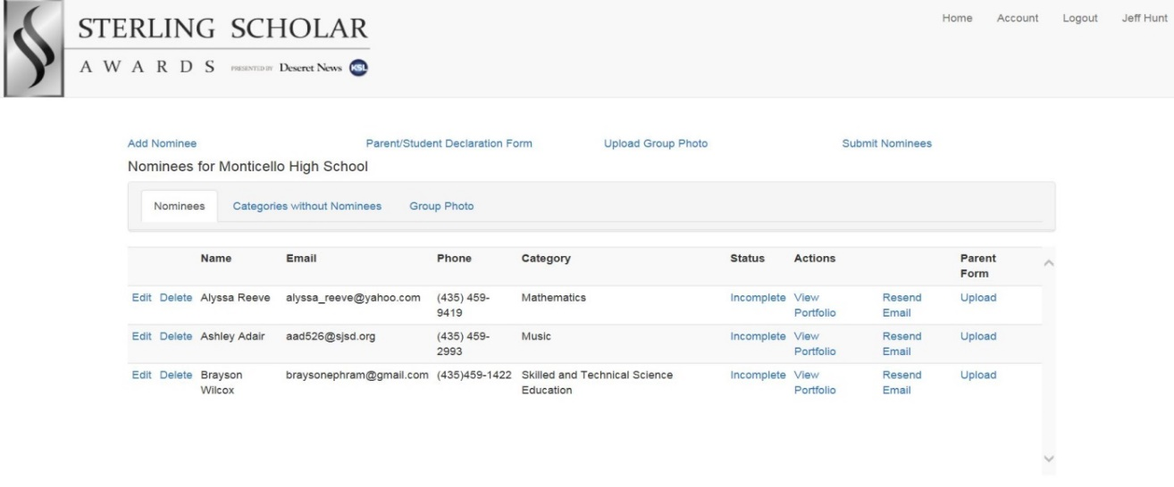

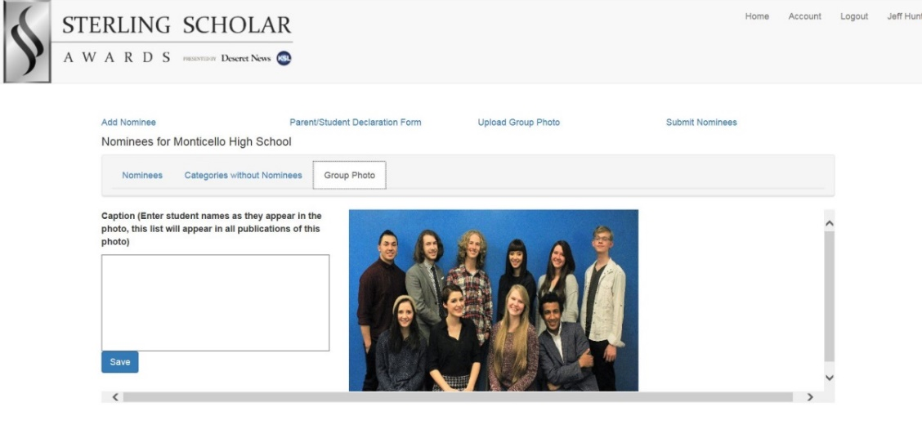

The coordinator will be responsible for the initial setup of each Sterling Scholar nominee profile, which includes entering student information, transcripts and scores. Each nominee will receive a welcome email with their login information along with a temporary password based on the email information entered by their coordinator during this initial setup process. As illustrated below, coordinators should also upload the nominee’s individual picture and update personal information including the nominees address and parents name (in the “Robert and Carol Jones” format please) and any comments you would like to make (This would be a good place to make a note when there are two sets of parents or any other particular situation which may need to be annotated). At this time the coordinator should print out the Release Form to be signed by each nominee and their parent(s). Coordinators and nominees are to have all forms uploaded to the student’s profile by Friday, December 18, 2026. The coordinator should also have individual photos, group photo, and Captions uploaded by this date. NOTE: The student’s name, as it is entered by the coordinator, will be the name used for interview times, email correspondence, newspaper articles and the Sterling Scholar awards program and certificate.

Monday, January 11, 2027 @ Midnight – 📁 ❗ DEADLINE for submission of student PORTFOLIOS to Sterling Scholar website. All access to portfolios will be closed at midnight and will not reopen. NO EXCEPTIONS. * The submit button has been removed. All portfolios that have been uploaded will go through to judging at the deadline (no matter the status).

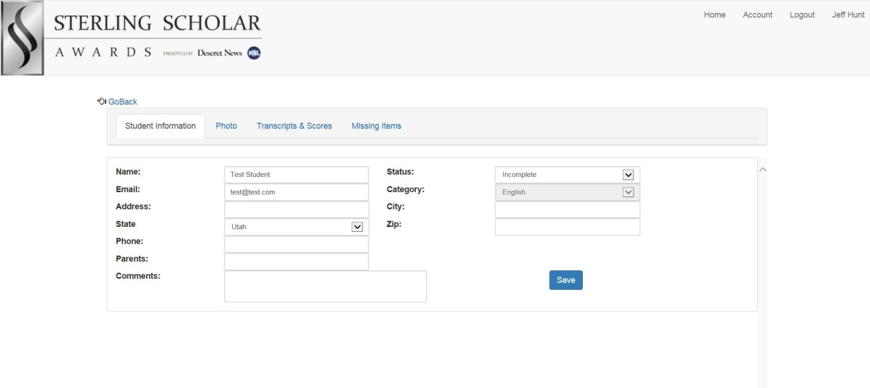

After completing the above screen, you will have access to a listing of all the portfolio items to be completed for that nominee:

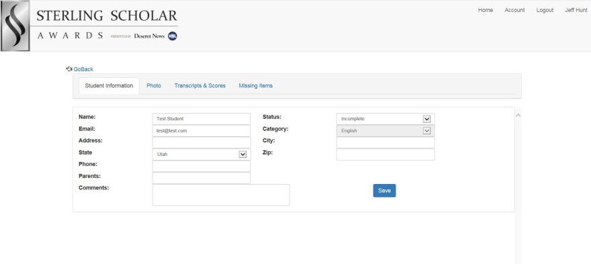

The coordinator has completed the initial setup process once all student information and transcripts and scores have been entered. The remaining pages numbered on this screen are different screens that the nominee will complete. You will be able to monitor the nominees’ progress and review each section. It is your decision as to how often you do so.

When the nominee’s portfolio is complete, it is recommended that you go over the portfolio with each nominee and agree upon changes should be made at that time. Once the nominee has submitted their portfolio, only the coordinator can reopen the portfolio for the nominee to make corrections or additions as needed.

For the Nominee

When a nominee has been entered into the system by the coordinator, the nominee will receive an email with their login information along with a temporary password (their individual email address is their unique User ID). The first portion of their portfolio contains their “Personal Information”, school transcripts and college entrance exam scores which have been entered by the school’s Sterling Scholar Coordinator. The screen below shows the different sections to be filled out by the nominee to complete their portfolio.

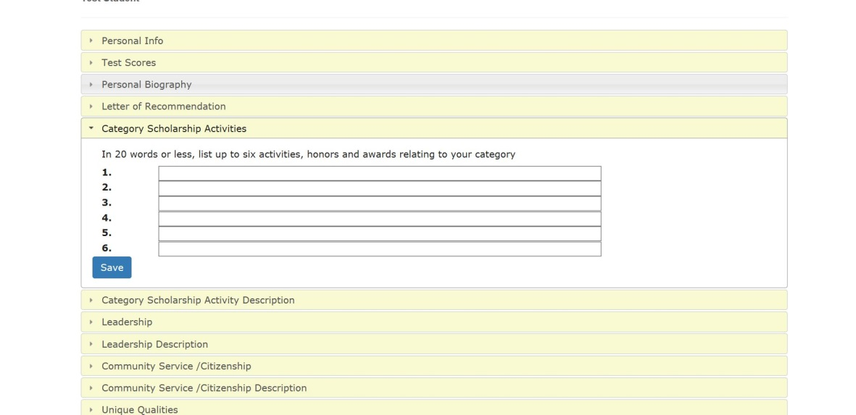

Each nominee will begin preparing their portfolio with the upload of their “Letter of Recommendation”. For the remainder of your portfolio the acceptable file formats are .PDF, .TXT, .RTF, .JPG, .TIF, WAV, WMA, .MP4, .ACC, .MP3 and .MPG. The maximum file size for all attachments is 20MB so make sure that any files exceeding this limit are compressed before uploading them. External links to YouTube, Vimeo or other video sharing sites are the preferred path for videos. The nominee will have an opportunity to upload a supporting document within each section and more at the end of the portfolio.

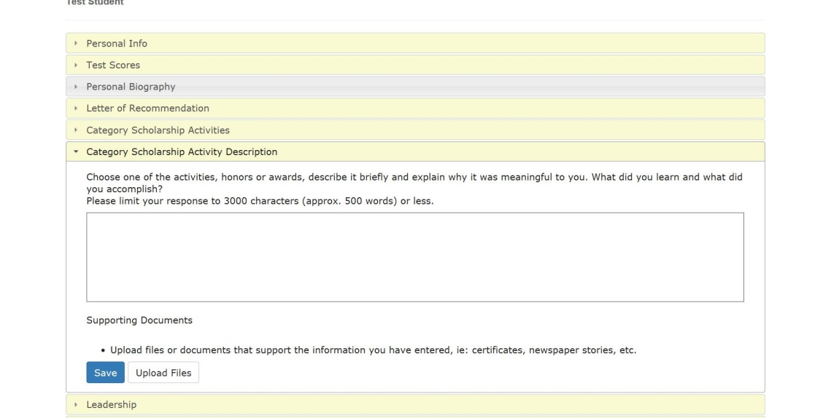

Letter of Recommendation: A letter of recommendation by any teacher/instructor should include the teacher’s assessment of the individual with specific reasons for the recommendation plus examples of evidence as to why “This is an outstanding nominee,” etc. Only one letter of recommendation is preferred.

Category Scholarship Activities: The nominee will have the opportunity to list six different Category Scholarship Activities each using 20 words or less.

Category Scholarship Activity Description: Choosing one of the above listed activities, the nominee will write in detail about that activity (in 500 words or less). They will also be able to upload a supporting document (e.g., a pdf of the actual award, a picture of nominee receiving award, or an external link to a video of the activity itself highlighting the nominee’s participation).

Leadership Activities and Community Service/Citizenship: The previous two screens will be duplicated for these two sections list/essay requirements.

Unique Qualities (list & essay): Please describe two or three unique things about yourself while relating them to your competition category. The nominee should take this opportunity to relate the challenges they have had to overcome and describe any distinctive experiences they may have had and how they affected them.

Life Enrichment (essay): How do you think your involvement in this category will enrich your life?

Attachments: This section of the portfolio is for the nominee to include examples of their work within their category.

Note: Each essay section will allow only 500 words maximum, so it is recommended that the essay be written in Word®, making sure of the word count as well as spelling corrections, and then copied to the essay screen.

Screen Example:
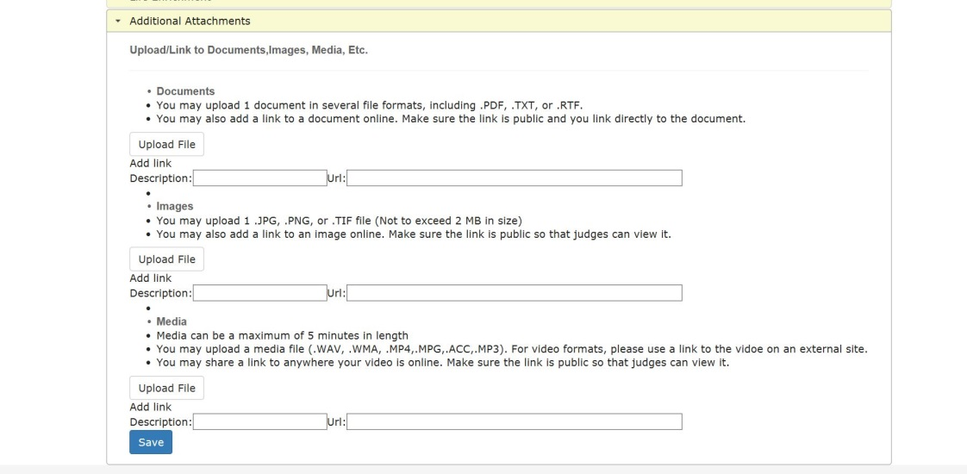

Final Preparations

Upon completion of the portfolio each nominee will submit their completed document to their Sterling Scholar Coordinator. Uploaded documents and pictures will be embedded within the portfolio pdf. Any external links for video or audio files will be included as hyperlinks. The coordinator will be notified of the submission. It is recommended that the coordinator meet with the nominee to review the portfolio. If changes are suggested, the coordinator may re-open the portfolio for the nominee to make those adjustments. The nominee will then, again, resubmit their portfolio.

Monday, January 11, 2027 @ Midnight, all coordinators and nominees will be prevented from making any additions or updates to portfolios. All student profiles will be then sent to the judges for review and scoring as-is.

After the award ceremony on Date TBD 2027, all portfolios and judging documents will be deleted from the Sterling Scholar Award Program, servers and documents will be unrecoverable. Students are encouraged to save their portfolio as a .pdf beforehand if they would like a copy.

General Information

Organizers will be sensitive to situations involving divorced or single parents and stepparents. Please make intentions clear.

For those participating in the Wasatch Front Sterling Scholar area, each school (coordinator or principal) must complete and upload the following: signed Release Form (by student and at least one parent), nominee’s individual photo, school nominee group photo, and caption on or before Friday, December 18, 2026. This deadline should not be confused with the deadline for PORTFOLIO submission on Monday, January 11, 2027 @ Midnight.

Nominees will be judged on their portfolios, exhibits and personal interviews. The interviews are important, and nominees should prepare for them. ALL NOMINEES MUST BE PRESENT AT THE APPROPRIATE TIME AND PLACE FOR THE INTERVIEW. FAILURE TO PARTICIPATE IN THE PERSONAL INTERVIEW ARE GROUNDS FOR DISQUALIFICATION. THERE ARE NO EXCEPTIONS. DEPENDING ON UNFORSEEN CIRCUMSTANCES, THE DESERET NEWS/KSL BROADCAST GROUP RESERVES THE RIGHT TO RESCHEDULE THE JUDGING OF INTERVIEWS. NO provisions will be made to schedule special interviews to suit individual needs or for a videotape, audiotape, PowerPoint presentation, or teleconferencing (facetime, Zoom, teams, etc.) or for another individual to represent that nominee.

The use of Artificial Intelligence (A.I.), in any form, is not permitted in the Sterling Scholar Competition. Students should seek to be honest in their portfolio. They should complete their own work. If the use of A.I. is found, the student will be disqualified from the Sterling Scholar competition.

Nominees should be counseled to bring only pertinent exhibits to interviews. Any samples, demonstration presentations, keepsakes, or other offering that could be interpreted as gifts for the judges are in extremely poor taste and are not allowed and, more importantly, may result in disqualification.

Regional programs follow these same basic Sterling Scholar guidelines but with their own schedule. Some procedures may vary.

Sterling Scholar Awards Ceremony

The nature and content of any award ceremony is solely in the discretion of the Deseret News and KSL Broadcast Group. The awards ceremony may not be used to make a political statement or to criticize or offend based upon race, color, religion, sex (including sexual orientation or gender identity), or disability. An award recipient who violates this provision forfeits any award or scholarship.

A WORD ABOUT PHOTOGRAPHS

Minimum photo sizes should be: No pdfs please. For group shot, 6.5 inches x 4.5 inches, 300 dpi (or about 135 kb). For individual shot, 1.75 inches x 2.5 inches, 300 dpi (or about 66 kb). No hands, books, flowers, etc. in the individual photo. Photographs should be in color. Nominees should be photographed individually against any PLAIN or light-colored background. Avoid any background that would distract from the subject. If photographing outdoors, shoot with the sun or light on the nominee’s face, never against their back. NO LASER PRINTS. Please review the pictures for inappropriate material (gang signs, clothing, etc.).
Please remember to include a caption with group photo of school nominees!

Wasatch Front Region 2026-2027 Schedule

- Friday, December 18, 2026 –✍️ DEADLINE for electronic submission of signed “Parent/Student Declaration” forms to be submitted electronically.

- Friday, December 18, 2026-📸 DEADLINE for uploading individual photos & school nominee GROUP photo, and Caption for group photo. Please include a caption of the student first/last names and their category. Upload photos to the Sterling Scholar Website.
Minimum photo sizes should be: For group shot, 6.5 inches x 4.5 inches, 300 dpi (or about 135 kb); for individual shot, 1.75 inches x 2.5 inches, 300 dpi (or about 66 kb). Please review the pictures for inappropriate material (gang signs, clothing, etc.). Please be prepared with an electronic copy of the group and individual pictures in case of Deseret News production needs.

- Monday, January 11, 2027 @ Midnight – 📁 ❗ DEADLINE for submission of student PORTFOLIOS to Sterling Scholar website. All access to portfolios will be closed at midnight and will not reopen. NO EXCEPTIONS. * The submit button has been removed. All portfolios that have been uploaded will go through to judging at the deadline (no matter the status).

- Tuesday, February 2, 2027 – 📢 Semi-finalists will be announced by e-mail to school coordinators by way of the semi-final interview schedule.

SEMI-FINAL INTERVIEWS

February TBD 2027 – Semi-final interviews: North Area @ 📍 Location TBD

February TBD 2027 -Semi-final interviews: Central Area @Location TBD
February TBD 2027 – Semi-final interviews: South Area @ 📍 Location TBD

- Date TBD 2027 – 📢 168 FINALISTS announced by e-mail to school coordinators by way of the Finals interview schedule.

FINAL INTERVIEWS

- Date TBD 2027 – Final interviews for all 168 finalists @ 📍 Location TBD

- Date TBD 2027-🏆65th Deseret News & KSL Sterling Scholar Awards Ceremony. All Wasatch Front finalists are invited to attend. Details and location to be announced.

Participating High Schools in the Wasatch Front Region

North Area

Bear River
Ben Lomond
Bonneville
Bountiful
Box Elder
Clearfield
DaVinci
Davis
Farmington
Fremont
Green Canyon
Intech Collegiate
Layton
Leadership Academy of Utah
Logan
Mountain Crest
Northridge
Ogden
Ridgeline
Roy
Sky View
Stansbury
Syracuse
Tooele
Utah Connections Academy
Utah Virtual Academy
Venture
Viewmont
Weber
Weber Innovations
West Field
Woods Cross

Central Area
AMES
American Prep Academy (Draper)
American Prep Academy (West Valley)
Beehive Academy
Bingham
Brighton
City Academy
Copper Hills
Cottonwood
Cyprus
East
Freedom Prep. Academy
Granger
Herriman
Highland
Hillcrest
Hunter
Innovations High School
Jordan
Kearns
Mountain Heights Academy
Murray
Olympus
Providence Hall
Riverton
SL School of the Perf. Arts
Skyline
Taylorsville
West
West Jordan

South Area

Alta
American Academy of Innovation
American Fork
American Leadership Academy
Cedar Valley
Corner Canyon
Karl Maeser Prep Academy
Lehi
Lone Peak
Maple Mountain
Merit Academy
Mountain View
Orem
Paradigm
Payson
Pioneer HS for Performing Arts
Pleasant Grove
Provo
Rockwell Charter
Salem Hills
Skyridge
Spanish Fork
Springville
Summit Academy
Timpanogos
Timpview
UT County Academy of Science
UT Military Academy-Camp Williams
Walden School
Westlake

Interview Tips for Students:

- Be prepared.
- Arrive 30 minutes early to allow time for check in and warm-up (if needed).
- Dress professionally.
- Make sure clothes are properly laundered, pressed, and professional in appearance.
- Turn off cell phone.
- Have electronic devices needed for presentation (laptops, mp3 player, etc.) charged upon arrival.
- Make eye contact.
- Speak clearly.
- Sit/stand up straight.
- Listen carefully.
- Give direct answers.
- Smile
- Bring an example of your work (if possible).
- Relax and have fun!
- Be courteous and allow the interview to end on time.

Wasatch Front Region Special Awards
General Sterling Scholar Award
The General Sterling Scholar Award recognizes the individual that not only excels in his or her category, but who also demonstrates exemplary scholarship, leadership, and citizenship excellence. The general sterling scholar winner for the Wasatch Front Region will receive an additional $2,500 scholarship.
Gail Miller Community Service Award
The Gail Miller Community Service Award is given to one of our 168 sterling scholar finalists in recognition of outstanding community service. This award is given to one student who exemplifies commitment to serving the community. The winner of The Gail Miller Community Service Award will receive a $2,000 scholarship.
Philo T. Farnsworth Award
Philo T. Farnsworth was the inventor television. Even though the odyssey of television involved many people, the basic concept of electronic television began in the fertile mind of a young boy from Utah. In the end, native Utahn Philo T. Farnsworth was recognized by time magazine as “the father of television” and as one of the greatest minds of this century. The Philo T. Farnsworth Award winner will receive a $1,000 scholarship.
Region Finalist Scholarship Amounts
Each category winner - $2,500
Two runners-up per category - $1,000

General Sterling Scholar Award - $2,500

Gail Miller Community Service Award - $2,000

Philo T. Farnsworth Award - $1,000

* The Sterling Scholar program proudly provides scholarships in the above amounts at the Region Finalist level.

Additionally, many institutions in Utah offer financial assistance to different levels of Sterling Scholars. A complete list can be found below on our Financial Assistance By Participating Institutions page below, in the handbook, and on our website: https://www.sterlingscholar.org/regions#wasatch-front

After the Wasatch Front Region Awards Ceremony, you may claim your scholarship by sending us a copy of your university/school acceptance letter. You must include your student ID number, along with the contact information for your university/school to kizieranA@deseretmgt.com. A check will be mailed directly to your school and deposited in your account under your student ID number.

Please be aware that applications must be made immediately as your scholarship is available for the 2026-2027 school year. If you will not be attending school in the fall due to other circumstances (mission call, military service, health, etc.) please let me know so that we can discuss your options for future award. Funds will be held up to three years.

FINANCIAL ASSISTANCE BY PARTICIPATING INSTITUTIONS

PLEASE READ: Most colleges and universities in Utah and Brigham young University – Idaho in Rexburg, ID, offer financial assistance to top nominees in the Deseret News/KSL Broadcast Group Sterling Scholar Awards Program. Some are offered to winners only while other institutions may offer scholarships also to runners-up, and even others offer to finalists or even nominees in the program. Several are renewable based on the nominee’s grade point average. The following are participating educational institutions and their financial assistance for Sterling Scholars. (Note: Awards are listed as described by the institutions. Exact amounts are not included due to some changes in fee structures. Application must be made immediately; good for the 2026-2027 school year.)

Bridgerland Technical College, Logan – $1,000 tuition waiver for enrollment in a Bridgerland certificate program beginning within one year of high school graduation to Regional Sterling Scholar Category Winners who graduate from one of the College's local area high schools (Bear River, Box Elder, Logan, Mountain Crest, Ridgeline, Sky View, Green Canyon, and Rich). Recipient must visit Bridgerland's Financial Aid Office -with documentation of the student’s status as a regional category winner- to activate the award and have the terms of the award explained. Visit Bridgerland Technical College online at www.btech.edu or call (435) 750-3204 or (435) 750-3268 for more information.
Brigham Young University, Provo – One-year (two semesters) full LDS tuition scholarships to all regional (final round) category winners contingent upon admission to BYU by appropriate deadline. Should you qualify for another scholarship from the Financial Aid Office at BYU, you will receive whichever scholarship is of greater value. For additional information about scholarships, visit our website at https://enrollment.byu.edu/financialaid/apply-for-scholarships. For questions regarding Sterling Scholarships at BYU, email us at scholarships@byu.edu.
Ensign College, Salt Lake City – Regional category winners will be eligible for one-year (two semesters) full church member tuition (visit our website to see current amount for school year). Runners-up in Business & Marketing categories also eligible for one-year full church member tuition. All other category runners-up eligible for one-year (two semesters) half church member tuition. Students who wish to apply for this scholarship at Ensign College must submit proof of Sterling Scholarship award details to Scholarships@ensign.edu by July 1 to be considered for the upcoming academic school year. Scholarship questions should be directed to the Ensign College Scholarship’s Office: scholarships@ensign.edu or 801-524-8111.

Utah State University – In addition to any other scholarship received from USU, regional category winners will receive a $2,000 stipend for two years ($500 per semester for 4 semesters), regional category runners-up will receive $1,000 stipend for one year ($500 per semester for 2 semesters); and finalists in the Wasatch Front Region receive a $500 stipend for one year ($250 per semester for 2 semesters). Sterling Scholar stipends can be used at all of the 32 USU campuses (including USU Logan Main Campus, Statewide Campuses, USU-Eastern, and USU Blanding). General USU scholarship requirements can be found at www.usu.edu/scholarships. Nominees must (1) apply for admissions by University deadline and (2) email a copy of the Sterling Scholar Award/Certificate to scholarships@usu.edu.
Neumont College of Computer Science, Salt Lake City -- Neumont College of Computer Science will award a full tuition scholarship to regional winners in the general, computer science and STEM-related categories. A half tuition scholarship will be awarded to regional runners-up in the same categories. Sterling Scholar winners are not eligible for other institutional achievement scholarships awarded by the college. Any combination of Sterling Scholar awards with other scholarships are not to exceed full tuition. Contact Rob Dillman, Vice President of Admissions, at rdillman@neumont.edu or call (801) 302-2828.
Salt Lake Community College, Salt Lake City – Salt Lake Community College offers a one-year (Fall semester/Spring semester) tuition waiver to regional category winners and runners-up. The exact tuition waiver amount is based on the number of enrolled credit hours. Recipients must enroll in a minimum of nine credit hours each semester they receive this award, with a maximum of 18 credit hours. Nominees are required to pay individual student and course fees. These tuition waivers are awarded on a first-come, first-serve basis. They are non-renewable and limited. This tuition waiver may be combined with other awards that are not covering tuition, but not in all cases. See website for application due date (apply early-only 4 available). Recipients must provide a copy of their certificate, or the newspaper clipping of award to the Scholarship Team at the Financial Aid Office on the Taylorsville Redwood Campus, or it may be emailed to scholarships@slcc.edu.

Snow College, Ephraim – Snow College is awarding Academic Scholarships based on High School Merit.
We encourage all Sterling Scholar participants to apply for Academic Scholarships based on their high school academics. We also encourage students to apply for Leadership and Departmental Scholarships in their areas of expertise.
Awards are based on scholarship criteria at: www.Snow.edu/scholarships

Southern Utah University, Cedar City - Southern Utah University offers the T-Bird Promise tuition-based scholarship of $1,000 annually ($500/semester) for a maximum of eight semesters to regional Sterling Scholar category winners and runners-up. This award may stack with other academic institutional scholarships. Any combination of tuition-based scholarships may not exceed cost of tuition. The availability of this scholarship is contingent on funding. Regional winners or runners-up must submit a copy of their certificate to be considered for this award. Contact Christine Fawson call 435-586-7735 or email at christinefawson1@suu.edu.

Utah Tech University, St. George – Utah Tech University offers a one-year, $1,000 scholarship to Utah High School Sterling Scholar winners in all regions. Sterling Scholar scholarships must be used directly out of high school; and cannot exceed the cost of full tuition when combined with any other scholarship awarded by UTU. To claim this scholarship, the nominee must be admitted to Utah Tech University and submit a copy of their Sterling Scholar Certificate (or a letter from a high school counselor verifying that the student is the winner in their category) to the scholarship coordinator by July 1st. Contact the scholarship office at: scholarships@utahtech.edu, jhale@utahtech.edu, visit www.utahtech.edu or call (435) 652-7578.
University of Utah, Salt Lake City – Renewable $5,000 annual scholarship to all regional category winners for a total value of approximately $20,000 for a maximum of eight (8) semesters or until the nominee receives a baccalaureate degree, whichever comes first. Recipients must maintain a minimum cumulative GPA of 3.6 and complete 24 hours of course work every two semesters of academic year, namely fall and spring. For additional information about scholarships at the University of Utah: Contact the University of Utah Scholarships and Financial aid office at financialaid@utah.edu or call 801-581-6211.
Utah Valley University, Orem – Region Winners – $4,000 per year ($2,000 per semester) for four-years. Retention criteria: 15 credits per semester with a cumulative GPA of 3.5. Region Runners-Up - $3,500 per year ($1,750 per semester) for two-years. Retention criteria: 12 credits per semester with a cumulative GPA of 3.2. High School Winners - $2,000 per year ($1,000 per semester) for one year. Not renewable. Must take 12 credit hours per semester. During their senior year students must apply for this award by being admitted to UVU and completing the online scholarship application by the deadline date of May 1st. Students will be required to provide documentation of their Sterling Scholar Award. For all eligibility requirements please visit our website https://www.uvu.edu/financialaid/scholarships/.
Weber State University, Ogden – Regional winners will be awarded a one-year tuition scholarship of $2,000. High school category winners will be awarded a one year tuition scholarship of $1,000. Nominees must be admitted to the university. To apply to the university, please see : http://weber.edu/admissions . Recipient must be a U.S. Citizen and Utah resident attending full-time (12-18 credit hours) each semester and maintain a 2.5 GPA. The Scholarship Office must be notified by July to post the Sterling Scholar Award. The Sterling Scholar Scholarship cannot be combined with academic scholarships. Contact Crystal Giordano scholarship@weber.edu or call (801) 626-7569.

Westminster College, Salt Lake City – Renewable $3,000 scholarship awards up to 4 years ($12,000 total) to all regional category winners. Renewable $1,500 scholarship awards up to 4 years ($6,000 total) to all regional category runners-up. These awards will be granted in addition to any the merit scholarships offered by Westminster (not to exceed full tuition). Nominees must maintain good academic standing and satisfactory progress to renew the scholarship for up to eight semesters of study or receipt of bachelor’s degree (whichever comes first). Full-time enrollment in the fall semester directly following high school graduation is required. Contact Jennifer Dahl jdahl@westminstercollege.edu or call (801) 832-2294.

