[ResponsibleSteel Certificate]

Public summary audit report

This is a concise public summary of the audit report for add site. The full version of the audit report is in the possession of the member company and the audited sites.

Audit overview

Member name | xx
Audited entity name | xx
Number of sites  Names & location | xx
Certification scope | xxx
Standard version audited against | ResponsibleSteel Standard V2-0 - Certified Site
Audit type and outcome | xx
Certification body | xx
Audit dates | xx
Number of auditors and audit days | xx auditors  xx days (pre-audit, stage 1, stage 2 and reporting)
Lead auditor declaration | The findings in this report are based on an objective evaluation of evidence, derived from documents, first-hand observations at the sites and interviews with site staff, workers and stakeholders, as conducted during stage 1 and stage 2 audit activities. The audit team members were deemed to have no conflicts of interest with the sites. The audit team members were professional, ethical, objective and truthful in their conduct of audit activities. The information in this report is accurate according to the best knowledge of the auditors who contributed to the report.  It should be noted that audits are snapshots that rely on sampling. Sampling of interview partners, of documentation and records, of observed operations and activities. The auditors can therefore not exclude the possibility that there are non-conformities in addition to the ones identified during the audit activities.
Next audit type and date | Surveillance / Re-certification audit  xx

Table of Contents
Introduction 5
Site information 7
Stakeholder engagement 7
Summary of audit findings 7
Assurance Panel declaration 10

Introduction

About ResponsibleSteel

Our mission is to be a driving force in the socially and environmentally responsible production of net-zero steel, globally.

We are a not-for-profit multi-stakeholder organisation founded to bring together business, civil society and downstream users of steel, to provide a global standard and certification initiative for steel. We have built a consensus on what sustainability looks like for steel – including the impacts of mining, steel production, the scrap metal supply chain, greenhouse gas emissions, water use, workers’ rights, communities and biodiversity. We are the first global scheme for responsibly sourced and produced steel.

Our Members include steel makers, mining companies, automotive and construction companies as well as civil society organisations focused on labour rights, biodiversity, climate change and many other important issues.

Overview of the certification process

To become a ‘Certified Site’, the process below must be followed:

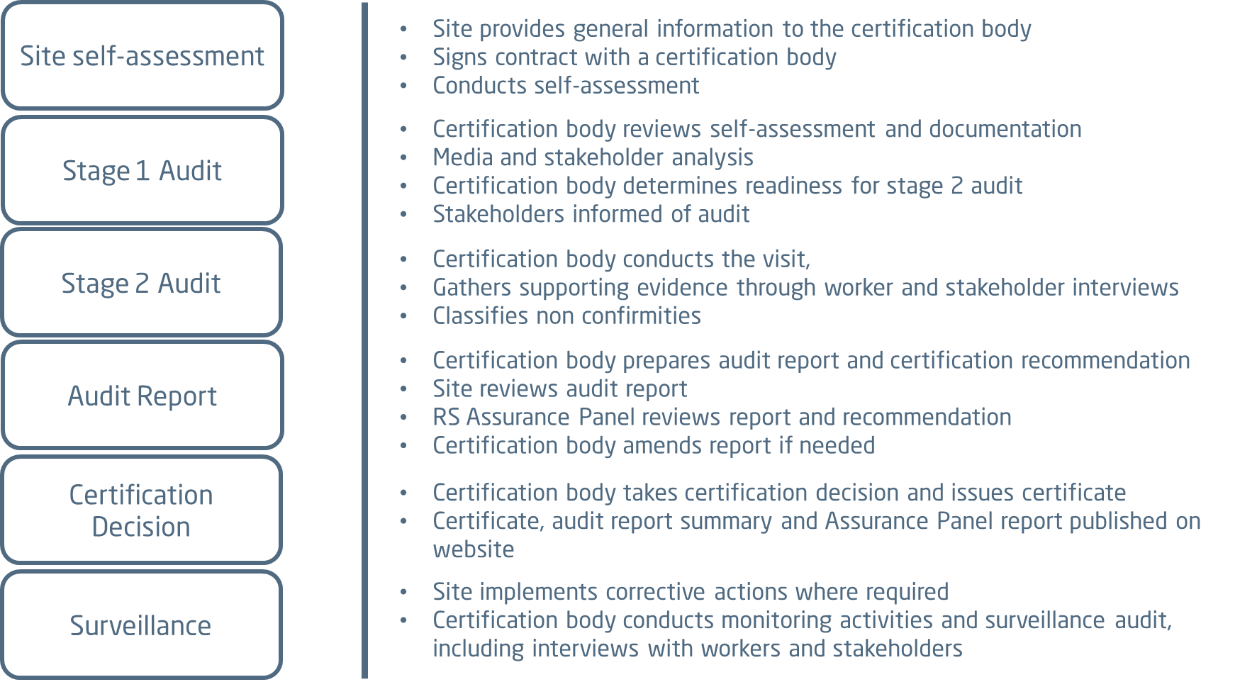

Sites can apply to be assessed against the ResponsibleSteel Standard on a voluntary basis. Conformity with the Standard is verified by independent certification bodies and auditors. They study documentation provided by the site, review relevant media and scientific publications on the site, visit the site to see operations first-hand, and interview site management, process owners, shopfloor workers and external stakeholders such as authorities, community and civil society representatives. The assessment is summarised in an audit report that is reviewed by an independent Assurance Panel. Only if that Panel is satisfied with the quality of the audit and the resulting report, can a site with a positive certification recommendation be certified. A ResponsibleSteel certificate is valid for three years and certified sites have to pass a surveillance audit after 18 months and subsequent re-certification audits to remain certified. The rules and processes for ensuring compliance with the Standard are outlined in the Assurance Manual and have been developed using the Assurance Code of Good Practice set by the ISEAL Alliance as a reference.
It should be noted that engagement of external stakeholders is not required for the additional responsible sourcing and GHG requirements. A site visit is only necessary for the additional requirements if the site’s GHG data has not been independently verified before the ResponsibleSteel audit or if the site and their certification body agree that a site visit would be useful.

ResponsibleSteel provides an Issues Resolution System that any stakeholder may use to log a complaint about any aspect of the ResponsibleSteel programme. The Issues Resolution System can be accessed via the ResponsibleSteel website.

More information on ResponsibleSteel can be found on https://www.responsiblesteel.org/.

Site information

Country and town | xx
Activities and products | xx
Year site opened | xx
Major extensions and / or refurbishments and year(s) when these occurred | xx
Annual production | xx million metric tons of xx per year
Number of employees and contractors | xx employees  xx contractors
Carbon reduction target | xx
Further environmental and social information | Xx (add link)

Stakeholder engagement

Xx (for ‘Certified Site’ only)

Summary of audit findings

Conform | Conformity, the requirement is fulfilled.
Opportunity for improvement (OFI) | The respective requirement or criterion has been implemented, but effectiveness or robustness might be increased, or it is a situation that could lead to a future non-conformity if not addressed.
Minor non-conformity (NC) | Isolated, unusual or non-systemic lapse. Or a lapse with limited temporal and organisational impacts. A non-conformity that does not result in a fundamental failure to achieve the objective of the relevant requirement or related criterion. Sites can become certified with minor non-conformities, but they must have addressed them by the time of their next audit.
Major non-conformity (NC) | A non-conformity that, either alone or in combination with further non-conformities, results in or is likely to result in a fundamental failure to achieve the objective of the relevant requirement or related criterion. For example, non-conformities that continue over a long period of time, are systemic, affect a wide range of the site's production or of the site's facilities. Sites with major non-conformities cannot be certified.
Exclusion | The requirement is either not applicable: excluded from the audit since it is not applicable to the sites; or not rated: the requirement is very closely linked to another requirement where a non-conformity (NC) or opportunity for improvement (OFI) has already been raised. Sometimes, when requirements are linked to one and the same subject-matter, it is appropriate to count NCs or OFIs only once to avoid repetition.

Add overview table from audit report
* Note that the Total in the table does not correspond to the sum of Confom, OFI, Minor NC, Major NC and Exclusion due to the way that requirements and conformity classifications are counted.

Exclusions

Add exclusions from audit report

Strengths

Xx (from audit report)

Areas for improvement

During the audit, a few areas were identified that require the attention of the sites and xx minor non-conformities against requirements of the ResponsibleSteel Standard were raised. The sites are required to effectively address the non-conformities before the next audit. The non-conformity findings are related to:
Xx (from audit report)

Assurance Panel declaration

In line with the ResponsibleSteel Assurance Manual, three members of the Assurance Panel reviewed the full audit report for [audited entity name], including the auditors’ findings for each individual requirement of the ResponsibleSteel Standard. Subsequently, the Assurance Panel members met online to discuss individual findings and to align their views on the audit report. We sought clarification and asked for reconsideration of conformity classifications where the auditors’ conclusions were not sufficiently substantiated. Following review of the changes that were made by the auditors, we support the certification recommendation for [audited entity name].

The Assurance Panel’s conclusions on the final audit report are as follows:
- The audit report contains sufficient detail to support an informed certification decision
- The supporting evidence and rationales given in the audit report support the auditors’ conformity classifications
- The certification recommendation based on the audit report is conclusive

This statement has been approved by the three members of the Assurance Panel who reviewed the audit report on [insert date].

