

INSPIRING WORLD-CLASS

TEACHING PROFESSIONALISM

Workbook to support the *Exploring our Professional Values* resource



# **Supporting your professional Learning**

The resource is designed for you to use as an individual or to facilitate discussion with your colleagues. You can use this reflective notebook to explore and record your reflections.

This workbook is designed to be used alongside the accompanying PowerPoint. Both have been split into 3 parts for ease of use:

* Part 1: Introduction to the Professional Standards and Professional Values
* Part 2: Reflection on Professional Values Activity. Paired Professional Learning Conversation: The Professional Journey Map
* Part 3: Bringing the Professional Standards alive through our practice. Planning next steps.

You can save this reflective notebook as part of your professional learning record through MyPL, or to the professional learning record used by your employer.

## **1. Part One: Introduction to the Professional Standards and Professional Values**

Slides 4-10

Section 1 of the Professional Standards for Teachers, Being a Teacher in Scotland, provides a shared language for teaching professionals to explore Professional Values and Professional Commitments.

**What stands out to you from these slides?**

**1.2 Part Two: Reflections on Professional Values**

## **2 Part Two: Reflections on Professional Values**

Slides 11-15

### **2.1 Activity 1: Professional Journey Map – Paired conversation**

#### **2.1.1 Individual reflection**

**Professional Journey Map (10 mins)**

Sketch out your Professional Journey Map. Take a blank sheet of paper. Start where feels natural. You might begin with what brought you toward teaching. If you are working online, take a photo or scan your map to share with your co-coach.

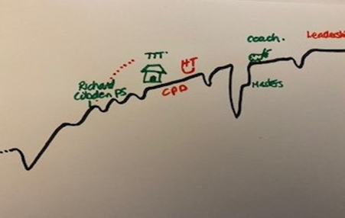

#### **2.1.2 Co-coaching reflections (15 to 20 mins)**

**Identifying your professional values:**

* Share the key aspects of your professional journey map/story
* How did each experience inform your professional values?
* Where have your professional values informed your decision making and actions?

**Clarify your professional values:**

Support/challenge each other to identify 3-4 professional values that have shaped/influenced your professional career.

* What motivated you to become a teacher?
* Why do you remain a teacher?

**Professional Values (vocabulary)**

* Kindness
* Honesty
* Integrity
* Courage
* Truthful
* Growth
* Commitment
* Trust
* Wisdom
* Learning
* Respect
* Equity
* Challenge
* Authenticity
* Fairness
* Inclusiveness
* Valuing

You can this page to sketch out your Professional Journey Map.

**Reflections and notes**

|  |
| --- |
|  |

## **3.1 Part 3: Bringing the Professional Standards alive through our practice. Next Steps.**

Slides 16-18

**What do the Professional Values mean to you?**

|  |
| --- |
|  |

**In your role, what are the implications for you and those you support?**

|  |
| --- |
|  |

**In your opinion: What is already working well?**

|  |
| --- |
|  |

**In your opinion: What are the key challenges you are likely to face?**

|  |
| --- |
|  |

**What are your next steps?**

|  |
| --- |
|  |

**What support would be helpful?**

|  |
| --- |
|  |