How to set up your provisional registration profile

Published: September 2025

Getting started
When getting started on the new MyGTCS platform, we recommend that you follow these steps in order:
- Create a reviewer association
- Add a school
- Begin populating your provisional registration profile – beginning with:
  - adding a teaching block
  - adding key strengths and areas for development
By completing these steps first in your new MyGTCS account, when you come to add records of observations, professional discussions, development plans etc. to your profile, you will have the option to link these to your key strengths, areas for development and associations. These associations must be set up beforehand to appear in the relevant dropdown menus.

How to create an association
After setting up your new MyGTCS account with your employment and contact details, as a provisional registrant you can create an association with supporters. There are three types of associations you can choose from:
- Reviewer
- Supporter
- Observer
You will need to know the GTC Scotland registration number and last name of the person you wish to associate with. To set up an association:
- Select ‘Associations’ in the navigation menu.
- Under Supporters & Reviewers, select the ‘+ Create association’ button.
- Complete the create an association form and select the ‘Submit’ button.
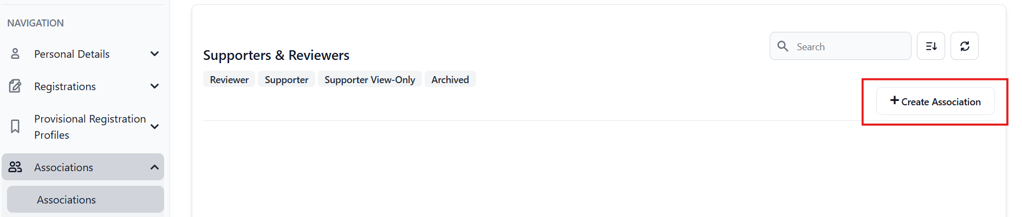
Once you have submitted this form, your associate will receive notification that they have an association request to review. Once they have accepted, you will see them listed under the associations area of MyGTCS.
If you select the reviewer or supporter role, your associate will be able to view your provisional registration profile. This access allows supporters to perform actions such as:
- provide feedback on learning activities
- add key strengths and areas for development
- provide agreement on observations
- make progress reports (reviewers only)
- make a recommendation for Full Registration (reviewers only)
Please note, any associated Reviewers and Supporters can also provide feedback on any observation records you later add to your profile without you having to set up an Observer association with them.

How to add a school
To set up a school:
- Click ‘Associations’ in the navigation bar
- Under Schools, select the ‘+ Add school’ button.
- 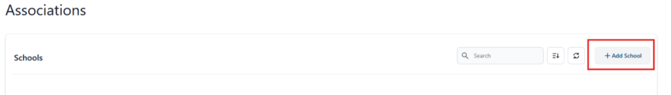Complete the add school form and select the ‘Submit’ button.
- Important: if you add a school located in Scotland, you will be asked to confirm who the reviewer and supporter is in that school. Any reviewers or supporters you have already linked with under the “Supporters & Reviewers” in the ‘Associations’ area will appear in the drop-down list. You need to complete this step to be able to share files with your reviewer/supporter, or to request a progress report or recommendation for Full Registration.
- 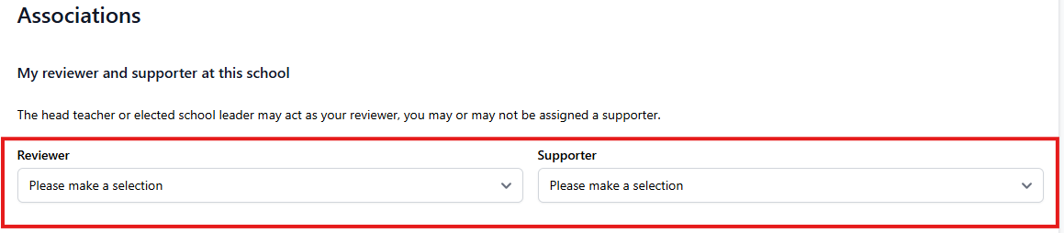
Completing this step also means that a local authority probation manager is aware who you are associated with.

Association with local authority probation managers
By default, if you are creating an association with a local authority school, you will be prompted to form an association with the local authority probation manager. They will be able to view your provisional registration profile and provide support during your induction.

