MyGTCS: Reviewers’ guidance

Published: November 2025

The role of a reviewer

GTC Scotland holds the role of a reviewer in the highest possible regard. As a reviewer you have a key role in deciding who belongs to the teaching profession.
It is a long-held element of our system of education that headteachers and other fully registered teachers play a critical role in ensuring trusted teaching. They assess whether provisionally registered teachers have met the requirements in order to be fully registered and therefore qualified teachers.
On MyGTCS, as a reviewer you can:
- accept or decline association requests
- view provisional registration profiles
- provide feedback on learning activities and agreement on observation records
- view, edit and add key strengths and areas for development
- provide a reviewer statement on any submitted progress reports and mark them as satisfactory, cause for concern or unsatisfactory
- make a recommendation on Full Registration

Read more about what is expected of you as a reviewer.

Associations

Accepting an association request
Provisional registered teachers (PRTs) are responsible for sending association requests in MyGTCS, you do not need to do set up associations with PRTs. As a reviewer you only need to review and accept/decline any requests you receive. This means that until the new MyGTCS platform is launched to all registrants in early 2026, you will not have access to the new MyGTCS until a PRT requests to associate with you.
If a PRT has requested to associate with you, we will get in touch to help set up your MyGTCS account on the new platform.
Once logged in to MyGTCS you will see any notifications in the banner along the top off the page. In the notification dropdown, you can click on the notification to be taken to the association request.
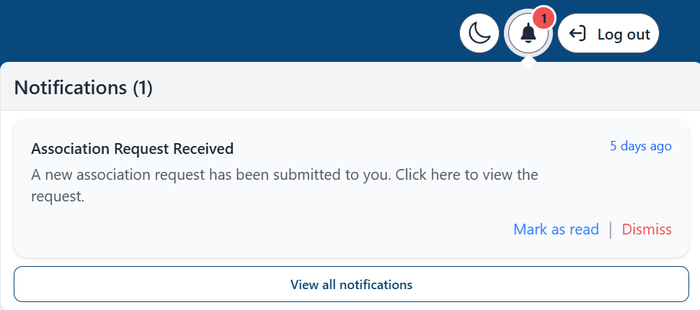
Or you can also go to ‘Shared records’ under the Associations area.
You can choose to accept or decline the request.

Viewing your associations
After accepting a request, under ‘Associations – Registrants I support’, you will be able to see the full details of the registrant’s profile, including:
- the school(s) at which the PRT has recorded you as their reviewer
- any key strengths and areas for development they have recorded
- teaching blocks – where PRTs record a ‘block’ of teaching service while working towards the Standard for Full Registration
- development plans
- observations
- learning activities
- professional discussions
- teaching days (this is where PRTs can also upload their timetable)
If they have more than 1 profile, for example if they have dual registration, you’ll also be able to see the details of these individual profiles.
You can view individual records within their profile by selecting the eye symbol next to that record.
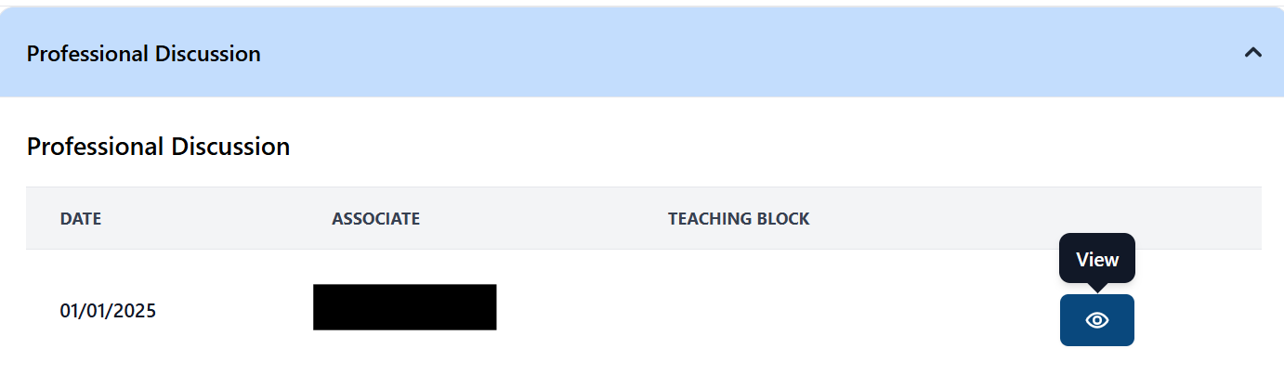

You can also view individual records grouped by teaching block.
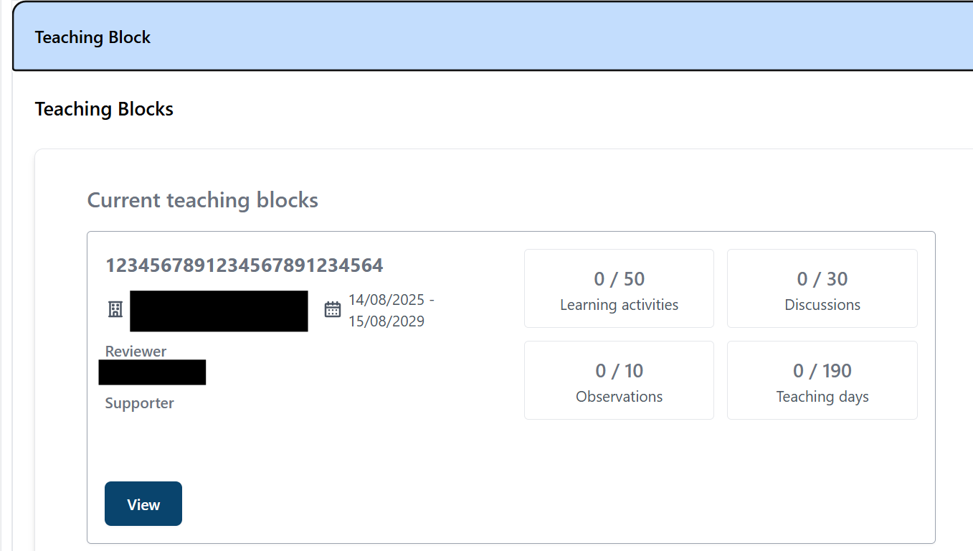

Provisional registration profiles

Profile areas
Find further guidance on what makes a good provisional registration profile in our guidance video.

Meeting the standards
The meeting the Standards area is where PRTs can add a key strength or area for development to their profile. Once an association has been created, as a reviewer you can also edit and add any key strengths of areas for development.

Teaching blocks
A teaching block is a collection of Professional Learning evidence that relates to your employment at a particular school over a set period of time.

Observations
In the observations area a PRT can record details of planned observations where the timing and focus have been agreed beforehand. They can also submit observation records to the observer, who can provide feedback and agree the record is accurate.
To recommend a PRT for Full Registration, you must declare that you have observed the PRT teach in their registration category at least once.

Learning activities
The learning activities area is where a PRT can record and reflect on any professional learning activities they have undertaken during their induction.

Development plans
The development plan area is where PRT’s can maps out their focus for a specific period of time as they work towards the Standard for Full Registration, using the key strengths and areas for development that they have already identified in their profile.

Professional discussions
In this area, PRTs will record professional discussions with their supporter or other colleagues, such as a line manager.

Teaching days
The teaching days area is where PRTs record of any periods of relevant teaching. They can also upload a copy of their timetable to this area, if they wish. Adding key strengths and areas for development
For a PRT, the ‘Meeting the Standards’ area is where key strengths and areas for development are recorded. Once they have identified and recorded these, they can then upload an overarching plan in the ‘Development plans’ area. This is where they will outline how they will go on to meet the areas for development that they will focus on over a period of time (and how they will enhance or embed their key strengths).
As a reviewer, once you have accepted an association, you can add key strengths or areas for development for a PRT to their profile, under the ‘Registrants I support’ area.
To do this:
- Go to the ‘Registrants I support’ area by using the navigation menu
- Select the appropriate registrant from your associations list using the ‘Details’ button
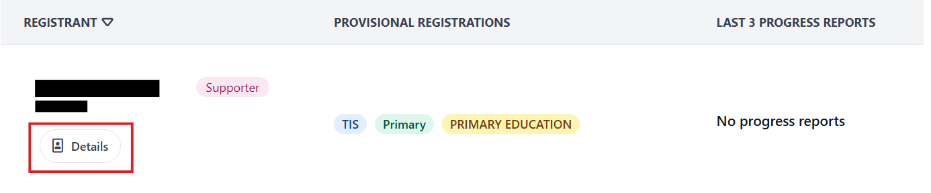
- In their profile, scroll to the ‘Meeting the Standard for Full Registration’ dropdown. In here, you will be able to view any key strengths or areas for development they have previously added.
- To add any more, select either the ‘Add a key strength’ or ‘Add an area for development’ button.
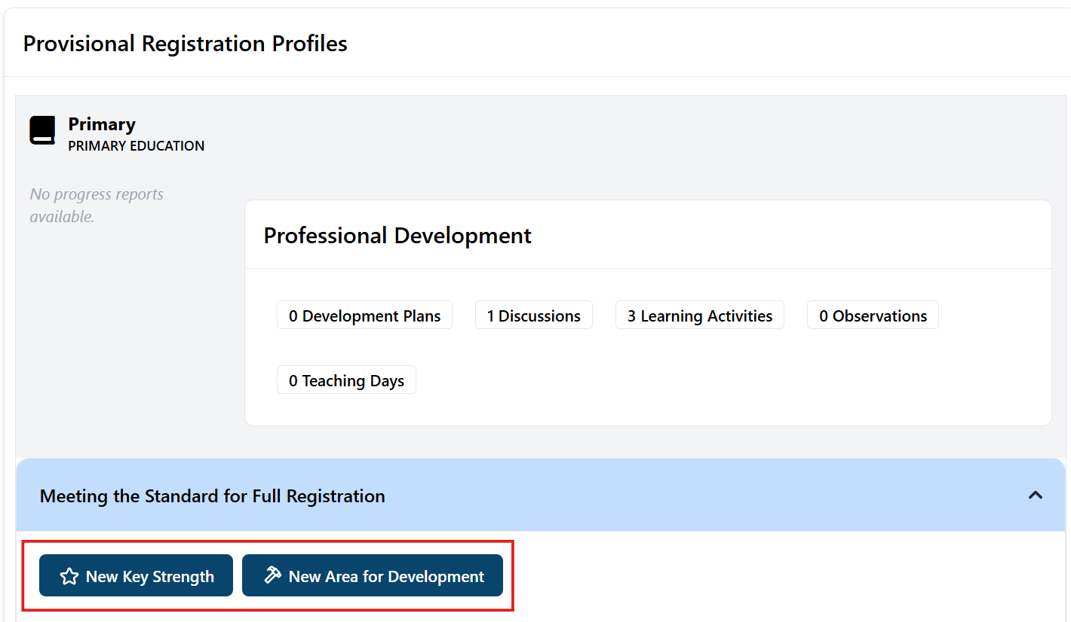

Providing feedback on records
As a supporter, PRTs may ask you to provide feedback for:
- Learning activities
- Observations
You do not need to sign off or record professional discussions with PRTs, but you are able to view any logged by the PRT once you have an association with them. It’s the responsibility of PRTs to record professional discussions.
When a provisionally registered teacher submits a record to you for feedback, you will receive notification in MyGTCS.
You can provide feedback on this individual record by either clicking on the notification or by going to Associations – Shared Records in the navigation bar.
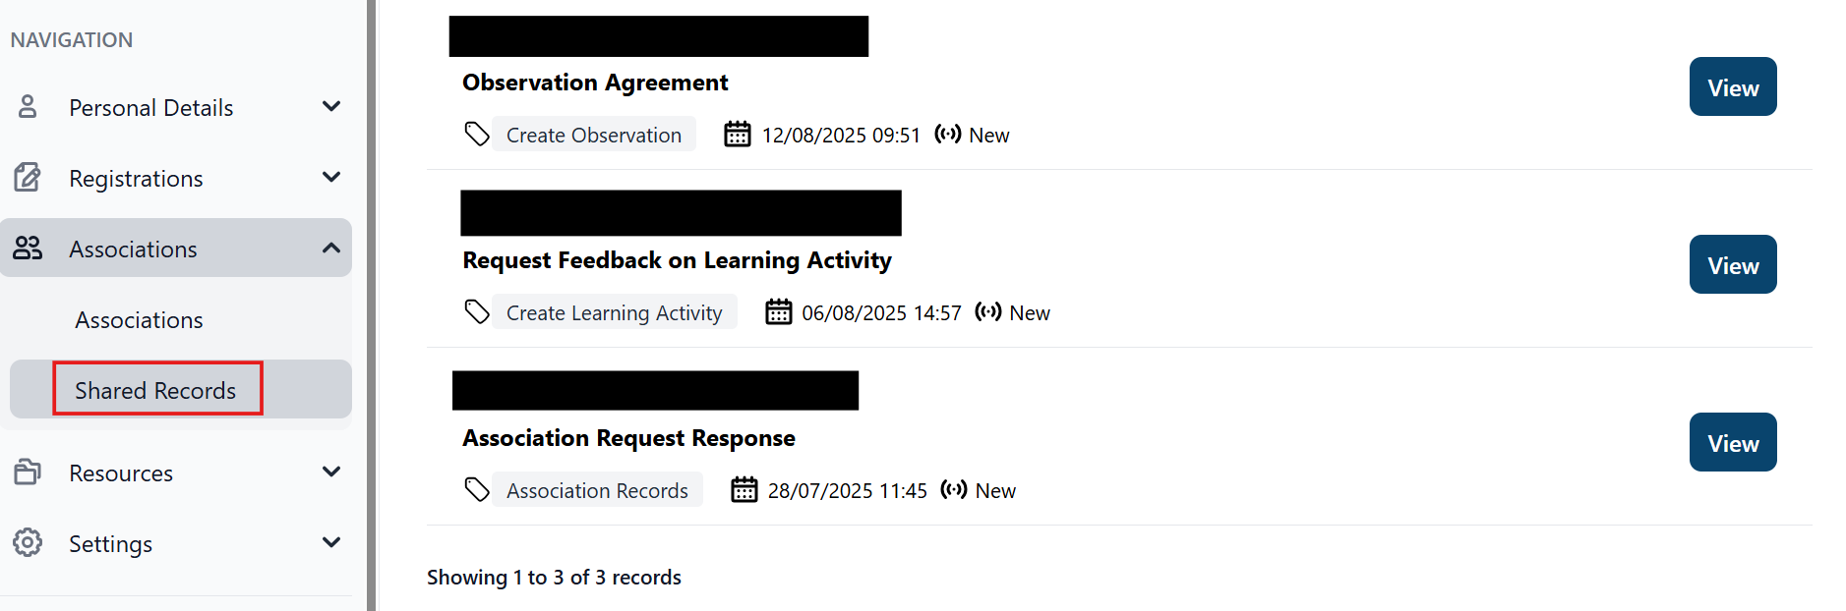
Here you will be able to view any information sent to you from the PRT and submit your feedback. Once you have submitted your feedback, the PRT will receive notification that this is ready to review.
Please note, PRTs can also revoke this request for feedback at any point.
Progress reports
PRTs can request a progress report on a teaching block at any point they wish to. They can send the request for a progress report directly to you as their reviewer or they can first request a statement from a supporter.
Please note, once a PRT has received a progress report for a particular teaching block, it is no longer editable – only viewable.

Reviewer and supporter statements
Once a PRT has submitted a progress report to you for review, you will receive a notification in your MyGTCS account. You can review the progress report by either clicking on the notification or by going to Associations – Shared Records in the navigation bar.
From there, you can review the teaching block which has been submitted. If the PRT submitted the block to their supporter for a statement first, the supporter statement will be included for review.
Once you have reviewed the content of the teaching block, you can assess the PRT’s progress as either:
- Satisfactory
- Unsatisfactory
- Cause for concern
If you select unsatisfactory or cause for concern, you will then be asked to give a reason. This can be for reasons of service, competence or both.
You can also provide feedback as part of your progress report. When you are ready, click ‘submit’ to send the progress report back to the PRT. They will then receive a notification and can view the feedback provided from both their supporter and you as their reviewer.
Read more about what should be included in a reviewer statement

Making a recommendation
When a provisional registrant is ready to request a recommendation, they will submit their request to you as a reviewer.
You will receive notification both by email and in MyGTCS to let you know that you have a pending request for recommendation. Once logged in to MyGTCS you can review any requests either:
- in the 'Associations' area, under ‘Shared records’
- directly through your notifications on MyGTCS.
The submitted request for Full Recommendation will include the PRT’s profile and any additional notes. Once you have reviewed the request, you can choose to either 'Recommend for Full Registration’ or ‘Other recommendation’ from the dropdown.
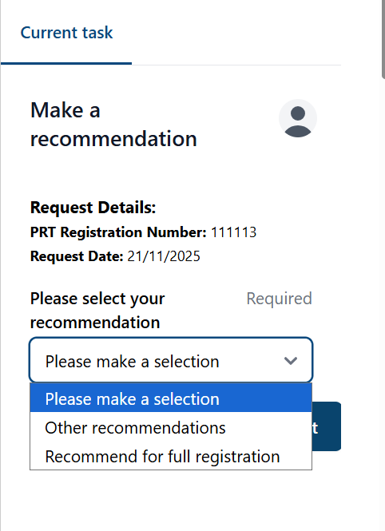

Other recommendation
If you select ‘Other recommendation’ you will be asked to provide:
- your reason for not recommending Full Registration
- what your recommendation is
- any further comments or feedback.
You can find the declarations for each recommendation on our website.

Recommend for Full Registration
If you select ‘Recommend for Full Registration’, you can add any additional comments or feedback before checking the declarations and submitting your recommendation to the PRT.
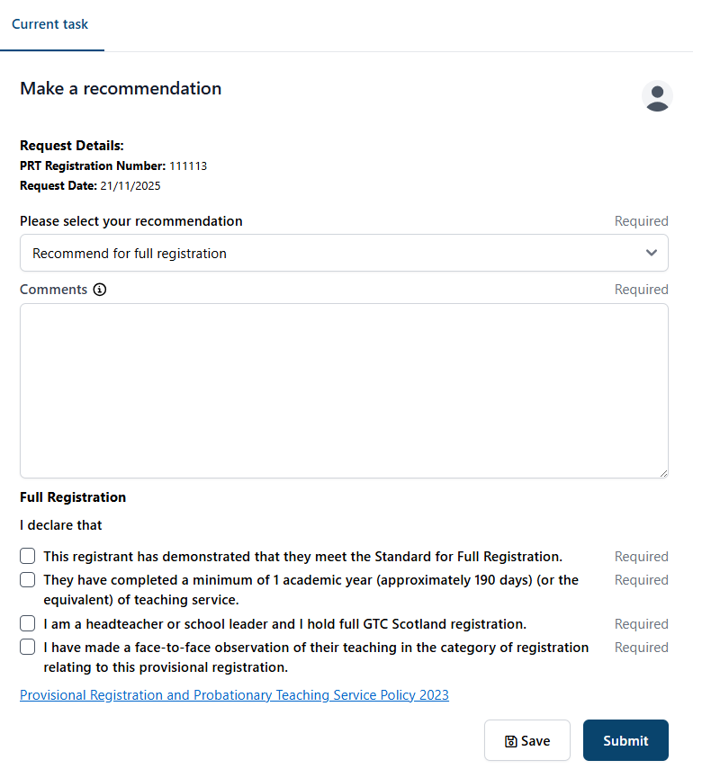
You can find the declarations for recommendation for Full Registration on our website.

Need help?
You can find further guidance on the new MyGTCS platform on our website.
If you need help logging into the MyGTCS platform or have any technical questions, please get in touch using the contact form.

