MyGTCS: Supporters’ guidance

Published: September 2025

Contents
MyGTCS: Supporters’ guidance 1
Contents 2
The role of a supporter 3
Associations 4
Accepting an association request 4
Viewing your associations 5
Provisional registration profile support 7
Adding key strengths and areas for development 7
Providing feedback on records 8
Progress reports 10
Supporter statements 10
What to include in a supporter statement 10

The role of a supporter

The support of an experienced, fully registered teacher is core to ensuring a supported induction to the profession for every provisionally registered teacher (PRT).
On MyGTCS, as a supporter you can:
- view provisional registration profiles
- provide feedback on learning activities and agreement on observation records
- add key strengths and areas for development
- provide a 'supporter statement' for a progress report

Read more about what is expected of supporters
Associations

Accepting an association request
Provisional registrants are responsible for sending association requests in MyGTCS, you do not need to do set up associations with PRTs. As a supporter you only need to review and accept/decline any requests you receive. This means that until the new MyGTCS platform is launched to all registrants in early 2026, you will not have access to the new MyGTCS until a PRT requests to associate with you.
You can log in and review any association request you have been sent. Once logged in you will see any notifications in the banner along the top off the page. In the notification dropdown, you can click on the notification to be taken to the association request.
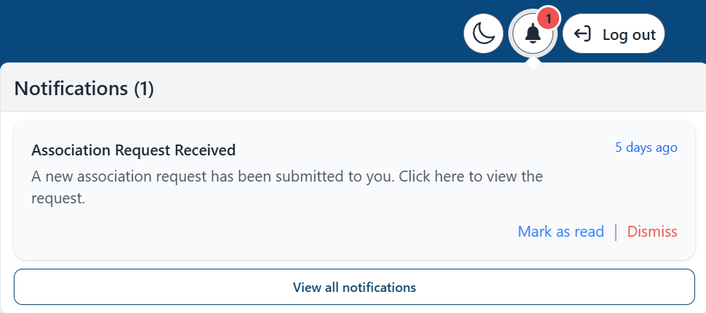
Or you can also go to ‘Shared records’ under the Associations area.
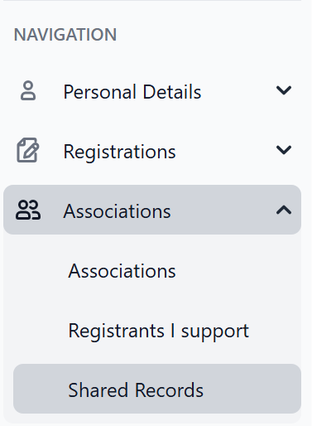
You can choose to accept or decline the request.

Viewing your associations
After accepting a request, under Associations – Registrants I support, you will be able to see the full details of the registrant’s profile, including:
- the school(s) at which the PRT has recorded you as their supporter
- any key strengths and areas for development they have recorded
- teaching blocks – where PRTs record a ‘block’ of teaching service while working towards the Standard for Full Registration
- development plans
- observations
- learning activities
- professional discussions
- teaching days (this is where PRTs can also upload their timetable)
If they have more than one profile, for example if they have dual registration, you’ll also be able to see the details of these individual profiles.
You can view individual records within their profile by selecting the eye symbol next to that record.
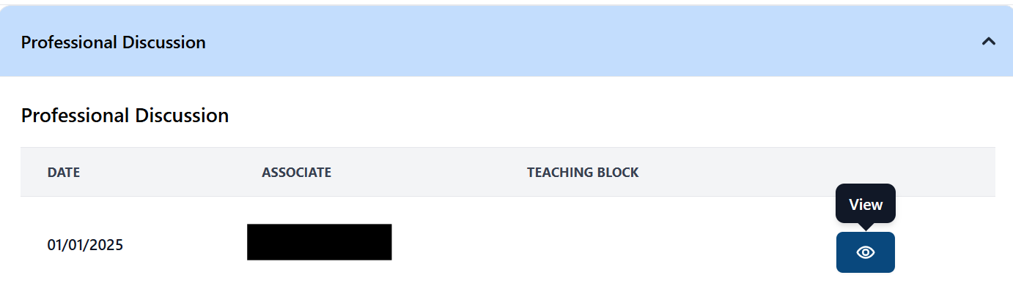
You can also view individual records grouped by teaching block.
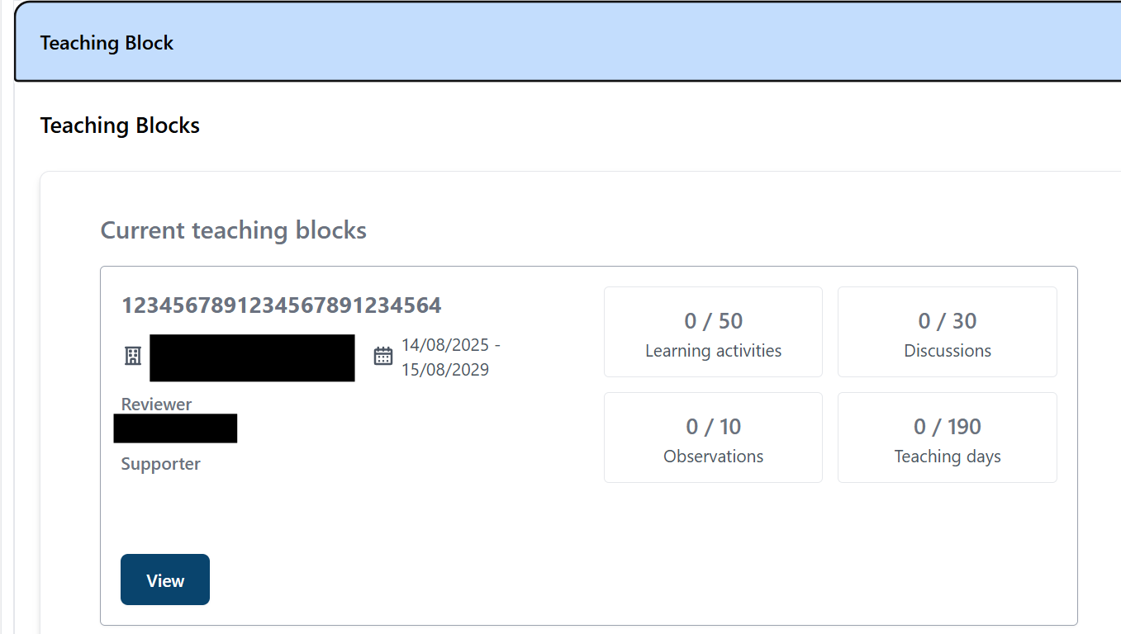

Provisional registration profile support

Adding key strengths and areas for development
For a PRT, the ‘Meeting the Standards’ area is where key strengths and areas for development are recorded. Once they have identified and recorded these, they can then upload an overarching plan in the ‘Development plans’ area. This is where they will outline how they will go on to meet the areas for development that they will focus on over a period of time (and how they will enhance or embed their key strengths).
As a supporter, once you have accepted an association, you can add key strengths or areas for development for a PRT to their profile, under the ‘Registrants I support’ area.
To do this:
- Go to the ‘Registrants I support’ area by using the navigation menu
- Select the appropriate registrant from your associations list using the ‘Details’ button
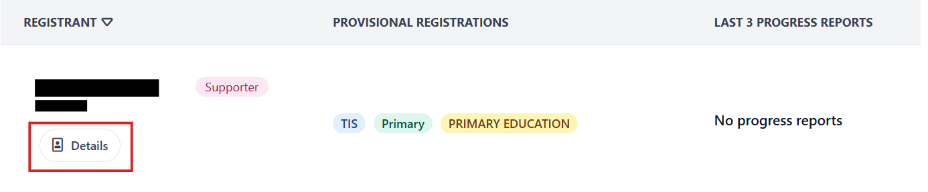
- In their profile, scroll to the ‘Meeting the Standard for Full Registration’ dropdown. In here, you will be able to view any key strengths or areas for development they have previously added.
- To add any more, select either the ‘Add a key strength’ or ‘Add an area for development’ button.
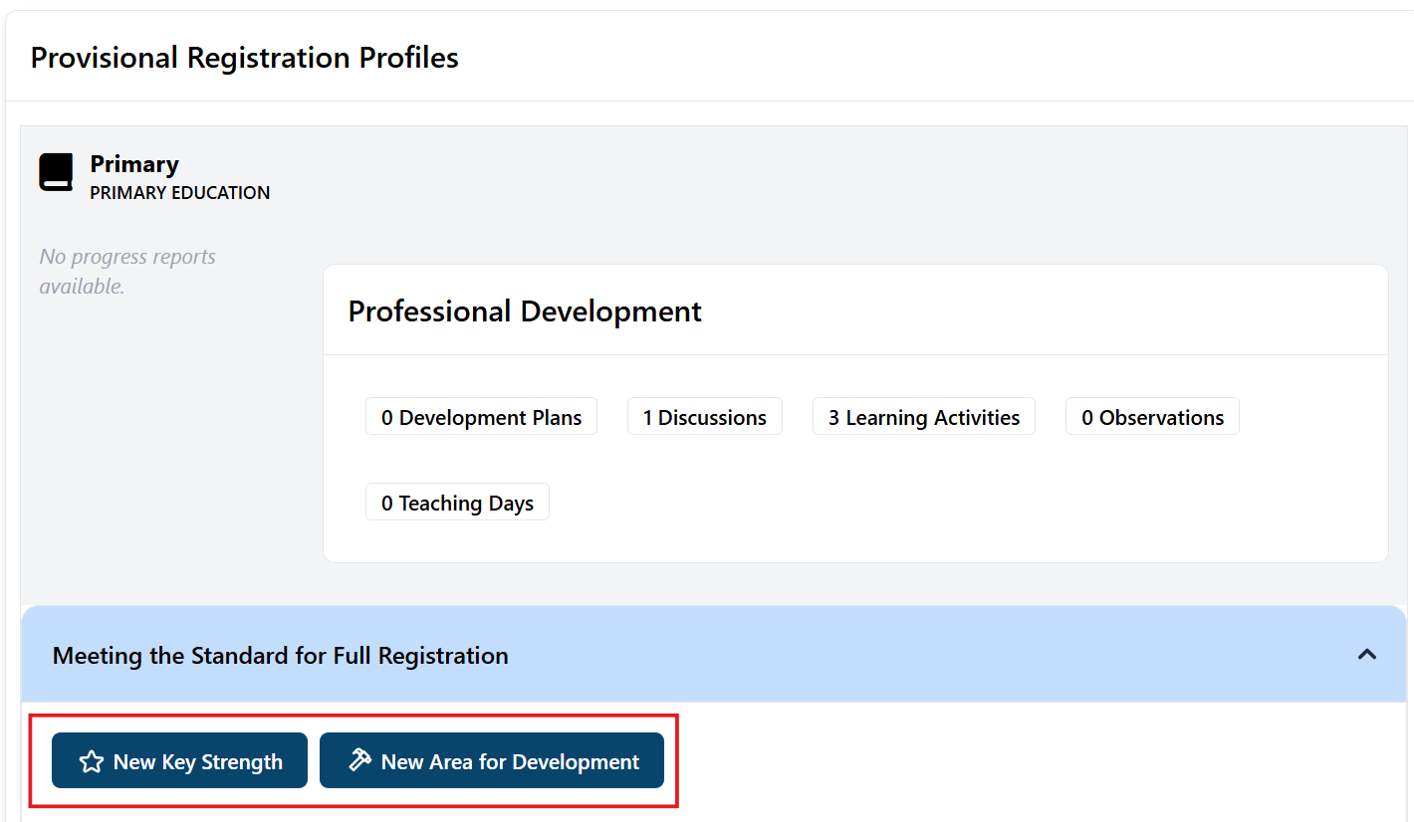

Providing feedback on records
As a supporter, PRTs may ask you to provide feedback for:
- Learning activities
- Observations
Please note, you do not need to sign-off or record professional discussions with PRTs, but you are able to view any logged by the PRT once you have an association with them. It’s the responsibility of PRTs to record professional discussions.
When a provisionally registered teacher submits a record to you for feedback, you will receive notification in MyGTCS.
You can provide feedback on this individual record by either clicking on the notification or by going to Associations – Shared Records in the navigation bar.
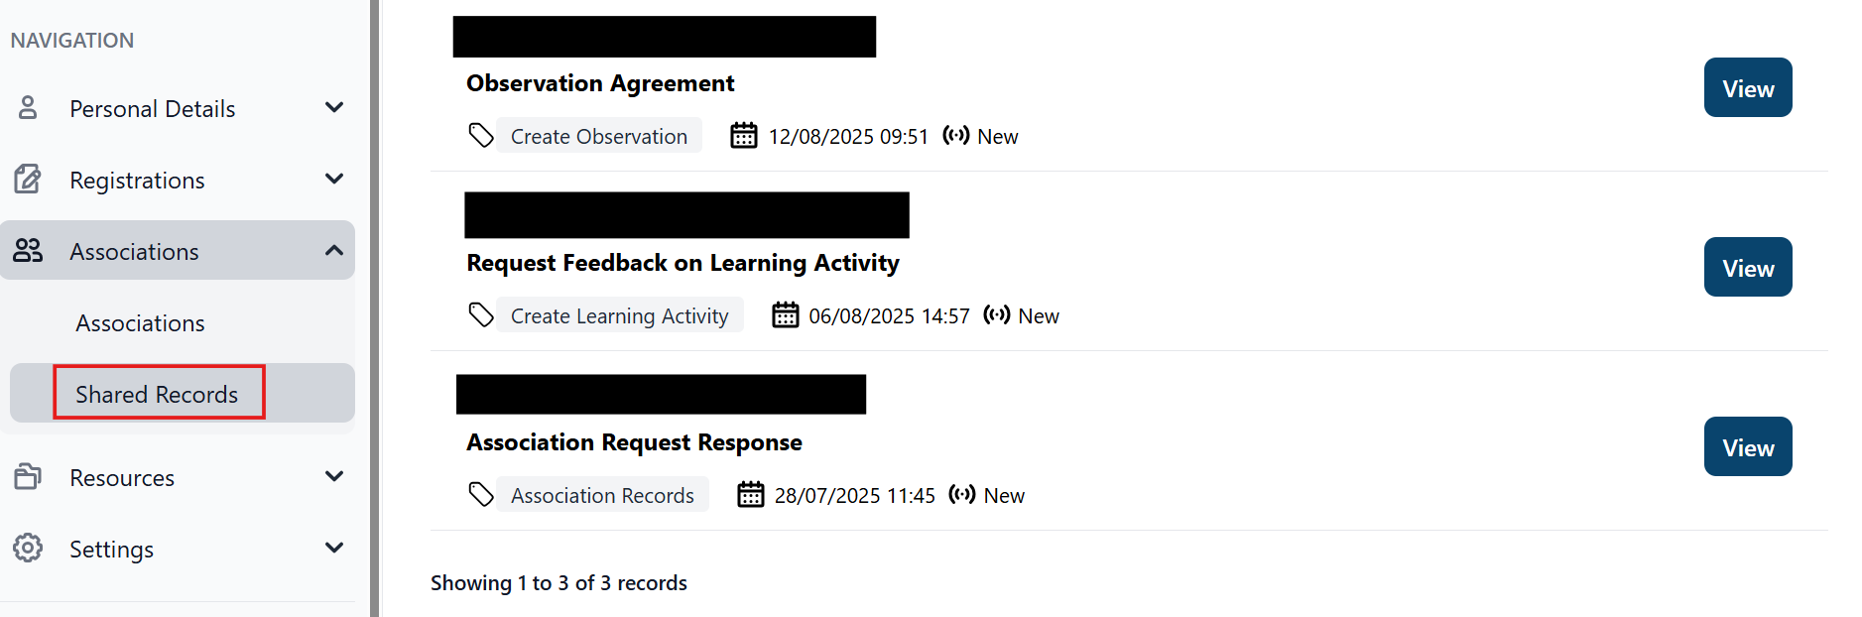
Here you will be able to view any information sent to you from the PRT and submit your feedback. Once you have submitted your feedback, the PRT will receive notification that this is ready to review.
Please note, PRTs s can also revoke this request for feedback at any point.

Progress reports
PRTs can request a progress report on a teaching block at any point they wish to. They can send the request for a progress report directly to the reviewer or they can first request a statement from a supporter.
Please note, once a PRT has received a progress report for a particular teaching block, it is no longer editable – only viewable.

Supporter statements
If you receive notification that one of your PRTs has requested a supporter statement as part of a progress report, you can provide this statement by either clicking on the notification or by going to Associations – Shared Records in the navigation bar.
From there, you can review the teaching block which has been submitted and either choose to accept or decline the request for a supporter statement.
Once you have provided your supporter statement and have selected to ‘Submit’, the progress report, along with your statement, will then be forwarded on to the reviewer. The reviewer then has the option to assess the PRT’s progress as either:
- Satisfactory
- Unsatisfactory
- Cause for concern
The Reviewer will make their decision and send the progress report back to the PRT, who will then receive a notification and can view both supporter and reviewer’s feedback.

What to include in a supporter statement
Your statement should reflect on the PRT’s overall progress. We recommend you use the 3 areas of the Standard for Full Registration to help structure your comments:
- Being a teacher in Scotland
- Professional knowledge and understanding
- Professional skills and abilities

