**Renaissance Orthopaedics**

**and The Bone and Joint Center**

**at UPMC Magee-Womens Hospital**

300 Halket Street Pittsburgh, PA 15213

Dr. Noelle DiGioia Guthrie

Dr. Tony DiGioia

P: 412-683-7272, F: 412-683-0341

**Hula Exercises**

Want to speed the evening out process after your total hip replacement?

Try to “hula” your way there.

Hula exercises stretch your muscles around the hip and may help you to feel more balanced.

**Here’s how:**

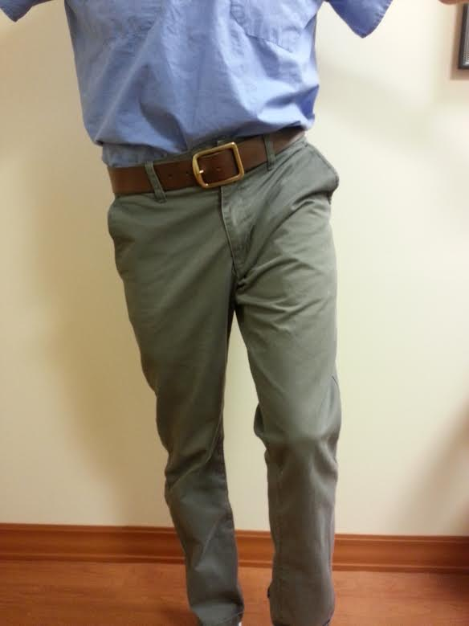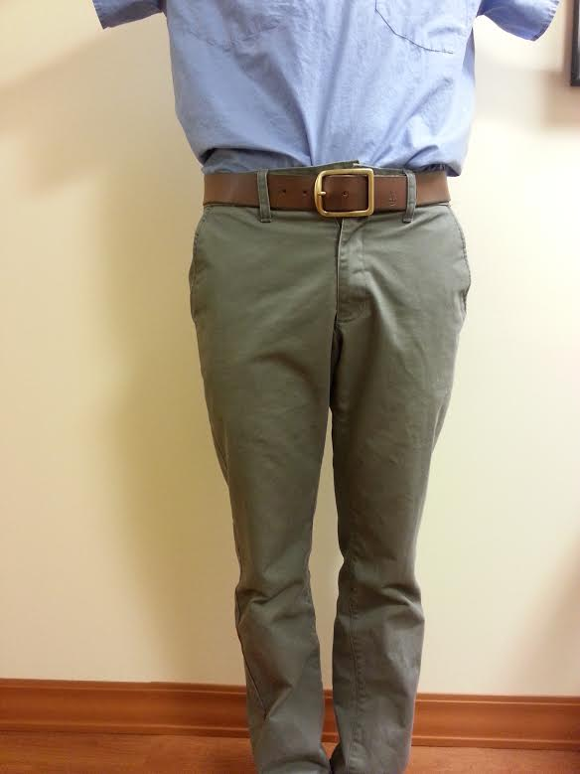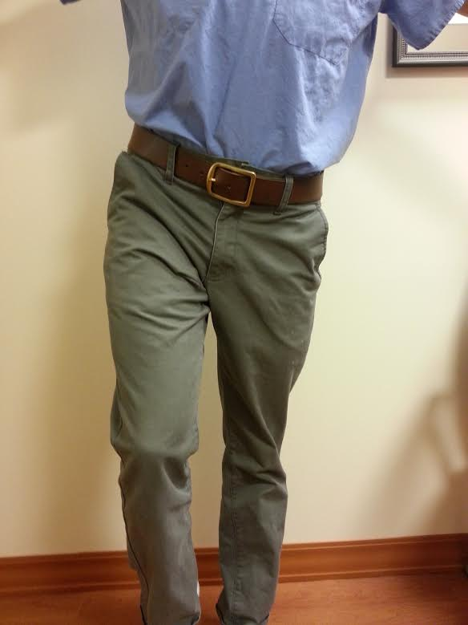

**Left leg down Rest position Right leg down**

While lying down, keep your knees straight, and push one leg down towards the end of the bed/table while drawing the other leg back.

Your pelvis will move as if you are doing the hula dance.

Hold each stretch for 2 seconds and relax. Complete 10 repetitions for each leg.

Exercising both legs will help you to feel more balanced.