PRE-TESTING

EDUCATION PACKET

Bone and Joint Center phone number:

412-641-8609

Renaissance Orthopaedics phone number:

412-683-7272

**Contents**

**Pre-testing Appointment at Bone and Joint Center (page 5)**

* Checklist – what to bring and complete before coming to your appointment
* Vaccine and Dental information
* When to call the doctor before surgery?

**Before your surgery (page 6-9)**

* How to prevent infection before surgery
* Bathing before surgery: Hibiclens body wash
* Mupirocin (nasal ointment) Ointment Instructions
* Pre-Surgery Daily checklist and Flomax (for male patients only)

**Day of surgery to Hospital discharge (page 10-13)**

* What must I do on the day of surgery?
* What to bring to the hospital?
* In your hospital room and going home

Pre-testing appointment

To prepare for your pre-testing appointment, please be sure to do the following:

|  |  |
| --- | --- |
| Checkmark with solid fill | Checklist |
|  | Complete **Pre-op questionnaire** and BRING to your appointment. |
|  | Complete **Joint replacement survey** and BRING to your appointment. |
|  | **Bring all PRESCRIPTION medication bottles** with you on the day of your pre-testing appointment.  You do NOT need to bring supplements or vitamins. |
|  | Bring your insurance card and Photo ID |

**Vaccine and Dental Information**

You should NOT receive vaccines 2 weeks before or 2 weeks after your surgery.

No dental work 4 weeks before or 4 weeks after your surgery.



**When to call the Bone and Joint Center**

**before your surgery?**

**Call us if…**

1. You are prescribed any new medications between your Pre-testing appointment and your surgery date.
2. If you have a recent Emergency Department visit
3. If you have any new medical problems
4. If you have an emergent/ urgent surgery

Before your surgery

**How to prevent infection before surgery**

Preventing infection is an important part of your surgical process. You will be prescribed Hibiclens soap to use 5 days prior to surgery on your body.

* **Hibiclens bottle will be given to you at your pre-testing appointment.**

|  |  |
| --- | --- |
| **Bathing before surgery**  **How to apply the Hibiclens (4% CHG) body soap:**   1. Wash and rinse your hair and body with your normal soap and shampoo. 2. Pump the Hibiclens soap on a clean, wet washcloth. Apply to your entire body from the neck down. **DO NOT apply to your face, hair, or genital areas.** 3. Gently rub the soap onto your body for three minutes, then rinse thoroughly. 4. Dry yourself with a clean towel and dress in clean clothes after each cleansing. | [Image result for hibiclens picture](https://www.google.com/url?sa=i&rct=j&q=&esrc=s&source=images&cd=&cad=rja&uact=8&ved=2ahUKEwiQorCL7LPhAhWvSt8KHSHSBfEQjRx6BAgBEAU&url=https://www.walmart.com/ip/Hibiclens-Skin-Cleanser-32-oz/48683583&psig=AOvVaw3lCk4ebTU0fvXqx2_nTutH&ust=1554378171187687)**A white bottle with green label  AI-generated content may be incorrect.** |

**Hibiclens Soap Instructions:**

* Follow the above steps for five days prior to surgery, as well as the morning of surgery.
* While using Hibiclens, do not apply lotions (lotion is okay to use on face, hands, and feet), powders, or perfumes to your body. Deodorant is okay to use. If you have eczema or psoriasis, you may continue to use your medicated creams.
* Should you develop any kind of allergic reaction, stop using the Hibiclens and use an antimicrobial soap instead (such as Dial).
* DO NOT SHAVE the area that will be operated on while you are using the soap. Doing so may irritate your skin. The pre-op nurse will shave the operative site, if necessary, on the morning of surgery.

HELPING TO REDUCE THE RISK OF SURGICAL SITE INFECTION

*What’s in My Nose??*

*Staphylococcus* is a family of bacteria commonly found on the skin and other warm, moist areas of all people. There are many kinds of “staph” bacteria, but the one that causes the most problems is called *Staphylococcus aureus.* Because we want to do everything that we can to prevent infection, we will be prescribing an antibiotic nasal ointment called Mupirocin. This will get rid of the bacteria in your nose.

* **Mupirocin will be called into your pharmacy; it is a prescription.**

|  |  |
| --- | --- |
| **How to Apply the Mupirocin (nasal ointment) Ointment**   1. Wash your hands. Place a pea-size amount of ointment on a cotton applicator. 2. Insert the cotton applicator about ¼ of an inch into the nostril and rotate swab. 3. Close the nostril with your finger and massage the area to spread the ointment. Throw the used cotton applicator in the trash. 4. Get a new cotton applicator and repeat the directions on the other nostril and dispose of the cotton applicator. Wash your hands. |  |

**Mupirocin (nasal ointment) Ointment Instructions:**

* Start the first dose of the medication in the evening 5 days before your surgery. Use the ointment twice a day for 4 days. Apply it once in the morning and once in the evening. The last dose of the medication should be applied the morning of surgery.
* 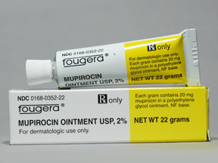If your surgery is rescheduled, please start the new schedule 5 days from your new surgery date.
* The instructions may say not to apply to the nose but please disregard these directions.
* If you have an allergy to Mupirocin, please notify the office.

Pre-Surgery Daily Checklist

Please **initial or check each day** as a reminder to yourself to complete the protocols below:

|  |  |  |  |
| --- | --- | --- | --- |
|  | [Image result for hibiclens picture](https://www.google.com/url?sa=i&rct=j&q=&esrc=s&source=images&cd=&cad=rja&uact=8&ved=2ahUKEwiQorCL7LPhAhWvSt8KHSHSBfEQjRx6BAgBEAU&url=https://www.walmart.com/ip/Hibiclens-Skin-Cleanser-32-oz/48683583&psig=AOvVaw3lCk4ebTU0fvXqx2_nTutH&ust=1554378171187687)Hibiclens body wash | Mupirocin nasal  ointment C:\Users\bartonka\Pictures\Mupirocin ointment.JPG | **For Male Patients:**  **FLOMAX medication** |
| 5 days before surgery  **Date: _____________** | Wash daily ____ | **Apply one dose in PM ____** | Take one pill in the **evening ____** |
| 4 days before surgery  **Date: _____________** | Wash daily ____ | **Apply one dose in AM ____**  **Apply one dose in PM ____** | Take one pill in the **evening ____** |
| 3 days before surgery  **Date: _____________** | Wash daily ____ | **Apply one dose in AM ____**  **Apply one dose in PM ____** | Take one pill in the **evening ____** |
| 2 days before surgery  **Date: _____________** | Wash daily____ | **Apply one dose in AM ____**  **Apply one dose in PM ____** | Take one pill in the **evening ____** |
| 1 day before surgery  **Date: _____________** | Wash daily ____ | **Apply one dose in AM ____**  **Apply one dose in PM ____** | Take one pill in the **evening ____** |
| **Surgery day**  **Date: _____________** | Wash morning of surgery ____ | **Apply one dose in AM ____** |  |

**Flomax medication**: this is prescribed for male patients to assist with decreasing urinary symptoms due to anesthesia, Flomax will help relax smooth muscle of the bladder to help male patients urinate after surgery and decrease a need for urinary catheterization after surgery.

Day of your surgery

**What must I do on the day of surgery?**

**At home**

**There are several things you need to do at home before you come in for surgery.**

* You will receive a phone call from a discharge plan manager 1-2 days prior to your surgery.
* You will receive your pre-op phone call the day before surgery, or the Friday before surgery if you are scheduled on a Monday. The phone call will come between 8am and 1pm. We must speak with you during this time. **We are unable to leave a message** with your instructions so please plan to be able to answer the phone. **If you miss our call, please call us back by 1pm**.
* You can purchase oral rehydrating drinks such as Gatorade, G2 Gatorade (for diabetic patients), Pedialyte, Propel (**NO** Red flavors). This, as well as water, will help to hydrate you for surgery. The best time to drink is before you go to bed the night before surgery, or in the morning of surgery.
  + - No caffeine, no vitamin water and no carbonated beverages
* On the day of surgery, you will be permitted to drink **ONLY** oral rehydrating drinks such as Gatorade, G2 Gatorade, Pedialyte, Propel (**NO** Red flavors) and water up until **2** hours prior to your **ARRIVAL** time. Not following these instructions could lead to the cancellation of your surgery.
  + - Example: if your surgery **arrival time is 7am**, you should **stop drinking at 5am.**
* Stop eating, drinking, and chewing gum before surgery as instructed.
* Take only the medicines your doctor instructed you to take with a small sip of water.
* Shower as instructed – do not use deodorant, powders, perfume, lotion, hair spray or make up.
* Remove all jewelry including body piercings
* Remove all nail polish
* Do not wear contact lenses on the day of surgery
* Wear comfortable clothing that is easy to put on and take off
* Bring the items below to the hospital
  + Bring the pink medication sheet from your Pre-Testing appointment
  + Driver’s license or other identification
  + Insurance card
* If you plan to spend the night in the hospital, also bring:
  + Hearing aids and case with your name
  + Cell phone and charger (with extra-long cord if you have one)
  + Underwear and bra
  + Personal toiletries if you wish (toothbrush, toothpaste, deodorant)
  + Glasses and case with your name
  + Dentures
  + Loose fitting clothing for therapy (shorts, sweatpants, pants) no yoga pants or leggings they may not fit over your surgical dressing
  + Athletic shoes/ Comfortable shoes that have a back (no slip-ons or heels)
  + CPAP machine, BIPAP device, or oral appliance. Unplug your device at home, empty any remaining water from the humidifier chamber, bring your power cord, tubing and MASK

**In hospital**

* You can have 2 people accompany you to pre-op area.
* You can bring your overnight bag into the hospital with you if you are staying one night.
* The morning of surgery you will go to Surgical Services. To get there, go through the front entrance at Magee. Take the elevators in the main lobby to the third floor. As you walk out of the elevators, make a sharp left. Surgical Services is down the hallway on the right.
* You will see your surgeon and he/she will mark the area to be operated on.
* You will also meet with your anesthesiologist who will explain spinal anesthesia and sedation. If necessary, a foley catheter will be placed in the operating room once you are asleep.
* When it is time for surgery you will be taken to the OR by a member of your anesthesia team. Your family will then be directed to the 4100 Bone and Joint Center Family Room to wait for a phone call from your surgeon.
* Surgery will take approximately 1-2 hours. Following surgery, you will be taken to the Recovery Room where you will be for approximately 2-3 hours.

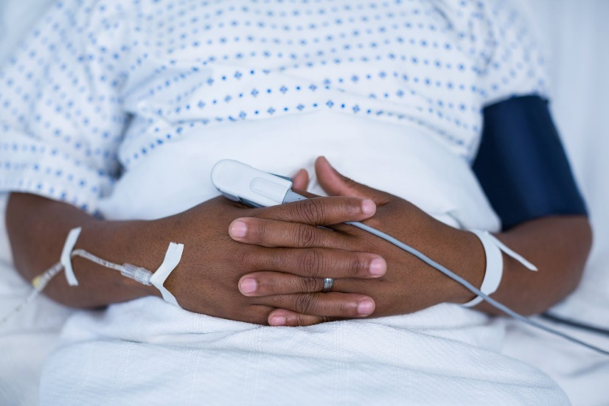

**After your surgery**

**In your hospital room**

* After your stay in the Recovery Room, you will be taken to your room on the 4100 Bone and Joint Center (orthopaedic) Unit. Upon arrival you will meet your nurse who will assess your pain level, check your operative dressing and monitor your vital signs.
* You will start with a clear liquid diet. When you tolerate that, you will resume the diet you
  + followed before surgery.
* Your physical therapist will complete an initial evaluation that includes your gym schedule, goals and introduction to exercises. You then will have your first therapy session. At the end of the session, you will be encouraged to sit in a chair for as long as you would like.
* Your Bone and Joint Center Care Team will see you to monitor your progress.
* You will participate in Physical Therapy while you are in the hospital.
* Ask for pain medication if you are in pain and be sure to take your pain medication at least 1 hour before physical therapy.
* You will be able to wear regular clothes, please bring loose comfortable clothing and a good pair of comfortable walking shoes.
* For Total Knee Replacement patients, you will be using a Continuous Passive Motion (CPM) Machine. You will receive a phone call 5-7 days prior to your surgery date. The CPM machine will be delivered to your house.
* Your length of stay in the hospital is dependent on your progress with your physical therapy.

**Going home**

* You will need someone to drive you home and we recommend someone stay with you for the first 48 hours after discharge.
* Home physical therapy will start one to two days after being discharged from the hospital. You will have Home Physical Therapy for one to two weeks and then go to Outpatient physical therapy a few times a week for several weeks.