Person First Language

What is the purpose of a person-first language?
The goal of person-first language—to avoid language that dehumanizes or stigmatizes people—is a worthy one.

What is person-first language in recovery?
Person-first language maintains the integrity of individuals as whole human beings—by removing language that equates people to their condition or has negative connotations. For example, “person with a substance use disorder” has a neutral tone and distinguishes the person from his or her diagnosis.

What are examples of person-first language?
Person-first language places the focus on the person, not the disability. For example, “an individual with epilepsy” is a person-focused phrase, while “an epileptic person” is disability- focused. This shift in language eliminates labeling and instead helps us view individuals with disabilities with respect.

What is an example of person-first language in mental health?
As such, person-first language places emphasis on the person first rather than the disability (e.g., "person with schizophrenia" rather than "a schizophrenic").

Person-first language conveys respect and acceptance by emphasizing the fact that people with behavioral, psychological, or substance use disorders are first and foremost just that: people.

In short: it’s people first, it’s not the problem first. When we use a person-first language, we put the emphasis on a person, but not their diagnosis, condition, or challenge.

Terms like “user,” “junkie”, “addict”, “crackhead” are demeaning and disrespectful. But when you refer to a “person in recovery from substance use” or “a person with depression”, that can make a big difference in reducing stigma about the disease of addiction or mental health challenges.

There are also other terms that can be adjusted. If a person is being drug tested, they are not “clean” or “dirty.” They either tested negative or positive. When it comes to mental health, perhaps rethink the everyday use of “crazy” or “psycho” because both perpetuate stigma.

On occasion, we may be in a situation where we hear a person with substance use refer to themself as an “addict” or a “junkie.” That is their personal choice. How that person chooses to self-identify is up to them but that does not give us permission to use that same language.

One of the most common reasons people don’t seek treatment for mental health challenges or substance use is stigma or shame. It affects workers who fear losing their jobs or being treated differently by colleagues. It affects teens and college students who don’t want to appear “different” from their friends.

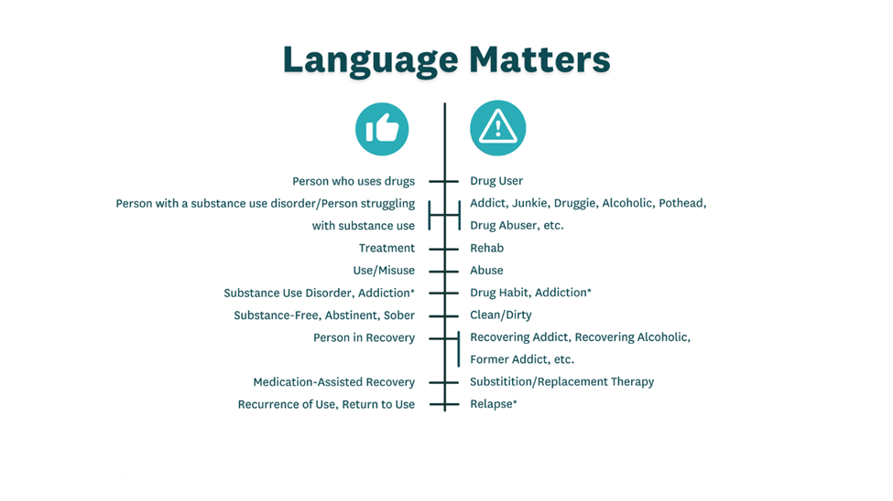
Put Lessons into Action

In addition to using person-first language, there are other ways you can help yourself, family, and friends by understanding what contributes to stigma.

- Be conscious of your language — person-first language, not problem or issue-first.
- If we are in a situation where we don’t know what the appropriate person-first language is to use, simply ask.
- Seek reliable and factual information to learn more about substance use disorders and/or mental health.
- If you have a family member or friend managing an often-stigmatized health challenge, find support in your community for yourself and for them.
- See the person, not the illness or disorder. Every person is so much more than the challenges they experience.
- Demonstrate empathy and compassion when others share their personal story with you about their challenges. Ask questions, but please don’t pry.

