|  |  |  |  |
| --- | --- | --- | --- |
|  | **Form 330-2** | | |
|  | **Duty to Report Confirmation – to be completed after call** | | |
|  | Box 700, Rosetown, Sask., S0L 2V0  Phone: (306) 882-2677 Fax: (306) 882-3366  Toll Free: 1(866) 375-2677, www.sunwestsd.ca | **Reference** | **AP 330 Protective Services Reporting of Child Abuse** |
| **Revised** | **February 19, 2025** |
| **Level** | **School and Student Services** |
| **Submit to** | **Superintendent of Student Support Services**  **Supervisor of Mental Health** |
| **When** | **As Required** |

**Once you have made your call to report to Child and Family Services we would like you to complete tis form. It will be kept confidentially at the division office. Please do not print this or reproduce it.**

**If you are concerned a child may be at risk of abuse, immediately contact the Ministry of Social Services at:**

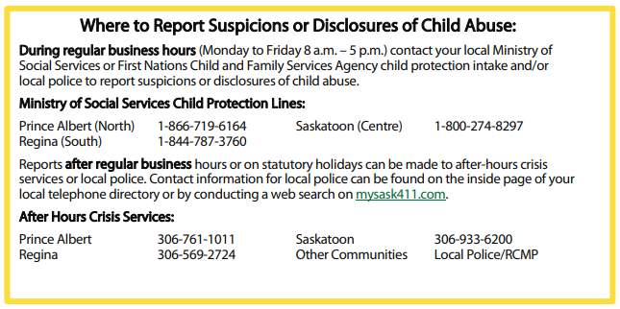

**Remember that you are still required to personally document the encounter, situation or scenario as objectively and professionally as possible.**

**Please remember if you have not already, inform your School Based Administrator that you have made this call.**

**Should you have any questions please connect with your school administration or the Supervisor of Mental Health.**

**The form can be found at this link -** [**https://forms.office.com/r/JcsCTHjb95**](https://forms.office.com/r/JcsCTHjb95)