Form 371-1
Student Placement & Retention Plan
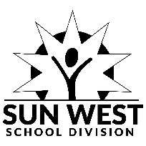 | Adopted: January 7, 2025
External References:
Ministry of Social Services - Child Abuse and Neglect https://publications.saskatchewan.ca/api/v1/products/12574/formats/18812/download
Internal References:
- AP 371
Student: |  |  | Birthdate:
Grade: | Age: | School: | Final Plan Date:
Team Members and Role:
Background and Assessment Results:
- Relevant Background Information

- Results of Formalized Assessment/Reports

- Results of Informal Assessment and Observations

Final Placement Decision and Reasoning:
Plan moving forward for support next school year:
Follow Up Communication/Action Plan:

