Form 110-3
School Learning Improvement Action Plan
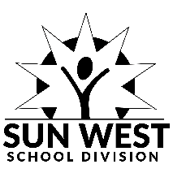 | Box 700, Rosetown, Sask., S0L 2V0  Phone: (306) 882-2677 Fax: (306) 882-3366  Toll Free: 1(866) 375-2677, www.sunwestsd.ca | Reference | AP 110 Learning Improvement
 |  | Revised | August 25, 2025
 |  | Level | Division
 |  | Submit to | Upload to School Based Admin Group
 |  | When | September 30th or Update as Necessary

School Name
Date

Steps should be included in the Action Plan.
This is a living document and may be updated throughout the year as necessary.
To be uploaded to the School Based Administrator Team by September 30th.

 | Date | School  Topic/Activity
 | August 25, 26, 27, 28, 29, 2025
 | October 14, 2025 | EA PD Day
 | November 28, 2025 | School Admin Assist/Librarian PD
 | January 30, 2026
 | March 13, 2026
 | June 26, 29, 30 2026

 | Date | Colony School  Topic/Activity
 | August 25, 26, 27, 28, 29, 2025
 | October 23 and 24, 2025 | SHEA
 | January 6, 2026 | PD/Meeting @ Rosetown Learning Centre
 | May 14, 2026 | In-School PD/meeting
 | May 25, 2026 | In-School PD/Meeting
 | June 29, 2026

