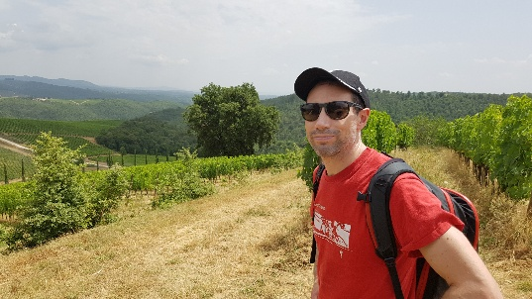
Exploring the Mechanisms and Pathways Contributing to Dementia in Parkinson’s Disease
Steve is a PhD student at the UCL Queen Square Institute of Neurology researching dementia in Parkinson’s disease.
Why the Project is Important
While Parkinson’s is often associated with motor symptoms, such as tremor and problems with movement, it is often the cognitive symptoms, such as difficulties with memory and concentration, which have the greater impact on the quality of life of patients and their families. Approximately 50% of Parkinson’s patients go on to develop dementia within 10 years from their Parkinson’s diagnosis, however the factors which predict whether patients are likely to develop dementia or not are currently poorly understood. Studying the biological structures and processes in the brain, which are affected in Parkinson’s patients who go on to get dementia is an important step in developing better treatments for the cognitive symptoms.
How the Project Will be Conducted
The project will have two stages, one based upon data from human participants and one laboratory based.
- The first stage will involve using a large dataset including demographic, lifestyle, brain imaging and biological data from Parkinson’s patients to identify factors which are associated with dementia.
- The second stage of the project is laboratory based. It will explore further the brain circuits identified in the first stage of the project, using human stem cells and animal models to study the biological mechanisms which lead these circuits to break down in Parkinson’s patients.
The Role of the Lived Experience Advisor
I am hoping to recruit a Lived Experience Advisor (LEA) to join my PhD thesis committee, to support me in this project, sharing your opinions and ideas based upon your experience. We will be joined on the committee by three academics with experience of dementia research covering both the mathematical and laboratory-based techniques which will be used. The committee will meet a minimum of five times over three years.
How can you help?
To be consistent with the theme of the project, I would welcome applications from people aged 50 or above and with a Parkinson’s diagnosis. No previous experience of scientific research is required. However you will be expected to read project updates, which I will send in advance of each meeting and be comfortable working collaboratively with the rest of the committee to guide the progress of the PhD.
How to apply
If you are interested in applying or have any questions, please send an email to steven.allsopp.24@ucl.ac.uk with a couple of paragraphs giving some background on why you are interested in the role and how you would like to contribute to the committee.
Based on the number of interests I receive, I will shortlist around 5-6 applications and schedule a brief chat online with you to check our fit to work together. After this, we will invite final applicants to be the Lived Experience Advisors for this project.

Payment
Payment of £25/hour is available for Lived Experienced Advisors, if you want to claim it. This will include 1 hour preparation time for each meeting (e.g. for reading reports), so total payment of £50 per meeting. Meetings will typically be online.
Deadline for applications
17:00 (UK Time) on Monday 5 January 2026

