CARMAN FAIR – DIRT BIKE/QUAD BARREL RACING

PLEASE READ CAREFULLY. WARNING: BY SIGNING THIS, YOU GIVE UP THE
RIGHT TO SUE. WAIVER OF LIABILITY AND ASSUMPTION OF RISK AGREEMENT:
I/WE DO UNDERSTAND and acknowledge that there are particular hazards and risks which are directly or indirectly related to this Dirt Bike/Quad Barrel Racing Event and /or which are either associated with this Dirt Bike/Quad Barrel Racing event and/or are inherent in their nature.
I/WE DO UNDERSTAND and acknowledge that I/my child, may sustain personal, bodily injury and may sustain property loss or damage through my participation in this Dirt Bike/Quad Barrel Racing event.
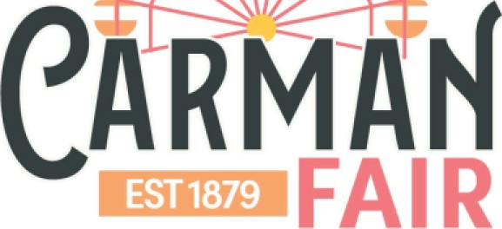
I/WE DO UNDERSTAND the risks and dangers involved in this Dirt Bike/Quad Barrel Racing event and willingly and voluntarily assume them at my/my child’s own risk.
I/WE DO UNDERSTAND that by signing this agreement, I give up my right to sue and I release the DUFFERIN AGRICULTURAL SOCIETY and all sponsors of the Dirt Bike/Quad Barrel Racing event from any claims, costs, causes of action or personal injuries that may arise out of my/my child’s involvement in this Dirt Bike/Quad Barrel Racing event.

I/WE also agree that photos taken of me at the Carman Fair can be used for social media, marketing, or promotional purposes.

THE TERMS OF this agreement shall be binding upon me, my heirs and personal

representatives.

For participants under 18, parental/guardian consent is necessary. Please read the above waiver and sign that you have read, understand and agree to the waiver and that your child _____________________________ may participate in the Dirt Bike/Quad Barrel Racing event.

Parent/Guardian Name ____________________________________

Parent/Guardian Signature _________________________________

Participant Name _________________________________________

Participant Signature ______________________________________

