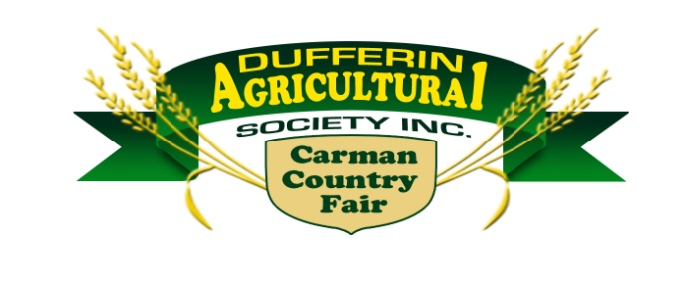

CARMAN COUNTRY FAIR MOTOR SPORTS

GUIDELINES FOR CARS/TRUCKS

These are the guidelines in no particular order; please abide by them or your car may be disqualified.

- Your car number must be shown on the top right-hand corner of the entry form. This number must be displayed on the left, right and top of the car. ANY NUMBER MAY BE CHOSEN AS YOUR NUMBER. In the event of duplication in numbers on cars, the entry received first will retain the original number. The duplicated number may be changed or altered as necessary.

- Any stock North American made, hardtop automobile, or station wagon is allowed.
- Truck Class;
  - Two wheeled drive truck preferred.
  - Four wheel drive truck allowed with front driveshaft removed.
  - ¾ Ton chassis allowed.
  - Reinforcement restrictions are the same as the cars.
  - Crossbar is allowed behind the seat;
    - Any crossbar installed MUST NOT be bolted through to the frame.

- All glass, including head and tail lights, must be removed with the exception of the windshield which may be left in at the driver’s discretion. Auto must be swept out clean.
  - If a windshield is removed, half the area (minimum) must be covered with expanded metal screen.
  - The driver’s window must be covered with mesh or netting (seat belt type).
  - “Chicken wire” NOT ALLOWED.

- Gas tanks must be mounted inside car, behind the driver, over or ahead of the rear axle, but will not be permitted in the front seat. Gas tanks must be fastened securely. NO TARP STRAPS. In case of trucks, fuel tank must be mounted inside box directly behind cab between frame rails. A rubber floor mat or like material must cover the tank.

- Cars equipped with fuel injection will be allowed to use the factory fuel tank and fuel supply system. Fuel lines must be routed securely and may need to be routed under the car for safety reasons (high pressure fuel pump). Above rule for securement & cover applies.

- One or two (1 or 2) 12 volt automobile battery will be allowed in each car and must be covered and secured. NO TARP STRAPS.

- No special bumpers or any reinforcements will be allowed. No trailer hitches permitted.

- Roll bars are allowed but not necessary.

- Driver’s door must be painted white and show the car number. Driver’s door to be reinforced with a metal bar or filled with sand. Door can be black if the car is white, with white numbering.

- All doors must be fastened shut by chains, bolts or 20% welded.

- No altered suspension – No reinforcing or welding. Suspensions must be stock and free from blocks; must have free travel with minimal pressure.

- Cutting fenders for wheel clearance is permitted

- Hood and trunk lids must be operable. They may be chained, with limited amount of chain.

  - Bolts are allowed; NO REINFORCEMENT please.

- Vehicles must have brakes before the beginning of heat.

- A factory type / passenger car rear axle assembly must be in the car.

- Rear axle assemblies from a truck / 8 Bolt Hub / are not allowed in a car.

- No junk tires, wheels, metal parts, etc. allowed in cars. CARS MUST BE CLEAN AND ALL CHROME REMOVED.

- Tires – DOT Automotive tires only. No AG or forklift tires. No extra weight added to cars or tires.

- No moving of radiators, no extra water storage tanks or radiator inside car. With the exception of transmission coolers, a factory trans cooler can be installed be behind the driver seat following the same conditions as rule 5 (fuel tanks).
  - There is potential for driver injury / burns.

- A hole, one foot by one foot, must be cut in the hood above the engine.

- Safety belts and helmets are mandatory

- A hole must be cut in the roof to pass a flag through.

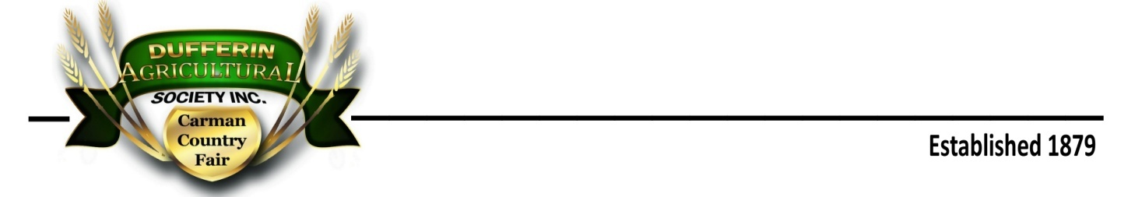

Carman Country Fair Demolition Derby
General Rules & Regulations

In the interest of safety anyone entering is subject to, and must obey the following rules and regulations, which are set up by the promoter and the track where this event is being held.

- a. Each driver must fill out an entry form and sign a liability waiver, which must be mailed, emailed, or dropped off to the DAS Office by the deadline on the entry form.

b. Entry fees, payable at the DAS Office, will be accepted until 4 p.m. Wednesday prior to the fair. If an entry must be cancelled, fees will be refunded providing the DAS office (745-2226) is notified prior to noon on Saturday.

- The track (DAS) or promoter (CDFD) reserves the right to approve or reject any and all entries.

- Only the driver and two pit crew members who sign the WAIVER FORM will be permitted in the pit area. No horseplay or drinking in the pit area.

- ABSOLUTELY NO DRINKING OF ALCOHOL ON THE TRACK OR IN THE PIT AREA. Violators will be removed and their team disqualified.

- All cars will be inspected before the demo. At the discretion of DAS / CDFD winning cars may be inspected at any point during the competition. Any reinforced cars will be disqualified.

- Cars must be in the pit area by 12:00 noon for inspection.

- Drivers, male, or female must be 18 or older. Use of the DAS Release Form will be at the discretion of the DAS / CDFD. No others under the age of 18 will be allowed in the pit area.

- Vehicles may be subject to a re-inspection at any time, including prior to prize payouts.

  - Any protest is subject to a $50 fee / cash in hand at time of protest.
  - Only the driver may enter a protest.
  - Only the driver and Officials will be involved in the protest resolution.
  - If Officials rule in favour of the driver, the fee will be refunded.
    - A ruling against the driver results in loss of the fee.

- Any driver, pit crewmember, or person found not obeying the rules and regulations will cause disqualification of the car and team. NO REFUND.

- Drivers must carry two flags: one white and one red. These flags will be supplied when you sign in.
WHITE FLAG- Out of Demolition RED FLAG – Stop Demolition

- Drivers may maneuver forward or backward. NO DELIBERATE HITTING ON THE DRIVER’S DOOR. DELIBERATE HITS WILL RESULT IN IMMEDIATE DISQUALIFICATION. N0 REFUND.

- The judges will announce and enforce a time limit of one minute for car hits. If a driver does not hit another live car within the limit, he or she may be disqualified from the heat. Playing “possum” will lead to disqualification.

- Pit boundaries must be observed and will be enforced.
  - Vehicles unable to get off the berm will not be removed until the heat is complete.

- Any car catching fire twice is automatically disqualified from the heat if unable to start and continue within one minute.

- If a car catches fire, all other cars must stop.

- The LAST CAR MOVING will be awarded the heat, not the last hit.

- Remaining TWO (2) cars from the individual heats are allowed in the “feature heat” depending on entries is what will determine the final.

- All entries shall be in the demo pit before the beginning of all heats.

- Drivers must proceed with caution at all times, or risk being disqualified.

- ALL DRIVERS / TEAMS WILL RESPECT THE PROPERTY USED FOR THE DEMO DERBY. DELIBERATE DAMAGE TO THE GROUNDS, FENCING, ETC. WILL RESULT IN IMMEDIATE DISQUALIFICATION. NO REFUND

- NO GANGING UP. The derby committee (DAS / CDFD) reserves the right to make a judgment call. Do not avoid making a hit on a teammate / participant as means of eliminating a chosen car. “Holding” a car until a teammate / participant is in a position to hit it will result in a stoppage and possible disqualification. Any discussion on the matter will be held at the drivers meeting prior to the start of the derby. The matter may result in ongoing discussion if deemed necessary.

- The premise of the Demolition Derby is one of fan appeal and entertainment. The fans expect a fast-paced derby and vehicle demolition; please observe rules # 11 and # 20.

- For safety and crowd control, NO FAMILIES OR EXTRA HELP in the pit area. Your co-operation would be greatly appreciated.

- All cars and associated debris / parts must be removed from the grounds within 3 hours after the demo derby or cars will become the property of the promoter. The Grounds are to be left in the same condition as entered.

- Any abuse perceived or actual, of officials (DAS / CDFD), DAS staff will not be tolerated. Any occurrences will be reviewed by officials and decisions rendered. Driver / team will risk forfeiture of the entry fee and any forthcoming prizes and prize monies. Future participation in any DAS event will also be at risk.

- All decisions of the Demo Derby committee (DAS / CDFD) are final.

DAS Motorsports Committee
Carman Dufferin Fire Department

.

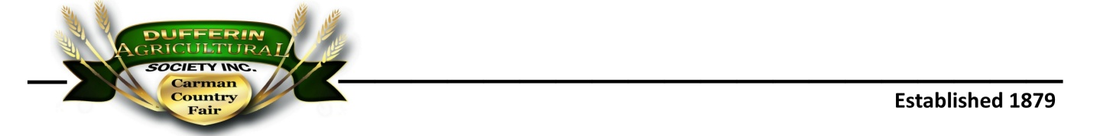

Carman Fair Demolition Derby Checklist

Number on car

All Glass Removed (Windshield Optional) If the windshield is removed a heavy screen must be installed in front of the driver – ½ width of the opening
- Heavy screen on Drivers Door Window – a seatbelt “mesh” will also be allowed
- Gas Tank Removed or ahead of rear axle behind front seat.
- fastened securely – no bungee cords or tarp straps
- Electric fuel pumps are allowed but must have a separate power switch that is clearly marked & accessible by reaching in cab from window
- 1 or 2 - 12 volt battery fastened securely and covered - no bungee cords or tarp straps.
- Reinforced bumpers –Tie bars & trailer hitches removed
- Doors Fastened- welded, bolted or chained securely
- Suspension must be free and of original build – no reinforcing or welding suspension
- Hood & trunk to be chained or bolted. There must be a sufficient size hole in the hood to facilitate fire control. No bolt / bolts will be allowed to reinforce the vehicle. Any reinforcements must be removed before participation is allowed
- Brakes must work on all wheel positions
- A factory type / passenger car rear axle assembly must be in the car.
- Rear axle assemblies from a truck / 8 Bolt Hub / are not allowed.
- Car interior must be clean of all glass and debris
- No extra weight or reinforcements allowed
- Tires must be DOT Automotive tires only. No AG, or forklift tires allowed.
- Rad in original position
- Transmission coolers are allowed – must be securely mounted and hoses clamped properly
- Hole in hood to facilitate fire control
- Fire extinguisher – optional. If mounted, the bracket shall not allow the extinguisher to be dislodged and create a danger to the driver
- Seat belt – shoulder belt is preferred
- Helmet – must be in reasonable condition, with a strap and the strap used when worn
- Hole in roof – must be large enough to allow flag to be raised through
- Red & white flags – provided by officials
- Crossbar behind seat is permissible, not mandatory. Due to the age and fatigue of some vehicles, a reasonable means of use of a “crossbar” is allowed. Such as the Officials deem the “crossbar” to constitute severe reinforcement of the vehicle, alterations must .
- Trucks are subject to the same consideration
- Any crossbar installed MUST NOT be bolted through to the frame.
- Driver door painted white (exception white cars, door painted black)
- The driver’s door may also have a “protector bar” (channel) welded to the door exterior. The channel must be tapered at each end and will only serve as extra protection to the driver. Such as reinforcement of the vehicle is seen, alterations must be preformed prior to participation

