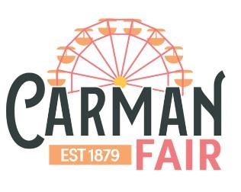

JACKPOT Dirt Bike Barrel Racing Rules
OBJECT
All competitors, on two-wheeled dirt bikes, will run one at a time, two different patterns: a clover-leaf pattern course around three barrels and barrel bending pattern around six barrels. This is a timed event; the best time of each pattern will be added together to find the win. In the event of ties, runoffs will be held. Each competitor may have three runs, depending on time constraints and number of riders entered. The fastest time will be counted.
This year there will also be team classes: a team of two riders from the same age category and a mixed team with three riders one from each age category. Team winners will be determined by adding the placings together with the team having the lowest points being declared the winner. Eg Team A gets 1st, 3rd, & 10th place = 14 points
Clover Leaf Pattern Rules: If rider starts with a right turn, it must be followed by two left turns and vise versa.
DISQUALIFICATIONS
- If a contestant fails to round a barrel, in the correct direction.
- If a contestant fails to round any barrel.
- If a contestant does not drive between the first two barrels while crossing the finish line.

PENALTY
There will be a 2 second penalty, for each barrel that is knocked over. Rider must still circle the barrel.
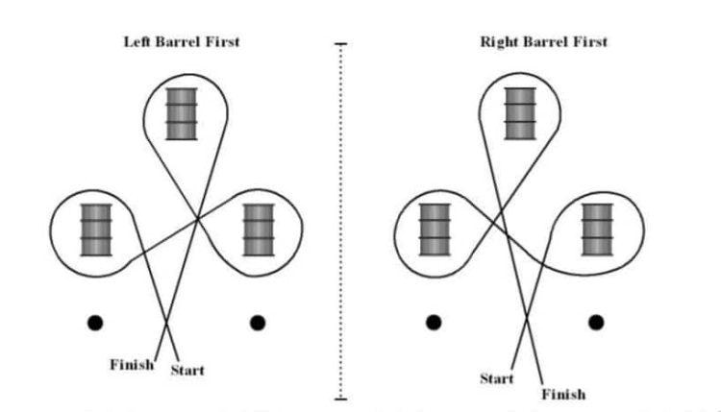
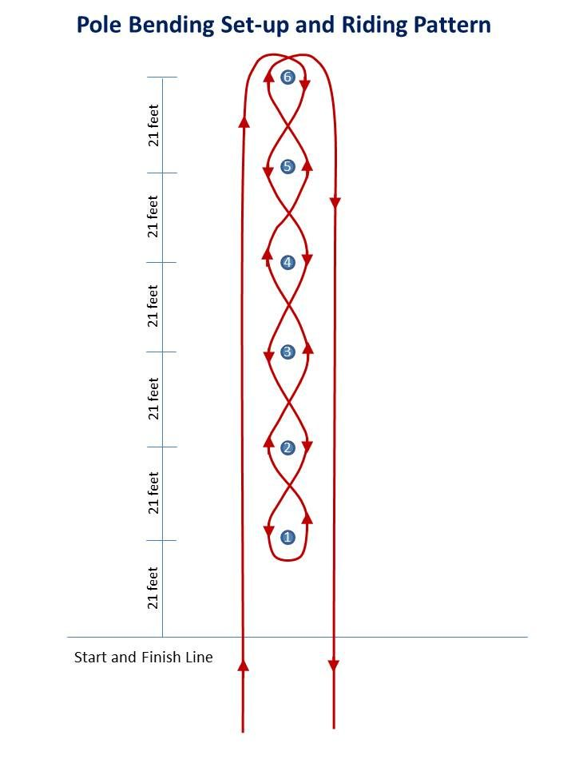

ADDITIONAL RULES
- All riders must wear a Helmet
- Provide your own Dirt Bike
- Closed toe shoes
- Each rider will enter the arena separately
- May enter from either right or left

JACKPOT PRIZE
Winner of each Class takes home the pot for that Class.

AGE CATEGORIES
PeeWee – 5-12 years of age
Youth – 13-15 years of age
Open – 16+ years of age
CLASSES
Open – single rider
Team – 2 riders from same age category
Mixed Team – 3 riders, one from each age category

