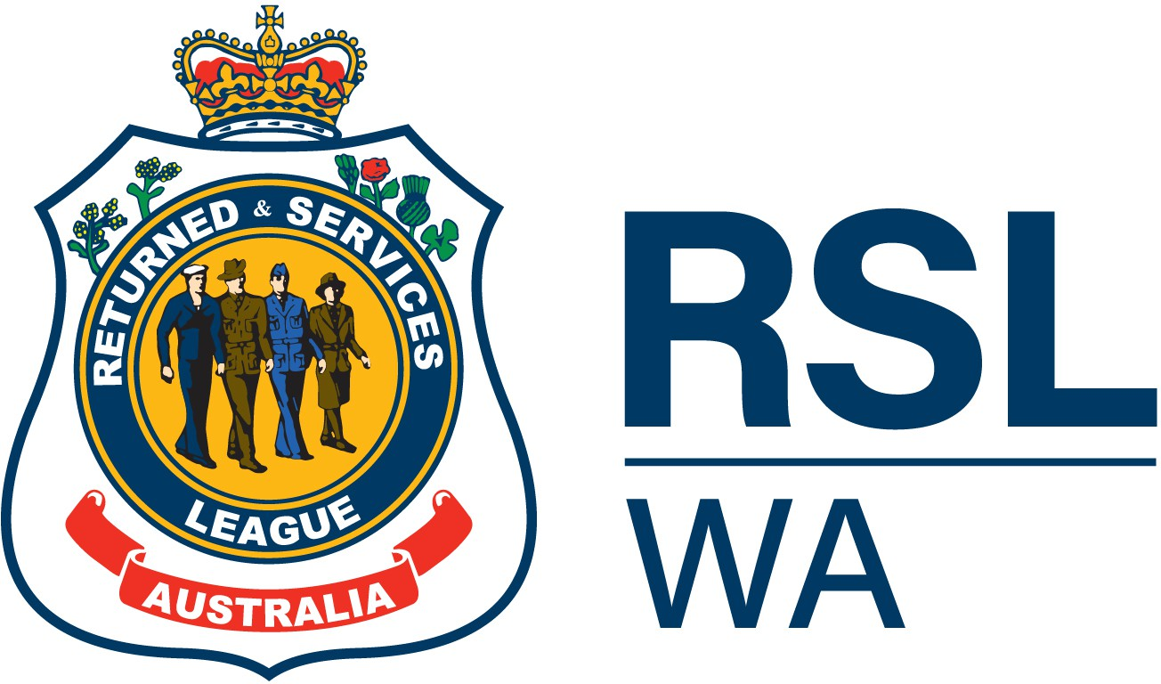

LOST/DAMAGED BADGE or CARD
DECLARATION FORM

Personal Details

Title First Name Middle Name Last Name

Member Number (AFF# or Service Member #):

Mobile Number

Email
Residential Address
Postal Address

Lost/Damaged Badge or Card Details
Badge Number:
Circumstances of Loss:

Declaration & Agreement
☐ Membership Badge: I do solemnly and sincerely declare that I have lost the RSL Badge as detailed above. THAT to the best of my knowledge and belief the said Badge is not in the hands of any other person on my behalf or with my consent. If I find my Lost Badge I will return it to:
RSL WA
Attention: Membership
PO BOX Z5424, St Georges Terrace PERTH WA 6831.
☐ Membership Card: I do solemnly and sincerely declare that I have lost or have a damaged RSL WA Membership Card as detailed above.

Print Name Signature Date

Payment Details
Cost of Replacement is $5.00, you will be invoiced by the Membership team upon receival of this form.
This amount must be forwarded with this declaration for a replacement badge to be issued.

State Branch Administration Only
Badge Number | Receipt Number | Receipt Date | Mailed Date
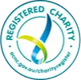
The Returned & Services League of Australia Western Australia Branch Inc.
ABN: 59 263 172 184
Level 4, 28 St Georges Terrace, Perth WA 6000
T: (08) 9287 3799, E: admin@rslwa.org.au, W: www.rslwa.org.au

