How to Guide- Using ClickView

The following provide guidance on how to get started on ClickView.

Click on a box below for more information on that area or scroll to get started.

Logging into ClickView
Searching for Content
Personalising
Creating Clips
Subtitles
Extra Guides

Logging into ClickView
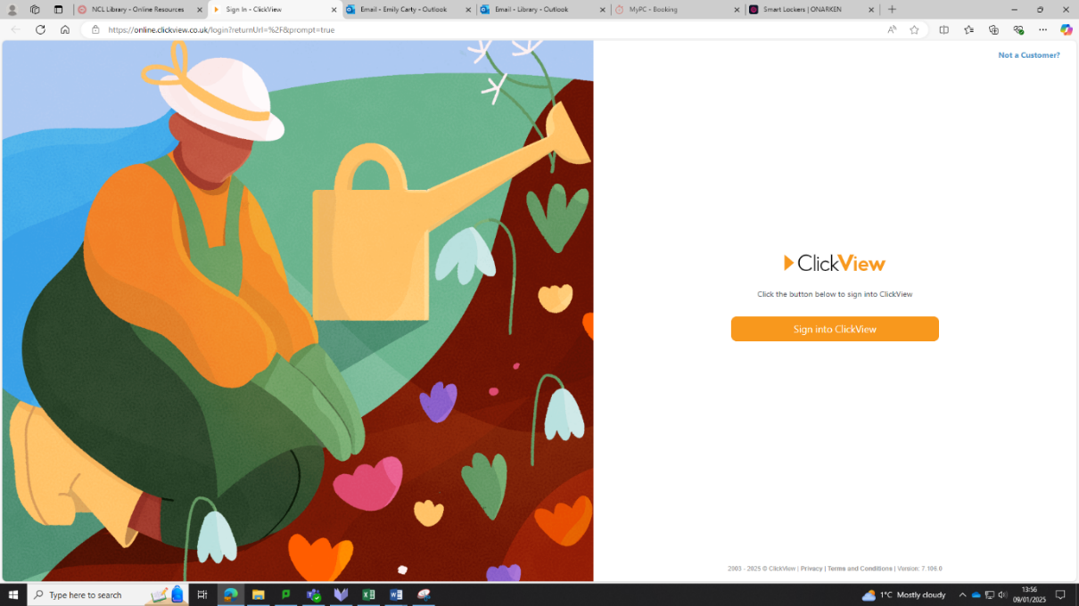

Click the Sign into ClickView button

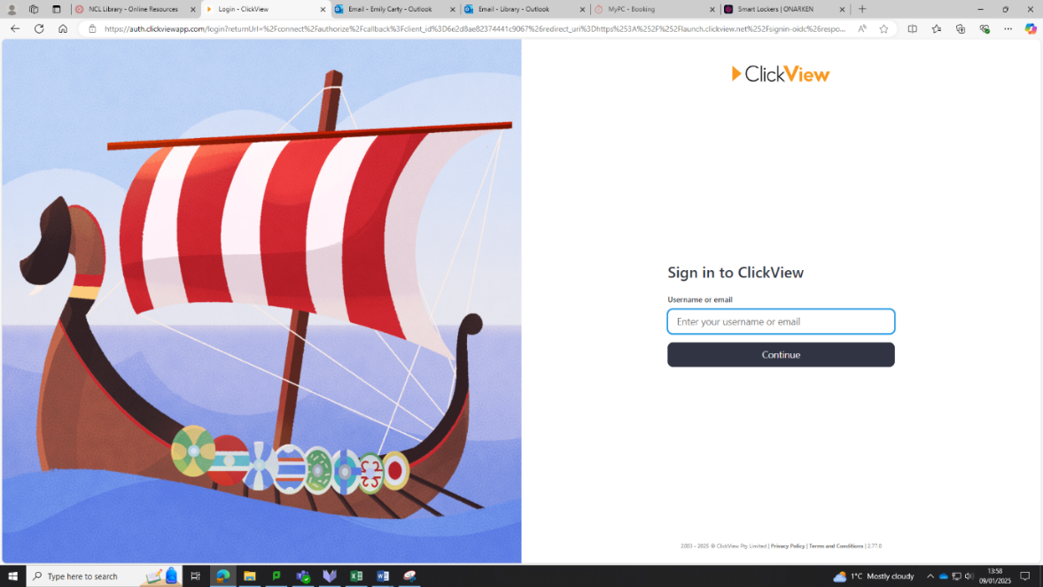

Enter your college email address

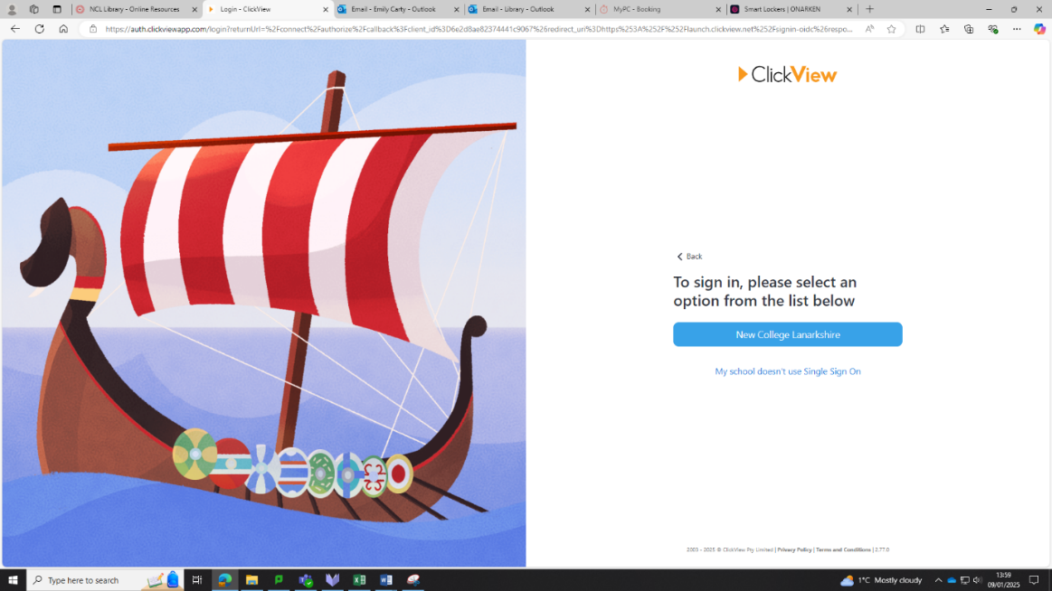

Select New College Lanarkshire

After selecting ‘New College Lanarkshire’ the discover page will open:
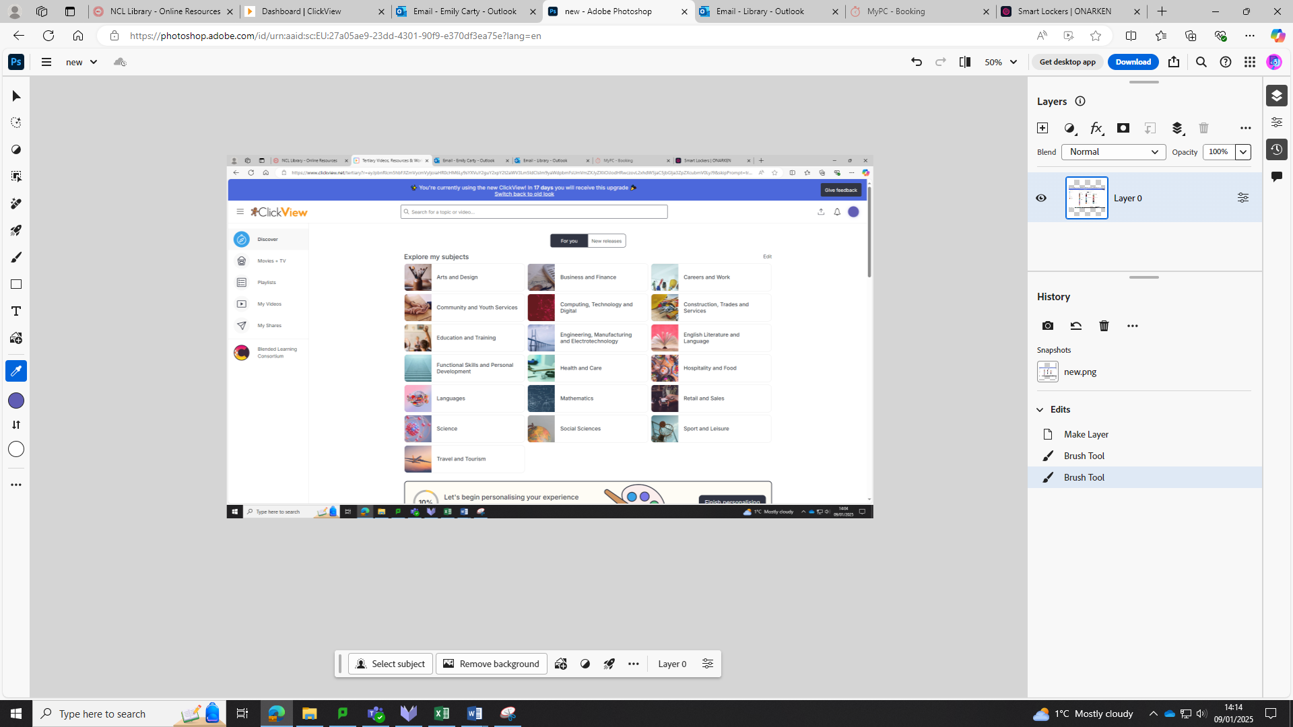

Searching for Content

There are 2 different ways to search in ClickView.

- Searching through Topics
This method of searching may be useful if you aren’t searching for anything specific, but searching or browsing within a certain topic.

From the Discover page:
Select the Topic you are searching in

For example: English, Literature and Language
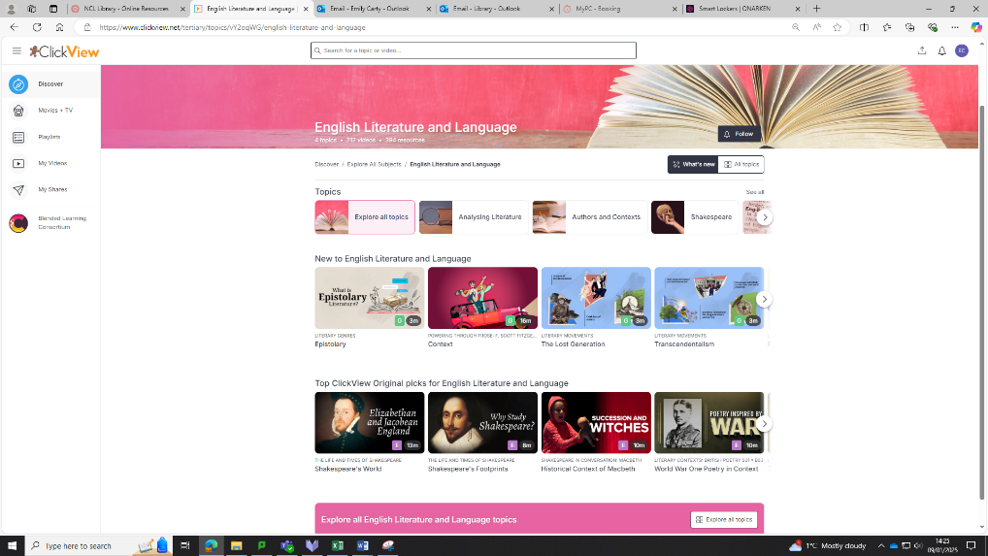
The subject is then split into more specific topics

This section highlights the new content added for the subject

Clicking through to the topic- ‘Analysing Literature’ for example:
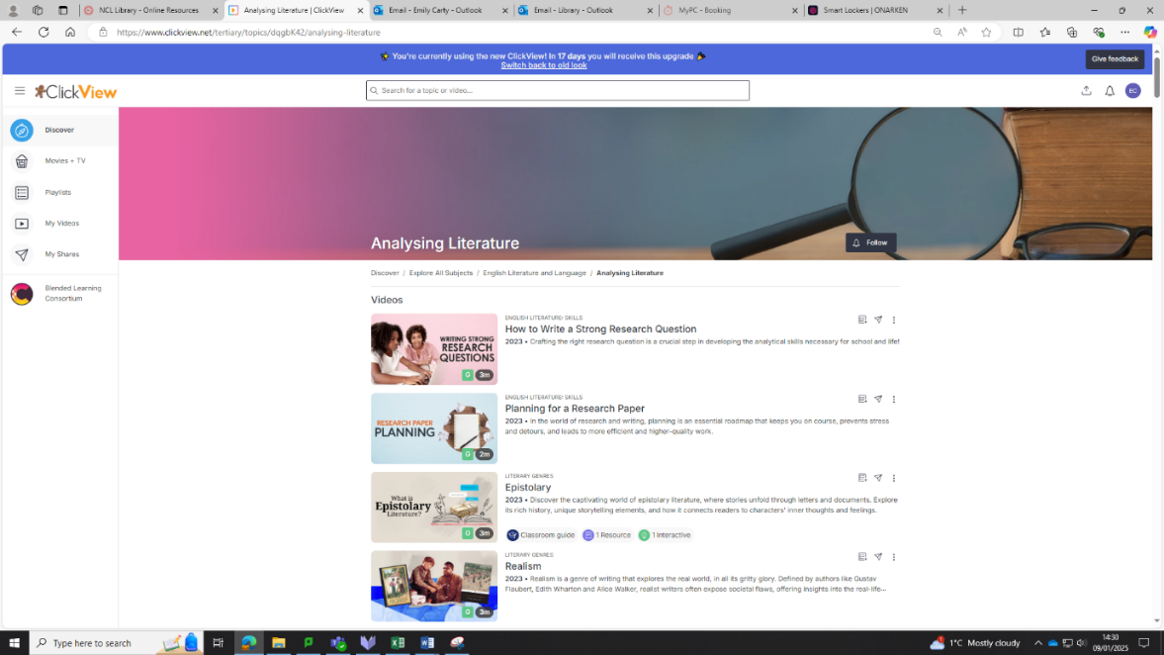

Results are shown which are relevant to the topic

- Searching using the Search Bar
This method of searching may be useful when you are searching for something specific.

From the Discover page:
Enter your Search
.

For Example: Research Questions
You can use the filters to show more specific results- for example videos with subtitles

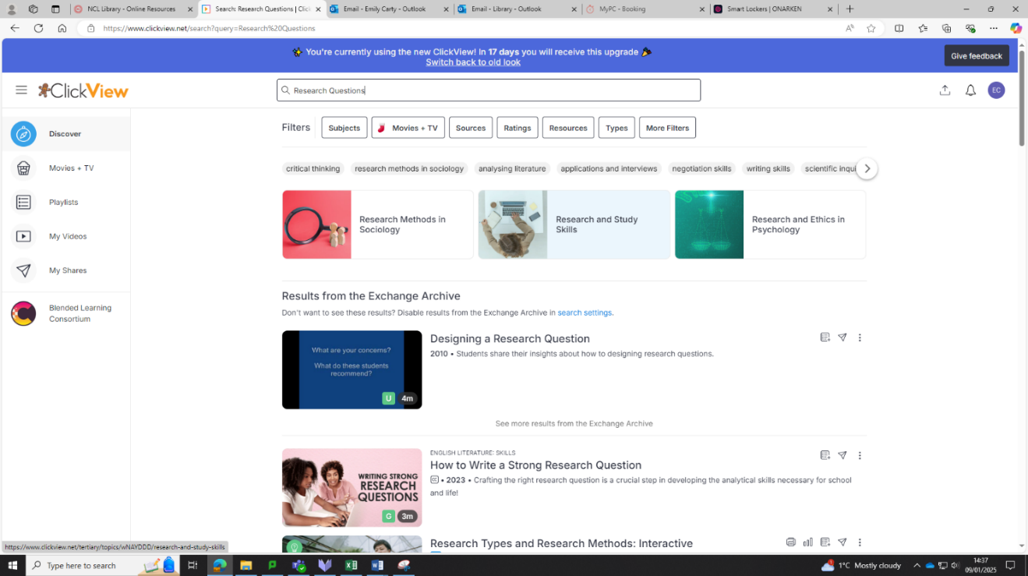
Topics which are relevant to the search are shown here

You can favourite videos from here- once favourited they can be found in the Playlists tab
Clicking on a Video:

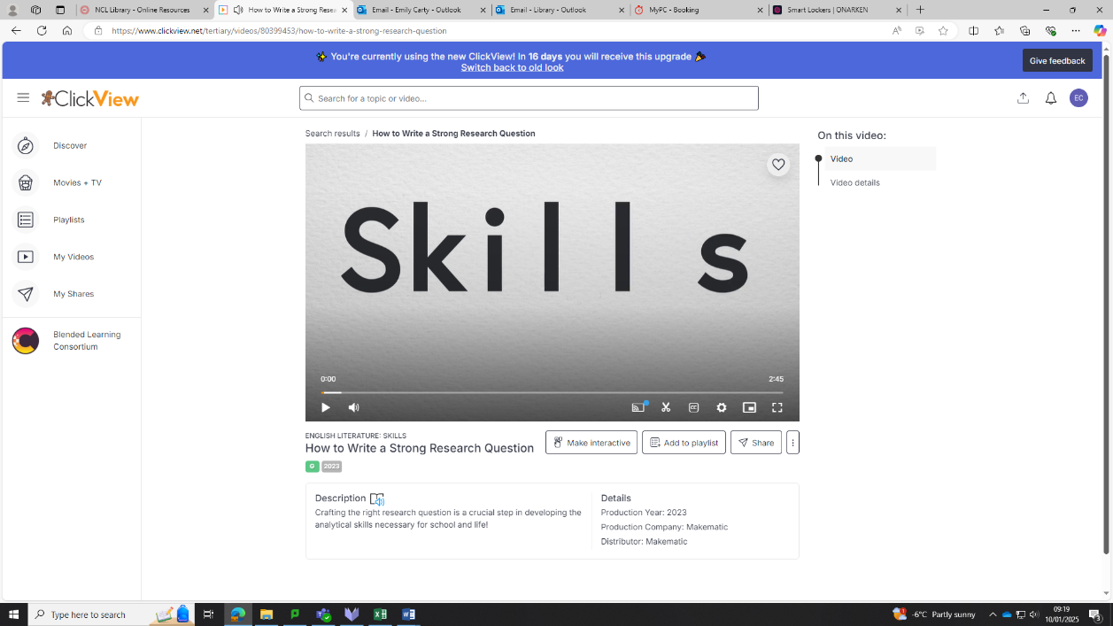

Use the CC button to turn on subtitles

You can share the video from here
You can add the video to a playlist

Personalising

From the discover page:
Select the Edit button
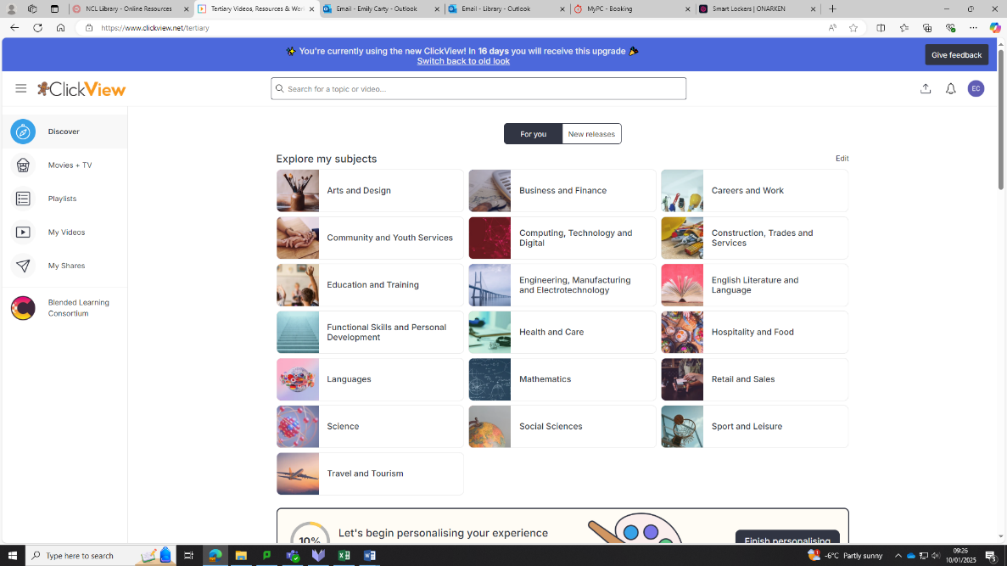

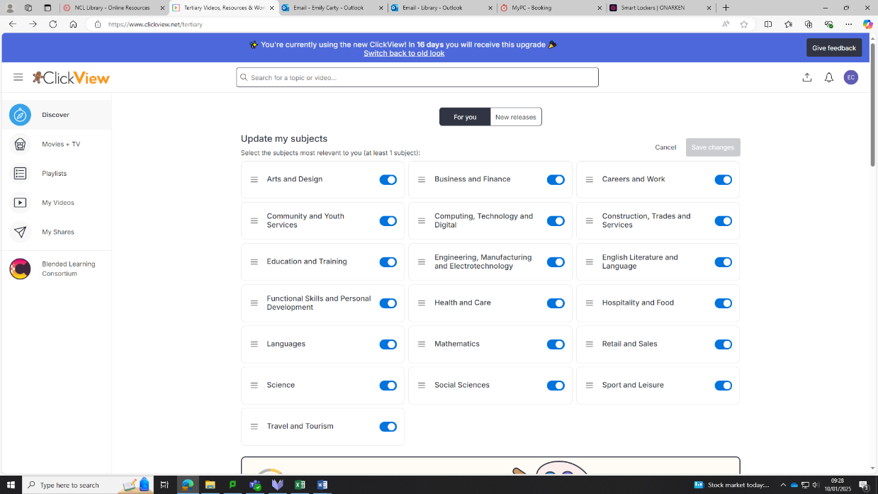
For Example: Studying Social Sciences
Use these switches to toggle subjects on and off

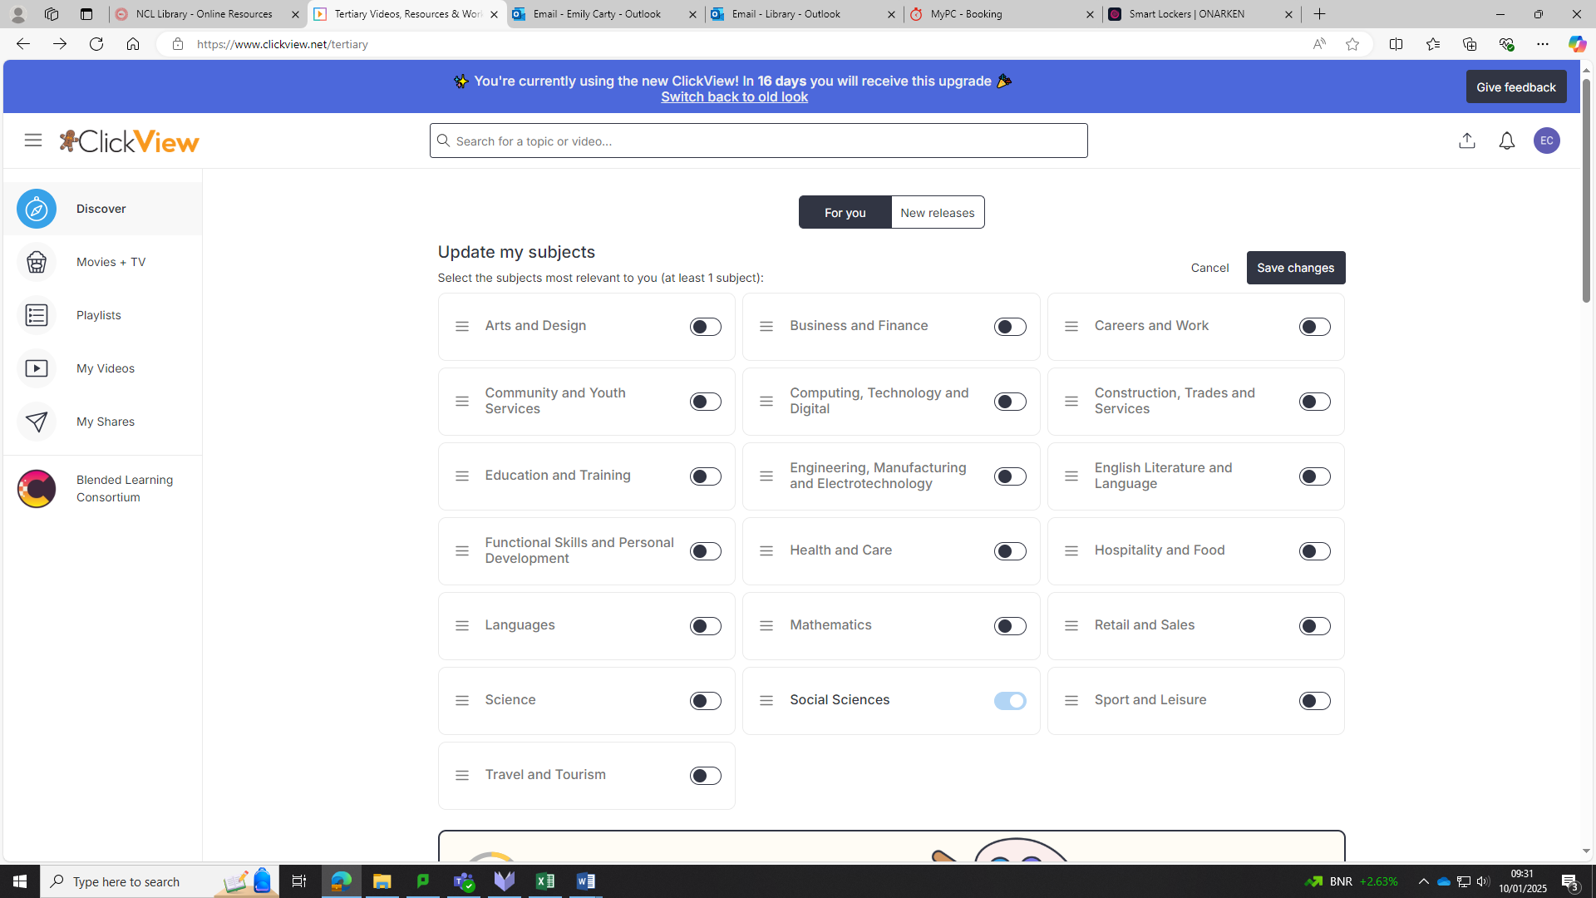
Once you have toggled on/off the subjects you want select ‘Save Changes’

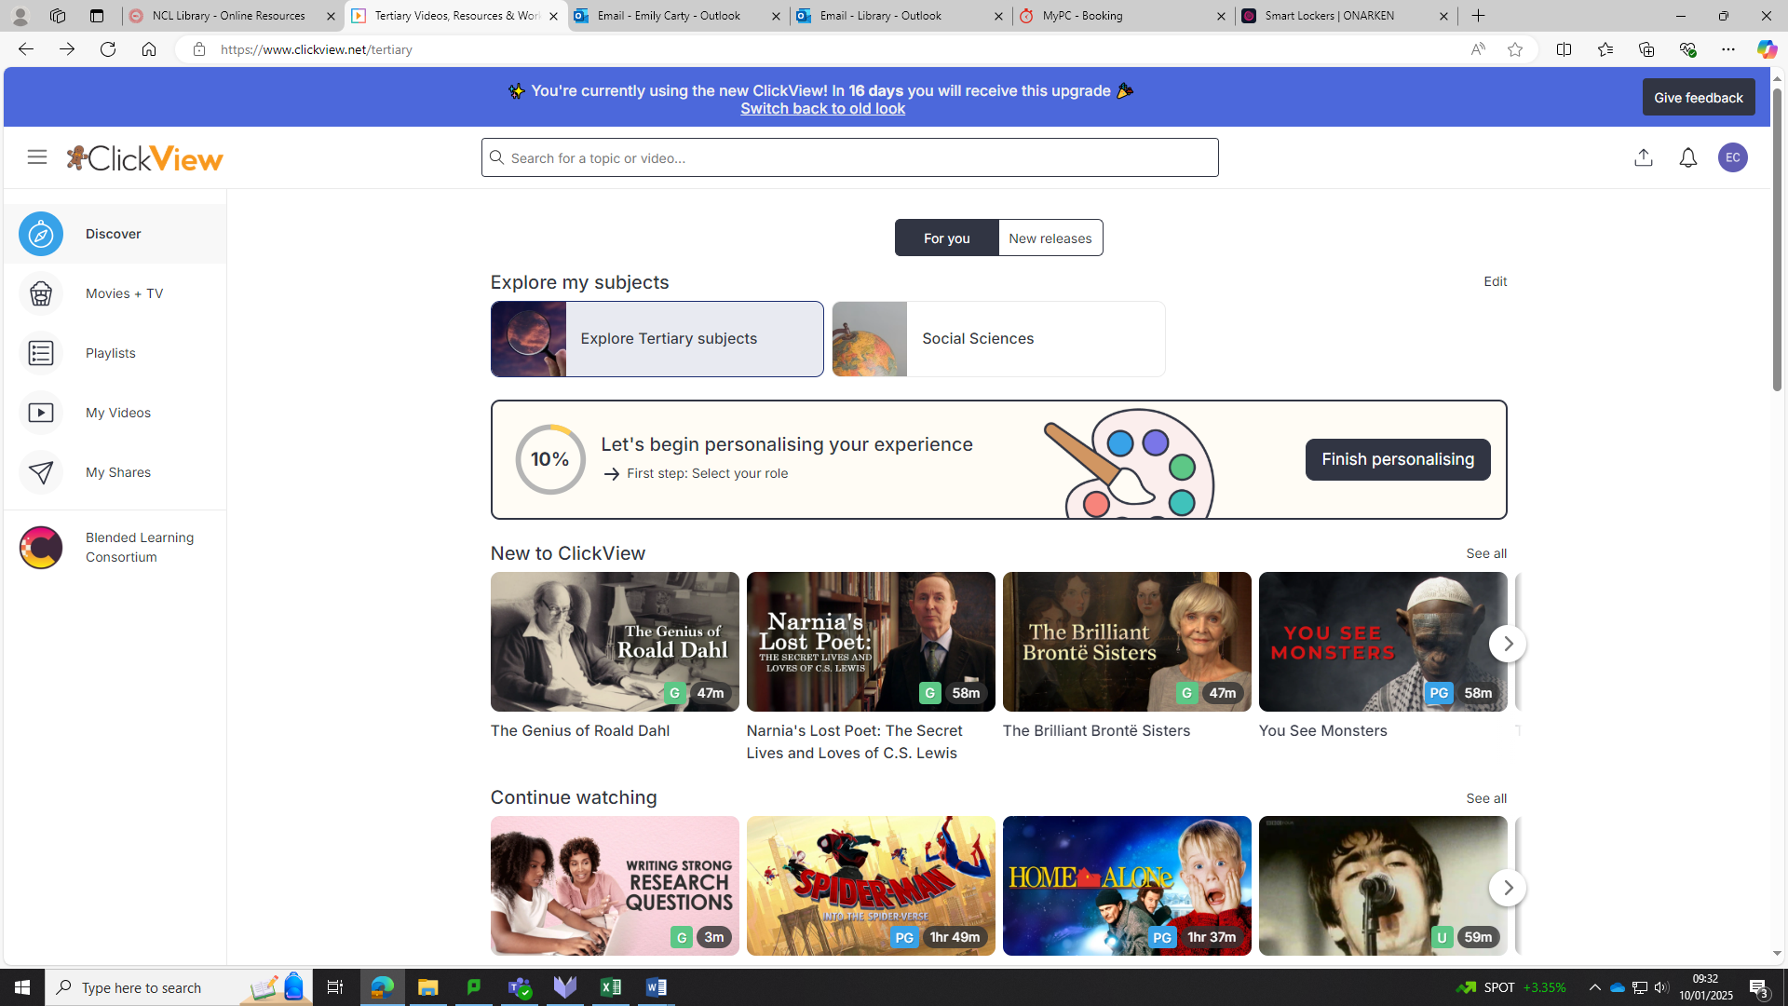
Your Discover page will update to show the subjects you have toggled on at the top

Note: You can re-toggle subjects back on again in the same way they were toggled off.

Creating Clips

When viewing a video:

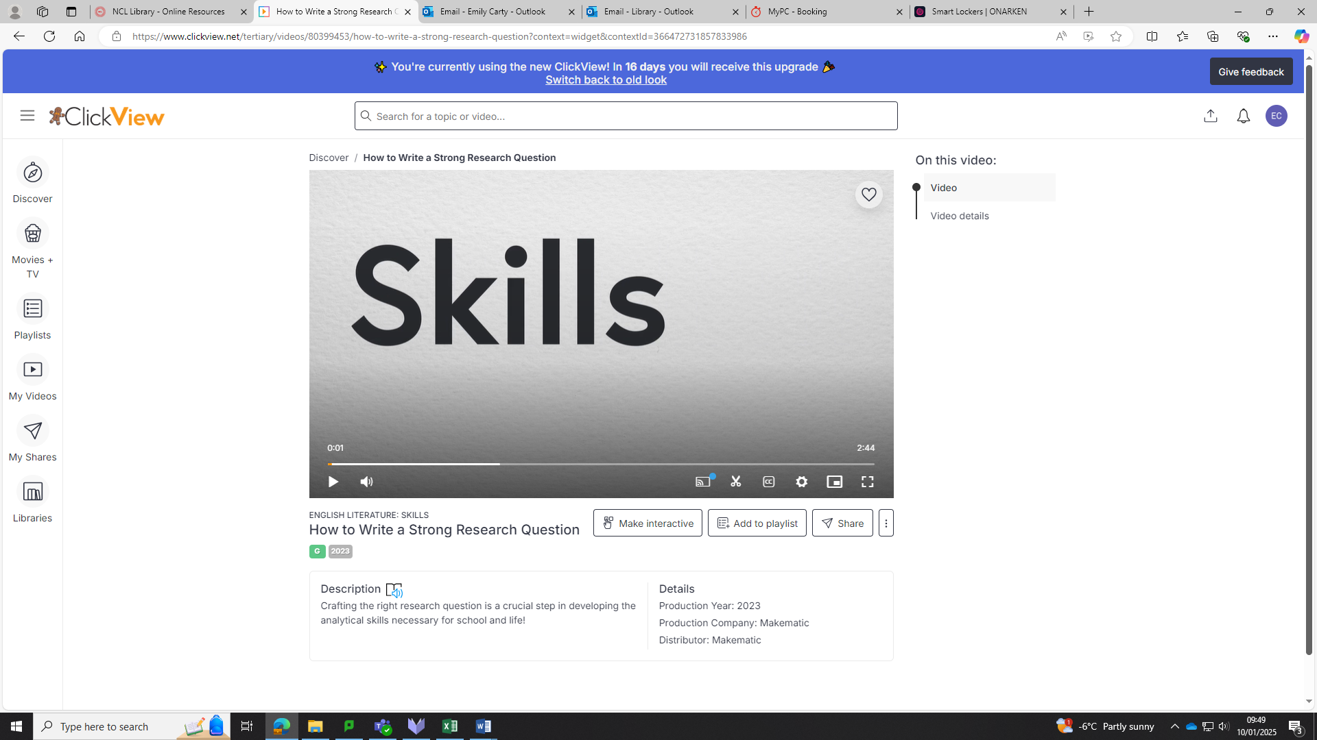
Select the Scissor icon to make a clip

There are 2 ways to select the section of the video you wish to clip:
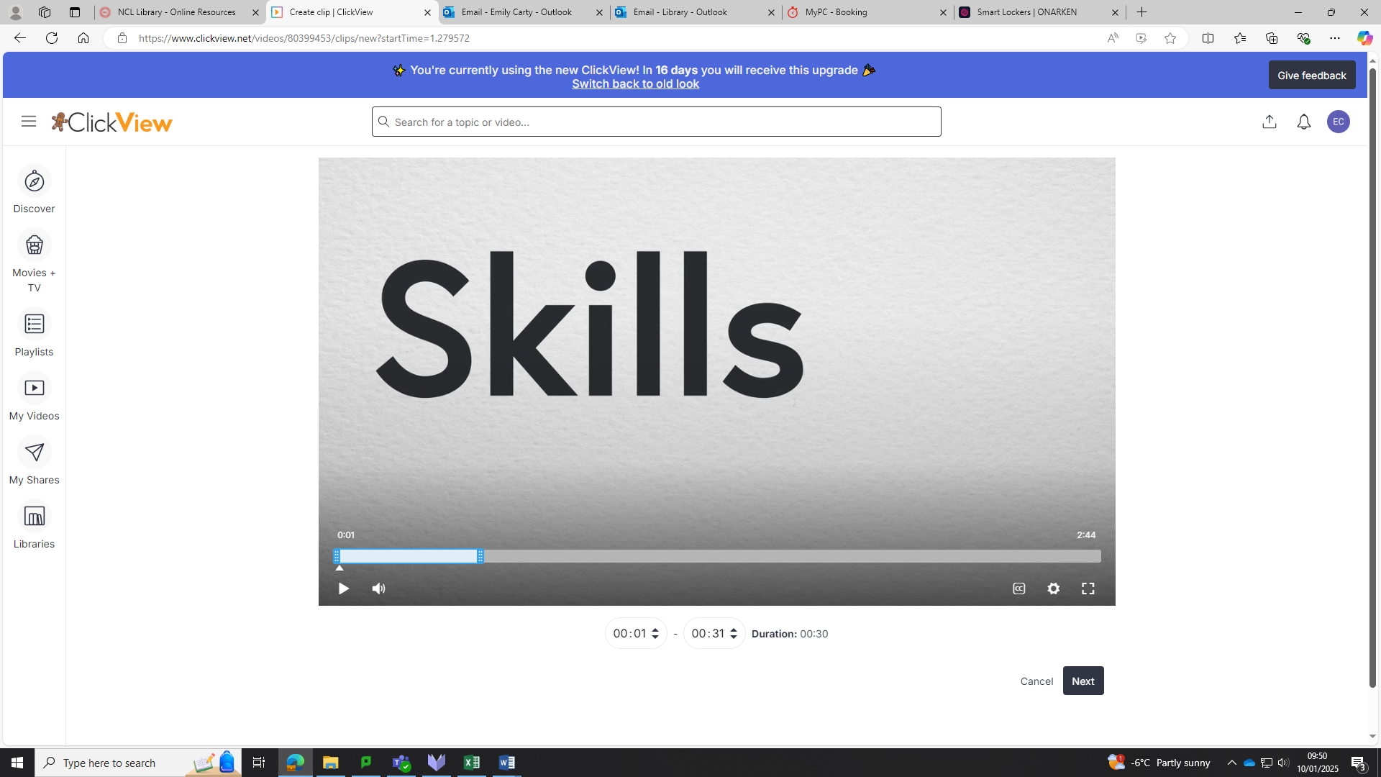
2.Use the timestamps to select the section of the video you wish to clip
Once you have created your clip select ‘Next’
1.Drag the bar to select the section of the video you wish to clip

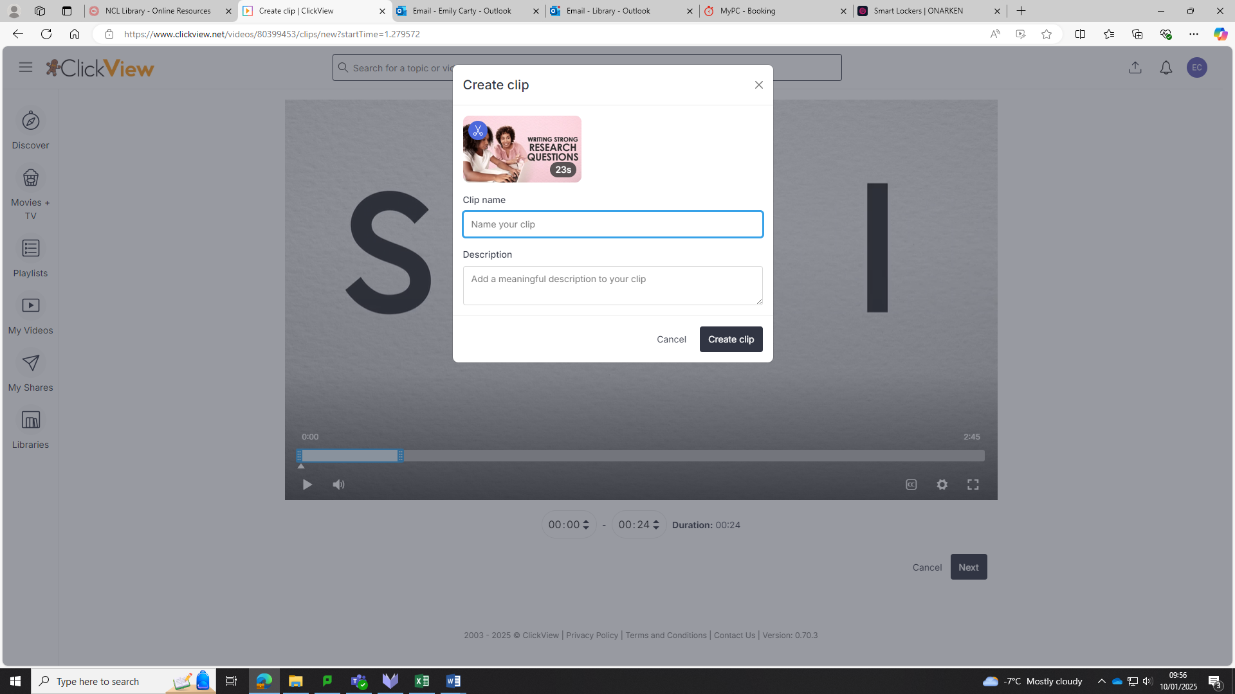
Once you have named your clip select ‘Create clip’
You can also add a description for your clip
Enter a name for your clip

You can now find the clip you created in 2 places:

- Under the Original Video
- Under ‘My Videos’ in the navigation bar

Subtitles

To find content with subtitles, use filters within your search to only show videos with subtitles. See the ‘Searching for Content’ guide above for more information.
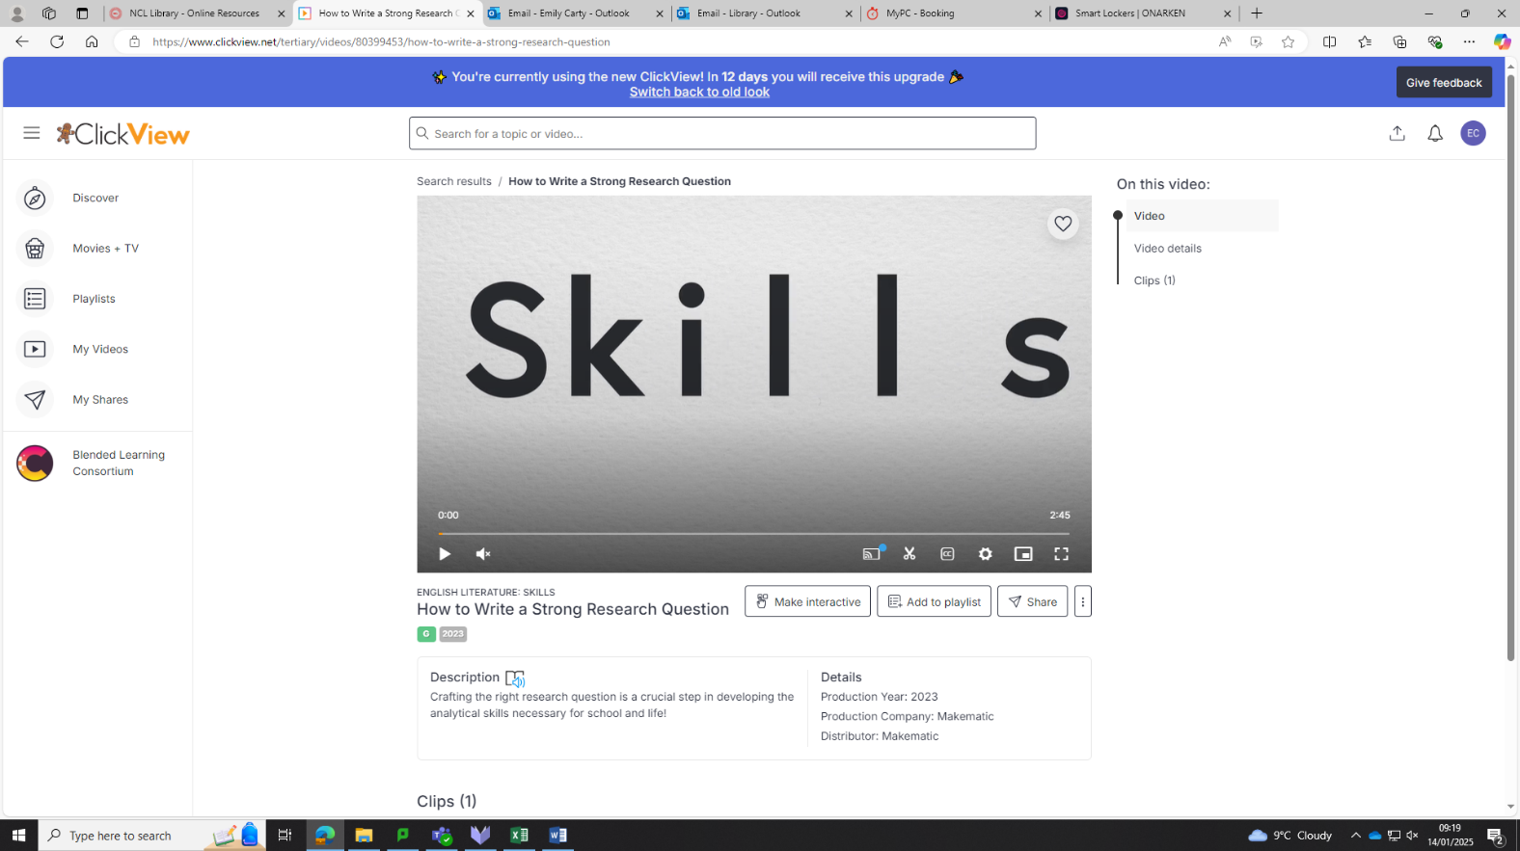

Within a video select the ‘CC’ button for subtitles

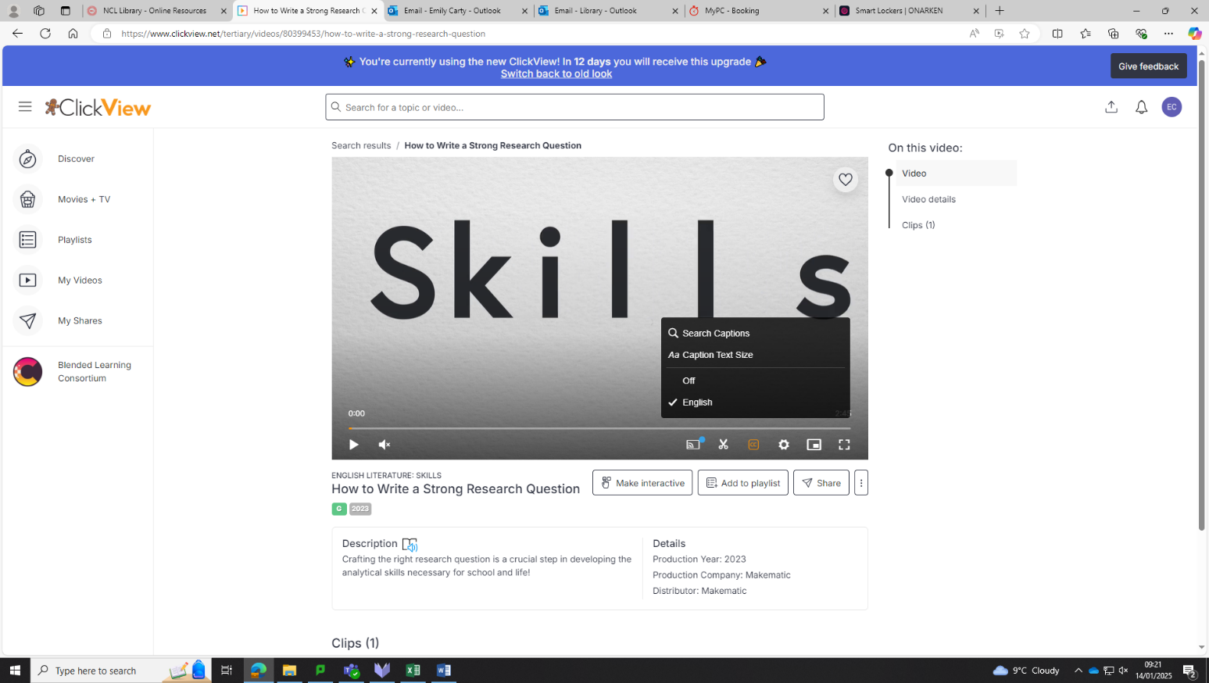
You can search within the subtitles
You can change the size of the subtitle text

From here you can turn subtitles on/off

Searching within the subtitles- for example: Social Media
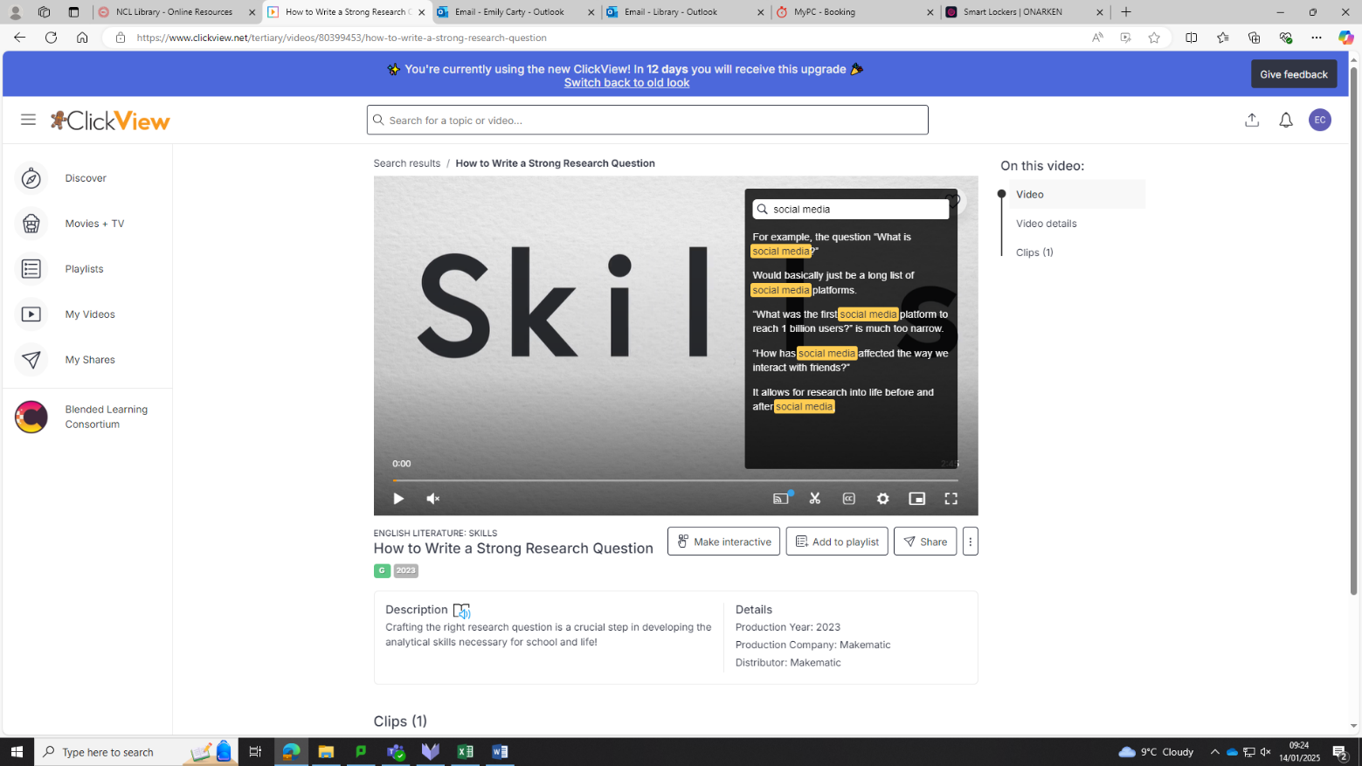
Results of when ‘Social Media’ is mentioned in the video will be shown
Enter your search in the search bar

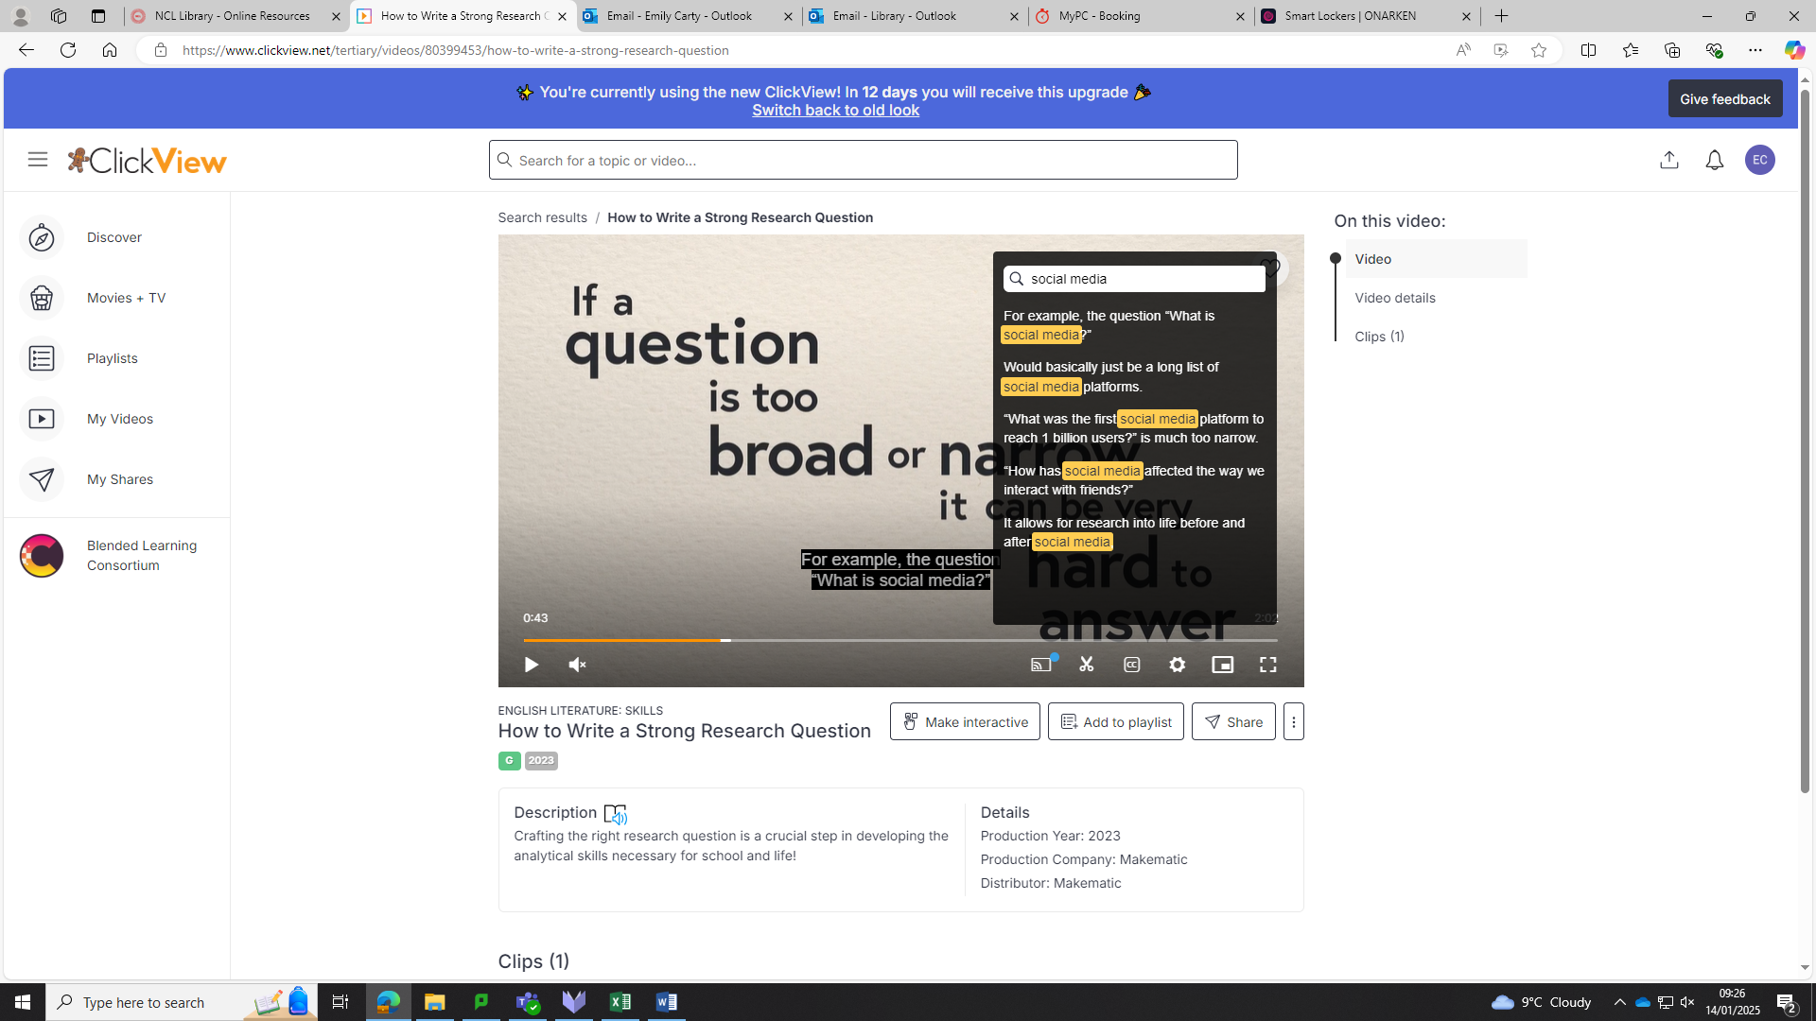

Clicking on a result takes you to the corresponding section of the video

Extra Guides

The below playlist of short training videos might be helpful when exploring ClickView. You can ‘Follow’ the playlist- saving it to your playlists tab.

Getting Started with ClickView Video & Resources | ClickView

There are also helpful guides in the Help Centre on ClickView. The Help Centre can be found under the user icon at the top right-hand side of the webpage. Click here to view the guides.

