### Creating an Account

For first time users of Hachette Learning Magazines click [here](https://passport.hoddereducation.co.uk/Register/WpcHlz9xw25814ce34-2e8c-4bcd-895a-f107783d59daz9xw230z9xw2z9xw2z9xw2vhlYOuwfMpAO7Ga3AOk9z9xw29C75395A89321DD4CC3104A6D31D7614) to register for an account.

You need to register for an account to access the resources.

Once clicked on the link it will take you to the following page:

Fill in with your Student Email and Name

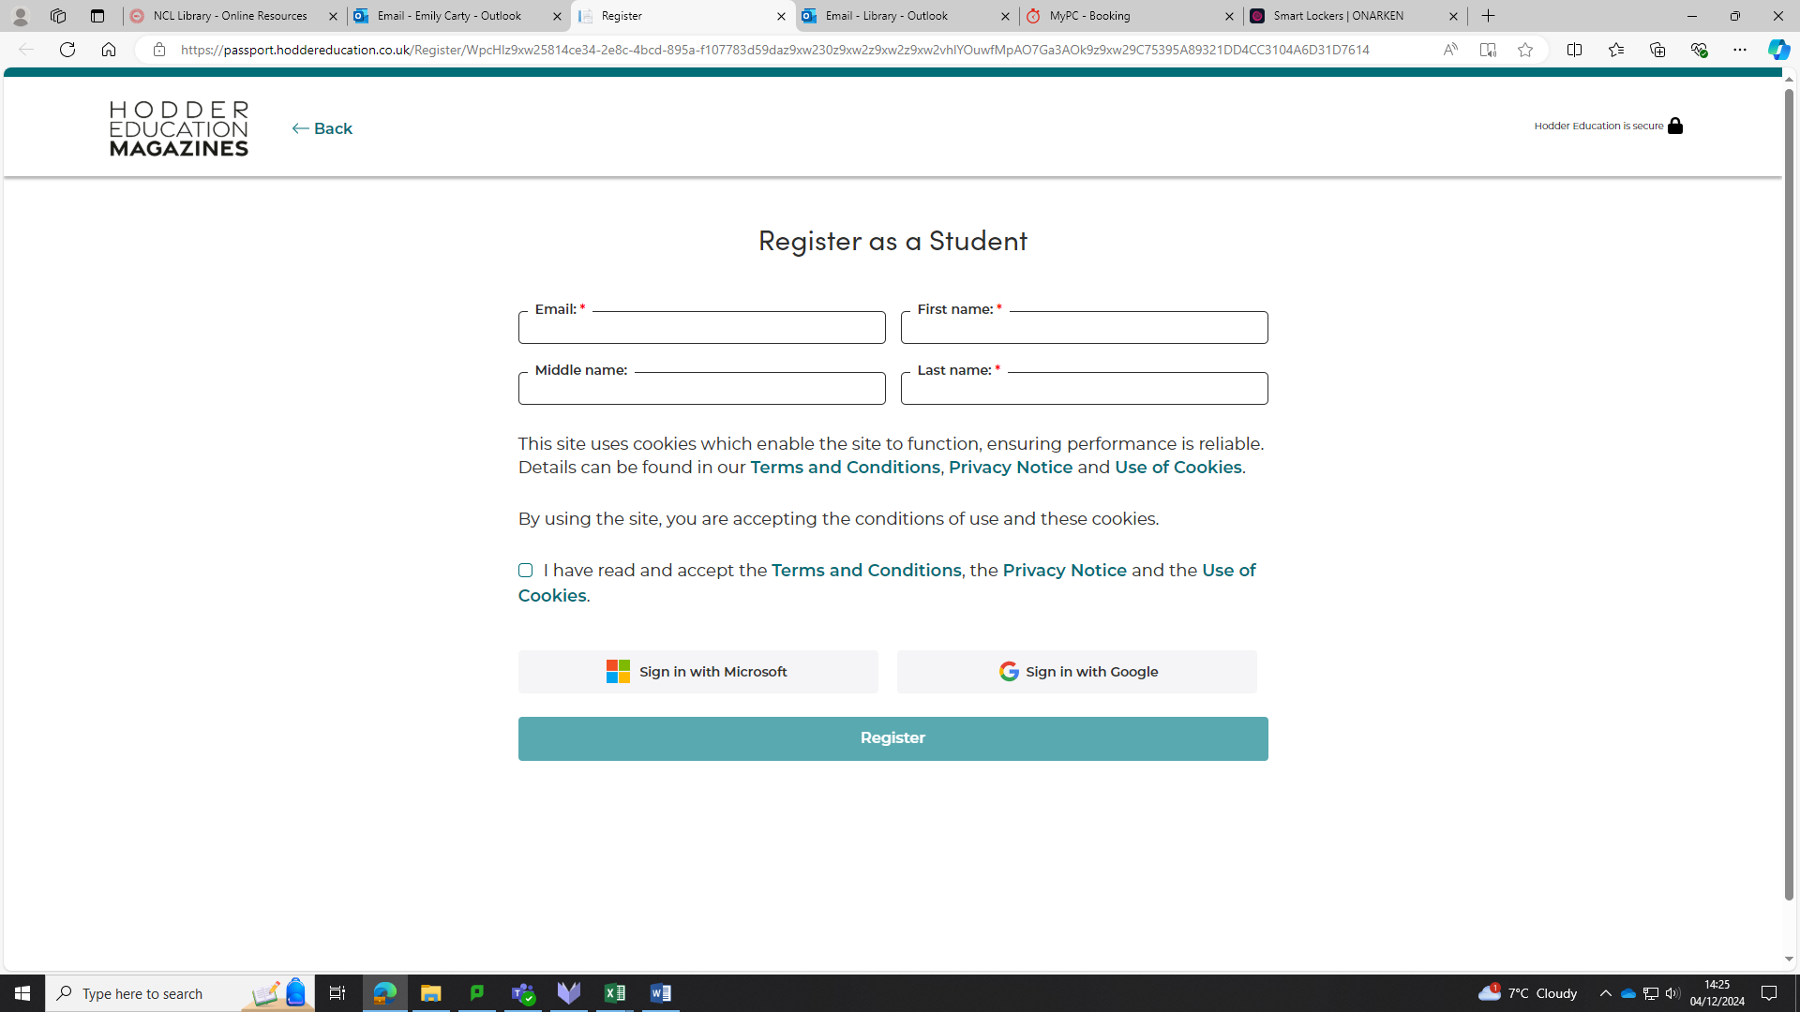

Click Register

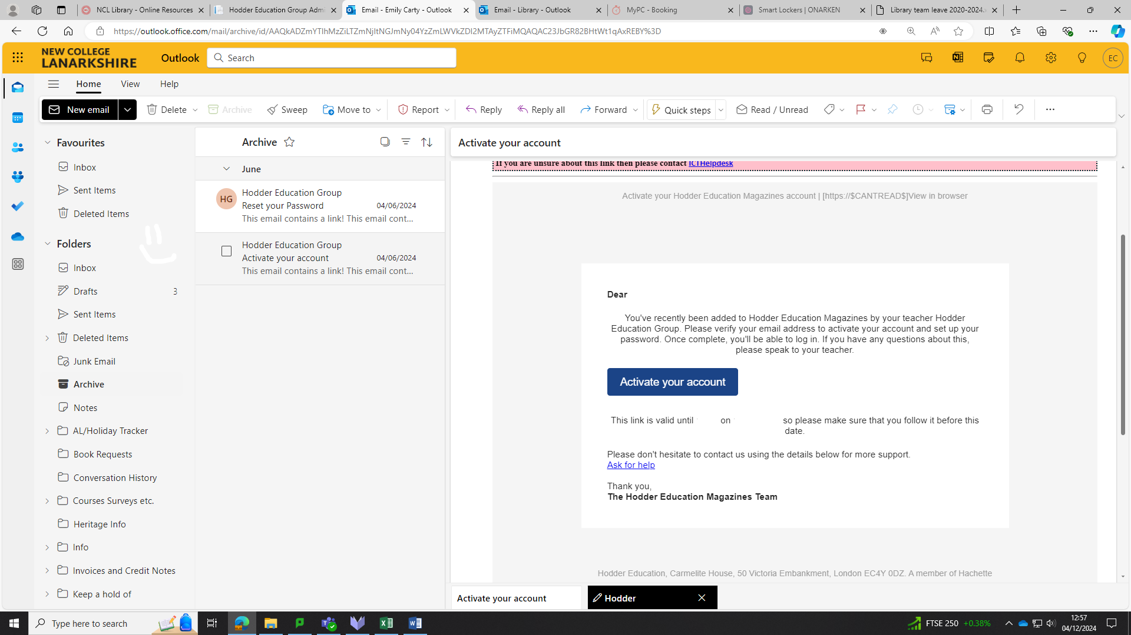

Once registered you will receive an email to activate your accoun

Click on the link to Activate your Account