**HOW TO GUIDES – LAPSAFE LAPTOP LOCKERS**

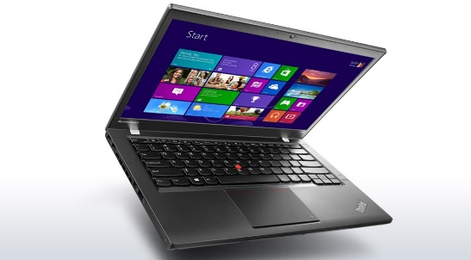

Did you know that you can borrow a laptop to use for the day at college in our Coatbridge, Cumbernauld and Motherwell campuses?

Location of Lapsafe laptop lockers:

Motherwell – ground floor in the atrium, beside the Food Court

Coatbridge – ground floor in the atrium, beside the library

Cumbernauld - ground floor in The Street, opposite Reception

How to borrow a laptop:

1. Log in – scan your digital student card from your MyNCL app or manually enter your student number on the Lapsafe touch screen
2. Create a pin – the first time you borrow a laptop you will be required to create a PIN – this must be a minimum of 4 characters, and you will need to enter this PIN every time you want to borrow a laptop so make sure you remember it
3. Reserve a laptop – using the touch screen, log in and then press ‘Borrow’. Then press ‘HP Laptop 1 day’. The locker number assigned to you will then begin to flash and the locker number will be displayed on the screen
4. Open the locker – unplug the laptop from the built-in charger and remove it. The locker also contains a laptop bag if required for use.
5. Close the locker – please ensure that the locker clicks shut correctly once you have removed the laptop, so that the loan is registered to your student account

The laptop must be returned to the original locker before 9pm on the same day.

If you would like a charging cable for additional power to the laptop, please come to the campus library desk where a cable can be borrowed for the day from library staff.

How to return a laptop:

1. Log in – scan your digital student card or log in manually on the touch screen, and enter the PIN you previously created
2. Return the laptop – on the touchscreen, press ‘Return’ and the assigned locker will begin to flash. Place the laptop (and bag if borrowed) back in the locker, ensuring that you attach the laptop to the built-in charger in the locker. Make sure that the charger clicks in correctly, as this registers as your loan being returned and starts to charge the laptop ready for another student to borrow
3. Close the locker – click the door closed on the locker and press ‘Finish’ on the touchscreen. The light at the side of the locker door should show a red light to confirm that the laptop is charging. Your loan is now complete
4. Charging cable – if you borrowed a plug-in charging cable, please return it to the library (open 08.30am to 4.30pm Mon to Fri)

Borrowing a laptop from the Lapsafe lockers on campus for the day has now become extremely popular, so to make sure that there are laptops charged and ready for you to borrow when you really need them, please follow the simple steps above.

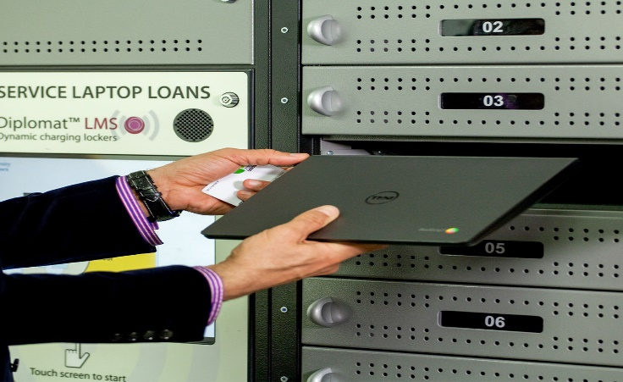

Troubleshooting

If you forget your PIN, when you log in on the touch screen with your student number, there is an option to press for an PIN reminder email to be sent to you.

Please note that all the laptops have a white sticker on the underside which advises the locker number it belongs to – if you are returning laptops together with other classmates, please make sure that your laptop goes back in the correct locker number.

If you haven’t returned the laptop to the correct locker or closed the door correctly, you will receive an email advising you to return to the Lapsafe lockers to correct this.

If you haven’t attached the laptop to the charging cable correctly, you will receive an email advising you to return to the lockers to correct this.

Until the laptop is returned to its original locker and plugged in to charge correctly, it will continue to register as being on loan to you, and you will receive overdue loan emails. If you ignore these emails, until your laptop loan is returned correctly, you could eventually receive an invoice for the full replacement cost of the laptop.

If you have any problems or issues at all with trying to use the Lapsafe lockers for borrowing or returning a laptop, please come and see a member of Library staff and they will assist you.