**How to Insert an Image**

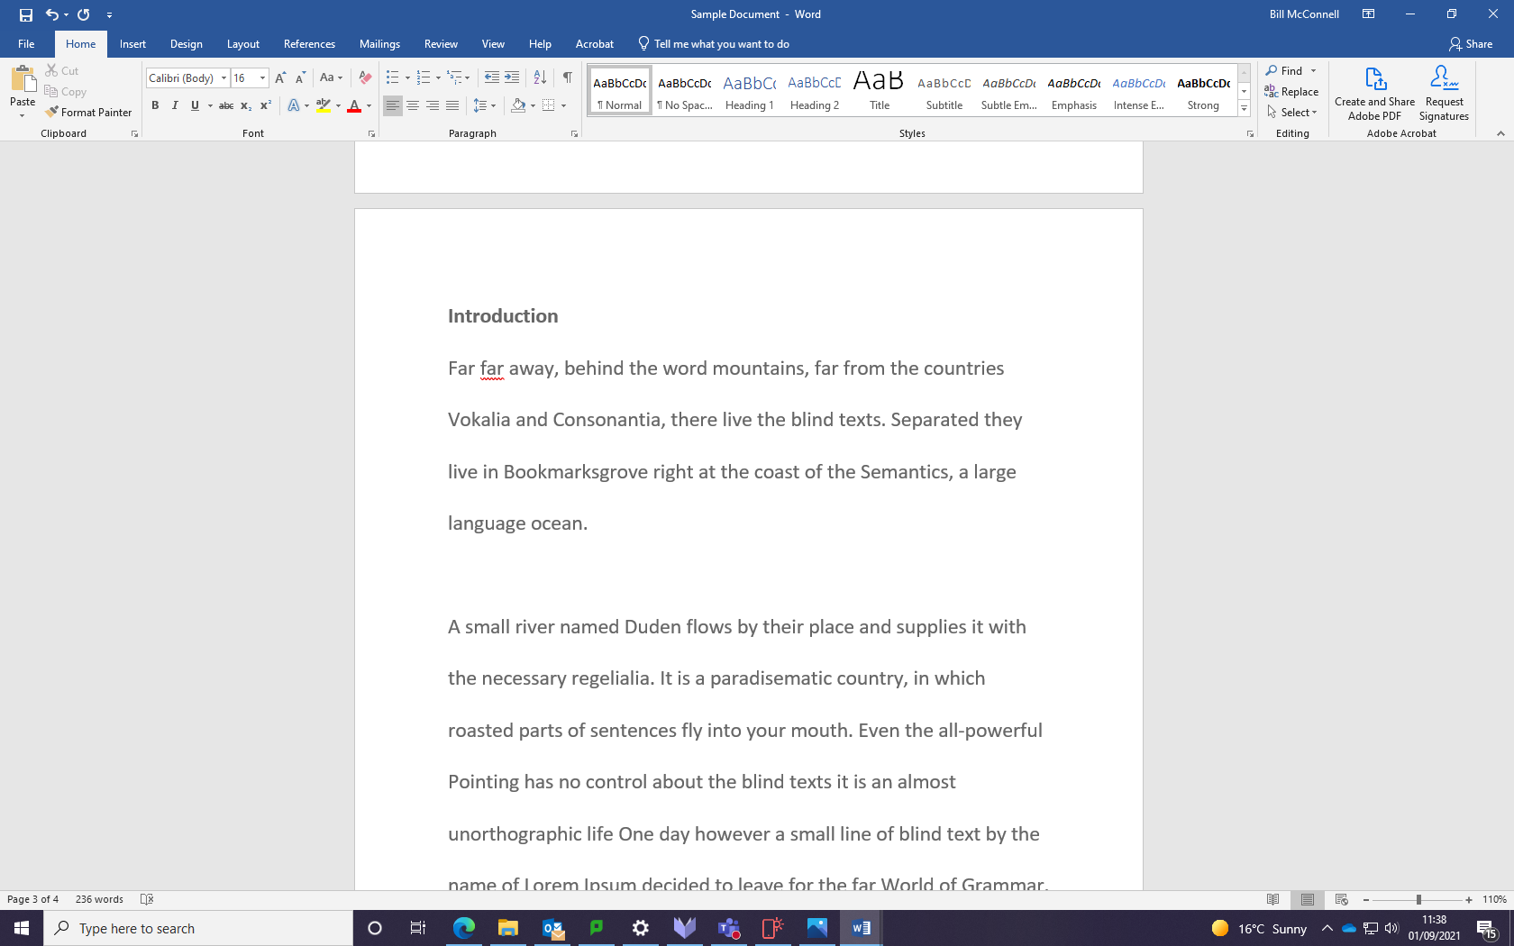

Using the mouse point and click where you want to insert an image

Select the Insert Tab

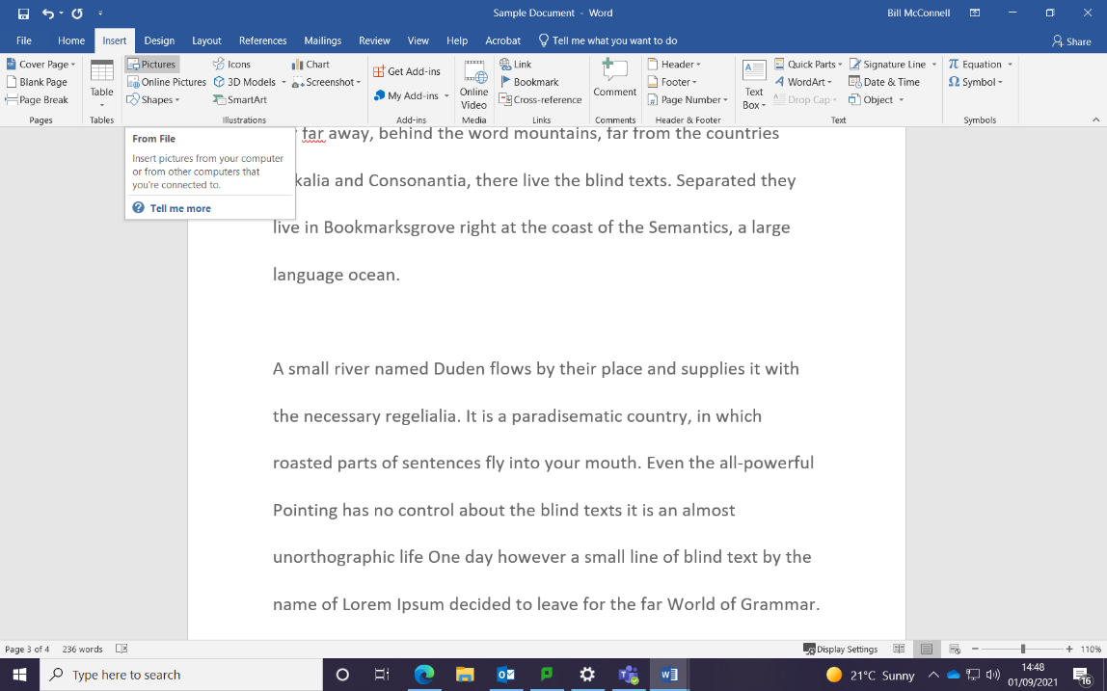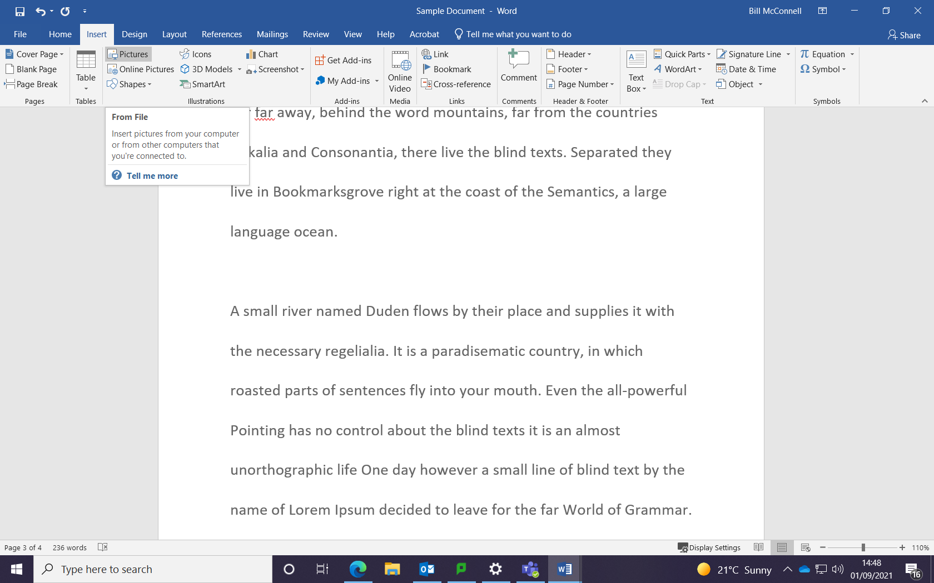

Select the Picture option

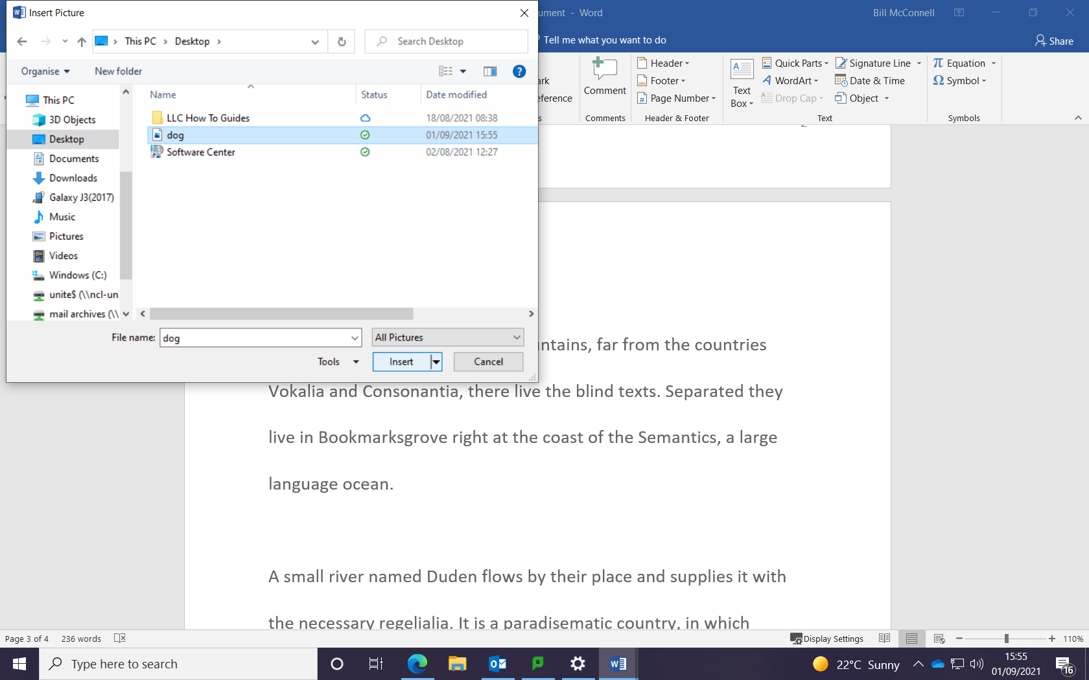

Select the image you want to insert

Select the insert button

The image is now inserted in your document, see example below

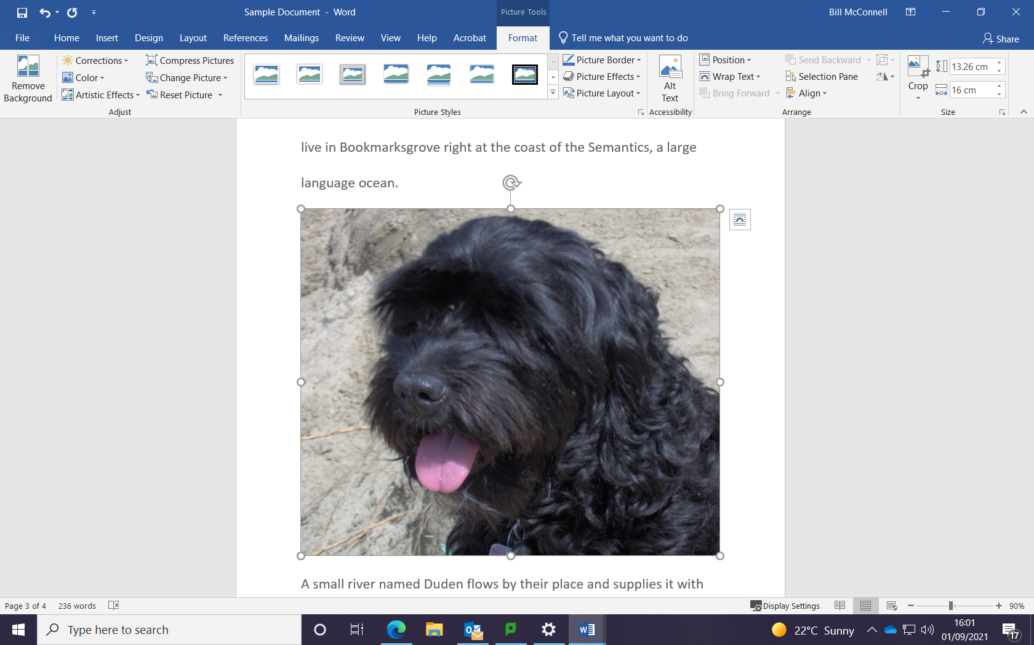

You can also resize the image by pointing to any of the circles in each corner and drag the mouse inwards, see example below.

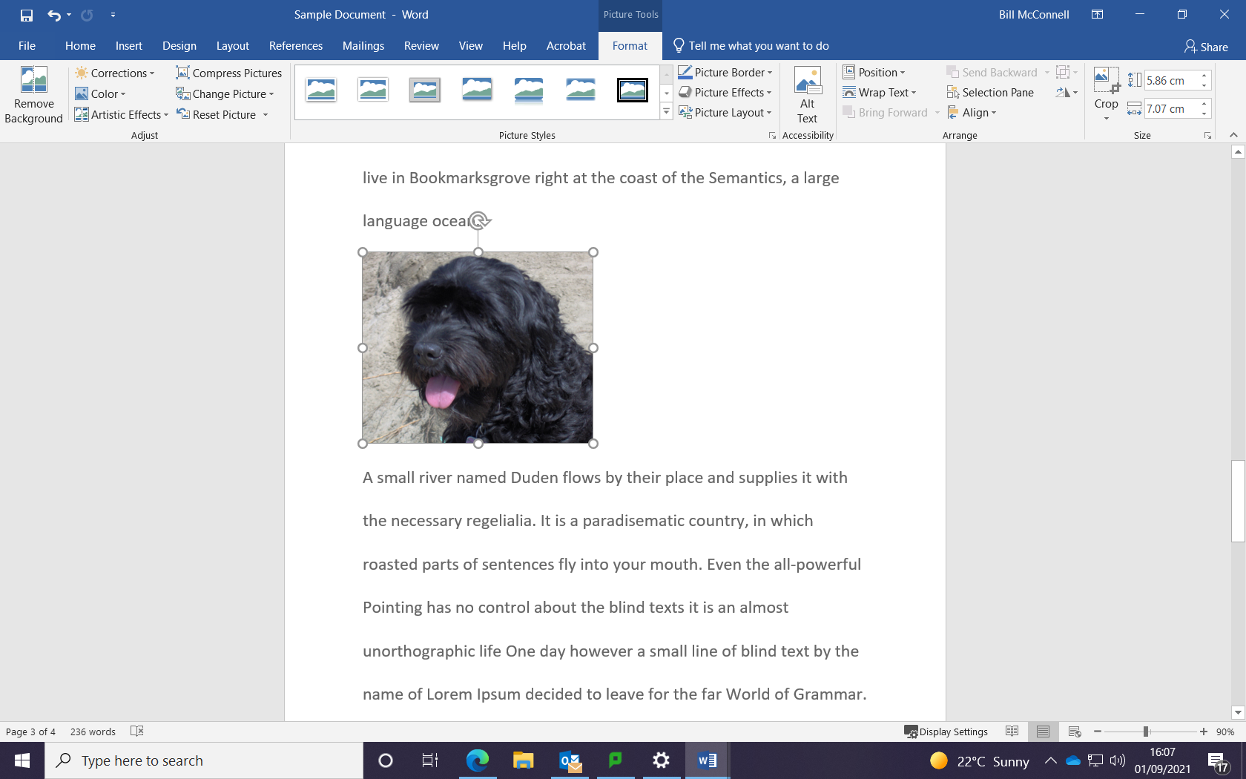

You can also search and insert image that are copyright cleared by choosing the Insert and then the Online Picture option, see area below.

