**[1]**

**How to Create a Column Chart Using Excel**

To create a chart, you need three things…

Text or numbers used as column labels for along the top of your chart

Text or numbers used as row labels in each box and usually starting in box A2

Numerical s values associated with the row and column labels

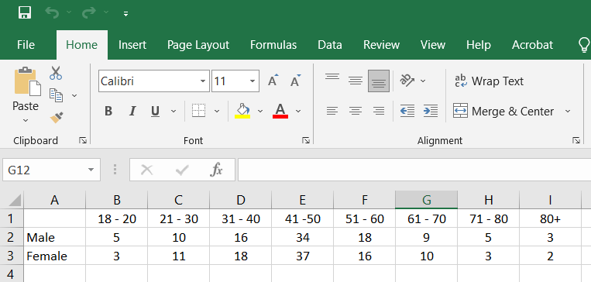

Using the mouse, point and hold down the left mouse button in box A1, while holding the left mouse button, move the mouse pointer down to box A3 and across to column I3, see example below.

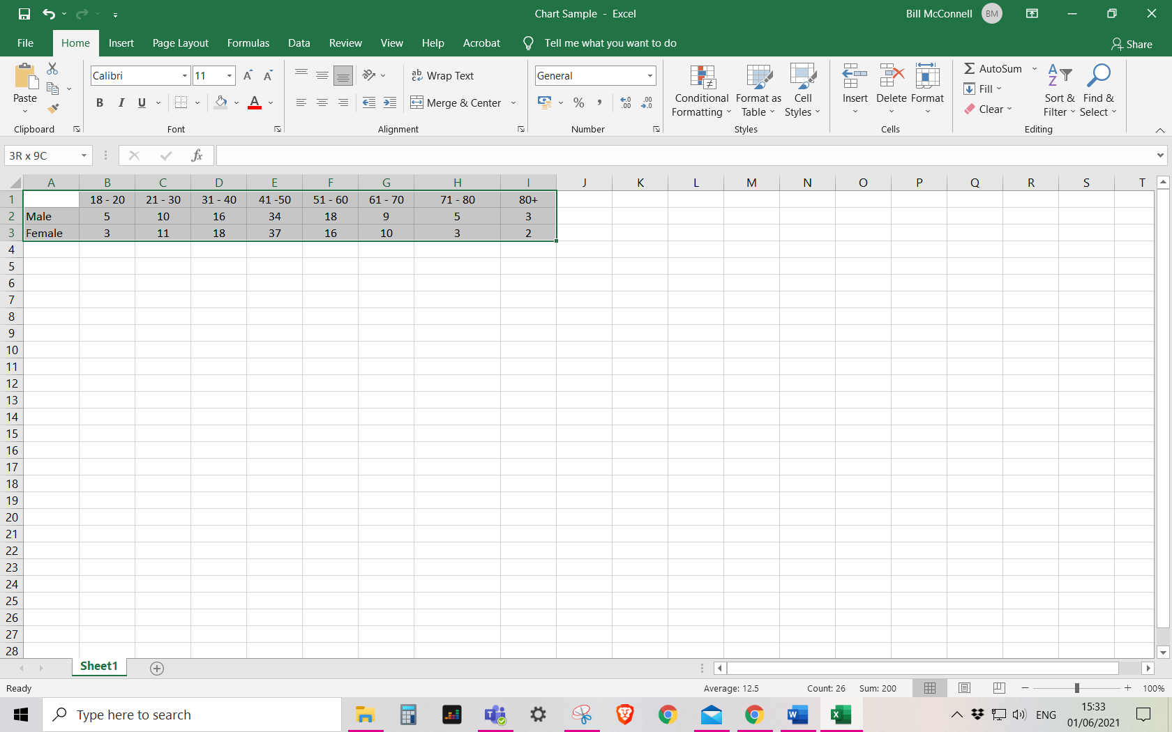

Select the dropdown arrow next to ‘Insert Column or Bar chart’ and choose an option.

Select the Insert Tab

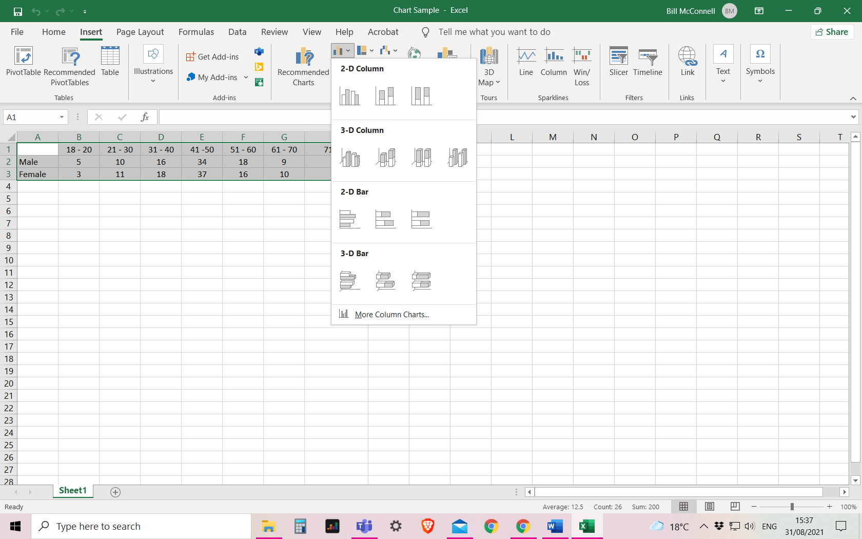

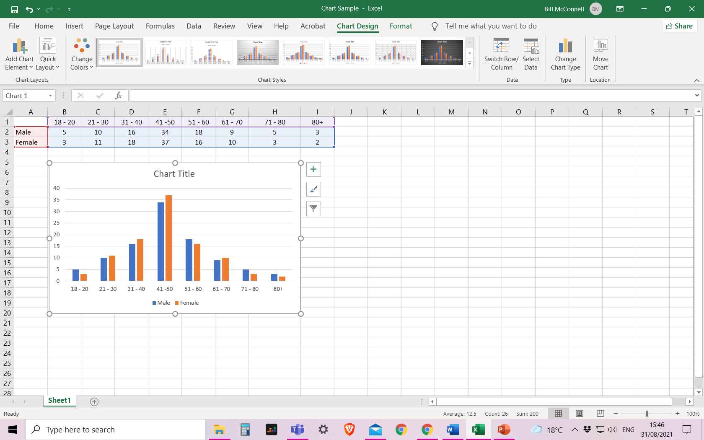The example below on the left is standard column chart but you can experiment and use the same values to create a Bar Chart, seen on the right,

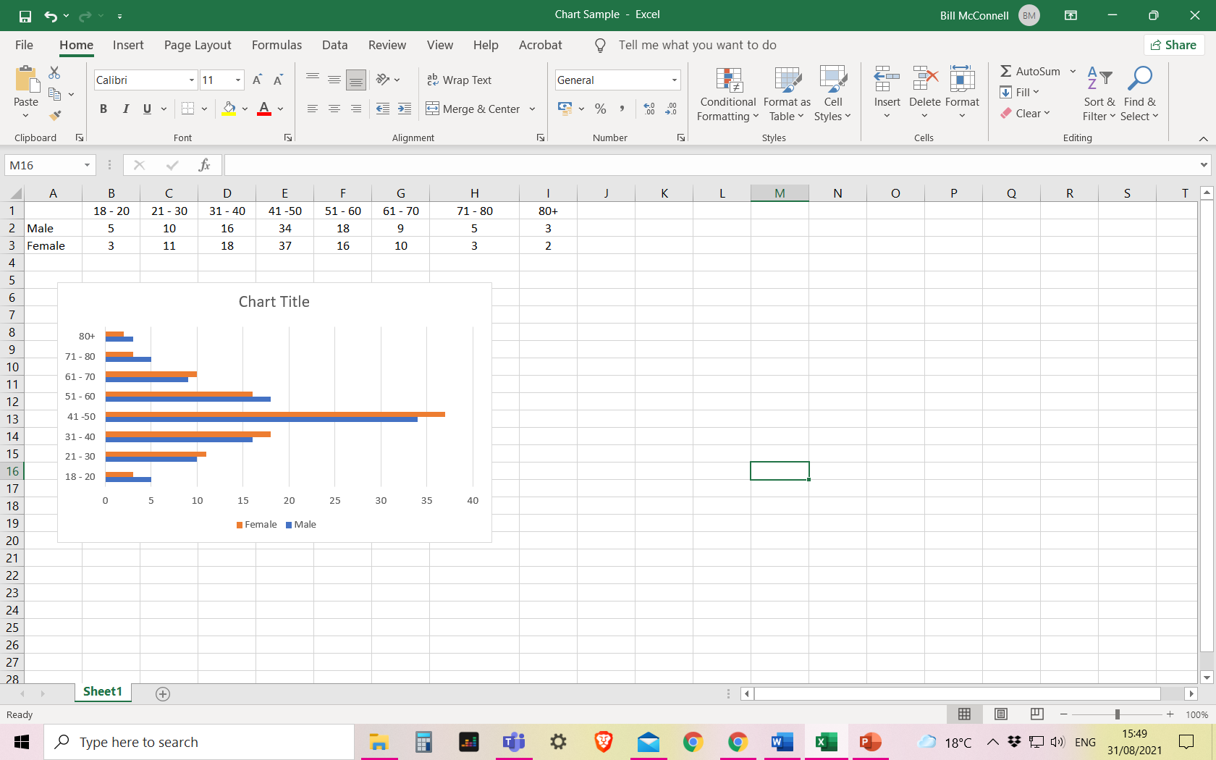

Do not leave gaps or empty boxes in your datasheet, notice in the highligted grey areas below, this will affect how your chart will look.

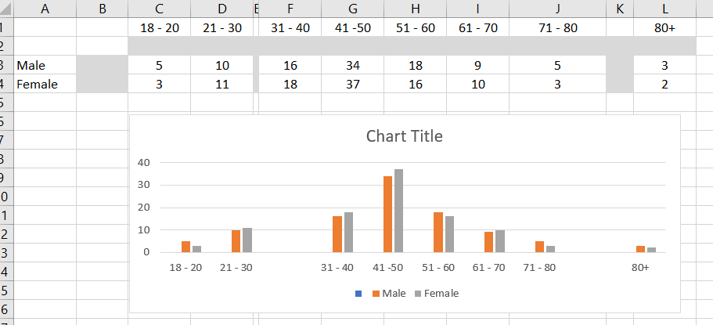

1.