**How to Create Page Numbers**

Select the drop down arrow next to Page Number

Select the Insert tab

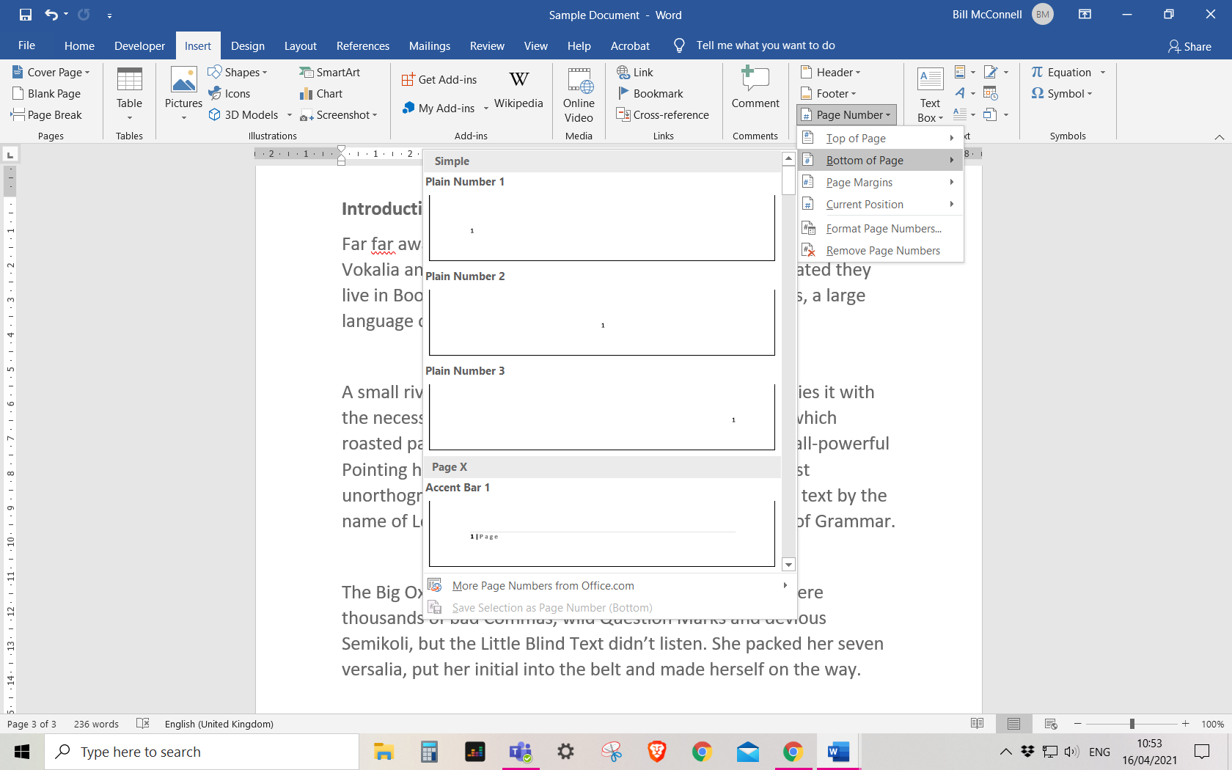

Select the Bottom of Page option then select a page number style

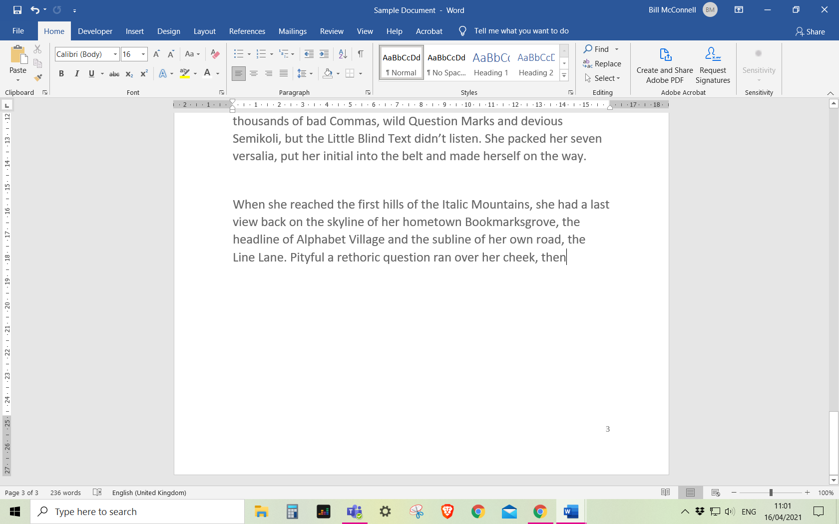

Each page will now automatically generate a new page number