**How to Create a Front Cover**

Select the Insert tab

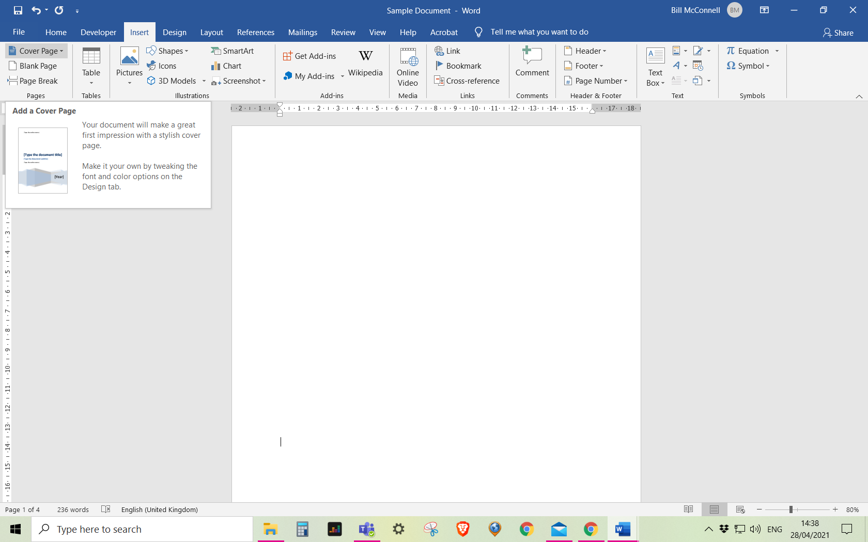

Select the drop down arrow next to Cover Page