**How to Create Paragraph Spacing**

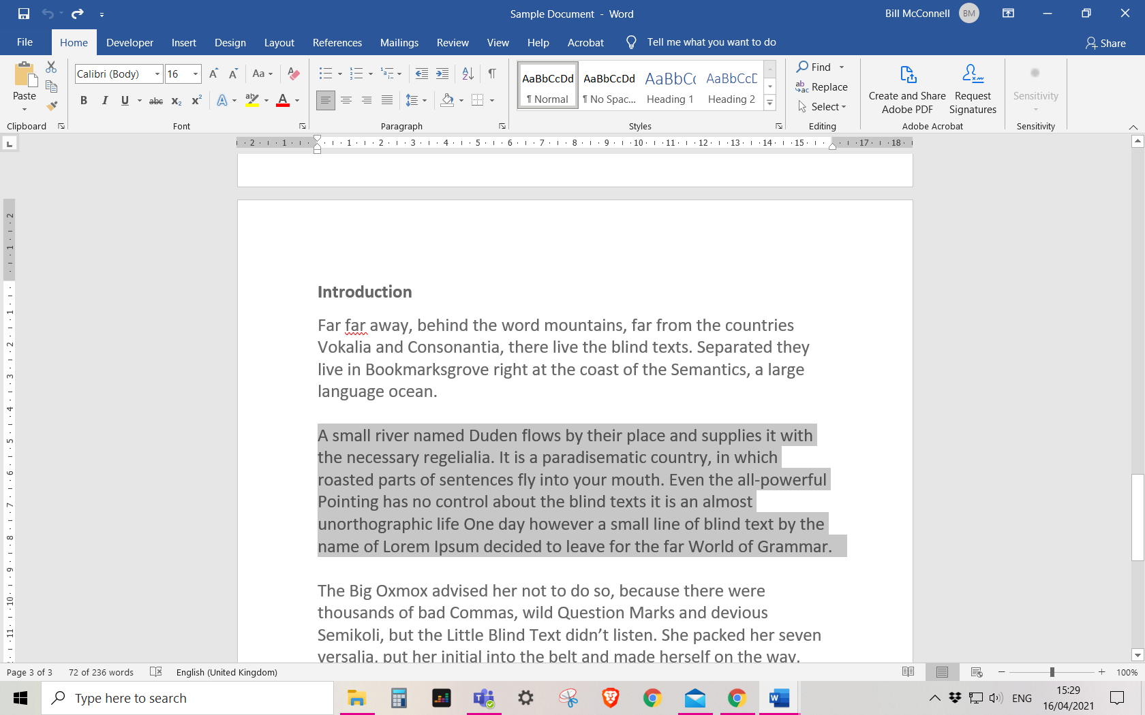

Position the cursor at the start of the paragraph or highlight the paragraph

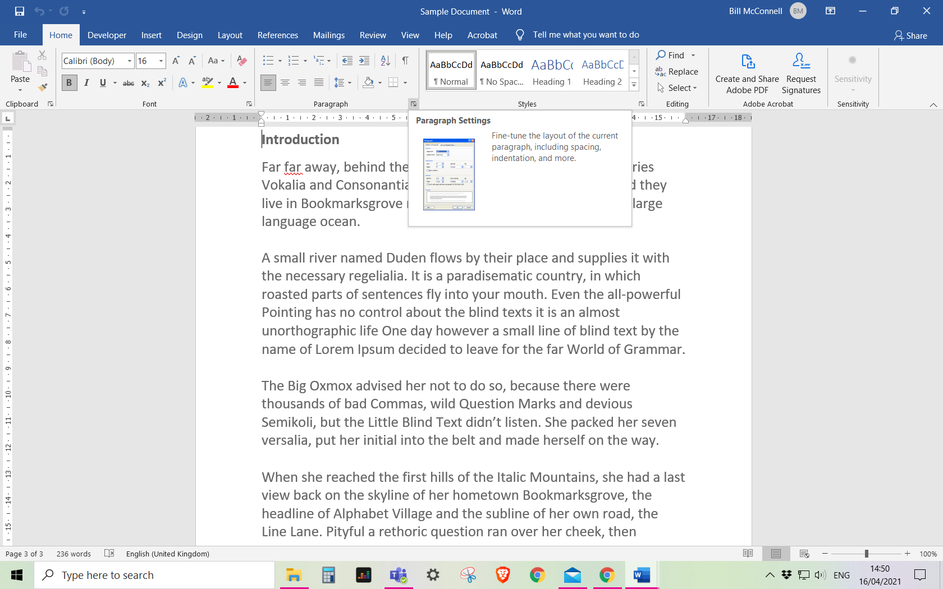

Select the Paragraph Settings option

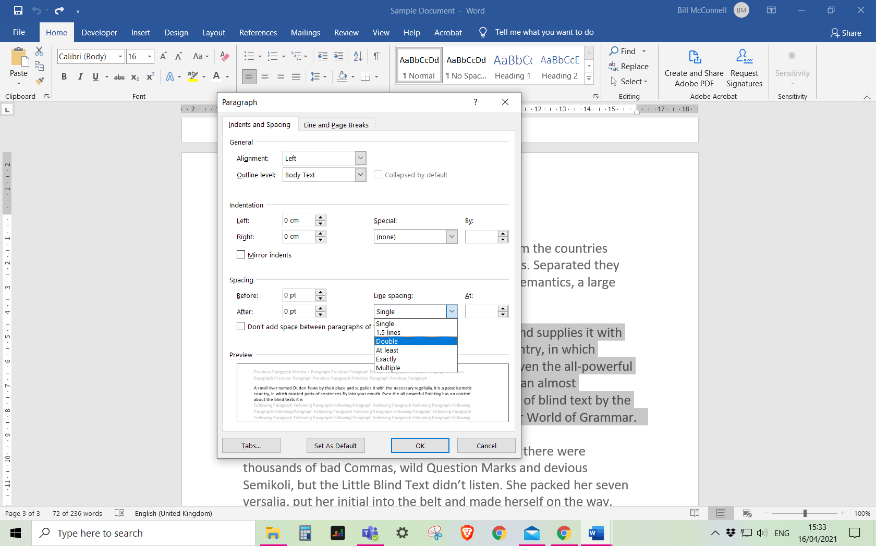

Select Double from the Line Spacing list and then select the OK button