**How to Create a Table of Contents**

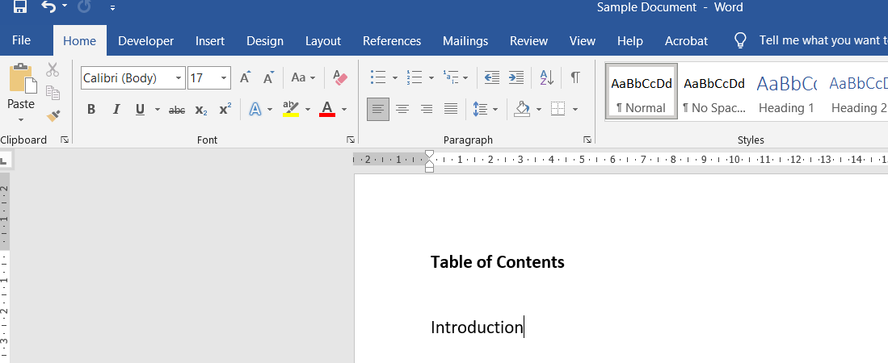

Type in the name of your first heading.

Click on the ‘View’ tab.

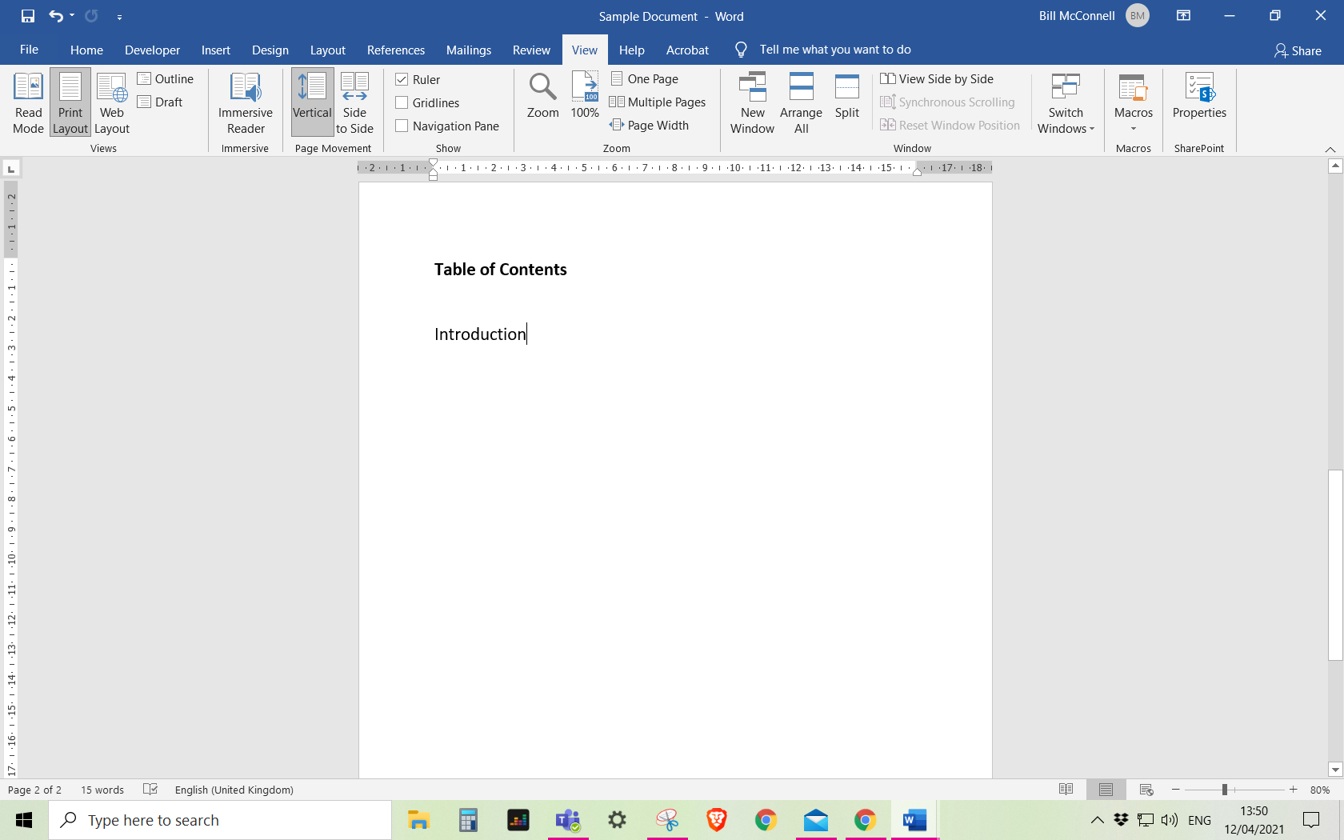

Click on the ‘Ruler’ box to turn it on.



Make sure your cursor is positioned at the end of your heading and using the ruler establish where you want your page numbers to be positioned, for example, at 14 or 15 cm on the page.

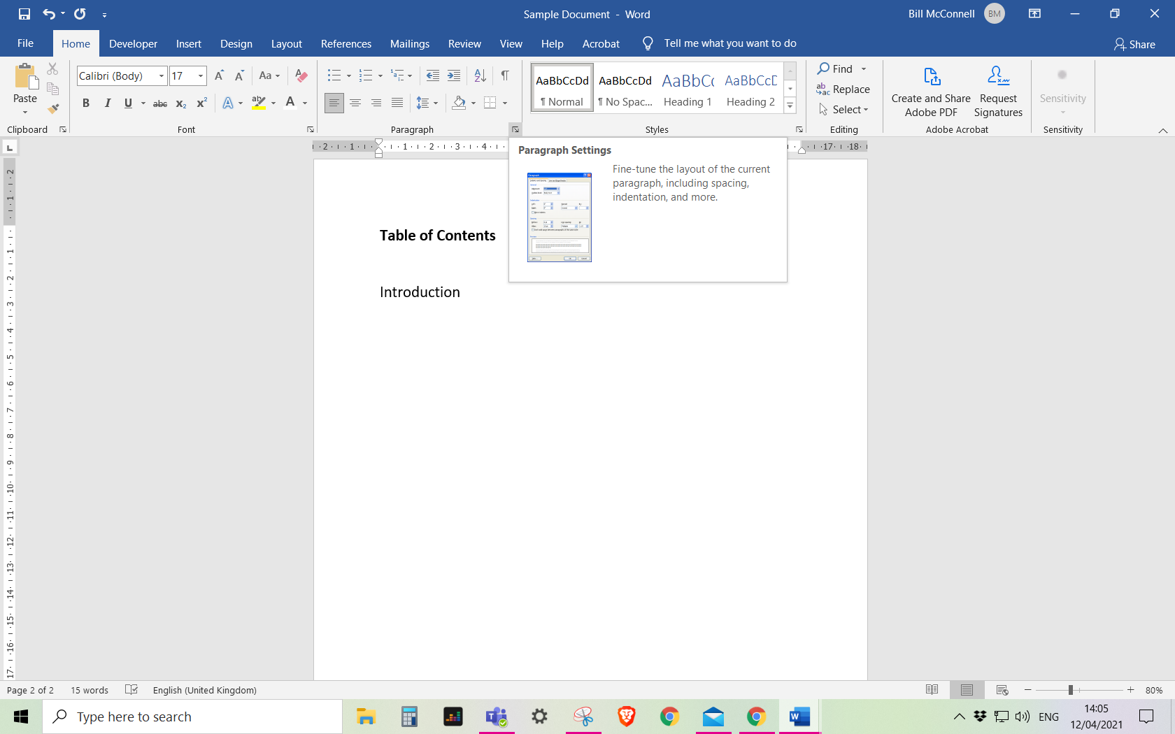

Click on **Paragraph setting**.

Click on the **Home** tab.

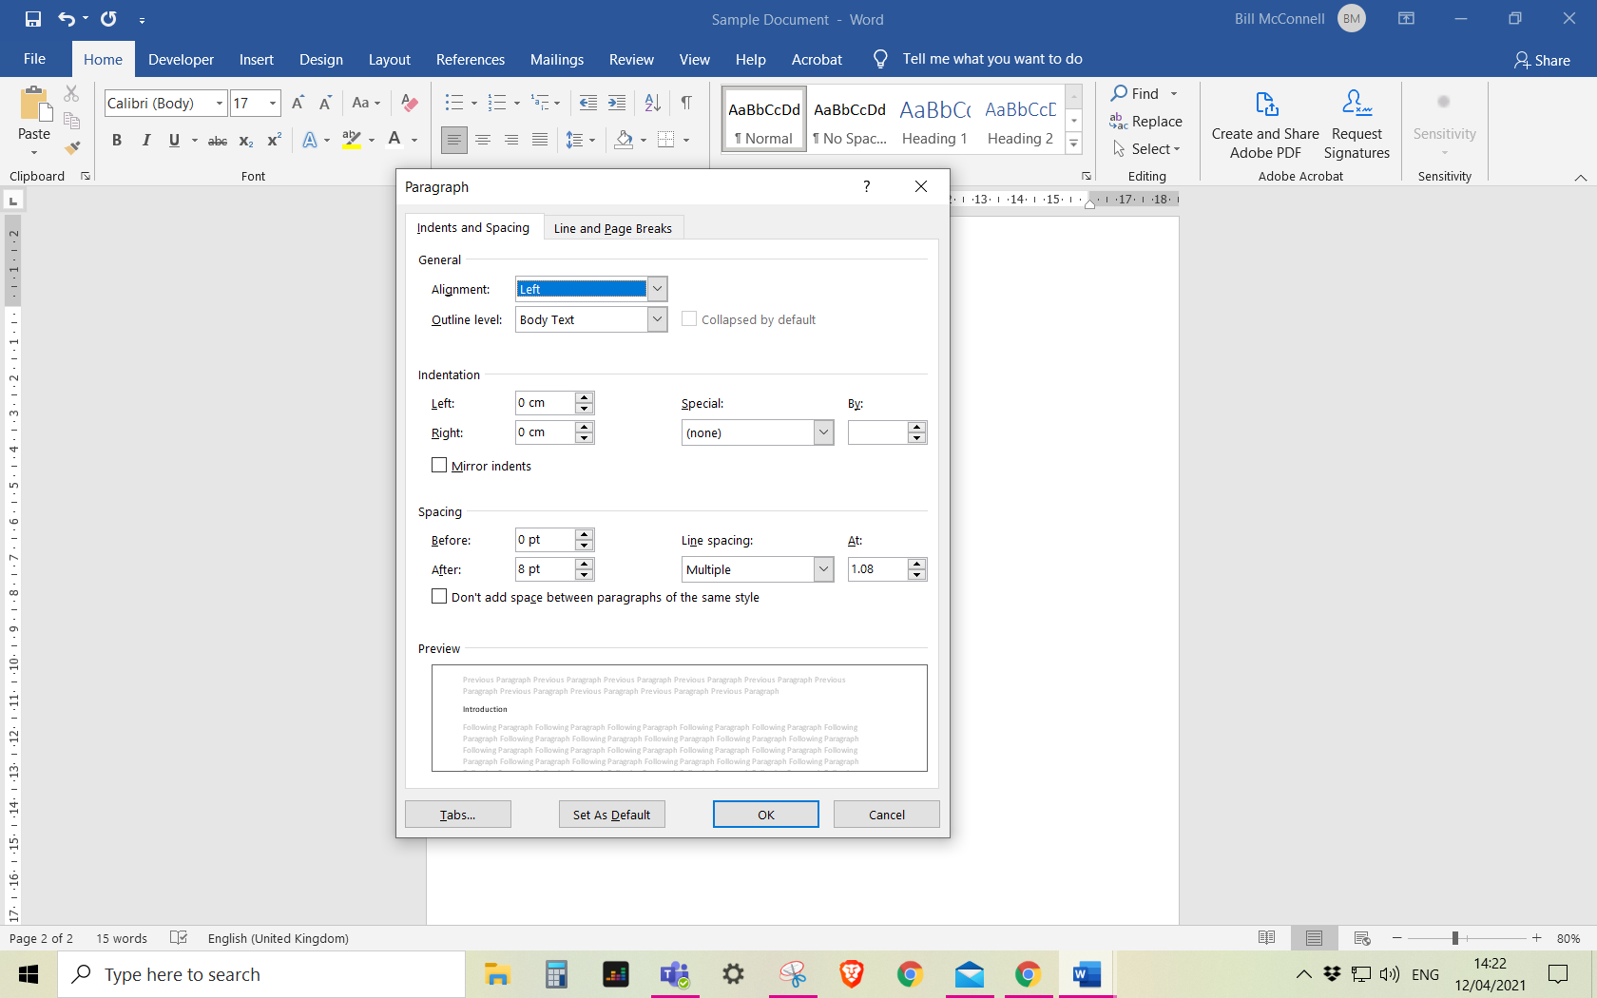

Click on **Tabs**.

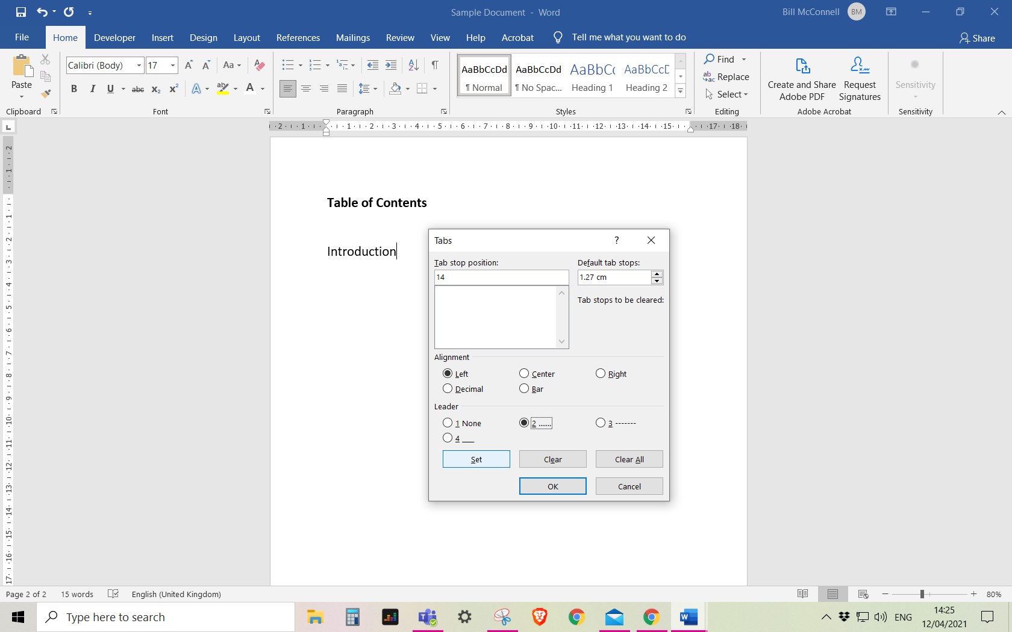

Select OK then press the Tab button on the keyboard.

Select ‘Set’ to confirm the details you want

Select if you want a solid line or dotted line on the page

Type in the number you want the cursor to jump to.

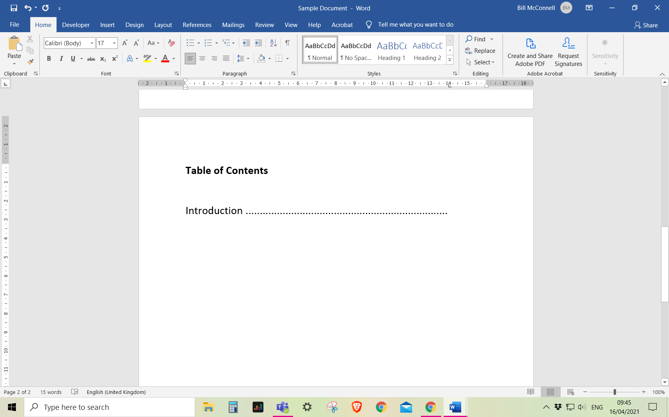

Type in the page number

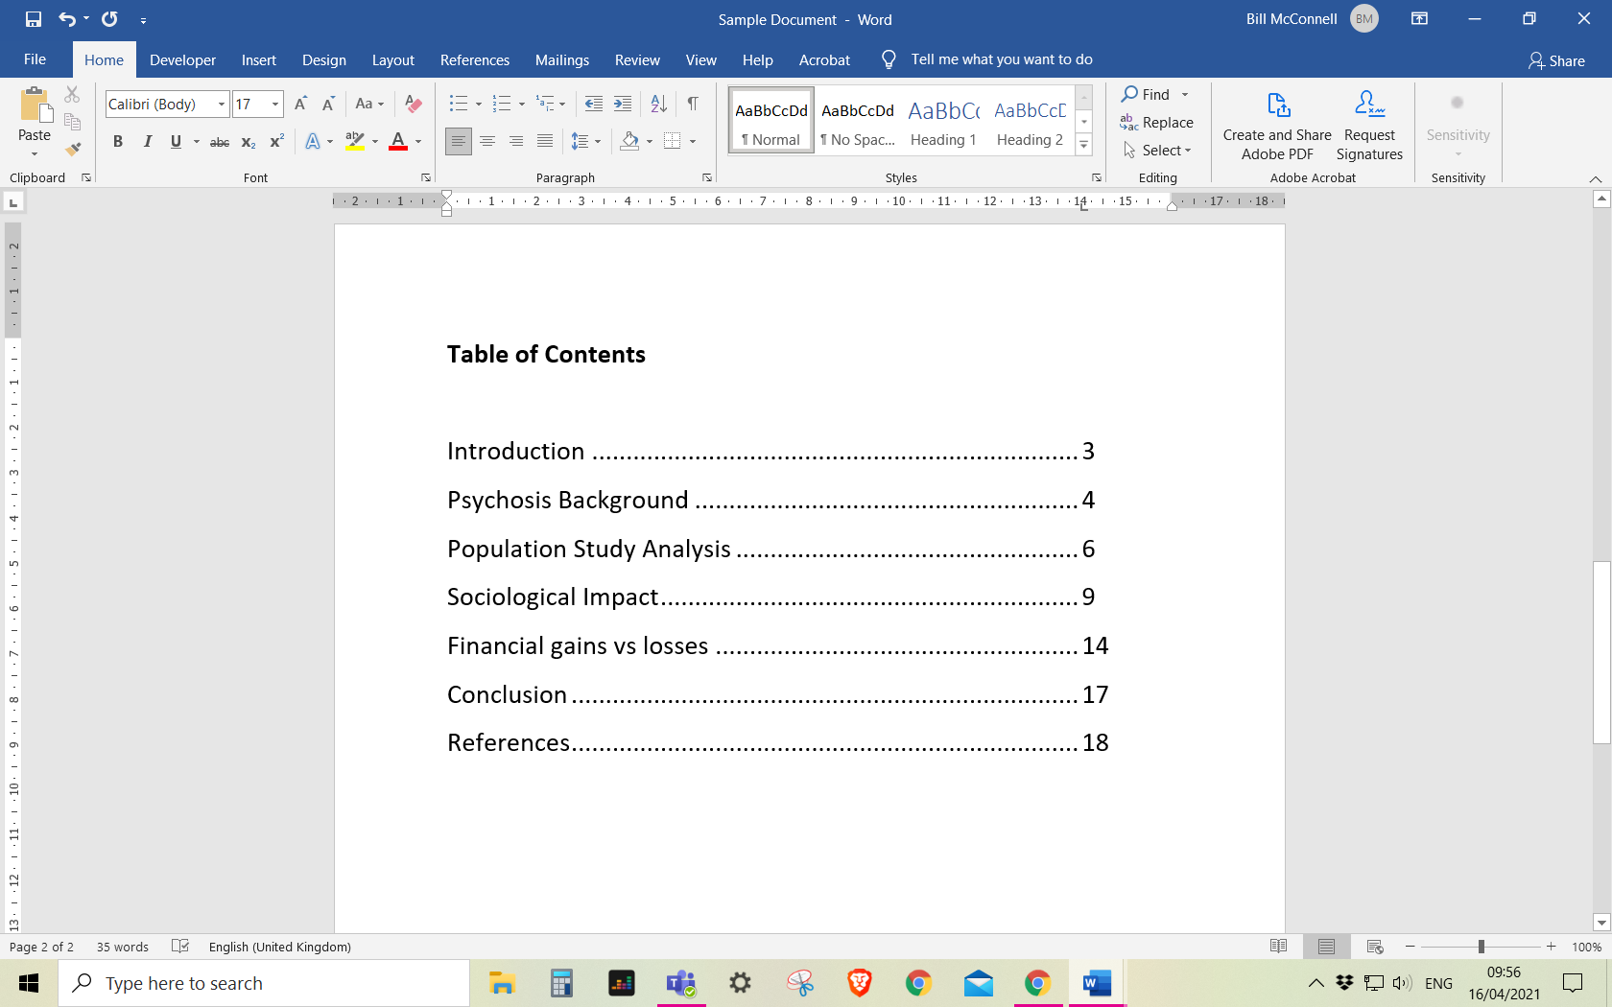

Repeat the previous steps after typing in each heading