*Resource of the Month*

*[](https://search.ebscohost.com/login.aspx?authtype=ip,shib&custid=ns148572&groupid=main&profile=ehost&defaultdb=ccm)*

Click on a box below for more information on that area:

|  |  |
| --- | --- |
| Introduction to CINAHL | Getting Started on CINAHL |
| How to Guides (Videos) | |

If you have any queries, please contact us at [library@nclan.ac.uk](mailto:library@nclan.ac.uk)

# Introduction to CINAHL

CINAHL (Cumulative Index to Nursing and Allied Health Literature) is a large and in-depth nursing research database, offering journal articles, book extracts and evidence-based care sheets.

CINAHL can be accessed through the [Online Resources](https://library.nclan.ac.uk/online-resources) page on the Library Website or through this [link](https://search.ebscohost.com/login.aspx?authtype=ip,shib&custid=ns148572&groupid=main&profile=ehost&defaultdb=ccm).

This resource may be useful for subjects such as:

* Nursing and Healthcare
* Dentistry
* Sport, Health and Fitness





# Getting Started on CINAHL

Below are some useful guides for getting started on CINAHL, they cover the following areas:

|  |
| --- |
| Basic Search |
| Advanced Search |

Click a box for more information on that area or scroll to read.

### Basic Search

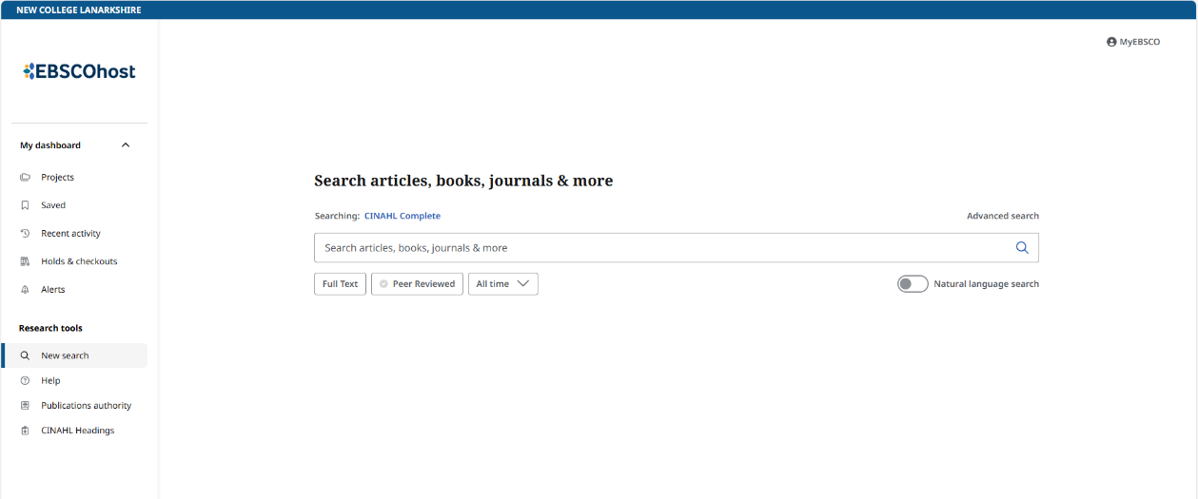

Enter your search into the search bar

**Example Search:** Asthma

Note: when searching a list of suggestions appear under the search bar. Click a suggestion to search.

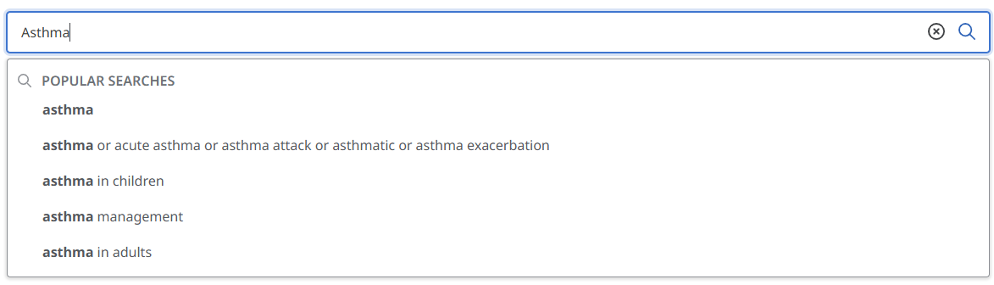

After searching a list of results will appear:

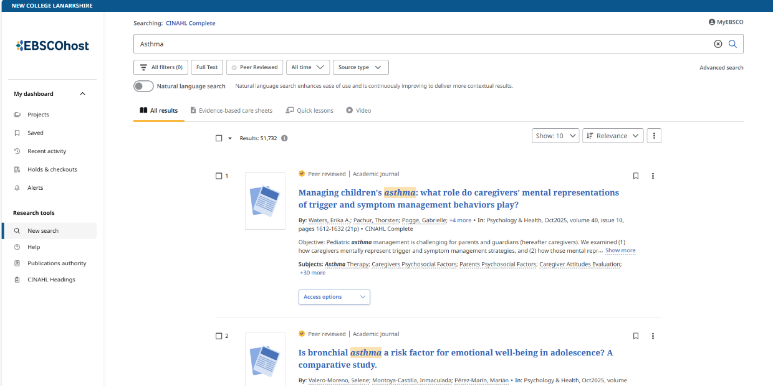

You can filter the type of result/publication from these tabs:

Evidence Based Care Sheets, Quick Lessons, Videos or All Types

You can sort the results here

You can filter the results here by Date or Source for example

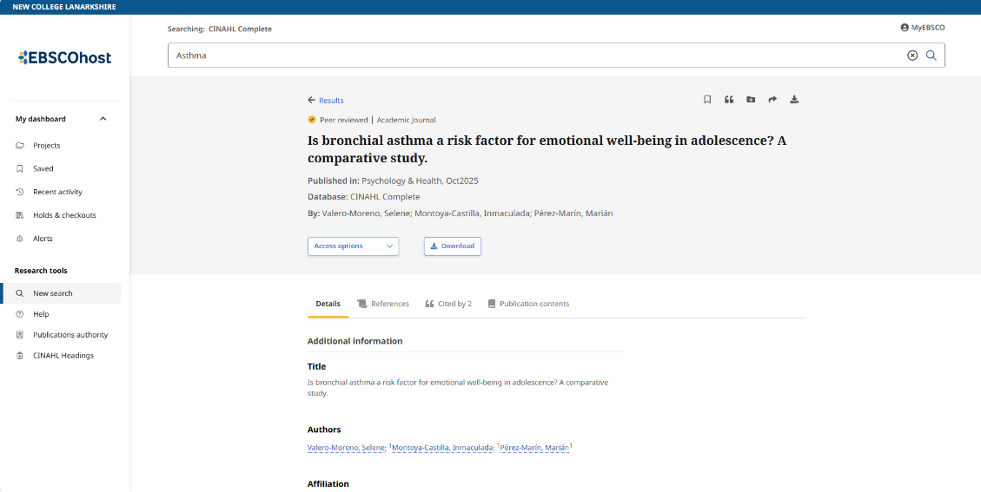

After clicking a result:

You can access the publication to read online or as a PDF here

### Advanced Search

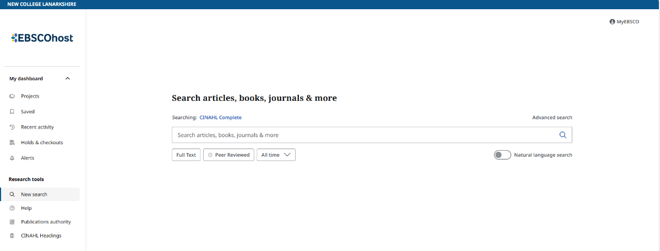

Select ‘Advanced Search’

**Example Search:** Asthma and Children

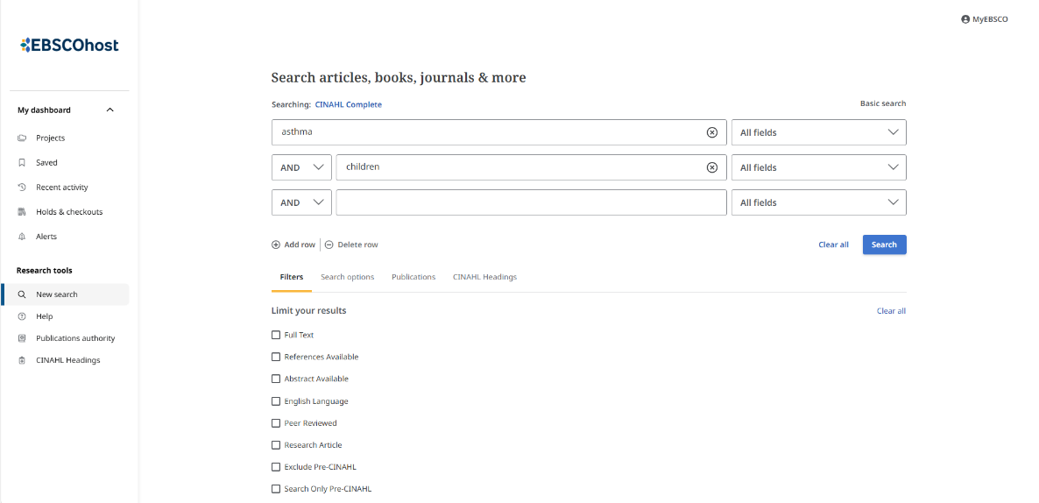

Once you have filled in the search, select ‘Search’

There are further filters and options that can be used here

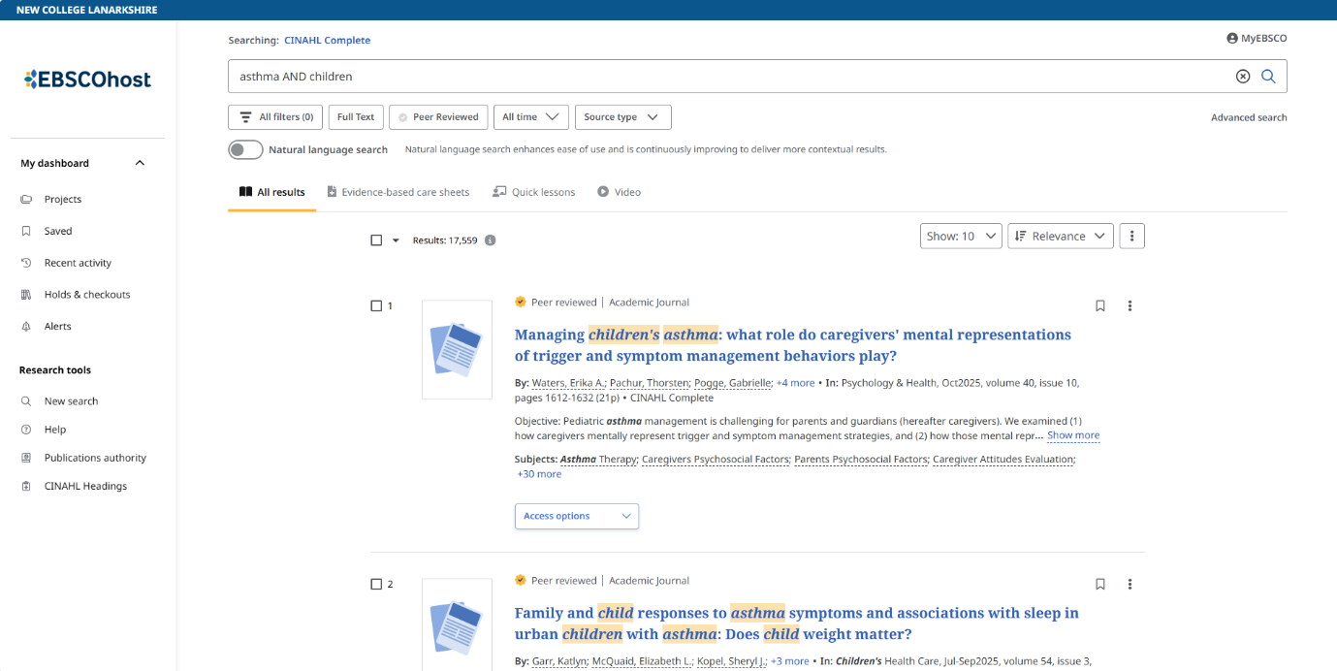After searching a list of results will appear:

You can filter the results here by Date or Source for example

You can sort the results here

You can filter the type of result/publication from these tabs:

Evidence Based Care Sheets, Quick Lessons, Videos or All Types

After clicking a result:



You can access the publication to read online or as a PDF here

# How to Guides (Videos)

Below are a few useful how to videos for using CINAHL.

To access: right click on a video and select “Open in Browser”.

Introduction to CINAHL:

[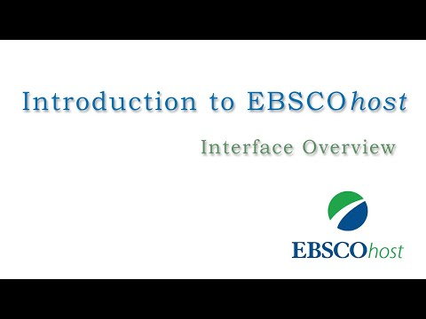](https://www.youtube.com/watch?v=s9QmFBSz17A)

Creating a Basic Search:

[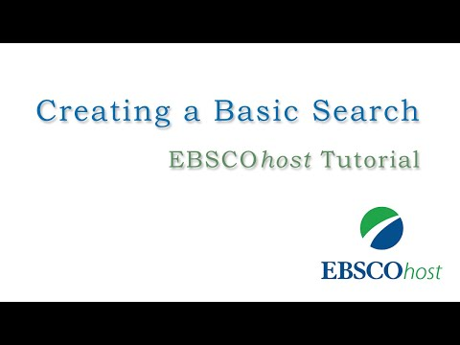](https://www.youtube.com/watch?v=vT833d5F2yI)

Creating an Advanced Search:

[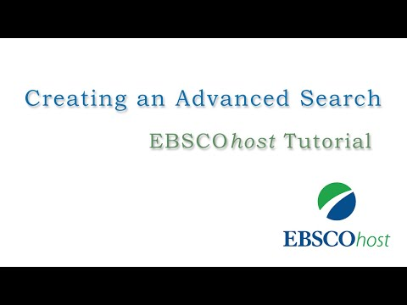](https://www.youtube.com/watch?v=OsD0ZH1hx4o)

Reading Articles:

[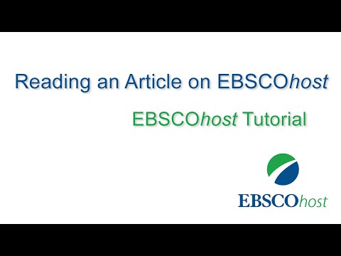](https://www.youtube.com/watch?v=_3wx3qTenHc)