How to use the VLe App

VLe now has an app which means you can access e-books 24/7 from your phone!

Below are some useful guides for the VLe app, they cover the following areas:

Downloading the App

Signing into the App
Using the App

Click a box for more information on that area or scroll to read.

Downloading the App
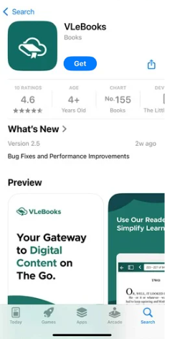
In the App Store search “VLe Books”
and Download the App

Signing into the App

To sign into the app for the first time you have to create an account on VLe Books.

- Sign into VLe Books using Shibboleth- same as above
- Find a book to download
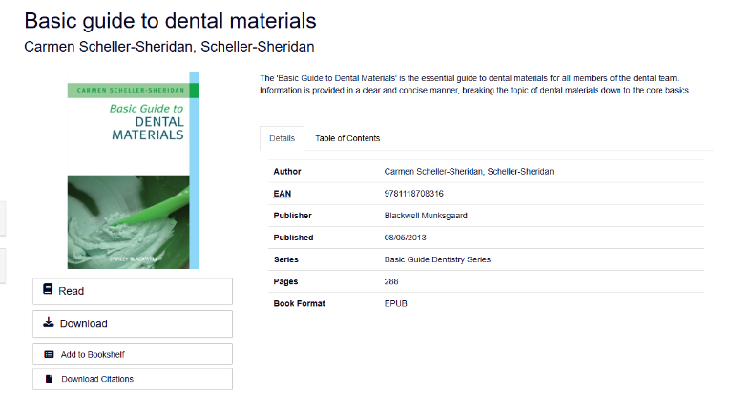
- Click Download

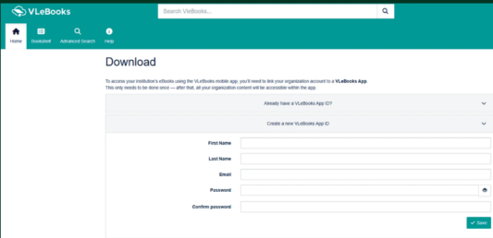
- Fill out the form to create your VLe Books App ID

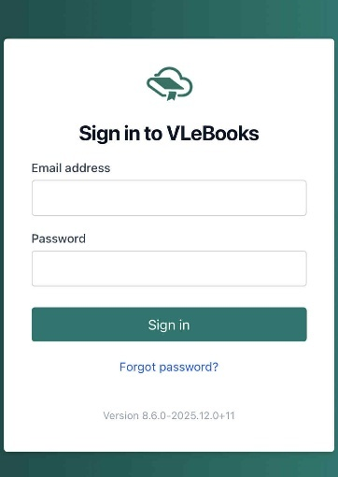
- Open the App and Sign In
using your VLe Books App ID

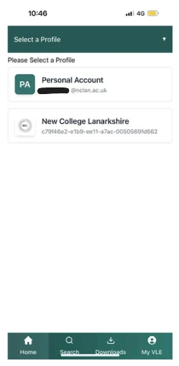
- Select ‘New College Lanarkshire’
from the Profile list

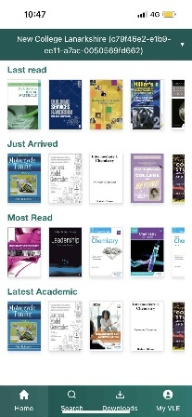
- You now have access to VLe
Books through your phone

Click here for another full guide to downloading and signing into the VLe App.

Using the App

The VLe Books App works in the same way as the VLe Books Website.
Below are some useful guides on how to search, read and loan e-books on the VLe Books app.

Searching for E-books

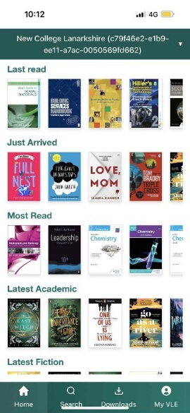
Select the ‘Search’ Tab

There are two different methods of searching: basic search and advanced search.
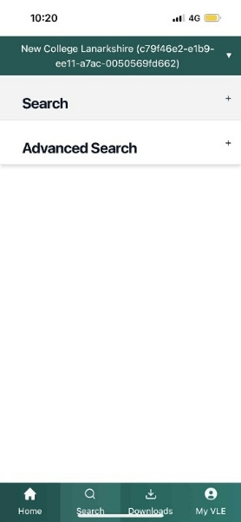
Basic Search
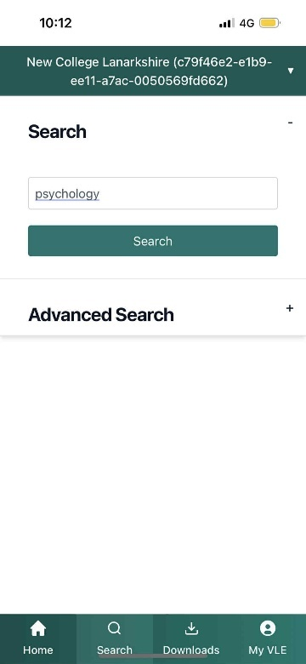
Enter your search using the search bar

Example Search: Psychology

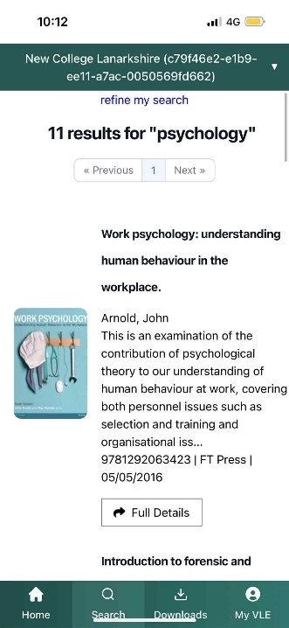
A list of results will be shown here
Click here for more information on reading e-books

Advanced Search

Example Search: psychology AND sport

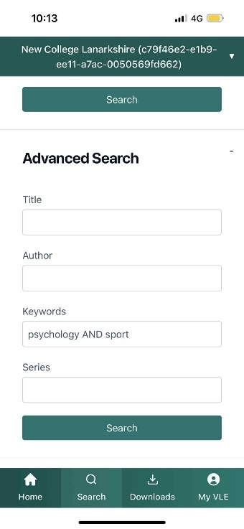
Once filled in select ‘Search’

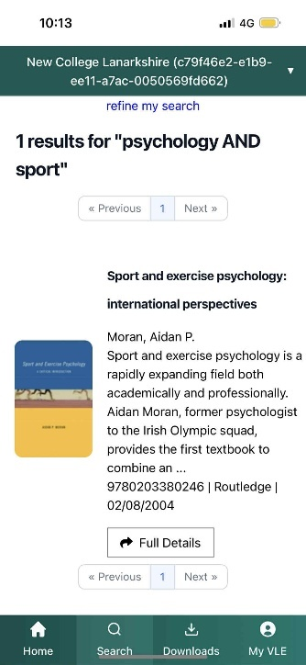
A list of results will be shown here
Click here for more information on reading e-books

Reading E-books
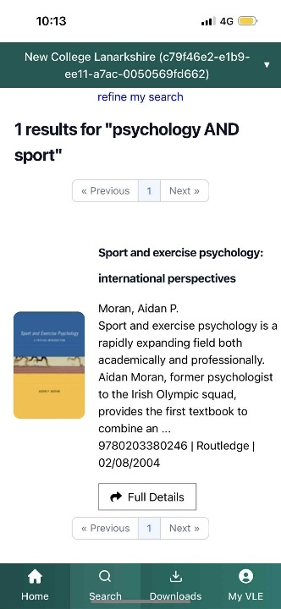

Select the title you want to read

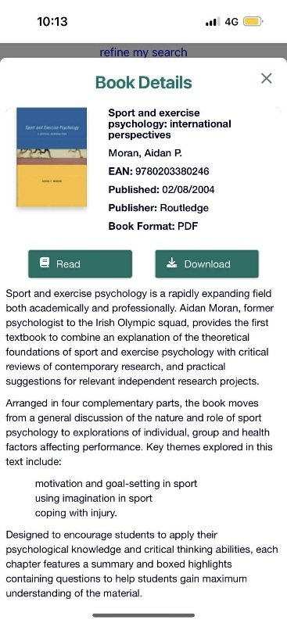
This page provides details about the book

Click ‘Read’ to read the book or ‘Download’ to loan it
Click here for more information on loaning e-books

You can find the table of contents here
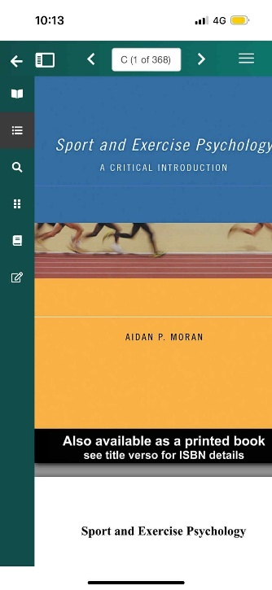
You can also search within the book from here
This works in a similar way to a basic search

Loaning E-books

Find the book you wish to download:
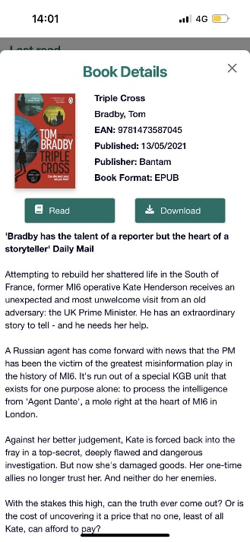

Select ‘Download’

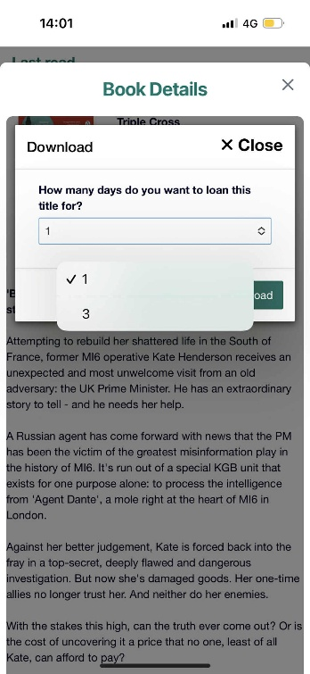
You will be asked to choose how many days you want to loan the title
Max loan time is 3 days
After selecting download the title will then start downloading


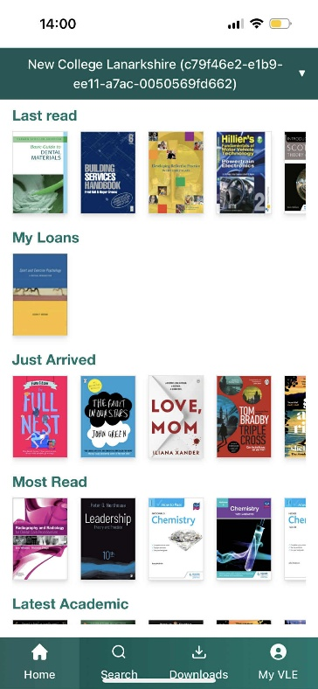
Loans can be found under the ‘Downloads’ Tab
You can also delete loans and find the expiry date for your loans from the downloads tab

Loans can be seen on the home page

