Resource of the Month
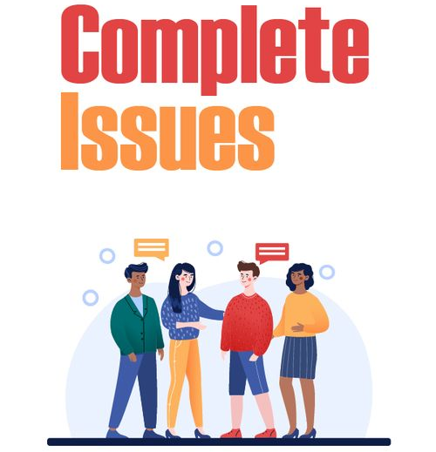

Click on a box below for more information on that area:

Introduction to Complete Issues | Getting Started on Complete Issues
How to Videos

If you have any queries, please contact us at library@nclan.ac.uk

Introduction to Complete Issues

Complete Issues is a resource which contains articles, statistics, personal accounts and links to websites on a wide range of topics.

Complete Issues can be accessed through the Online Resources page on the Library Website or through this link.

NOTE: When accessing you will then be taken to the Moodle Home screen – click on the top right-hand corner of the page to log in with your college email and password. A page will then be displayed which contains a link to click to access Complete Issues, and below the link the Username and Password required to access the site are also displayed.

Complete Issues is useful for all subjects:

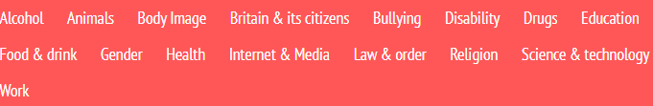


Getting Started on Complete Issues

Below are some useful guides for getting started on Complete Issues, they cover the following areas:
Accessing Complete Issues

Searching for Content

Click a box for more information on that area or scroll to read.

Accessing Complete Issues

When accessing you will then be taken to the Moodle Home screen:


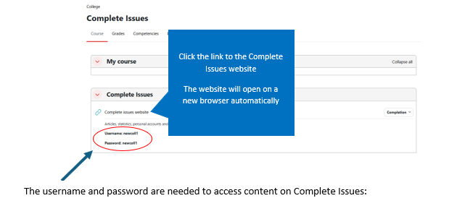

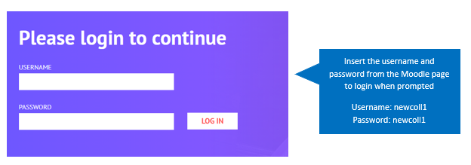

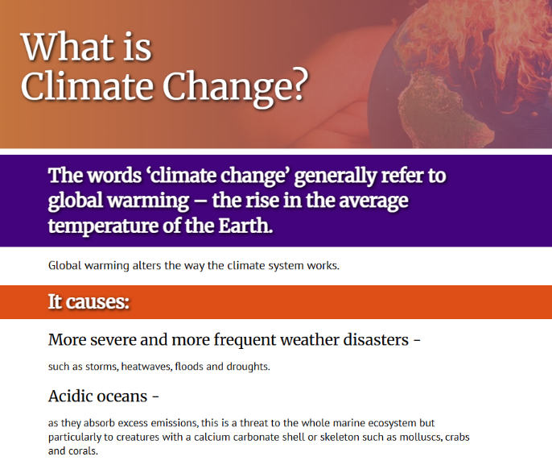
Logging in will give access to the issues and articles etc.

Searching for Content

There are two ways to search on Complete Issues.
- Searching using the search bar
- Searching through subjects

Searching using the Search Bar
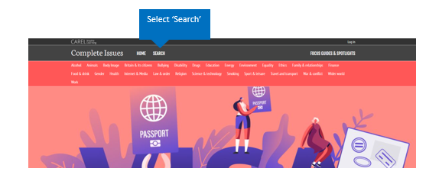

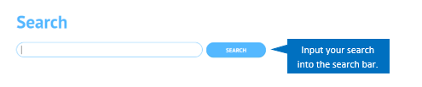
Example Search: Climate Change

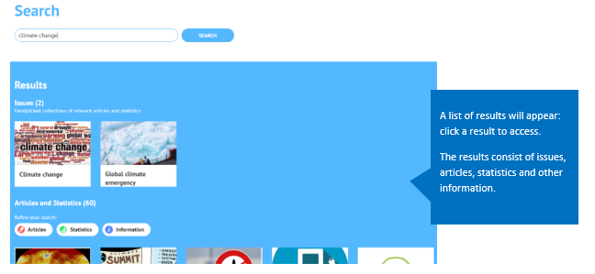

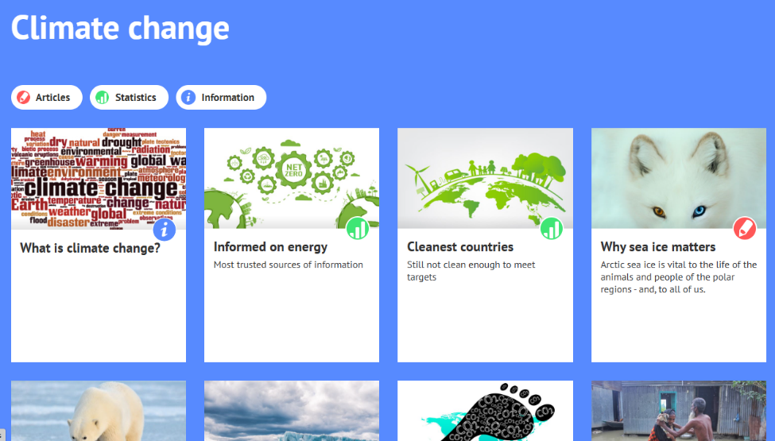
Issues contain several articles, statistics and other information:

Click a result to access.
Note: you have to be logged in to access content.
Click here for further information on how to access.

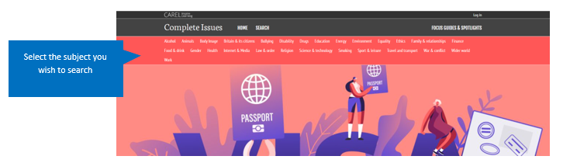
Searching through Subjects

Example Search: Climate Change
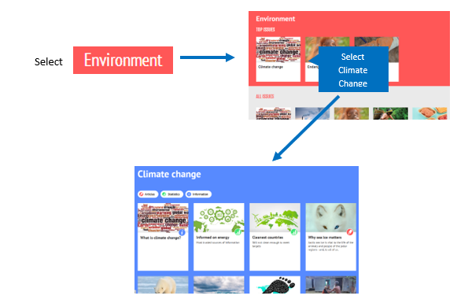
Click a result to access.
Note: you have to be logged in to access content.
Click here for further information on how to access.

How to Videos
Below is a useful how-to video for getting started on Complete Issues.
Click on the thumbnail to access.
