Resource of the Month



Click on a box below for more information on that area:

Introduction to VLe Books | Getting Started on VLe Books
How to Videos | VLe App

If you have any queries, please contact us at library@nclan.ac.uk

Introduction to VLe Books

VLe Books is a collection of E-books including many recommended texts.

VLe Books can be accessed through the Online Resources page on the Library Website or through this link.

VLe Books is a useful resource for all subjects.



Getting Started on VLe Books

Below are some useful guides for getting started on VLe Books, they cover the following areas:
Signing into VLe Books

Searching for Content

Reading Content

Click a box for more information on that area or scroll to read.

Signing into VLe Books
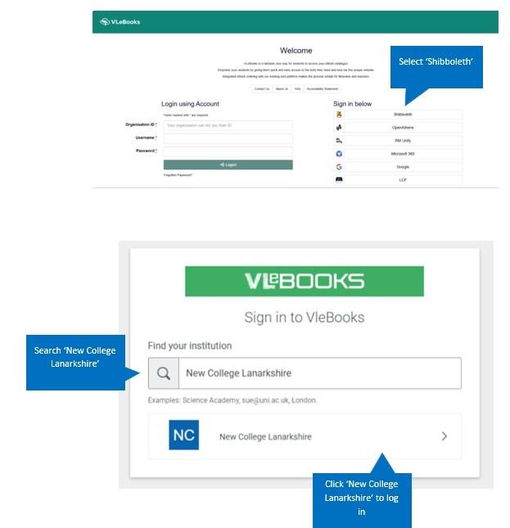

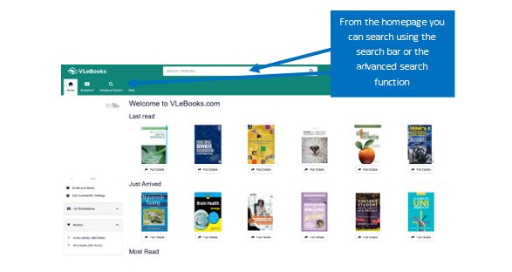
Searching for Content

Search Bar
Example Search: Psychology
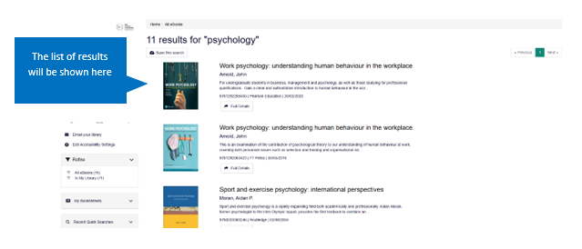

Advanced Search

Example Search: psychology AND sport

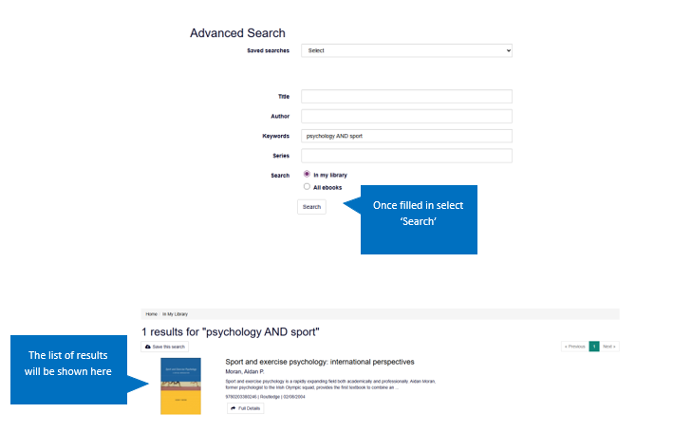

Reading Content

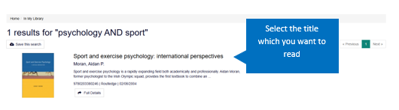

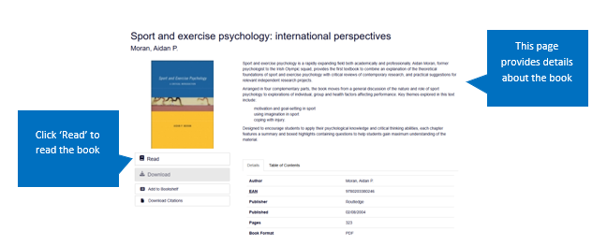
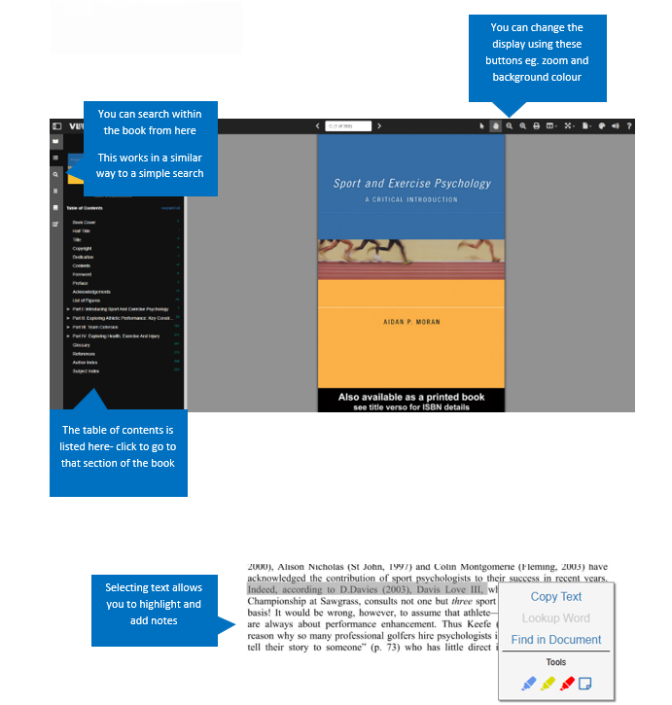

How to Videos

Below is a useful how-to-video for getting started on VLe Books.
Click the thumbnail to access.
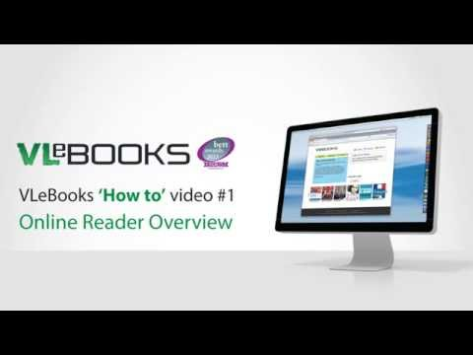

VLe App

VLe Books now has an app where you can access e-books 24/7 from your phone!

Below are some useful guides for the VLe app, they cover the following areas:

Downloading the App

Signing into the App
Using the App

Click a box for more information on that area or scroll to read.

Downloading the App
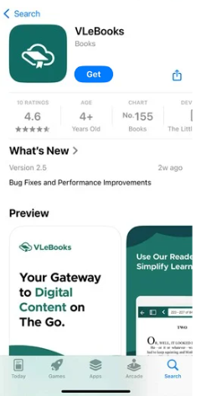
In the App Store search “VLe Books”
and Download the App

Signing into the App

To sign into the app for the first time you have to create an account on VLe Books.

- Sign into VLe Books using Shibboleth- same as above
- Find a book to download
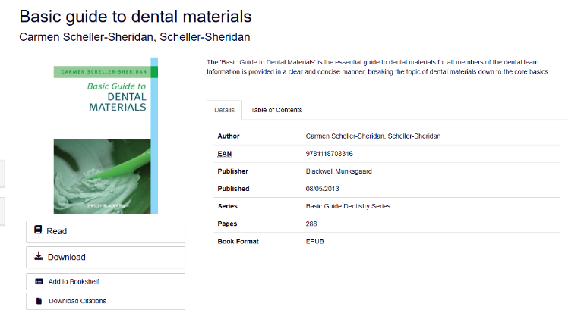
- Click Download

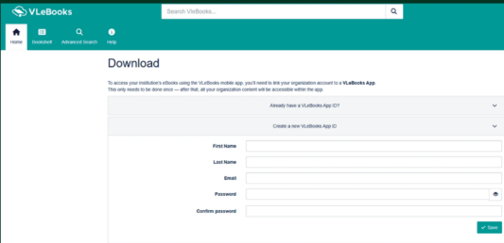
- Fill out the form to create your VLe Books App ID

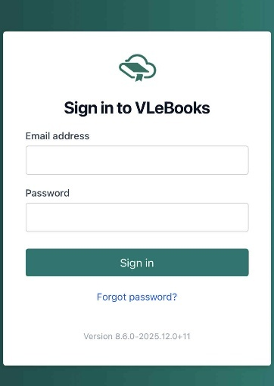
- Open the App and Sign In
using your VLe Books App ID

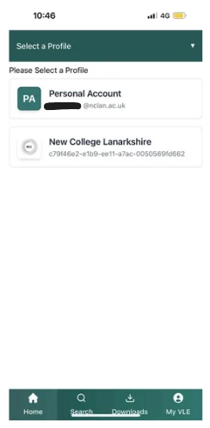
- Select ‘New College Lanarkshire’
from the Profile list

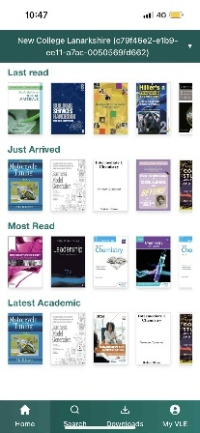
- You now have access to VLe
Books through your phone

Using the App

The VLe Books App works in the same way as the app for searching and reading books for example.
Click here for more information and for getting started on VLe Books.

A further guide to using the VLe app can be found on the How to Guide page on the Library Website.

