Resource of the Month


Click on a box below for more information on that area:

Introduction to CINAHL | Getting Started on CINAHL
How to Guides (Videos)

If you have any queries, please contact us at library@nclan.ac.uk

Introduction to CINAHL

CINAHL (Cumulative Index to Nursing and Allied Health Literature) is a large and in-depth nursing research database, offering journal articles, book extracts and evidence-based care sheets.

CINAHL can be accessed through the Online Resources page on the Library Website or through this link.

This resource may be useful for subjects such as:
- Nursing and Healthcare
- Dentistry
- Sport, Health and Fitness






Getting Started on CINAHL

Below are some useful guides for getting started on CINAHL, they cover the following areas:

Basic Search

Advanced Search

Click a box for more information on that area or scroll to read.

Basic Search
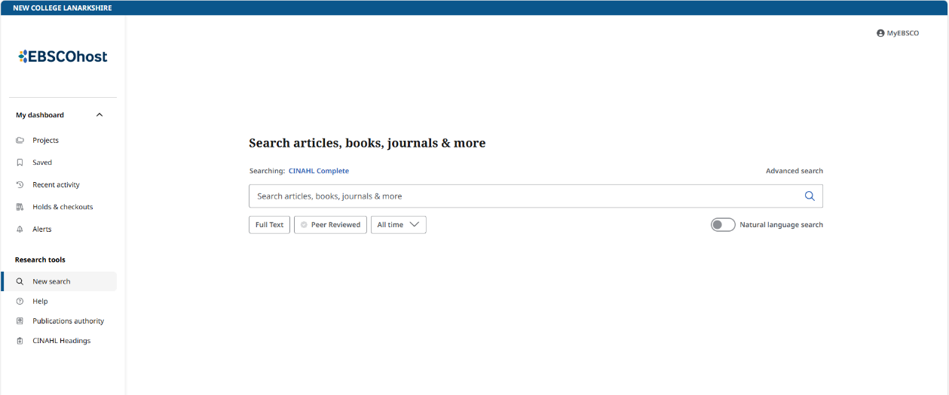
Enter your search into the search bar

Example Search: Asthma

Note: when searching a list of suggestions appear under the search bar. Click a suggestion to search.
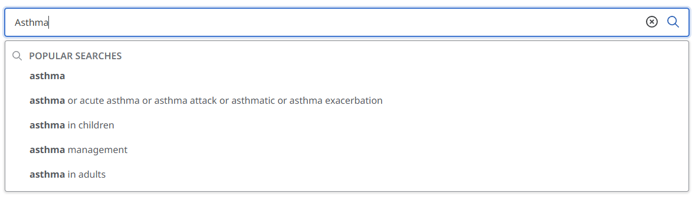

After searching a list of results will appear:

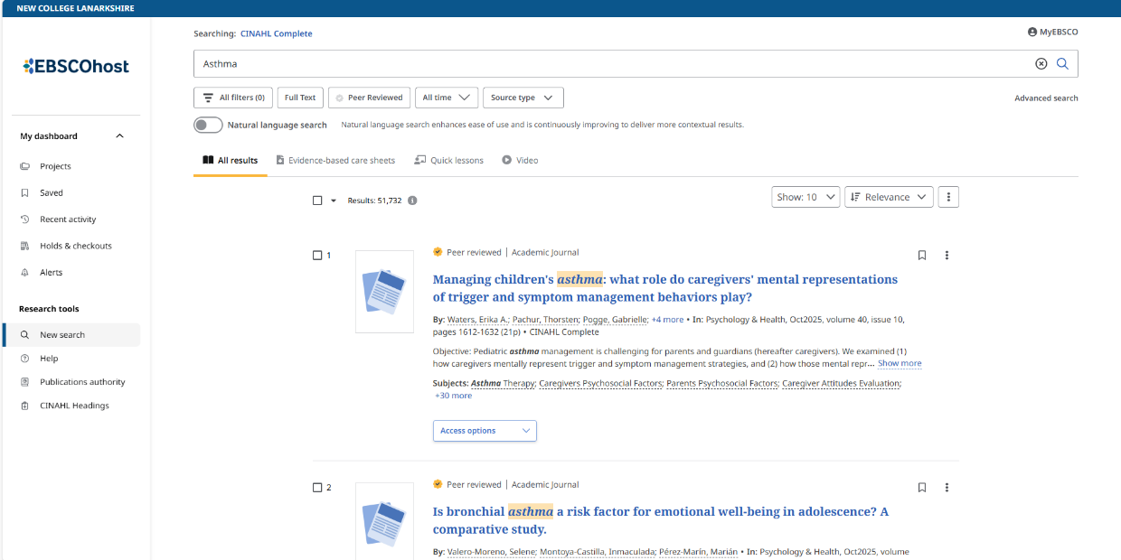
You can filter the type of result/publication from these tabs:
Evidence Based Care Sheets, Quick Lessons, Videos or All Types
You can sort the results here
You can filter the results here by Date or Source for example

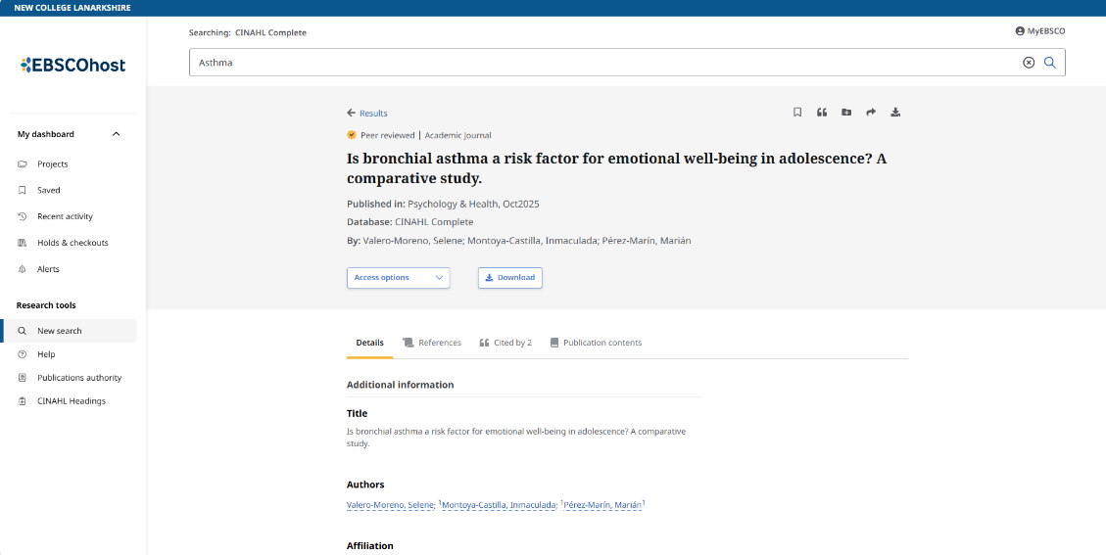
After clicking a result:
You can access the publication to read online or as a PDF here

Advanced Search

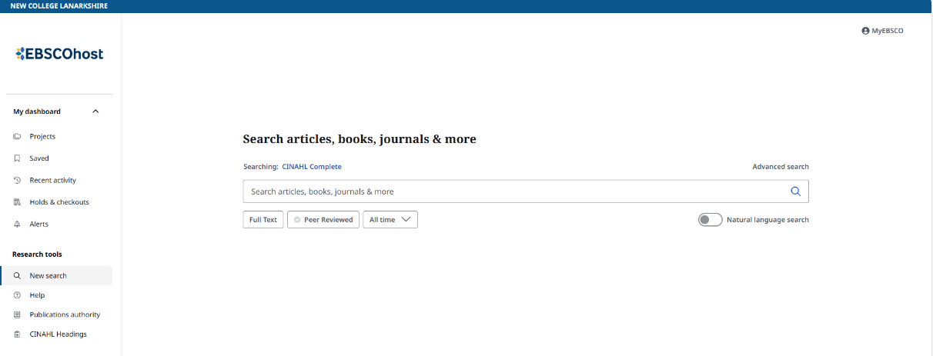
Select ‘Advanced Search’

Example Search: Asthma and Children

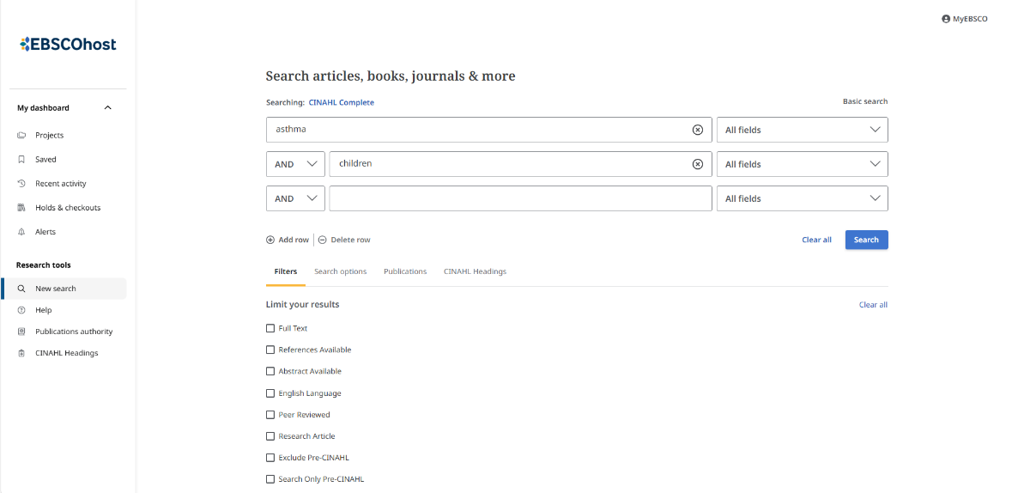

Once you have filled in the search, select ‘Search’

There are further filters and options that can be used here

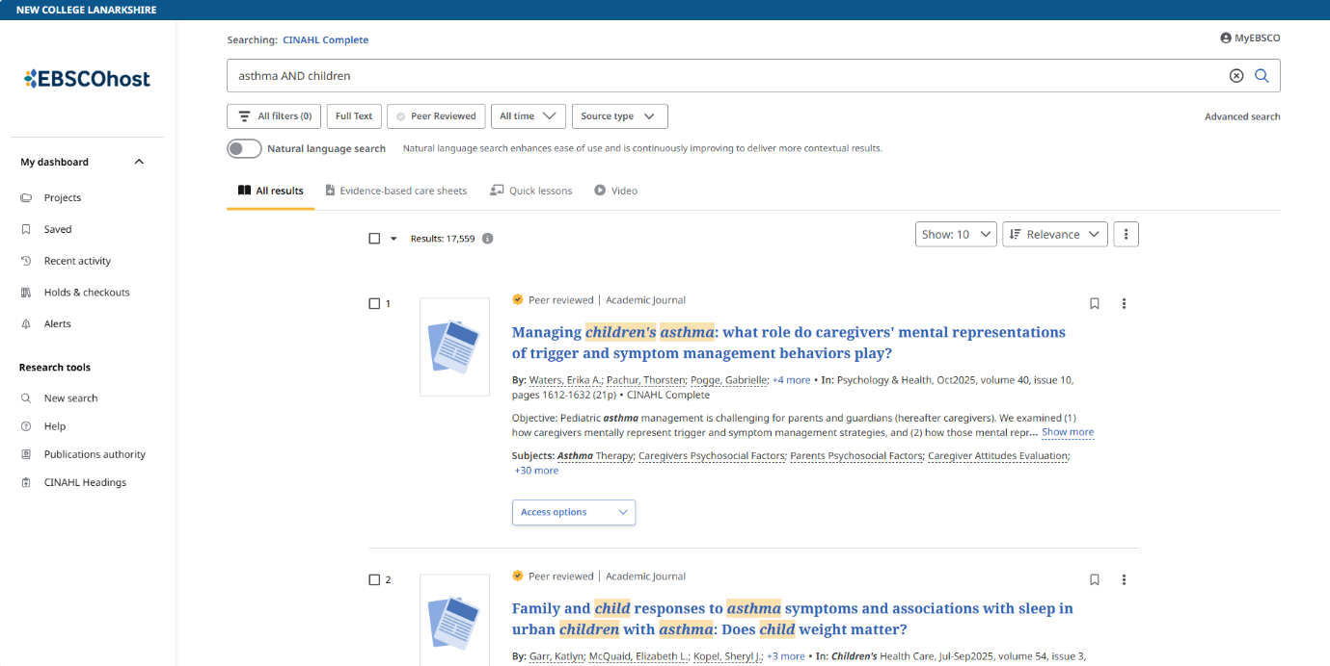
After searching a list of results will appear:
You can filter the results here by Date or Source for example
You can sort the results here
You can filter the type of result/publication from these tabs:
Evidence Based Care Sheets, Quick Lessons, Videos or All Types

After clicking a result:

You can access the publication to read online or as a PDF here

How to Guides (Videos)

Below are a few useful how to videos for using CINAHL.
To access: right click on a video and select “Open in Browser”.

Introduction to CINAHL:
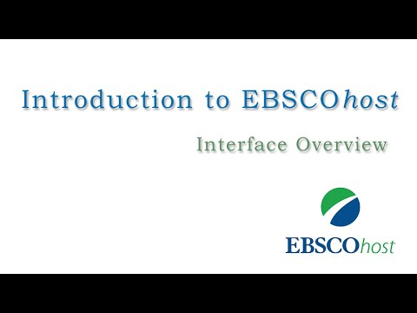

Creating a Basic Search:
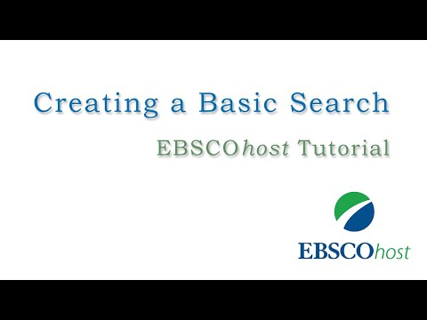

Creating an Advanced Search:
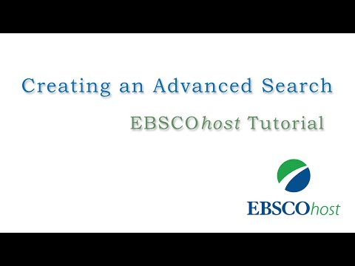

Reading Articles:
