Parking Directions for Campus Center Garage L-29
Walking Directions to the George S. Dively Conference Center (Dively Building)

The entrance to Campus Center Garage (also called Lot 29 or S-29) is located on East Blvd., between Euclid Ave. to the south and Bellflower Rd. to the north.
- Please note, each Map app (Google Maps, Apple Maps) may utilize different street addresses for this garage.
  - Google tends to use 11172 East Blvd. (This sometimes drops the pin across the street from the garage entrance near Wade Lagoon, but it is in close proximity to the entrance.)
  - Apple Maps seems to use 11152 East Blvd to mark this location.
- It may work best to search and map the garage by name: CWRU Campus Center Garage Lot-29 or S-29 LAZ Parking.
- Click here to open a link to Google maps to this garage.
- From the garage, there is an entrance to the Tinkham Veale University Center, which you can walk through to exit on foot to get to Bellflower and complete the walk to the Dively Building, located at 11240 Bellflower Rd.
Nearby Landmarks to the garage include: Severance Hall, Wade Lagoon, and Kelvin Smith Library.
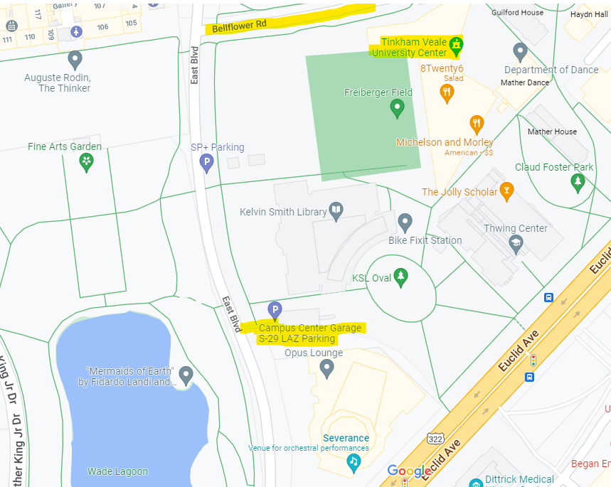
To Dively

To access the Campus Center Garage:
- Use the ramp entrance from East Boulevard and pull a ticket to enter.
- After entering the garage, proceed towards the left, following the large blue signage for Tinkham Veale University Center to park in the sections (E, F, G, or H) closest to this entrance – you may park anywhere in this garage, but these sections are most conveniently located to the University Center entrance.
- The entrance is a marked set of gray doors with Tinkham Veale University Center signage and a wheelchair ramp leading into the building.
- Upon entering through the gray doors into the University Center’s lower level lobby, take the elevator or stairs to the main floor.
- Follow the large blue tiled striped pathway (pictured below) past the food court and the information desk to lead you out to Bellflower Road.
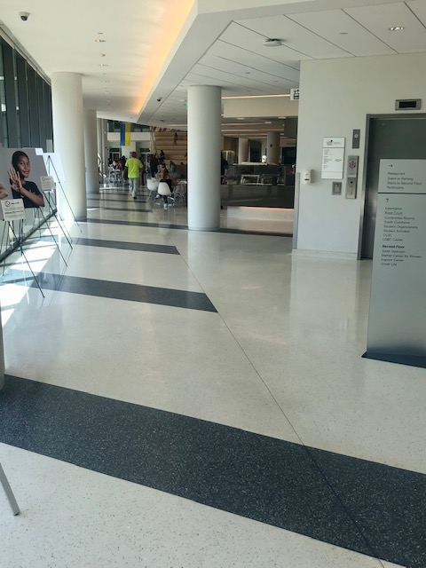
- It's about a 5 minute walk east on Bellflower Road to the Dively Conference Center (located at the corner of Ford and Bellflower) from the parking garage.
- Also, please remember to keep your pulled parking ticket. We will provide a chaser ticket you will use to exit the garage.

