

THORNBURY PRIMARY SCHOOL

Teaching and Learning Policy



Policy reviewed on: | May 2025
Date of next Review:
Who reviewed this policy:

Contents

1) Rationale – What is Teaching and Learning?
2) Intent
3) Aims
4) Teaching and Learning Principles
5) Assessment
6) Monitoring and Evaluation

- Rationale – What is Teaching and Learning?

Why is high quality teaching important?
High-quality teaching is important because it has a direct and lasting impact on student achievement, engagement, and overall development.
When teaching is effective:
Pupils learn more deeply – concepts are better understood, retained and applied.
Achievement gaps narrow – great teaching can level the playing field for pupils from all backgrounds.
Critical thinking develops – children analyse, question and create.
Motivation increases – engaged pupils are likely to be curious, persistent and self-directed learners.
This policy has been created collectively and collaboratively by the teachers and SLT at Thornbury Primary School. It is shared with all staff, to ensure we know how children learn, regardless of need or barrier, and how we can most effectively support learning through our teaching methods and underlying principles to ensure children are achieving their best.
What is Effective Teaching?
At Thornbury Primary School, we consider effective teaching to be the art of creating a meaningful learning experience that not only conveys knowledge but also inspires curiosity, critical thinking, and personal growth. It involves understanding pupil’s needs, adapting to different learning styles, and building a supportive environment where learners feel encouraged and challenged.
Rosenshine (2012) found that more successful teachers spent longer guiding pupils’ practice through explanations and modelling than less effective teachers. In this time, they asked many questions to allow pupils to retrieve and rehearse material and check pupils’ understanding before moving on to subsequent steps. Less effective teachers spent less time on guided practise and asked pupils to move on to independent work sooner. During the independent work, the pupils who received more guided practise before completing the independent tasks were better prepared and achieved higher success in their work than those who received less guided practise. Insufficient early practise or guidance often leads to more problems during independent work and can have a negative impact on pupil motivation.
What is Effective Learning?
Effective learning is the process through which a learner acquires new knowledge and skills. They retain and apply them in real world contexts.
Active – learners participate, question, and interact.
Meaningful – content connects to prior knowledge.
Sustainable - knowledge and skills are retained over time.
Transformative – changes how learners think, solve problems, and see the world.
- Intent

At Thornbury Primary, we would expect to see all lessons reaching at least ‘good’ within the OFSTED framework and it is our aspiration to create classrooms in which every child can be an active, reflective, confident and successful learner.
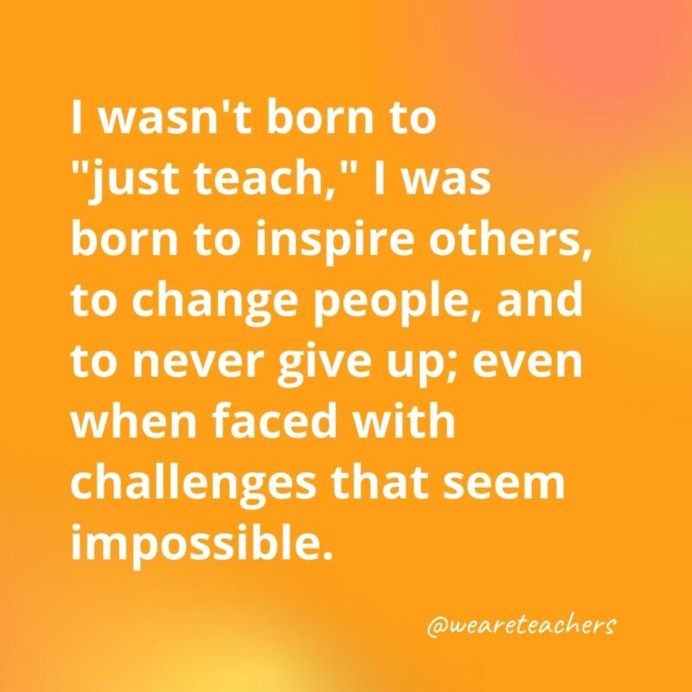
At Thornbury, our staff will be:
-supportive
-inspirational
-proactive
-organised
-collaborative
-passionate
-kind
-approachable
-calm
-motivating
-knowledgeable
-creative
-reflective
-inclusive
-resilient
-nurturing
-quick thinking
-adaptable

- Aims

What are the essential components and processes of teaching and learning, that underpin our work?
Clear objectives and outcomes – define what pupils should know and be able to do by the end of a lesson or unit.
Engaging content – connect learning to real-world contexts to make it meaningful.
Instructional strategies – use varied teaching methods to meet diverse learning styles and needs.
Assessment and feedback – use both formative and summative assessments to monitor progress. Provide timely, constructive feedback that guides improvement.
Classroom environment – Foster a safe, respectful, and inclusive space for learning. Encourage pupil voice, collaboration, and risk-taking.
Pupil engagement and motivation – Inspire curiosity, autonomy, and a growth mindset.
Reflection and adaptation – Teachers reflect on their practice and adjust based on what’s working or not.

- Teaching and Learning Principles

Our Teaching and Learning principles stem from the research evidence and work of Barak Rosenshine (1930-2017). At Thornbury, we align our teaching and learning ethos through teacher instruction and have adopted the approaches and strategies that were features of the most successful teachers’ practice, as found in Rosenshine’s work. To enable learning to occur, we agree that these following procedures need to be in place during every lesson to underpin any effective approach:
- Begin a lesson with a short review of previous learning and vocabulary.
- Present new material in small steps with pupil practice after each step.
- Ask a variety of purposeful questions to embed knowledge and build schemas.
- Think aloud and provide a vast variety of models and worked-out problems.
- Provide a high level of active, guided practice for all whilst modelling and having high expectations of children.
- Check for clear understanding and address misconceptions promptly through high quality interactions.
- Promote high rates of independent success with aspirational outcomes.
- Provide effective scaffolds for difficult tasks.
- Provide opportunities for independent practice giving children ...
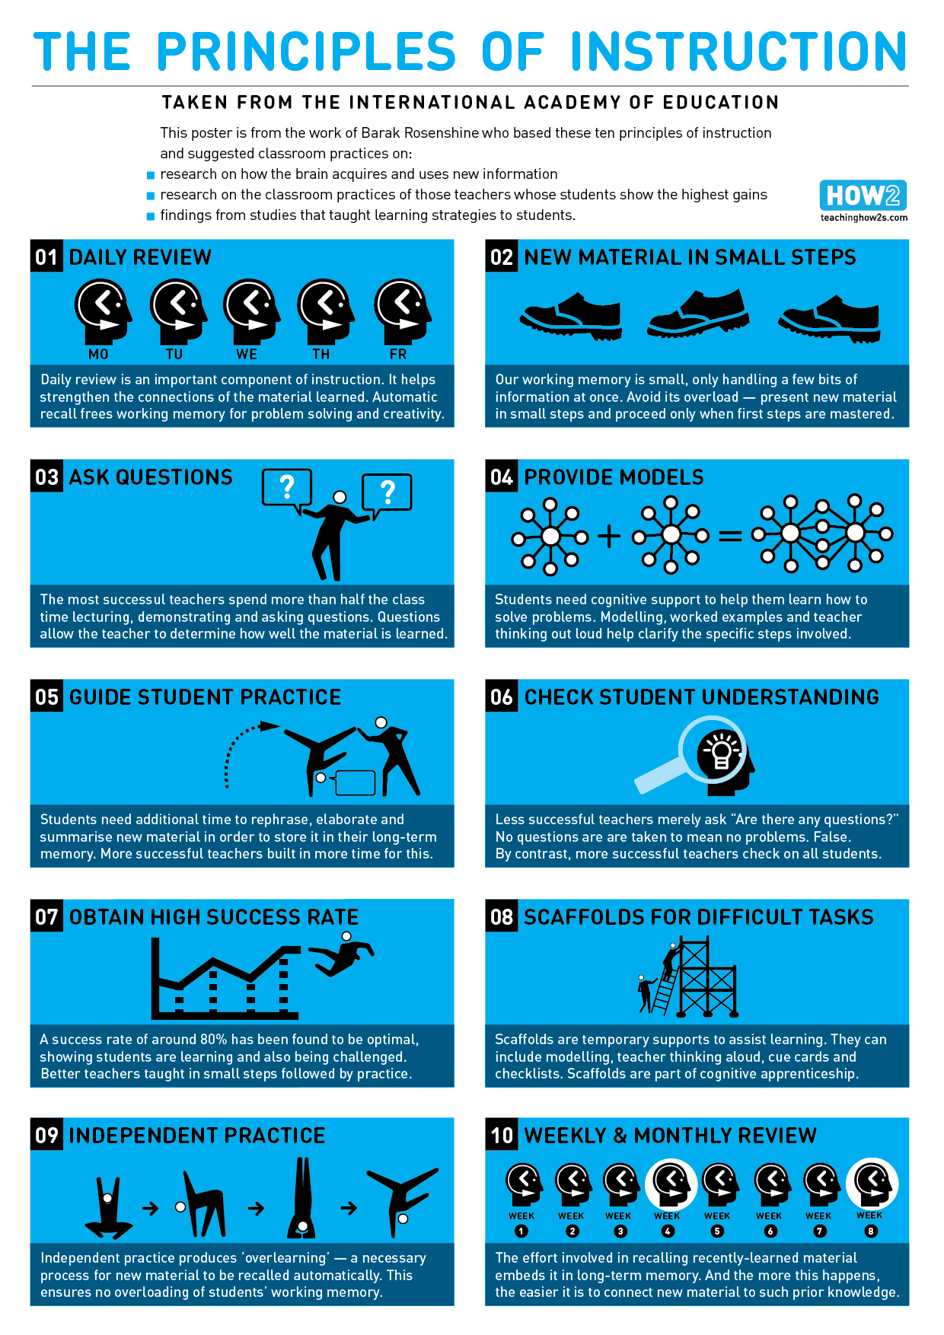
- Allow time to review weekly and monthly through a range of different assessment strategies.

Principle: | Rosenshine’s Instruction | Examples in Action:
- Daily Review  This helps strengthen the connections of the learning material learned. |  | - Flashback 4  - SPaG Spotters  - Pre-teach  - Questioning  - Low stake quizzes  - Planned on PowerPoint (Recap icons) Big Idea  - Recap Vocabulary and prior knowledge  - Recap from previous lesson, week, year.  - Concept maps  - Morning task  - ‘Connecting Spider’  - Making links across the curriculum.  - Concept maps – particularly at the beginning of a unit.
- New material in small steps  Present new material in small steps and proceed only when first steps are mastered. |  | - Rucksacks  - ‘Language I’m Looking For’  - High quality visuals  - Dual coding  - Manipulatives  - Working walls  - Worked examples  - Clear modelling  - My turn, your turn  - Colourful Semantics  - Consistency across the school.  - Pre-teach  - Knowledge of pupils  - Thinking out loud  - Intentional mistakes
- Ask questions  Questions allow the teacher to determine how well material is learned.  Open-ended Questions  Close Questions  Hinge Questions to check understanding  Questions for Assessment |  | - Say it again better  - No opt out/cold calling  - Probing questions  - Questions for understanding  - Whole class answer  - Check for understanding  - Wide range of closed and open questions  - Colourful question grid to deepen thinking  - Recap questions  - Partner talk before answering to allow discussions  - Giving appropriate thinking time  - Adapting questioning choice and wording to meet all learning needs and abilities.
- Provide models  Modelling worked examples with the teacher thinking out loud, clarifies the specific steps involved. |  | - Shared writes: modelling errors.  - Worked examples.  - Following the I Do, We Do, You Do model across all subjects.  - Working walls and post it notes.  - Teacher thinking out loud.
- Guide student practice  To store learning in their long term memory, pupils need time to rephrase, elaborate and summarise new learning. |  | - Worked examples.  - Mark along with the teacher in green pen (tick or fix).  - Concept maps at the start and end of new units.  - I Do, We Do, You Do.  - Reasoning in Maths – prove it, show me, convince me  - Class discussion.  - Talk partners.  - Recap questions and vocabulary and the beginning of each lesson.  - Retrieval symbols to encourage a range of question styles.  - Say it again but better.  - Vocabulary on learning walls  - Homework grids.
- Check pupil understanding  Successful teachers check on all pupils. |  | - A range of questioning  - Live marking and verbal feedback  - Summative assessments (SATS, EoU assessments, Phonics screening, MTC)  - Elicitation task.  - Peer and self marking.  - Concept maps at end of each unit (green pen).  - What have I done wrong?  - Speech bubbles
- Obtain high success rate  A success rate of 80% shows pupils are challenged, are taught in small steps and this is followed by practice. |  | - All pupils are challenged with adapted tasks.  - Teachers toolkits.  - How do we answer the Big Idea and what steps are we taking?  - Pupil ownership.  - Learning in different contexts.  - Green pen respond to marking and upscaling work.  - Speech bubbles.  - Interventions (Pre-Teach).  - High expectations.  - Learning journey steps on subject rucksacks.
- Scaffold difficult tasks  Scaffolds are temporary supports to assist learning and are part of the cognitive process. |  | - Widgit and colourful semantics.  - I Do, We Do, You Do.  - Worked examples.  - Flashbacks adapted for all learning abilities.
- Independent practice  This is a necessary process for new material to be recalled automatically. |  | - Pride and ownership of work.  - High expectations.  - Work scaffolded to support independent learning for all.  - Concept maps.  - White Rose Maths.  - Maths Menu and independent choice of physical resource to support learning.  - Skill development aspect of all subjects.
- Weekly and monthly review  This helps to embed learning into the long term memory. The more this happens, the easier it is to connect new material to prior learning. |  | - End of term tests.  - End of unit assessments  - Phonics screening.  - Concept maps.  - Phonics review weeks.  - Claire Christie times tables.  - SPaG spotters  - Retrieval questions.  - Flashback 4s  - Spelling tests  - Verbal and written range of questions.

Using these ten teaching and learning principles, the teaching staff have agreed the consistent format of a lesson will include four phases:
 | Examples could include (shared by staff):
Phase One: setting the scene, placing learning in a wider context, reviewing and retrieving prior ​learning; reviewing previous lesson; sharing intended learning outcomes. ​ | Introducing focus – discussing what this means.  Share what the sequence of the lesson will be.  2 x retrieval questions (carefully thought out to link to current lesson, previous year)  Retrieve vocab with icons (linked to prior lesson)  KS1 – have one of these stuck in books  KS2 – all stuck in books
Phase Two: explaining and introducing new learning in small chunks and providing rehearsal time for pupils. | Hook  Elicitation task  LILF (Language I’m Looking For) Introduce new vocab. Stick or copy into books if it is a key word.  I do, we do  Worked examples  Questioning – opportunities for children to have discussions.  Draw diagrams  Modelled use of manipulatives  Modelling
Phase Three: Time for pupils to complete guided or independent practice. | You do  Tick and fix  Adapted tasks  Purposeful tasks  Consider appropriate level of challenge  High quality resources (scaffolding)  Manipulatives available
Phase Four: Reviewing learning using success criteria and plan next steps. ​ | Plenary (10 minutes)  Adding new knowledge to concept maps (on wall)  Colouring in lesson objective on learning sequence on rucksack.
​

5. Assessment
To articulate their recent learning, children will:
- Answer the ‘Big Idea’ by writing a paragraph or drawing visuals.
- Engage in discussions – talk about what they learned with peers, teachers or family members.
- Create visuals – Draw pictures, make diagrams, or build models to represent new concepts.
- Write reflections – Write explanations about the learning experience.
- Teach others – Explain the concept to a friend or family member, reinforcing their understanding.
- Ask questions – Inquire further about topics that interest or confuse them, demonstrating active engagement.
For children to articulate their recent learning, teachers will ensure:
- Children have the knowledge and skills to write an answer to or draw a picture (or suitable adaptation) to answer the ‘Big Idea’.
- Create a safe and supportive environment – foster a classroom culture where all pupils feel comfortable expressing their thoughts without fear of judgement.
- Use open ended questions – Ask questions like, ‘What was the most interesting thing you learned today?’ ‘How would you explain this concept to someone else?’
- Model reflective practice – model thinking aloud during lessons.
- Incorporate collaborative activities – Design projects that require pupils to work together.
- Use visual and verbal aids.
- Give constructive feedback – provide specific, positive feedback on how well pupils articulate their learning and suggest ways to deepen their explanations.
- Peer interviews – children pair up and interview each other about what they learned. Encourage them to ask follow up questions to deepen understanding.
- Teach back activity – children to teach a younger child or classmate what they learned.
- Concept mapping – create a concept map that shows and connects their new knowledge.
- Learning showcase – Present a mini-project or poster about a recent topic they have studied.
6. Monitoring and Evaluation
What does this look like here?
Subject Deep Dive weeks – Twice a year.
Book looks
Pupil voice for subjects where there is less evidence in books.
Lesson drop ins
Coaching and mentoring discussions
End of unit assessments
Adaptations
Baseline assessments – EYFS
Learning walls
Subject specific non-negotiables – are they being followed?
Teacher voice – what is working/ how can we support planning/delivery as subject leaders

Learning Walks:
Why? What are we looking for in lessons?
Pupil Engagement, Climate, Relationships
Questioning and Modelling
SEND - adaptations
Resources and Scaffolds
Learning Environment
How do we want this fed back as staff?
During planning meetings
Learning walks – individual
Individual targets to work on
Book looks – department proforma emailed out



Thornbury Primary School
Learning Walk Monitor 2024-2025
Date: | Year Group: |  | Team:
Focus Area:

Teaching and Learning Principle |  |  | Classroom Monitor/Evidence
Daily Review  This helps strengthen the connections of the learning material learned. |  | 
New material in small steps  Present new material in small steps and proceed only when first steps are mastered.  Provide models  Modelling worked examples with the teacher thinking out loud, clarifies the specific steps involved. |  |   
Ask questions  Questions allow the teacher to determine how well material is learned.  Open-ended Questions  Close Questions  Hinge Questions to check understanding  Questions for Assessment |  |   What  How  If  Do  Why  Can  When
Guide student practice  To store learning in their long term memory, pupils need time to rephrase, elaborate and summarise new learning.  Independent practice  This is a necessary process for new material to be recalled automatically.  Scaffold difficult tasks  Scaffolds are temporary supports to assist learning and are part of the cognitive process. |  |     
Teacher Reach (including SEND and Disadvantaged)
Book Look (DPP pupils and ARE)
Subject:

Pupil Voice Summary (video shared)
Subject: (same children as Book Look)

Individual Strengths |  |  | Individual Considerations/Actions
Year Group Considerations/Actions
Considerations and Actions from last Learning Walk |  | Comments
Date of Review: |  |  | Review Comments:

Pupil Premium Overview: Who? What is current Data?

