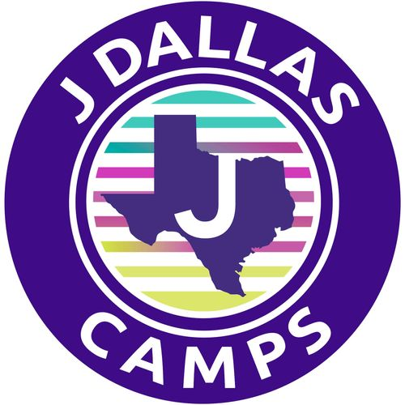

CAMP STARPOWER
PLAYBOOK 2026

Be prepared to make
memories that last a lifetime!

Dream. Create. Perform.



CAMP STARPOWER

Summer 2026
Dear Parents,
We’re thrilled your child may spend the summer with us at Camp StarPower!
At StarPower, campers do more than perform—they become creators. Whether they’re new to the stage or seasoned performers, campers work together to write, shape, and bring to life their very own Broadway Revue. It’s an unforgettable process that inspires confidence, creativity, teamwork, and fun.
You can count on a supportive, spirited environment where your child can take risks, express themselves, grow artistically, and form lasting friendships.
This Playbook is your go-to guide for all things Camp StarPower—packed with helpful info, camp dates, and key details you’ll want to keep handy.
We can’t wait to get started. Please reach out if you have any questions—my door is always open.

Shine Bright,

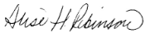
Alise Robinson
Camp Director, Camp Starpower

Aaron Family Jewish Community Center - 7900 Northaven Road - Dallas, Texas 75230

Behind The Scenes

Our Philosophy

You can do anything you set your mind to.

Experience:

We will provide a true sense of belonging, unleash creativity and offer a supportive, safe environment where youth are encouraged to create, explore and learn through the arts. Camp StarPower is a place where children are free to imagine the unimaginable and dream big!

How We Do it?

We fuse a traditional summer camp philosophy with a top-notch performing arts program designed to keep our campers invigorated, engaged, challenged and happy! Our unique summer experience will transform lives and will provide our campers with an excellent theater arts training program that promotes personal and artistic growth.

Campers will spend the mornings rotating through a variety of specialty activities that support the artistry and collaboration necessary to curate, create and perform in an original Broadway Revue. In the afternoon, the entire camp will work together as an ensemble as they create and rehearse to perform in their end of camp performance.

Our Staff:

Our staff is comprised of theatre professionals, college theatre art majors, and high school students who have participated in theater. As positive role models, our staff will teach our campers how to hone skills they already possess while learning new techniques bound to improve their craft and build their confidence.

To Connect

During the camp day, messages are checked a couple of times throughout the day and should be used for general questions not immediate responses.

For immediate assistance contact:
Camp Central, 214.810.2377 or jcamp@jccdallas.org

Otherwise contact:
Alise Robinson, Camp Director
arobinson@jccdallas.org
214. 279. 7140
Camp at a Glance, Daily Schedule & Important Dates

Camp StarPower

- A program with activities focused on personal and artistic growth
- Specialists in acting, voice, dance, stage direction, writing, producing.
- Creation of an original production
- Carnival Day – Fun all day long with afternoon at the pool!

Camp StarPower Daily Schedule At A Glance

- Mindfulness Circle & Energy Starter
- Specialty Activities that support creative collaboration and artistic skills
- Community Lunch & Creative Time
- Broadway Revue Production Exploration, Creation and Rehearsals.

Important Camp Dates

- Camp StarPower: July 6 – July 17
- Original Performance Debut for family and friends
  - July 16 at 2:30 (final time TBD)
- Carnival Day: Last day of camp Friday, July 17

Please note: It is important your StarPower camper attends camp each day as we put on a final performance for family and friends on July 16. Theater is a team sport.

Friendly Reminder! Mandatory Forms Are Due April 15

All mandatory forms that need to be filled out can be found on CampDoc, the software used to register your camper – campdoc.com. If you have any issues logging in, please email jcamp@jccdallas.org. Your camper’s profile must be complete, with all forms filled out, to attend camp.

