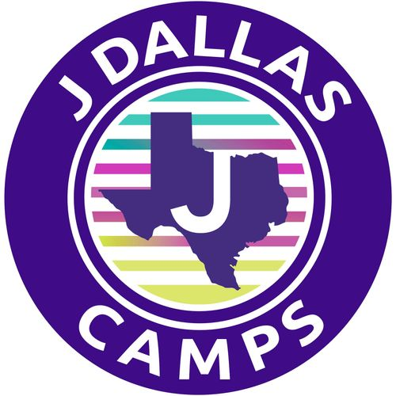

CAMP STARQUEST
PLAYBOOK 2026

Be prepared to make
memories that last a lifetime!

Dream. Create. Perform.

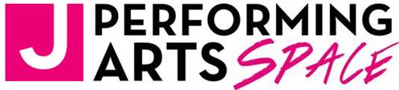

CAMP STARQUEST

Summer 2026

Dear Parents:

We couldn’t be happier your child may spend the summer with us at Camp StarQuest!

Camp StarQuest is a great choice for both experienced and novice performers who are committed to improving their skills and eager to learn about the theatrical process while exploring their creative self.

You can be confident that our camp environment will create a spirited community, where our campers can tap into their artistry, build confidence, take risks, have fun and make lifelong friends with memories that will last forever.

This playbook is designed to be your reference tool – your go-to document for all things StarQuest – packed with helpful info, camp dates and key details you will want to keep handy!

Our amazing staff can’t wait for the summer to get started. We look forward to getting to know each of our Campers and having the best summer ever! My door is always open should you have any questions.

Sincerely,

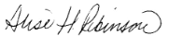
Alise Robinson
Camp Director

Aaron Family Jewish Community Center - 7900 Northaven Road - Dallas, Texas 75230
Behind The Scenes

Our Philosophy

You can do anything you set your mind to.

Experience:

We will provide a true sense of belonging, unleash creativity and offer a supportive, safe environment where youth are encouraged to create, explore and learn through the arts. Camp StarQuest is a place where children are free to imagine the unimaginable and dream big!

How We Do it?

We fuse a traditional summer camp philosophy with a top-notch performing arts program designed to keep our campers invigorated, engaged, challenged and happy! Our unique summer experience will transform lives and will provide our campers with an excellent theater arts training program that promotes personal and artistic growth.

Campers will spend the mornings rotating through a variety of specialty activities ie. voice, acting dance etc... in age and skill appropriate groupings. In the afternoon, each group will work together as an ensemble as they prepare for their end of camp musical performance debut.

Our Staff:

Our staff is comprised of theatre professionals, college theatre art majors, and high school students who have participated in theater. As positive role models, our staff will teach our campers how to hone skills they already possess while learning new techniques bound to improve their craft and build their confidence.

To Connect

During the camp day, messages are checked a couple of times throughout the day and should be used for general questions not immediate responses.

For immediate assistance contact:
Camp Central, 214.810.2377 or jcamp@jccdallas.org

Otherwise contact:
Alise Robinson, Camp Director
arobinson@jccdallas.org
214. 279. 7140
Camp at a Glance, Daily Schedule & Important Dates

Camp StarQuest

- A program with activities focused on personal and artistic growth
- Specialists in acting, dance, voice and more!
- Workshops in song writing, acting, etc...
- Battle of The Stars: Our spin on the classic sleep-away camp tradition, often referred to as color war or Maccabi!

Camp StarQuest Daily Schedule at a Glance

- Morning Huddle
- Rotation of Specialty Training and Workshops
- Lunch & Creative Time
- Group Production Rehearsals

Important Camp Dates – Attendance at Camp is Mandatory for Camp StarQuest Campers unless sick.

- Camp StarQuest: June 8 – July 3
- Audition for Camp Musical – June 8, in the afternoon on first day of camp.
  - Campers do not need to prepare anything in advance.
- Tech Days Mandatory: June 26, 29, 30, and July 1
- Musical Performance Debut for the entire community: July 1 at 6pm
- Parents will receive a video of the performance.
- Battle of The Stars: Hollywood Red vs. Broadway Blue. July 2 & July 3.
  - Our version of Maccabi / Color War So much fun! Don’t miss it!

Please note: It is important your StarQuest camper attends camp each day as we put on a final performance for the community on July1. Theater is a team sport.

Friendly Reminder! Mandatory Forms Are Due April 15

All mandatory forms that need to be filled out can be found on CampDoc, the software used to register your camper – campdoc.com. If you have any issues logging in, please email jcamp@jccdallas.org. Your camper’s profile must be complete, with all forms filled out, to attend camp.

