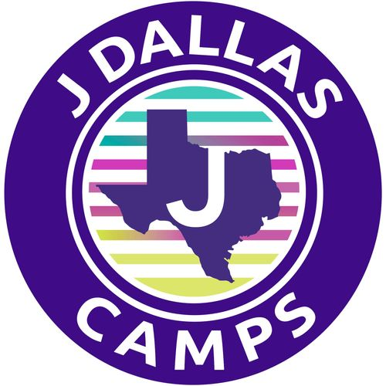

ONE WEEKERS
PLAYBOOK 2026

Be prepared to make
memories that last a lifetime!

Discover. Empower. Thrive.



ONE WEEKERS

Summer 2026

Dear Parents:
One-Weekers are more than just a camp option—it’s a dynamic experience where fun, learning, and empowerment come together in a uniquely crafted format designed to spark imagination and ignite joy.
Our thoughtfully built camp culture fosters a spirited, inclusive community where campers are encouraged to explore their passions, build confidence, take creative risks, and form friendships that will last long after the week ends. Along the way, they’ll discover new skills, create lifelong memories, and have a blast doing it.
This Playbook is your go-to guide for all things One Weekers—packed with helpful info, camp dates, and key details you’ll want to keep handy.
Our amazing staff are ready to make this the best week ever! We can’t wait to get to know your camper and share this unforgettable experience. If you have any questions, my door is always open.

Sincerely,


Alise Robinson

Aaron Family Jewish Community Center - 7900 Northaven Road - Dallas, Texas 75230

Behind The Scenes

Our Philosophy

You can do anything you set your mind to.

Experience:

Uniquely crafted formats blend fun, learning, and empowerment, leaving a lasting impact on growth and mindset. A place where uniqueness and innovation converge to create an extraordinary experience for your child.

How We Do it?

At our one-week specialty camps, we believe in building connections through a blend of learning, growth, and joy. Our success can be found in the art of seamlessly integrating valuable skills into activities that are so engaging, your child won't even realize they're learning—they'll simply be having a blast! Our carefully designed process encourages bonding, exploration of new passions, a sense of acceptance, all within a thoughtfully crafted space.

Our Staff:

Our staff is comprised of specialists and support counselors. As positive role models, our staff will teach our campers how to hone hard and soft skills while learning new techniques.

To Connect

During the camp day, messages are checked a couple of times throughout the day and should be used for general questions not immediate responses.

For immediate assistance contact:
Camp Central, 214.810.2377 or jcamp@jccdallas.org

Otherwise contact:
Alise Robinson, Camp Director
arobinson@jccdallas.org
214. 279. 7140

Camp at a Glance & Daily Schedule

One Weekers – Discover, Empower, Thrive

- Boutique specialty camps taught by specialists.
- With themed weeks and a traditional camp philosophy this is a transformative experience that builds connections, confidence and fosters acceptance while learning.
- Global Gourmet, July 20 – July 24
- Whisk and Wonder, July 27 – July 31
- Creative Fusion, August 3 – August 7

Average Day At Camp

- Morning Huddle & Energy Starter
- Morning Specialty Activities
- Community Lunch, Creative Time & Mindful Moment
- Afternoon Specialty Activities
- End of Day Huddle & Carpool

Last Day At Camp

- Special activities are designed to showcase campers’ progress and to celebrate all the goodness! Campers will need to bring a bathing suit, towel and sunscreen too!

Friendly Reminder! Mandatory Forms Are Due April 15

All mandatory forms that need to be filled out can be found on CampDoc, the software used to register your camper – campdoc.com. If you have any issues logging in, please email jcamp@jccdallas.org. Your camper’s profile must be complete, with all forms filled out, to attend camp.

