Question | Response
Can you discuss the processes for import and export and the tax that would be associated with this project? | You will be doing your import export via a customs broker. We would facilitate your contact with potential brokers and you will select your own. The import and export will be duty free.  The project has obtained duty free concessions for everything dealing with the integrated drilling services operation.
Are the three wells guaranteed? Regardless of the results of the 1st or the 2nd, there will be 3 wells drilled. | Yes, we will be drilling 3 wells because the locations targeted were done so for very specific reasons.
I noticed that there was no provision for directional drilling. Does that assume that there's no control? Everything should be drilled with a stabilized BHA? | Yes, the program is envisaging only vertical wells.
There's a mention of 30% local content or local personnel. How would some of the potential drilling contractors perhaps have access to  the local human capital. | For your bid you will need to identify those positions that would be filled with local labour.  And you may need to do some level of market research. Perhaps the best option would be to have a local counterpart and we can provide limited information on available companies, but you will be responsible for getting in touch with them. However, after contracting we can provide more support to facilitate your activities.
What is the anticipated tender schedule, the clarification period, tender due, anticipated award date and anticipated start of contract. | We're still making the final changes to the tender document and our goal is to launch the tender sometime around starting or mid-March roughly. Our goal is to have the entire process completed and contract signed around August of this year.  In the tender document you will have information on clarification period of the tender, due date for submission and so forth.
I just wanted to comment on the local crew requirement, assuming it's not local to only your island, but the region. We as a drilling company take safety as a high priority and the drilling application, the drilling projects can be very dangerous, so we have to be very careful about who we can employ and what positions. So they wouldn't be in the actual work itself, but it might be more administrative type role, so 30% might be a quite ambitious number to be able to achieve without overinflating the price of the project as well. Just be aware that it may increase the cost of your overall project as well. | With our own experience, we reviewed all positions and we came up with a percentage of up to 40% local labour can be employed for this project. So what are they? Just to mention, like cooks in your camp or in your site camp, the waiters, drivers if you are going to subcontract.  Crane or forklift drivers. There are actually plenty of options to meet the 30% of local labour requirement.
You'll need to ensure that the harbour has cranes and stevedores capable of unloading some of the heavy equipment. Some of the drilling equipment can be 70 tons in weight. | On the matter of the offloading capability at the harbour, we don't have any cranes at the port. So we are requiring ships that have their own offloading capability. We will provide in the bid document more precise information about the existing facilities of the port. See Note 2 below this table.
Logistics companies and the availability of suitable trailers and tractors to pull the equipment depending on the inclines of the road and bends in the road as well, depending on the loads that are being transported can be quite challenging. | There are adequate trucking companies and relevant resources for transportation of the containerized goods from the port to the sites.
You'll need to ensure that the harbour that you're looking to import the equipment in will take the berth  of the ship that's coming in.  So that it's deep enough for the ship to arrive and unload, and  that's something we do see quite a lot that some of the harbours are just not deep enough to take the vessels. | The harbour has sufficient berthing capacity and depth to accommodate the transportation vessels. See Note 2 below this table.
On the water supply, will you be including specifications of the type of pump and the power it's going to consume because you mentioned that we're responsible for providing the power to it.  Electrical, diesel and if it's electric, how much power it's going to consume. So we know, but also the flow rates that we can expect to it also given the elevation that's there as well. So we have an idea of the type of pump and the amount of flow that we can expect on site. | See Note 1 below this table.
Assuming that it's going to be an electrical pump, will the civil contractor be providing the power cable from the pump to the rig or do we need to provide that power cable. So when and if we're providing it, we'd need to know the specifications of the cable required as well. | The civil contractor is supposed to provide the cable from the pump up to the drilling site. The drilling contractor will provide a connection to power the pumps. See Note 1 below this table.
I wanted to ask about the petrographic thin sections. I noted that you included a contractor's comment on that and I wanted to suggest or comment that I think they are an excellent tool for the well site and I think or in my experience volcanic rocks are somewhat difficult to prepare in thin section and  I've usually worked with a dedicated technician who prepares it beyond the machinery or the equipment that you were pointing out in the comments. They are difficult to Polish. The variety of minerals is quite ample and sometimes you end up with thin sections that are very difficult to interpret if they're not properly prepared. So I want just to emphasize the need for maybe even a dedicated person. | Within the Employer’s team of engineering consultants, there is a highly qualified professional (PhD in Mineralogy and Petrology of Volcanic Rocks) with extensive expertise in thin section preparation and petrographic interpretation.  He has substantial experience in the volcanic environments of the Rift Valley, where he has conducted numerous studies involving the petrographic analysis of volcanic rock samples and drill cuttings.  This specialist will provide comprehensive support throughout the entire process, including the setup and installation of equipment for thin section preparation, the preparation of thin sections, and their detailed petrographic interpretation, taking into account all identified constraints.
We very much rely on providing a quality product and therefore would be uncomfortable providing a product that we do not 100% stand behind. So the long lead items are master valves which are currently about 8 months. | We will adjust the evaluation criteria to remove reduction in lead time and favour a strategy to reduce overall time to completion.

Note 1 - Pumping Station Energy Supply
There are n.2 pumps installed at the pumping station, one in operation and one in stand-by for emergency situations.
The pumps technical features are shown in the following table:
Location |  | No. of Pumps | Flow | Head | Power (kW)
Saltibus S5 |  | 2 | 15 liters/sec | 110 m | 25
Fond St.Jacques |  | 2 | 15 liters/sec | 20 m | 5
Belle Plaine | No pumps are needed since it is self flow

The Civil Contractor will supply, install and dismantle the electrical cables, which feed the pumping stations with the energy of the diesel generator (within the scope of Drilling Contractor).
The cable technical features are shown in the following table:
Location | Length (m) | Pump Power  (kW) | Absorbed  Current (A) | Cable Rated Current (A) | Cable Size  (mm2) | Cable Type | Circuit Breaker
Saltibus S5 | 235 | 25 | 45 | 70 | 25 | PVC 3C+E 0.6/1 Kv | Thermal magnetic type  63 A
Fond St.Jacques | 250 | 5 | 9 | 29 | 6 | PVC 3C+E 0.6/1 Kv | Thermal magnetic type  16 A

Note 2 - Port of Vieux Fort
The Port of Vieux Fort, is a small port located at the southern tip of the island of St. Lucia. The berths at Port Vieux Fort are mainly used for anchoring cargo vessels. There are no fixed cranes for the unloading of shipped material.
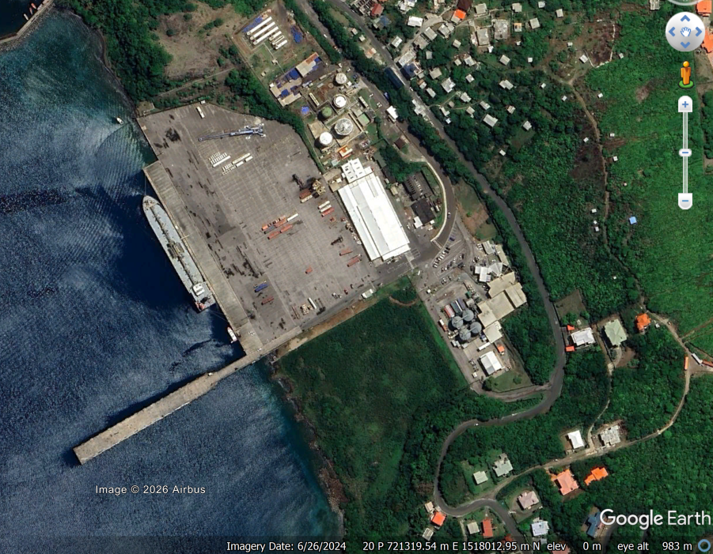
The technical features of the port are summarized in the following table.

