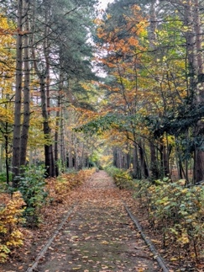
Oscott College
Volunteers Required
for
‘Laudato Si’ Schools’ Retreat Days

A new initiative, in January 2025, helped to support primary schools fulfil the requests of Pope Francis and the Catholic Social Teaching curriculum – Stewards of God’s Creation. We are now looking to roll this out to secondary school pupils in Autumn 2026 and need 6 volunteers to act as site guides for teacher-led groups of secondary school pupils.

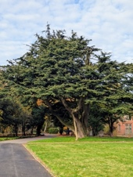
The retreats will involve numerous small group outdoor activities with a focus on education about nature, the environment, renewable energy and how we can protect the planet, “our common home” (Pope Francis).

We are looking for those who are:
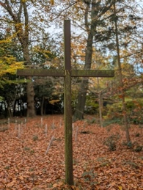
- Confident in talking to the public in small groups or one-to- one;
- Nature loving and enjoy being outdoors;
- Good timekeepers and reliable;
- Able to work as part of a team;
- Available to volunteer during school term time, at least once per term.
- Available for a training day at Oscott College.
All training and uniforms will be provided.


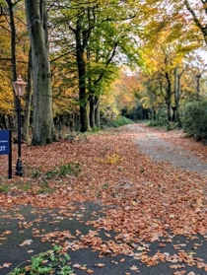
Oscott values diversity and inclusion and welcomes applications from candidates with diverse backgrounds who are supportive of the College’s Catholic ethos.

Please check out our website for further details, and send your expression of interest to: volunteercoordinator@oscott.org

