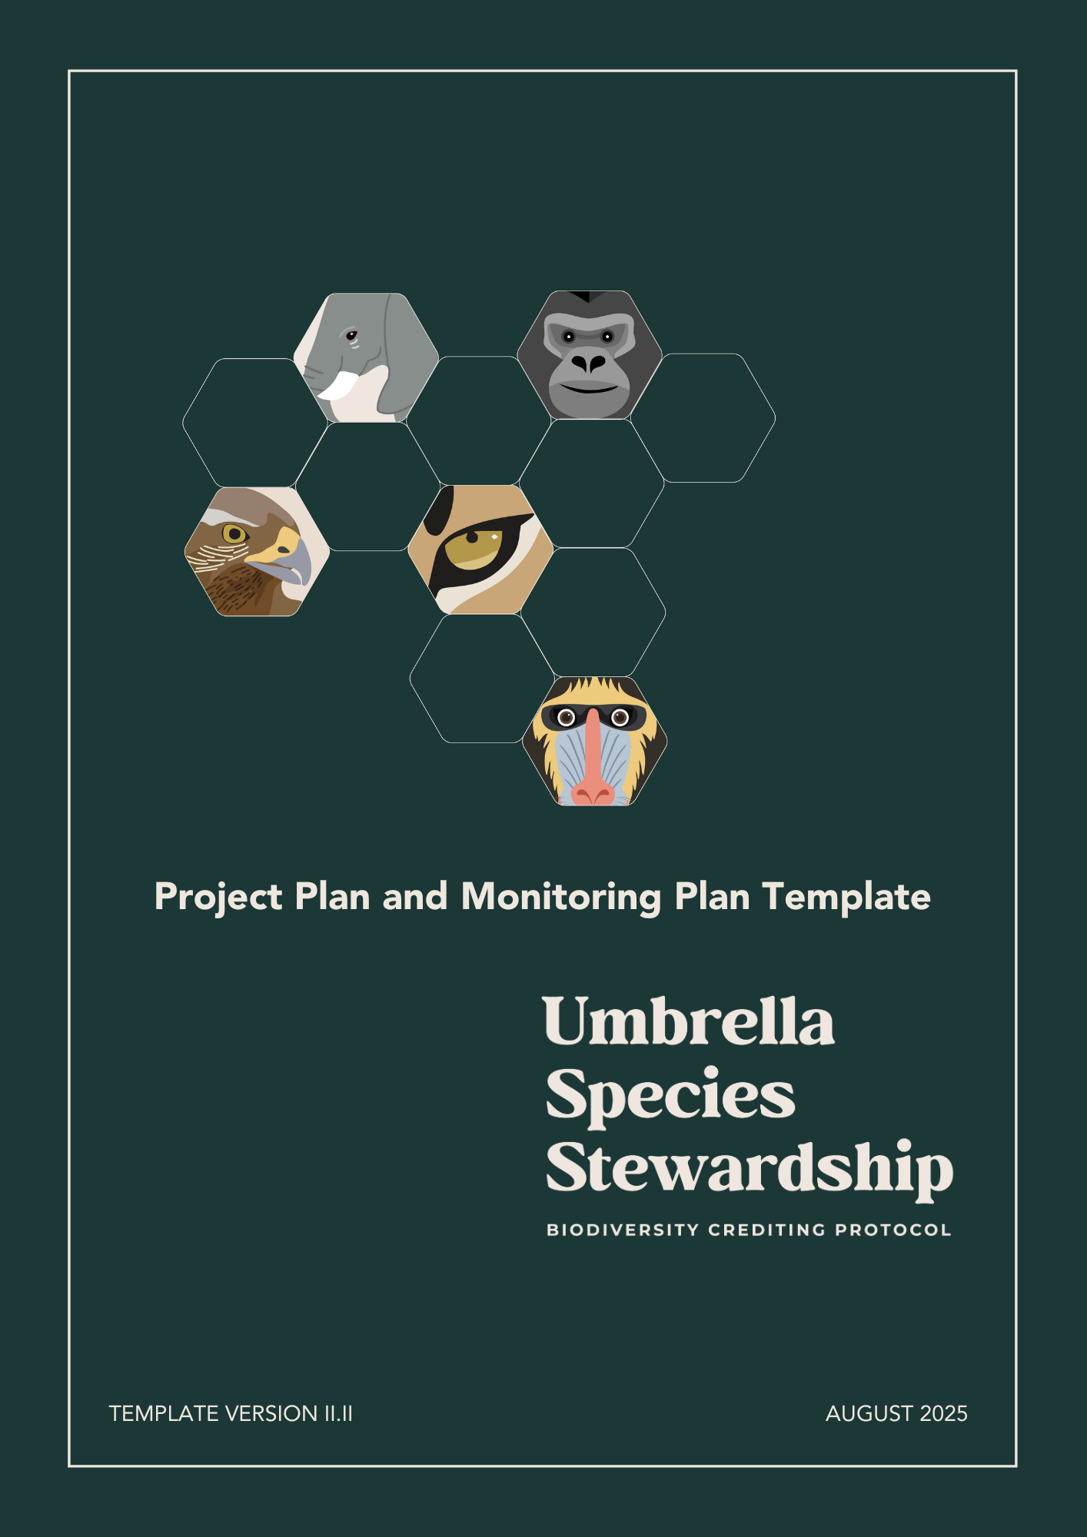

PROJECT PLAN AND MONITORING PLAN TEMPLATE

This template is for the design and implementation of projects using the Biodiversity Crediting Protocol for Umbrella Species Stewardship (“**Biodiversity Protocol**”), harbored in the Regen Registry.

Instructions for Completing the Project Description

**TITLE PAGE**: Complete all items listed in title page. All the listed items must appear on the title page of the final document. Project descriptions may also feature the project title and Project Proponent’s and partners´ name, logo, and contact information more prominently on the title page.

**PROJECT DESCRIPTION**: Instructions for completing the Project Plan and Monitoring Plan template are under the section headings in this document. Adhere to all instructions, as set out in the Biodiversity Protocol and instructions of this template. Instructions relate back to the rules and requirements set out in the Biodiversity Protocol. The Project Proponent will need to refer to these documents in order to complete the template.

**Note**: The instructions in this template are to serve as a guide and do not necessarily represent an exhaustive list of the information the preparer must provide under each section of the template.

Where a section is not applicable, explain why the section is not applicable. Submit the project description as a non-editable PDF.

Delete all instructions, including this introductory text, from the final document.

**Biodiversity Crediting Protocol for Umbrella Species Stewardship**

Project and Monitoring Plan

Project Title:

**Insert the Project Proponent´s and partners´ logo here.**

Date of issue:

Version of this Document:

Prepared by:

Contact:

Version of the Protocol:

**TABLE OF CONTENTS**

1. PROJECT PARTICIPANTS 5

1.1 PROJECT PROPONENT 5

1.2 LANDOWNER OR LAND STEWARD 5

1.3 OTHER ENTITIES INVOLVED IN THE PROJECT 5

1.4 PROJECT DETAILS 6

1.5 CREDIT OWNERSHIP AND BENEFIT SHARING 6

1.6 PROJECT LOCATION 7

1.7 CONDITIONS PRIOR TO PROJECT INITIATION 7

1.8 STACKING PAYMENTS FOR ENVIRONMENTAL SERVICES 7

2. PROJECT ELIGIBILITY 7

2.1 ECOSYSTEM TYPE CLASSIFICATION 7

2.2 FOREST/VEGETATION REQUIREMENTS 8

2.3 LAND OWNERSHIP TYPE 8

2.4 PROOF OF OWNERSHIP 8

2.5 REGULATORY COMPLIANCE 8

2.6 PERMANENCE OF PROJECT ACTIVITIES 8

2.7 PROJECT START DATE AND REGISTRATION DATE 9

3. PROJECT AREA BOUNDARY 9

3.1 GENERAL CHARACTERISTICS OF THE MESOREGION 9

3.2 SPATIAL BOUNDARIES 9

3.3 TEMPORAL BOUNDARIES 10

4. USp GENERAL INFORMATION 10

5. MONITORING PLAN FOR EVALUATING UMBRELLA SPECIES HEALTH (USH) 11

5.1 ECOSYSTEM STRUCTURE 11

4.1.1 ECOSYSTEM DISTRIBUTION 11

5.2 SPECIES POPULATIONS 12

4.2.1 PRESENCE OR ABSENCE DATA 12

5.3 SIZE OF THE POPULATION 12

5.4 MOVEMENT AND DISTRIBUTION 12

5.5 MONITORING METHODS 13

6. MONITORING PLAN FOR EVALUATING HABITAT QUALITY (HQ) 13

6.1 COMMUNITY COMPOSITION 13

5.1.1 TAXONOMY DIVERSITY 13

6.2 ECOSYSTEM FUNCTIONING 13

5.2.1 ECOSYSTEM MEASURES OF ECOSYSTEM DISTURBANCES 13

7. UMBRELLA SPECIES THEORY OF CHANGE DEVELOPMENT 13

# PROJECT PARTICIPANTS

## PROJECT PROPONENT

Provide contact information for the Project Proponent(s).

|  |  |
| --- | --- |
| Organization Name |  |
| Contact Person |  |
| **Title** |  |
| **Address** |  |
| Phone number |  |
| E-mail |  |

## LANDOWNER OR LAND STEWARD

Provide contact information for the Landowner or Land Steward. Please refer to the definitions of the Biodiversity Protocol.

|  |  |
| --- | --- |
| Organization Name |  |
| Contact Person |  |
| **Title** |  |
| **Address** |  |
| Phone number |  |
| E-mail |  |

## OTHER ENTITIES INVOLVED IN THE PROJECT

Provide contact information for any other entity involved in the development of the project.

|  |  |
| --- | --- |
| Organization Name |  |
| Contact Person |  |
| **Title** |  |
| **Address** |  |
| Phone number |  |
| E-mail |  |

## PROJECT DETAILS

Provide a clear and complete summary of the project, covering its main purpose, scope, and expected outcomes. Begin by explaining the project's primary focus and where it will take place, including the area of implementation, the biodiversity goals being targeted, and the umbrella species chosen to guide conservation efforts.

Provide an overview of the Project Activities and how they will achieve results for the conservation of the Umbrella Species and the general ecosystem it relies on. Include the following table providing a clear description of how the various organizations, communities, and other entities are involved in each Project Activity. This stakeholder list should specify the category of the activity (e.g., Fire Prevention and Combat, Ecotourism, Monitoring, Projects & Research, Conservation Area Management, etc.), provide a general description of responsibilities, and identify the entities involved.

|  |  |  |
| --- | --- | --- |
| **Category** | **General Description** | **Entities** |
|  |  |  |
|  |
|  |
|  |
|  |
|  |
|  |  |  |
|  |
|  |
|  |
|  |
|  |
|  |  |  |
|  |
|  |

Conclude the section by detailing the expected biodiversity benefits and specifying the estimated annual average of biodiversity credits issuance.

## CREDIT OWNERSHIP AND BENEFIT SHARING

If multiple participants are to hold a portion of the biodiversity credit title for each credit issuance, state the percentage each party will hold (e.g., Project Developer 20%, Landowner 80%). Valid only for participants listed in chapter one.

## PROJECT LOCATION

Indicate the project location and geographic boundaries (if applicable) including a set of geodetic coordinates. Provide a map with the Properties Areas and all Project Areas.

|  |  |
| --- | --- |
| Country |  |
| Region/State/Province |  |
| **City/Town/Community** |  |
| **Geolocation link or attach shape files** |  |

## CONDITIONS PRIOR TO PROJECT INITIATION

Describe the general conditions of the Project Area existing prior to Project Start Date. This includes, but is not limited to:

* Existing Environmental Services: Identify and describe any pre-existing Payments for Environmental Services (PES) such as carbon credits or other co-benefit standards. Explain their scope, implementation status, and any results or impacts observed.
* Justification for Biodiversity Credits: Provide a clear justification for adopting biodiversity credits. Explain how the introduction of biodiversity credits will address specific conservation challenges and contribute to the project's overall goals. If there is any pre-existing PES, highlight the additional benefits expected from integrating biodiversity credits into the existing PES framework.

## STACKING PAYMENTS FOR ENVIRONMENTAL SERVICES

Where applicable, describe which payments for environmental services are implemented in the project area, highlighting how each payment mechanism provides additional benefits.

# PROJECT ELIGIBILITY

## ECOSYSTEM TYPE CLASSIFICATION

Describe the ecosystem type in which the project is located, specifying that it belongs to a terrestrial biome rather than an aquatic one. Provide a map to illustrate the project's location within the biome and country.

## FOREST/VEGETATION REQUIREMENTS

Provide a brief contextualization of the biome’s ecological significance, an overview of the vegetation characteristics within the project area, specifying the official vegetation class. If relevant, reference other sections of the document that contain detailed descriptions of habitat areas.

## LAND OWNERSHIP TYPE

Describe the type of land property - private/public/tribal, explaining relevant details of this land ownership type as per the history, laws, and requirements of the Project´s host country.

## PROOF OF OWNERSHIP

Add link(s) or attach files to prove ownership, including land registry documents and any other relevant evidence. In Brazil, the indicated legaldocuments are the following:

* Property Deed (Matrícula do Imovel): document that individualizes the property and contains information about it.
* Chain of Title (Cadeia Dominial): detailed study of the history of the property’s ownership.
* Rural Property Registration Certificate (Certificado de Cadastro de Imóvel Rural – CCIR): document provided by Incra (Instituto Nacional de Colonização e Reforma Agrária), which constitutes proof of rural property registration.
* Rural Environmental Registry (Cadastro Ambiental Rural – CAR): an electronic record, mandatory for all rural properties, whose purpose is to integrate environmental information regarding the status of Permanent Preservation Areas, Legal Reserve, Restricted Use Areas and Consolidated Areas of rural properties.
* Clearance Certificates (Certidões Negativas): official document that confirms the absence of tax debts or pending legal proceedings in the name of the owner.

## REGULATORY COMPLIANCE

Describe how the project is compliant with any federal, state, or local laws, regulations, and other legally binding mandates directly related to Project Activities.

## PERMANENCE OF PROJECT ACTIVITIES

Add link(s) or attach files used to prove the permanence of Project Activities with an irrevocable and legally enforceable agreement between the Project Proponent, Land Steward and/or any other relevant parties that ensures that the Project Activities will be undertaken and that the Habitat Area will be protected, or any other legal or regulatory remedy, public or private in nature, that entails this specified outcome.

## PROJECT START DATE AND REGISTRATION DATE

Indicate and provide justification for the project start date, specifying the day, month, and year.

|  |  |
| --- | --- |
| Project Start Date | mm/dd/yyyy |
| Registration Date | mm/dd/yyyy |
| **Submission Date** | mm/dd/yyyy |
| **Crediting Term** | Indicate the project crediting period, specifying the day, month, and year for start and end dates and the total number of years. |

# PROJECT AREA BOUNDARY

## GENERAL CHARACTERISTICS OF THE MESOREGION

Provide a detailed description of the basic physical and social parameters of the Project Area bioregion. These may include, but are not limited to the following:

* Climate (temperatures, rainfall, seasonality, etc.).
* Hydrology (description of water bodies, information on water flow, and any significant hydrological features). Include a hydrological map of the Project Area.
* Topography (slope, aspect, geological features, etc.).
* Soils (main soil types).
* Vegetation (main vegetation types).
* Land use and economic activities (e.g. farming and pastoral practices or culture, areas of use for collection, fishing or hunting, managed and conservation lands, etc.). Include a land use map of the Project Area.
* Biodiversity (description of the biodiversity within the bioregion and threats to that biodiversity).
* Main settlements (towns, villages, or household clusters where communities reside). Include a settlements map of the Project Area.
* Important Socio-cultural information (e.g. ethnicity, gender, age, household income, land ownership, education, health statistics, migration patterns, etc.).
* Relevant historic conditions.

## SPATIAL BOUNDARIES

Provide a map of the Project Area, including:

**Project Area:** The total Project Area in hectares. Attach a link to the shape files used to prove geolocation (e.g., kml/kmz/shp/geojson polygons) - specifying project spatial boundaries (including the limits of Consolidated and Habitat Areas), and areas like natural reservoirs, or other relevant areas.

**Consolidated Area:** The total Consolidated Area in hectares. Data formats may include polygon shapefiles, KML/KMZ files or other GIS vector files.

**Habitat Area:** The total Habitat Area in hectares. Data formats may include polygon shapefiles, KML/KMZ files or other GIS vector files.

If applicable, provide a map showing the potential expansion of the project area.

## TEMPORAL BOUNDARIES

Indicate the Project Timeframe.

|  |  |
| --- | --- |
| Project Timeframe | mm/dd/yyyy – mm/dd/yyyy |

# USp GENERAL INFORMATION

Include the following table providing a comprehensive overview of the chosen umbrella species (USp). At the end of this item, include a map showing the species' global distribution.

|  |  |
| --- | --- |
| Scientific name | Scientific name of the animal, including the author of the description. |
| Popular name | Common name(s) of the animal in the project bioregion. |
| Name in English | Name of the animal in English. |
| Conservation Status | Conservation status according to the IUCN and other relevant authorities. |
| Distribution | Description of the original and current geographical distribution of the animal, including information on where it is found today. |
| Territorial Area | Average habitat area size of the animal, varying according to location. |
| Diet | Description of the animal's diet, including examples of typical prey. |
| Reproduction | Information on reproductive habits, gestation period, and parental care. |
| Trophic level | Position of the animal in the food chain. |
| Main threats | Main threats to the species' survival in the region, including human and environmental factors. |
| Behavior and Social Structure | Description of whether the species is territorial or social and the implications for population size and habitat use, for determining the acceptable population size (Size of Population - SP) within the project context. |

# MONITORING PLAN FOR EVALUATING UMBRELLA SPECIES HEALTH (USH)

## ECOSYSTEM STRUCTURE

In this Ecosystem Structure section, the Project Proponent will provide detailed maps and analysis of the Ecosystem Distribution parameter, including detailed information about the Habitat and Consolidated Areas.

### 4.1.1 ECOSYSTEM DISTRIBUTION

**Habitat Area:**

Provide a Habitat Area map of the project area, detailing regions of native vegetation, water resources, regenerative systems, degraded areas undergoing regeneration, and ecological corridors or other areas (where applicable).

At the end of this sub-item, include the following table providing a synthesis of the Habitat Area classes, as per the requirements of the Biodiversity Protocol:

|  |  |
| --- | --- |
| **Habitat Area Classes** | **Hectares** |
| Native Vegetation |  |
| Water Resources |  |
| Regenerative Systems |  |
| Degraded areas in a State Regeneration |  |
| **Total** |  |

**Consolidated areas:**

Provide a Consolidated Area map of the project area, detailing regions of agriculture, pasture and Infrastructure areas, or other areas (where applicable).

At the end of this sub-item, include the following table providing a synthesis of the Consolidated Area classes, as per the requirements of the Biodiversity Protocol:

|  |  |
| --- | --- |
| **Consolidated Area Classes** | **Hectares** |
| Agriculture and/or pasture |  |
| Infrastructure areas |  |
| **Total** |  |

## SPECIES POPULATIONS

In this Species Populations section, the Project Proponent will provide detailed evidence of the presence of the Umbrella Species (USp) in the Project Area or mesoregion of the Project, including detailed information about the Monitoring Plan to evaluate the size of the population, movement, and distribution of the USp, as per the Biodiversity Protocol Requirements.

### 4.2.1 PRESENCE OR ABSENCE DATA

Present and describe detailed evidence of the USp presence in the Project Area, by means of photographic evidence and other supporting evidence. The documents and files should show the geolocation of the photographic evidence. The description should include the details of the field trip that produced such evidence, as well as the official fauna report, as well as other relevant information.

## SIZE OF THE POPULATION

Describe and justify how and when this parameter will be implemented, in relation to the Project Timeframe, specifying the planned sampling effort and the analytical methodologies to be applied.

## MOVEMENT AND DISTRIBUTION

Describe and justify how and when this parameter will be implemented, in relation to the Project Timeframe, specifying the planned sampling effort and the analytical methodologies to be applied.

## MONITORING METHODS

Describe which monitoring methods and technologies will be implemented throughout the Project Timeframe.

# MONITORING PLAN FOR EVALUATING HABITAT QUALITY (HQ)

## COMMUNITY COMPOSITION

In this Community Composition section, the Project Proponent will provide detailed evidence of the Monitoring Plan for investigating Taxonomy Diversity and Ecosystem Disturbances in the Habitat.

### 5.1.1 TAXONOMY DIVERSITY

Describe and justify how and when this monitoring parameter will be implemented, in relation to the Project Timeframe, specifying the planned sampling effort and the analytical methodologies to be applied.

## ECOSYSTEM FUNCTIONING

### 5.2.1 ECOSYSTEM MEASURES OF ECOSYSTEM DISTURBANCES

Describe and justify how and when the monitoring disturbance and the mitigation strategies will be implemented, in relation to the Project Timeframe.

# UMBRELLA SPECIES THEORY OF CHANGE DEVELOPMENT

Describe the process of developing the project's Theory of Change, specifying the stakeholders involved, the methods used, and the steps followed. Explain how the main threats to the umbrella species were identified (e.g., through a problem flow diagram), including evidence whenever possible, and which of these threats will be addressed through the strategic lines of the Theory of Change.

Ensure that all steps required by the Biodiversity Protocol have been considered:

Step 1: Definition of long-term goals (Long-Term Goals)

Step 2: Identification of desired outcomes (Desired Outcomes)

Step 3: Planning of strategic interventions (Interventions)

Step 4: Establishment of monitoring indicators (Indicators)

Step 5: Adaptive management strategy (Adaptive Management)

Present the resulting Theory of Change using results chains, flow diagrams, or tables.

Finally, include the following summary table of the monitoring plan throughout the project's timeframe.

|  |  |  |  |  |  |  |  |  |  |  |
| --- | --- | --- | --- | --- | --- | --- | --- | --- | --- | --- |
| **Item** | | | **Actions** | **Minimum Frequency** | **Score** | **Year 1** | **Year 2** | **Year 3** | **Year 4** | **Year 5** |
| 1. UMBRELLA SPECIES HEALTH (USH) | | | | | | | | | | |
|  | 1.1 | Jaguar Presence | Confirmation of the USp presence. | In the first MR and minimum every 2 years | 2 points |  |  |  |  |  |
| 1.2 | Size Of The Population | Estimate the size of the USp population in the Project Area. | At least once during the project's timeframe | 1 point per individualmonitored in the area |  |  |  |  |  |
| 1.3 | Movement And Distribution | Analysis and discussion of Movement and Distribution | At least once during the project's timeframe | 1 point per individual/group monitored in the area |  |  |  |  |  |
| 1.4 Monitoring  Methods | | Camera traps, radio collar, active search, and innovative techniques such as bioacoustic, eDNa, and molecular analysis of feces, whenever possible. | According to the available financial resources and workforce | 1 point per monitoring method |  |  |  |  |  |
| 2. HABITAT QUALITY | | | | | | | | | | |
|  | 2.1 | Community Composition  (Taxonomic diversity) | Inventory and classification of at least mammal species according to conservation status and endemism on a global and local scale. | Minimum sampling effort of 5 days, ideally distributed across seasonal climatic period | 1 point for each mammal inventory carried out per seasonal climatic period plus 1 point for other groups inventoried |  |  |  |  |  |
| 2.2 | Ecosystem functioning  (Ecosystem disturbance mitigation) | Environmental characterization after the occurrence of a disturbance and mitigation strategies implemented to minimize disturbance | Each disturbance event if applicable | 1 point for each disturbance reported with the corrective mitigation measures OR 2 points per year with no disturbances |  |  |  |  |  |
| 3. UMBRELLA SPECIES THEORY OF CHANGE | | | | | | | | | | |
|  | 3.1 | Strategic Lines | Intervention Activities proposed in the USp Credit Calculator | Every MR cycle with intention of increasing scoring per cycle | 1 point per intervention activity held |  |  |  |  |  |