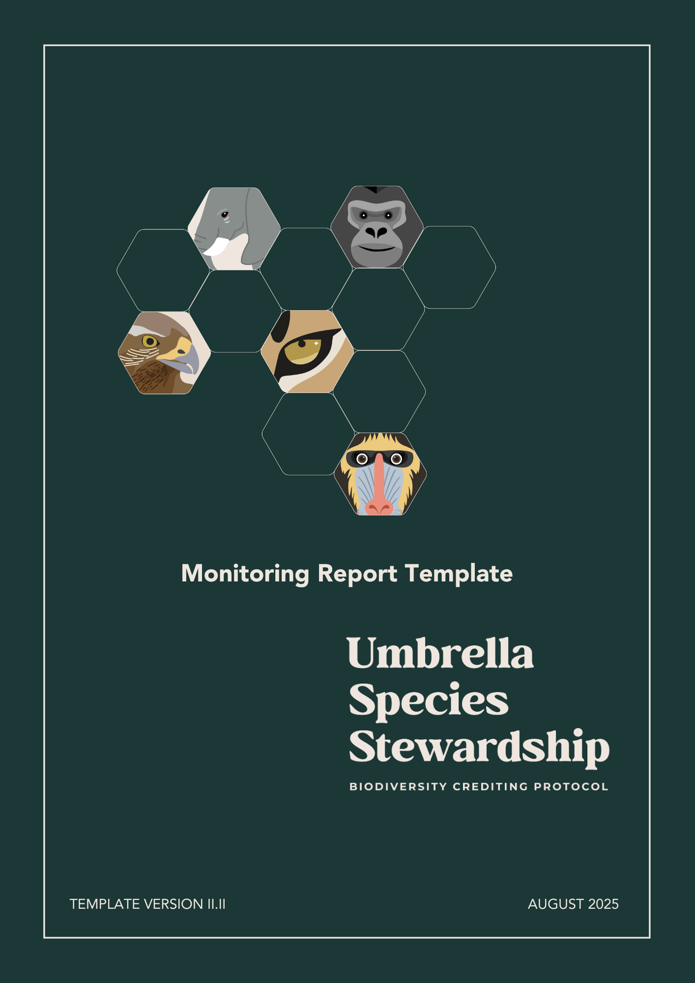

MONITORING REPORT TEMPLATE

This template is for the design and implementation of projects using the Biodiversity Crediting Protocol for Umbrella Species Stewardship (“**Biodiversity Protocol**”), harbored in the Regen Registry.

Instructions for Completing the Project Description

**TITLE PAGE**: Complete all items listed in title page. All the listed items must appear on the title page of the final document. Project descriptions may also feature the project title and Project Proponent’s and partners´ name, logo, and contact information more prominently on the title page.

**PROJECT DESCRIPTION**: Instructions for completing the Project Plan and Monitoring Plan template are under the section headings in this document. Adhere to all instructions, as set out in the Biodiversity Protocol and instructions of this template. Instructions relate back to the rules and requirements set out in the Biodiversity Protocol. The Project Proponent will need to refer to these documents in order to complete the template.

**Note**: The instructions in this template are to serve as a guide and do not necessarily represent an exhaustive list of the information the preparer must provide under each section of the template.

Where a section is not applicable, explain why the section is not applicable. Submit the project description as a non-editable PDF.

Delete all instructions, including this introductory text, from the final document.

**Biodiversity Crediting Protocol for Umbrella Species Stewardship**

Monitoring Report

Project Title:

**Insert the Project Proponent´s and partners´ logo here.**

Date of issue:

Version of this Document:

Prepared by:

Contact:

Version of the Protocol:

TABLE OF CONTENTS

1. PROJECT PARTICIPANTS 3

1.1 PROJECT PROPONENT 3

1.2 LANDOWNER OR LAND STEWARD 3

1.3 OTHER ENTITIES INVOLVED IN THE PROJECT 3

2. CURRENT MONITORING PERIOD 4

3. MONITORING THE UMBRELLA SPECIES HEALTH 4

3.1. ECOSYSTEM STRUCTURE 4

3.1.1. ECOSYSTEM DISTRIBUITION 4

3.2 SPECIES POPULATIONS 5

3.2.1. PRESENCE OR ABSENCE data 5

3.3 SIZE OF THE POPULATION 5

3.4 MOVEMENT AND DISTRIBUITION 6

3.5 MONITORING METHODS 6

4. MONITORING THE HABITAT QUALITY 7

4.1. COMMUNITY COMPOSITION 8

4.1.1. TAXONOMY DIVERSITY 8

4.2. ECOSYSTEM FUNCTIONING 8

4.2.1. ECOSYSTEM DISTURBANCES 8

5.1. PROJECT ACTIVITIES 9

6. MONITORING PERIOD CURRENT SCORE 11

# PROJECT PARTICIPANTS

## PROJECT PROPONENT

Provide contact information for the Project Proponent(s).

|  |  |
| --- | --- |
| Organization Name |  |
| Contact Person |  |
| **Title** |  |
| **Address** |  |
| Phone number |  |
| E-mail |  |

## LANDOWNER OR LAND STEWARD

Provide contact information for the Landowner or Land Steward. Please refer to the definitions of the Biodiversity Protocol.

|  |  |
| --- | --- |
| Organization Name |  |
| Contact Person |  |
| **Title** |  |
| **Address** |  |
| Phone number |  |
| E-mail |  |

## OTHER ENTITIES INVOLVED IN THE PROJECT

Provide contact information for any other entity involved in the development of the project.

|  |  |
| --- | --- |
| Organization Name |  |
| Contact Person |  |
| **Title** |  |
| **Address** |  |
| Phone number |  |
| E-mail |  |

# CURRENT MONITORING PERIOD

Indicate this monitoring report’s coverage of the project timeframe.

|  |  |
| --- | --- |
| Current Monitoring Period | mm/dd/yyyy – mm/dd/yyyy |

# MONITORING THE UMBRELLA SPECIES HEALTH

### ECOSYSTEM STRUCTURE

In this Ecosystem Structure section, the Project Proponent will provide updated detailed maps and analysis of the Ecosystem Distribution parameter, including updated detailed information about the Habitat and Consolidated Areas concerning the current Monitoring Period.

### ECOSYSTEM DISTRIBUITION

Provide updated detailed maps of the Habitat Area, detailing regions of native vegetation, water resources, regenerative systems, degraded areas undergoing regeneration, and ecological corridors or other areas (where applicable). Include but not limited to information about disturbances, droughts, regeneration of forests or regenerative agricultural activities.

At the end of this sub-item, include the following table providing a synthesis of the Habitat Area classes, including explanations if any changes on the following Habitat Area Classes occurred:

##### **Habitat Area:**

|  |  |
| --- | --- |
| **Habitat Area Classes** | **Hectares** |
| Native Vegetation |  |
| Water Resources |  |
| Regenerative Systems |  |
| Degraded areas in a State Regeneration |  |
| **Total** |  |

##### **Consolidated areas**:

Provide updated detailed maps of the Consolidated Area, detailing regions of agriculture, pasture and Infrastructure areas, or other areas (where applicable). Include but not limited to information about disturbances, droughts, infrastructure or agricultural activities.

At the end of this sub-item, include the following table providing a synthesis of the Consolidated Area classes, including explanations if any changes on the following Consolidated Area Classes occurred:

|  |  |
| --- | --- |
| **Consolidated Area** | **Hectares** |
| Agriculture and/or pasture |  |
| Infrastructure areas |  |
| **Total** |  |

### SPECIES POPULATIONS

In this Species Populations section, the Project Proponent will provide updated detailed evidence of the presence of the Umbrella Species (USp) in the Project Area or mesoregion of the Project, including detailed information about the implementation of the Monitoring Plan to evaluate the size of the population, movement, and distribution of the USp, as per the Biodiversity Protocol Requirements.

### PRESENCE OR ABSENCE data

Present and describe updated detailed evidence of the USp presence in the Project Area, by means of photographic evidence and other supporting evidence. The documents and files should show the geolocation of the photographic evidence. The description should include the details of the field trip that produced such evidence, as well as the official fauna report and other relevant information.

At the end of this sub-item, include the following table providing a summary of presence or absence and score during the current monitoring period:

|  |  |  |  |
| --- | --- | --- | --- |
|  | **Year 1** | **Year 2** | **…** |
| Presence or Absence Score |  |  |  |
| Method |  |  |  |

### SIZE OF THE POPULATION

Describe and justify how this parameter is being implemented, concerning the current Monitoring Period.

At the end of this sub-item, include the following table providing a summary of population size and score during the current monitoring period:

|  |  |  |  |
| --- | --- | --- | --- |
|  | **Year 1** | **Year 2** | **…** |
| Size of Population Score |  |  |  |
| Method |  |  |  |

### MOVEMENT AND DISTRIBUITION

Describe and justify how this parameter is being implemented, concerning the current Monitoring Period. Provide movement patterns and dispersion graphics, as per the Biodiversity Protocol Requirements, ensuring an analysis and discussion of the results for each individual.

At the end of this sub-item, include the following table providing a summary of movement implementation and score during the current monitoring period:

|  |  |  |  |
| --- | --- | --- | --- |
|  | **Year 1** | **Year 2** | **…** |
| Movement Score |  |  |  |
| Method |  |  |  |

### Monitoring methods

Describe and justify how this parameter is being implemented, concerning the current Monitoring Period.

At the end of this sub-item, include the following table providing a summary of monitoring methods and score during the current monitoring period:

|  |  |  |  |
| --- | --- | --- | --- |
|  | **Year 1** | **Year 2** | **…** |
| Monitoring Methods Score |  |  |  |
| Methods |  |  |  |

# MONITORING THE HABITAT QUALITY

### COMMUNITY COMPOSITION

### TAXONOMY DIVERSITY

Describe and justify how this monitoring parameter is being implemented, in relation to the current Monitoring Period. Attach link or add files for the official fauna survey report.

At the end of this sub-item, include the following table summarizing the taxonomic diversity methods (animal groups inventoried and the seasonal climatic periods considered) and the scores obtained during the current monitoring period:

|  |  |  |  |
| --- | --- | --- | --- |
|  | **Year 1** | **Year 2** | **…** |
| Taxonomic Diversity Score |  |  |  |
| Method |  |  |  |

### ECOSYSTEM FUNCTIONING

### ECOSYSTEM DISTURBANCES

Describe and justify how this monitoring parameter is being implemented, in relation to the current monitoring period.

Provide a brief description of the disturbances as per the table below:

|  |  |  |  |
| --- | --- | --- | --- |
| Disturbance | **Brief description of the disturbance** | **Possible environmental impacts** | **Corrective mitigation measures** |
|  |  |  |  |
|  |  |  |  |
|  |  |  |  |

At the end of this sub-item, include the following table providing a summary of ecosystem disturbances score during the current monitoring period. Fill in each year in the "Summary" row if there is an ecosystem disturbance and mitigation strategies implemented.

|  |  |  |  |
| --- | --- | --- | --- |
|  | **Year 1** | **Year 2** | **…** |
| Ecosystem Disturbances Score |  |  |  |
| Summary |  |  |  |

1. UMBRELLA SPECIES THEORY OF CHANGE APPLICATION

### PROJECT ACTIVITIES

In this section, the Project Proponent will describe the Project Activities implemented during the Monitoring Period for each strategic lines, always referencing what was described in the Umbrella Species Conservation Planning Spreadsheet (USpCPS). For each strategic line, specify the actions carried out, detailing the activity implemented, its purpose, execution process, the year(s) it was conducted, and the results of the indicators.

All supporting evidence must be provided.

At the end of this item, include the following table providing a summary of of Umbrella Species Theory of Change (USpToC) score during the current monitoring period:

|  |  |  |  |
| --- | --- | --- | --- |
|  | **Year 1** | **Year 2** | **…** |
| USpToC Score |  |  |  |

# MONITORING PERIOD CURRENT SCORE

Include the following tables providing a summary of all the indicators and scores from the current monitoring period used to calculate the amount of biodiversity credits. All information must align with the details provided in the Umbrella Species Conservation Planning Spreadsheet (USpCPS).

|  |  |  |  |  |  |  |
| --- | --- | --- | --- | --- | --- | --- |
|  |  |  |  | **Current Monitoring Period** | | |
| **Inputs** | **Acronym** | **Score** | **Unit** | **Year 1** | **Year 2** | **...** |
| Habitat Area | HA | Number of hectares | hectares |  |  |  |
| Presence or Absence data | PA | 2 points when present | points |  |  |  |
| Size of the Population | SP | 1 point per individual/group in the area | points |  |  |  |
| Movement | MO | 1 point per individual/group monitored in the area | points |  |  |  |
| Monitoring Methods | MM | 1 point per monitoring methods implemented | points |  |  |  |
| Taxonomy Diversity | TD | 1 point for each mammal inventory carried out per seasonal climatic period + 1 point per optional inventory carried out | points |  |  |  |
| Ecosystem Disturbances | ED | 1 point per year in which disturbance(s) are reported with corrective mitigation measures implemented in the area after the occurrence of the event(s) OR 2 points per year with no disturbances | points |  |  |  |
| Project Interventions | PI | 1 point per intervention implemented | points |  |  |  |

|  |  |  |  |  |
| --- | --- | --- | --- | --- |
| **Umbrella Species Health Calculation** | | **Year 1** | **Year 2** | **...** |
| USH | USH = (PA+SP+MO+MM) |  |  |  |
| Percent Increase | Percent Increase = ((USH_current / USH_year1)-1)*100 |  |  |  |
| USH Factor | Defined in Improvement Score Table |  |  |  |
|  |  |  |  |  |
| **Habitat Quality Factor Calculation** | | **Year 1** | **Year 2** | **...** |
| HQ | HQ = (TD+ED) |  |  |  |
| Percent Increase | Percent Increase = ((HQ_current / HQ_year1)-1)*100 |  |  |  |
| HQ Factor | Defined in Improvement Score Table |  |  |  |
|  |  |  |  |  |
| **Theory of Change Factor Calculation** | | **Year 1** | **Year 2** | **...** |
| USpToC | USpToC = PO |  |  |  |
| USpToC Factor | USpToC = PO / USpToC Max (28 points) |  |  |  |
|  |  |  |  |  |
| Total Biodiversity Credits | HA * ((USpToC Factor + HQ Factor + USH Factor)/3) |  |  |  |

The price of the credits:

|  |  |  |  |  |
| --- | --- | --- | --- | --- |
|  | | **Year 1** | **Year 2** | **...** |
| **Total Project Costs** | **USD$** |  |  |  |
| **Total Biodiversity Credits** |  |  |  |  |
| **Total price per credit** | **U$/unit** |  |  |  |